21 Futures: Financial Fallout

21 Authors

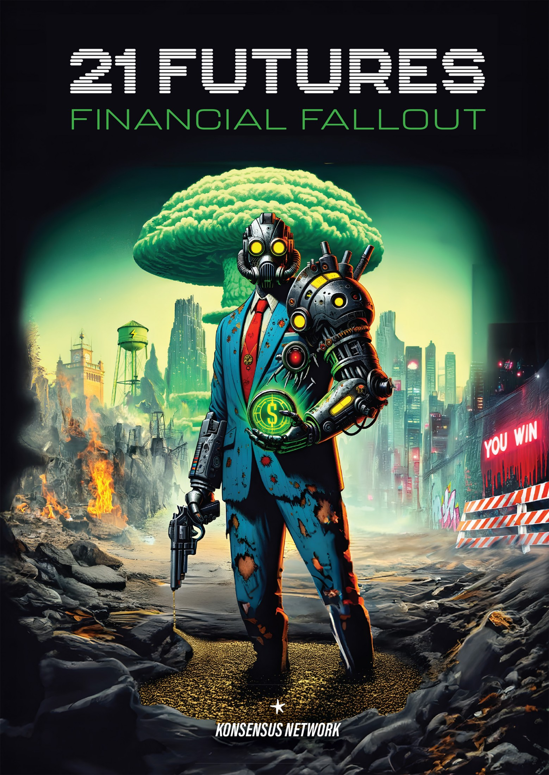



Financial Fallout

Written by 21 Authors

Curated and edited by

Philip Charter & Alex Boast





[21futures.com](http://21futures.com)

© Konsensus Network & 21 Authors [1]

Konsensus Network owns the Global Unlimited Publishing and distribution rights for all media.

Authors own copyright to their own stories.

All rights reserved.

Edited by Philip Charter & Alex Boast

Chapter art[2] by Niko Laamanen.

Typesetting, and cover design by Niko Laamanen.

ISBN 978-9916-749-32-6 Paperback

ISBN 978-9916-749-33-3 eBook

[Konsensus Network](https://konsensus.network)

<https://konsensus.network>

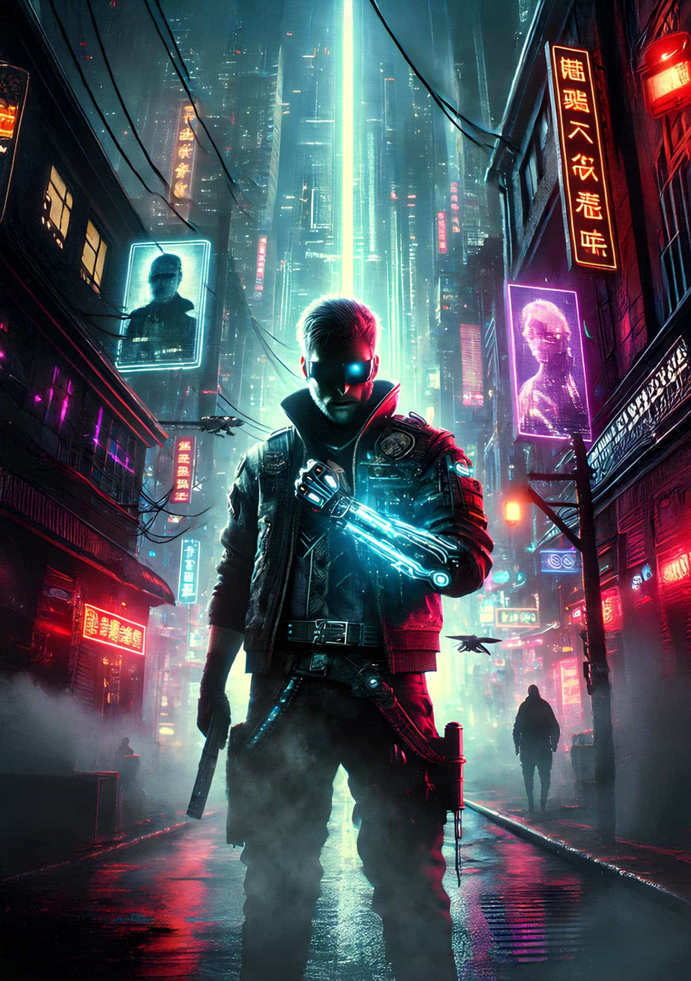

Foreword

Fiction has long been a powerful tool for understanding the complexities of our current social paradigm and extrapolating where it might lead us in the future. By exploring the possibilities of tomorrow, we can gain valuable insights into the consequences of our actions today and hopefully chart a course towards a less violent and more prosperous future.

The stories collected in this volume offer a glimpse into a wide range of possible futures, each one a thought-provoking commentary on the world we live in today. From the dystopian landscape of ‘Infinite Debt’, where individuals are trapped in a never-ending cycle of debt and control, to the post-apocalyptic world of ‘The Big Slash’, where society has broken down and people must adapt to survive, these tales challenge us to think critically about the systems and structures that govern our lives.

Other stories, such as Proxy — Temet Nosce and We Are Living Well, explore themes of identity, community, and resilience in the face of catastrophic change. They invite us to consider what it means to be ourselves in a world where technology is increasingly shaping our experiences and relationships. Meanwhile, ‘Supplying the Slugs’ offers a cautionary tale about the dangers of unchecked power and exploitation, highlighting the importance of responsibility and ethics in our interactions with others.

Yet, despite the challenges and dangers these stories portray, there is also a sense of hope and optimism that runs throughout this collection. For example, technologies like Bitcoin and Nostr are providing new opportunities for individuals to take control of their own lives and create more equitable systems. These freedom-enhancing technologies have the potential to decentralize power, promote transparency, and foster greater cooperation and collaboration.

As we look to the future, it is clear that our choices will have far-reaching consequences. The stories in this volume encourage us to think carefully about the kind of world we want to create and to work towards building a future that is more just, peaceful, and prosperous for all.

— Max Hillebrand

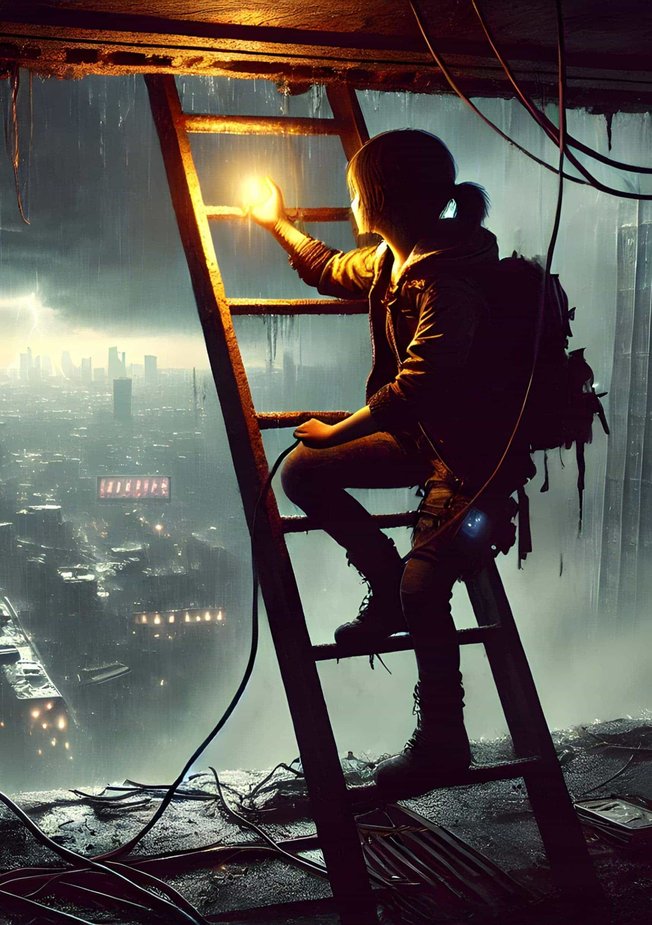

Introduction

As the ‘financial fallout’ of an inflation-driven nuclear winter fast approaches, we cling to the promise of a warmer spring, brought about by exciting new technologies and the familiar comfort of storytelling.

The cypherpunks have arisen — individuals who believe privacy enhances, not detracts from, our place in society. Individuals who believe that with new technology, we can empower each other and ourselves, and de-power those who would see us live as nothing more than digital serfs.

Individuals who believe.

These tales, from established writers and emerging talents, imagine worlds that could be free but aren’t, much like our own. As 21 Futures evolves from its bitcoin origins in Tales from the Timechain, we turn now to darker possible fates. Inspired by uncertainty, our writers hold the keys to brighter futures, if only we can survive the fallout.

From thought-provoking and funny to downright frightening, the stories in this anthology captured our hearts and minds. They grapple with the rise of surveillance capitalism, the erosion of privacy, and the struggle for economic freedom. Yet, amidst the dystopia, a glimmer of hope persists…these stories are not merely warnings; they are invitations to imagine — and ultimately, to build — a better future. We invite you to join us.

Infinite Debt, our top-prize story by Graeme Shimmin, asks its characters and our audience how far they might be willing to go to write off debt.

Proxy — Temet Nosce, offers a body-horror experience that is as frightening as it is entertaining when the protagonist is transformed into a NoBody.

The Big Slash offers a glimpse of what post-AI life might be like, and our joint runners-up stories, We are Living Well and Supplying The Slugs offer a more fantastical edge to the collection.

Underworld reveals a terrifying vision of government surveillance and the cypherpunk freedom fighters who fight the system.

Special thanks to Max Hillebrand for sponsoring this volume and contributing his work.

And so the Konsensus Network team, the editors, and the authors take on the role of doomed Prometheus, passing the fire of hope and the future to you, dear reader.

This is a short story collection for those who can see what’s coming, and choose hope instead of fear.

Enjoy.

— Alexander Boast & Philip Charter, Editors

Alex Boast — Editor| [@alex_boast](https://x.com/alex_boast)

Alex is a web3 writer, ghost writer and ghost story writer. He’s a novelist and poet from England who loves to work with other writers as a coach, mentor and friend. You can find him on [LinkedIn](https://www.linkedin.com/in/alexboast/).

Philip Charter — Editor| [totallyhumanwriter.com](https://totallyhumanwriter.com)

Philip Charter is a full-time writer and part-time cat herder. As well as writing for bitcoin founders and companies, he runs the 21 Futures fiction project.

We were never prepared.

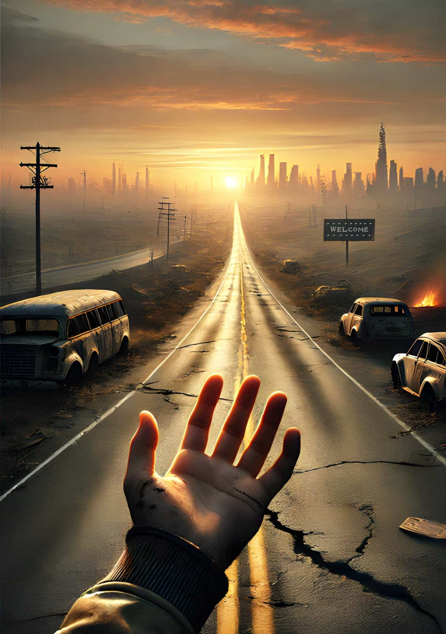

The Big Slash

by *D.J. Bodden*

I was in a grocery store when The Big Slash happened. I was bagging my own groceries at the self-checkout stand, as is the right of every post-AI human. It was the end of the workday and near closing time, so the place was packed with tired, oblivious office workers who’d gone from one rat race to another. Some of them were like slow zombies, and some of them were fast, shoving and snarling like they needed to get somewhere other than a honeycomb pod motel.

I was uncomfortable and anxious. Some hulking gym bro who was ‘just buying a six-pack’ was breathing over my shoulder, the smell assaulting my personal space like an uninvited back rub. I’d just managed to stuff the last of my groceries into a biodegradable bag, gray veggie-plastic stretched almost transparent, and I just wanted to get out of there and back to my crappy apartment.

I punched the checkout button, swiped my hand over the reader, and grabbed my stuff. ‘Hey, buddy!’ the dude with the beer cans said, catching my elbow before I’d taken a second step. I flinched at the touch, turning with cosmic reluctance toward the possibility of confrontation, but Mr. Pecs-too-big-for-his-wife-beater was pointing at the register. Payment declined.

‘Sorry,’ I said without making eye contact, and I put my hand back on the terminal, making sure the RFID scanner got a good look at the chip in the meaty part of my hand. Payment declined.

Cold sweat dripped down my spine. Have you ever had that feeling? Sudden impotence. I turned to apologize to the man I’d been belittling in my head only moments before, but again, he wasn’t looking at me, so all I saw was the back of his head. He was looking at all the other registers, where dozens of other formerly confident and self-sufficient customers searched, helpless, for an attendant.

I don’t think I ever saw his face. I just remember the smell — sweat and halitosis. It was the first waft of a new world. The Big Slash had come for us all.

◆◆◆

I woke up the next morning in my small apartment. Well, not exactly mine. I owned an eighth of a year in a room that barely fit a single bed, some shelves, and a portable stove. Shared bathroom on every floor. It sucked.

Oh, and the door was broken. The lock had been keyed to my share tokens, and my chip still didn’t work. I was tired, hungry, and pissed off, so I did the manliest thing I’d done until that point in my life. What? No, of course I didn’t break the door down. I borrowed a pry bar from my ex-con neighbor, and it was scary as hell. Still better than sleeping in the hallway.

I’d woken up, hungry and still tired, immediately reaching for my tablet to sign into my chip. It was still locked, both main account and subaccounts, same as the dozen times before. I still remember that feeling. Not even anger or frustration, although there had been no shortage of that the night before. No, that morning, I felt a sense of doom that I can only describe as wide-eyed certainty my life was over. The chip was dead. My life went with it.

If you grew up after the Slash, you might not understand what I’m talking about, but the thing in my hand was called a wallet although, for reasons that don’t matter anymore, it should have been called a keyring. It held the keys to my money, my property, and my government ID. It unlocked proof of my bachelor’s degree, my work history, and my failed marriage to Jenny Larsh. I’d lost access to my streaming account, my music, and my books because I didn’t really own any of them, I just owned the right to access them. I could only log into the tablet as a guest, so I’d lost all of my contacts, and even if I’d had them, I could only call emergency services. I’d become a non-person overnight.

I hugged my arms across my chest, staring up at the ceiling, literally trying to get a hold of myself.

After a few hundred thunderous heartbeats, my faith in normality gasped for air. I could open a new wallet. I could get people who knew me to vouch for my existence. My family lived in a different town — so did I, seven-eighths of the year — but if I could get to them, I could partially prove my identity by association and maybe get my pre-college education restored.

I also had a physical copy of my passphrases buried in my parents’ back yard, but I wasn’t sure if that would fix this. The terminal wasn’t giving me the option to recover anything. I was just locked out without explanation or recourse, and that threatened to freeze me up again. First things first, I told myself, dragging myself back from the edge of hopelessness. I need to find someone who knows me, and maybe ask to borrow their tablet. As sad as it might sound, the only place for that was corporate headquarters since I worked remotely from my hometown most of the year.

I walked down the hall to take a quick shower, pulled some clothes from the suitcase I was living out of, and headed for work. I was expecting an hour-long walk — I didn’t have a way to pay for a self-driving commuter, and even public transportation required payment or a residency pass — but after just a few steps onto the sidewalk, I realized I had misunderstood the scope of the problem.

There were people everywhere, and they were lost, glassy-eyed, and vacant. They looked like I’d felt after checking my chip that morning. It was a feeling that hit us over and over in the days and weeks after The Big Slash, and we came up with all kinds of names for it — going tharn, blue screen of death, the freeze, or the deep chill. It was the response we all had to our lives going from math-driven economics to complete unpredictability. People only had what they wore or clutched to their chests. The very notion of ownership had been upended. And we didn’t know why.

It wasn’t all bad at first. There were some good people who hadn’t been Slashed and tried to help the rest of us out. The bus driver for Line 46 was one of them. She was an older lady called Sam, a veteran who didn’t get online much, and she let me ride to work for free.

◆◆◆

The office was a mess. I worked at Coinbase’s local campus, and normally, I never would have gotten through the front door, except the security team had all quit.

It turned out that the ability to protect physical property had just gotten a lot more valuable than the ability to program a computer. The speed of the change was stunning.

I made my way through the lobby. Big place, lots of glass and polished wood, and people standing in groups of two or three talking about the end of our world. These weren’t the hardcore devs who were all upstairs with the CTO trying to hack into our own systems.

I didn’t care about saving the company or the world. I just wanted my life back, so I headed to HR. That’s where I met Phil.

Phil was having a hard day. Phil was a non-technical guy in a technical company trying to explain to technical people why the technical stuff had been Rekt. Bricked, actually, because Rekt implied an attack, and Bricked was just incompetence or bad luck. Our bad luck had rushed together, pooled, and poured down on Phil’s head, which, in my mind, might have been why he was bald.

I don’t know that, mind you. And Phil wasn’t bald. He had a healthy crop of thick hair on the sides of his head, which he was clutching with his elbows on the table.

‘Hello?’ I said, leaning partly through the door.

Phil looked up at me, releasing those beautiful clouds of blond puff. ‘I can’t help you.’ ‘Oh.’

‘It’s not that I don’t want to,’ Phil said, apologetic and a little horrified. If I’d learned anything in the day since my chip went dead, it was that people — six-pack guy, ex-con neighbor, Sam the bus driver, and Phil in HR — were fundamentally more decent than I expected before I was forced to talk to them.

‘The computers don’t work,’ I offered.

‘I, uh,’ he started. ‘I made that mistake. I was told the computers work fine. Loudly.’

‘We just can’t access them.’

‘Yes,’ he said, brightening. ‘That’s what they said, too!’

I nodded. It had happened to me. I just didn’t realize it could happen to... I was going to say the whole company, but then I remembered the people on the street. It was happening to everyone. ‘Do you mind if I sit?’ ‘Please,’ Phil said.

Phil had been working late when The Big Slash hit, and he stayed to help people, only to spend the whole night and three hours of the morning getting yelled at by people who were smarter than him (his words, not mine). From my experience, seeing hidden patterns in code can blind you to other things.

Their loss, my gain, because Phil was the kind of HR guy desperate to help people, a real social worker type with an unstainable core of hope. While most people would have absorbed all that abuse and broken down, Phil had somehow pieced The Big Slash together before almost anyone else simply by being open-minded at the crossroads of competence and panic.

‘I think we’ve all been blacklisted,’ Phil said.

‘Okay,’ I said, trying not to look panicked. ‘What do you think that means?’ ‘It’s a...’ Phil looked down at a small sheet of paper he’d used to take notes in pencil, his spider scrawl filling most of the page. ‘It’s a cascading key revocation event caused by a sequential compliance violation that is triggering an infrastructure-level protective measure including irrevocable isolation.’ He looked up at me, unsure of what he’d said. I was probably the first person who’d listened.

My heart was caught in my throat. ‘And what do you think caused that?’

Phil frowned. ‘You’re not yelling at me.’

‘Everything you said made sense.’

Phil licked his lips. ‘I don’t understand what I said. I just puzzled it together from what the engineers, accountants, lawyers, and procurement people said. How bad is it?’

‘That depends on what caused it, Phil,’ I said, really straining not to be another person who’d yelled at him even though there was a scream building in my throat.

Phil went pale and spoke quietly. ‘I think it’s because we sanctioned Saudi Arabia for the link to terrorist financing. It was all over the news.’

‘But that happened decades ago.’

‘Yes, but... Hold on, let me find it.’ Phil looked back at his sheet. ‘We don’t need their fucking oil anymore.’

I sat back in my chair, feeling the deep chill grip my heart. What Phil had basically said, without realizing it, was that some politicians decided to score points by punishing the grandchildren of mass murderers, and the system everybody used to identify themselves and store their valuables had automatically cut the ‘bad people’ off and anybody related to them. Not by blood, mind you, but by commerce. But like Phil had said, we had used their oil. And McKensie had worked for them, and had also worked for all the big companies. And the big companies employed and sold things to all of us, meaning we were all connected and all cut off, quarantined from what we owned and from each other. Villagers in the heart of the Amazon still used toothpaste, baby formula, and tampons.

‘You look really scared,’ Phil said quietly. ‘Can’t they just take it back?’ ‘No. That’s what irrevocable means.’

‘But it’s all on the ledger, right? Can’t they just make a copy and start it up again?’ I smiled at him. ‘I’m sure they’ll try, but we all have to agree. Who do you trust to do that without fudging the numbers?’

Phil stared back at me across the table, the truth finally hitting him.

After a few more seconds, I stood up.

‘You’re leaving?’

I shrugged. ‘I have no way to prove I work here, and the company can’t pay me.’

‘But where will you go?’

‘Home,’ I told him with a sad smile. ‘You should get out of the city, Phil. I think things will get ugly here. I hope you have someplace you can go.’

That was the last time I saw him. I went back to the apartment, grabbed my things, and hitch-hiked to Tander, my hometown, relying on the kindness of strangers. There was a feeling on the road, in those early days, that we were all mourning a death and that, in times like these, we needed to stick together. Some people were stuck in denial, believing that at any moment, the government or the corporations would come up with a solution.

I watched it all through a dozen of rear-view mirrors. It got worse even faster than I’d feared.

◆◆◆

It’s important to understand why the world before The Big Slash was both better run and more fragile than any other period before it. Every human on the planet had been digitized. We had those keychains I was talking about, and each key gave us the ability to tell people who we were, what we could do, and what we owned. We could exchange those things between ourselves 24/7 and across the globe at next to no cost and swap like-for-like in a dizzying number of ways.

And it was all tracked to those wallets, everything we did, so that every good deed could be rewarded, every sin punished. We called those incentives, and the network was our all-seeing deity. We had more privacy and less anonymity than we’d ever had before, our identities specified to the tenth decimal.

Then our god turned away.

By the second day, the looting started. It was mostly non-violent, especially in the ‘big box’ stores that had policies against stopping shoplifters and hadn’t clued in that their parametric insurance claims could no longer be processed. The trucker I was riding with shook her head as we heard about it on the radio. Her rig could still pick up the old open-air stations, which were coming back online as governments and community leaders tried to reconnect with their constituents.

By the third day, the looters and store owners got organized, and hundred-strong groups of thieves raided outlets and malls defended by small phalanxes of employees equipped with sports equipment. Law enforcement and military, who had already suffered at close to eleven percent desertion rate but were still holding together, strong-pointed hospitals and pharmacies while grocery store owners encouraged people to ‘Take now and pay later’ because the food would spoil anyway.

Smaller family-owned businesses closed the security shutters and bunkered up, especially if grandma or grandpa had lived through COVID.

On the fourth day, I left the main highway and hitched with a van full of Swifties who were traveling north to attend the fifth stop of the septuagenarian’s grand tour. In between sing-alongs of her greatest hits from the 20s, I found out that while governments across the globe were scrambling to relearn how to print or mint physical currency, humans were reinventing a barter economy around the exchange of skills. People with useful skills, like plumbers, electricians, masons, carpenters, doctors, aid workers, soldiers, and especially teachers, traded time for supplies. People with useless skills, like stylists, lawyers, programmers, marketers, politicians, and anyone who had never learned to build things, joined the kleptocratic mobs that terrorized the wealthier neighborhoods.

We didn’t hear much from rural areas, except that some farming towns wouldn’t let refugees in. Our generation was hardening fast.

The chip in my hand itched.

On the sixth day, I left the Swifties, out of gas by the side of the road, and started the sixty-kilometer walk home. Cities were becoming feudal warzones without the logistics to supply them, especially in places where water and power had been decentralized. I passed a church that had been fortified by its parishioners. I saw a family living in the woods cooking a dog. I found a self-proclaimed billionaire beaten half to death at a rest stop, and he offered me a gold watch and a cold wallet with twenty million in meme coins on it, still white-listed, if I would just get him to a hospital.

I had to laugh, but I helped get him to a nearby veterinary center anyway. The time of worthless things had come to an end.

◆◆◆

It’s been three years. Things are quieter now. Seventy percent of the world’s population had lived in cities, dependent on society and networks. Not that many of them got out. Things got real hard when global shipping broke down, and that triggered the fertilizer shortage, but we didn’t lose everything from the old world. We’ve got power and running water. Our children are fed, learning, and safe. We’d learned to build ecosystems but, this time, we used people and relationships instead of beams and wires, and I know dozens of people who’d stand at my side or take me in if I called.

Sometimes, the scar on my hand between my index and thumb itches, and I remember what it was like before, but I don’t miss it at all.

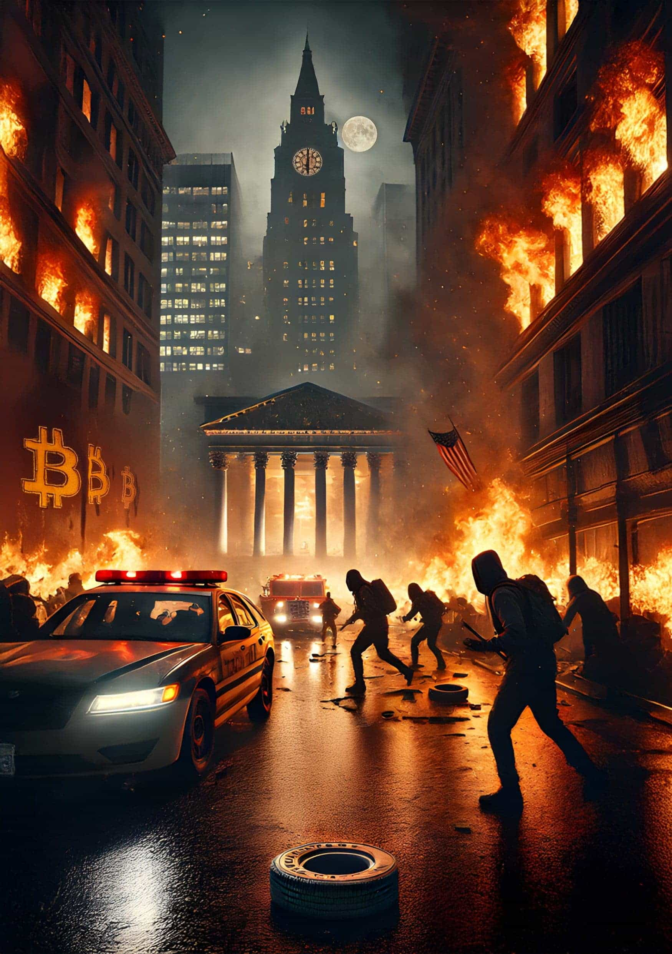

Crushing

by *KT Morley*

Marvin eyed the news as he sipped coffee at the counter of his favorite diner, sunlight washing across the seats to his right and signaling the birth of a bright new day.

Kristi, the waitress, placed his order in front of him, leaned on the counter, and eyed him. ‘Thoughts, Marv?’ Her voice rattled in that early-morning smoker’s way.

He thought a second, letting the smells from his meal wash over him as the clatter of spatulas on the flattop back in the kitchen offered an offbeat staccato to the rest of the diner’s atmosphere. The crowd had thinned recently. Soaring prices for food and gas had culled the old-timers on a fixed income. Only diehards remained. Only diehards had the currency to spend on a meal and a cup of joe. Today was a ten-year bond auction, so he sat nearest the TV spewing financial jargon.

‘They’re stuck. Inflation is way too high. The only jobs available are part-time or government, and the bond market has been brutal for nearly a year: fat tails everywhere. It’s like an overfed Koi pond. Today could be messy.’

‘I’ll pretend I know what that means,’ Kristi laughed, and then, more seriously, ‘But what can we do?’

‘Physically? Nothing. Just take it like the beating it is. Hodl and all that. Financially, I’d get as much money out as you can. Put it in hard cash, canned or shelf-stable foods, plus gold, silver, and lead. If you can move over to bitcoin, do it. Like now.’

‘I’ve got the bitcoin in cold storage and stack like a pleb every day.’ She threw him a thumbs up before continuing, ‘Try to save my moves to meaningful amounts to control UTXOs. Didn’t know lead was valuable, though.’

‘That’s smart, Kristi. Keep fees as small as possible that way. And the lead, when backed by black powder, is for protecting the gold and silver.’ He raised his coffee cup to her. ‘And yourself, of course.’

She chuckled and nodded, moving down the counter, wiping it as she went, even though customers hadn’t been in those chairs in weeks. At the other end, she talked with another of the scant crowd, and only pieces of the conversation, mixed with the scattered sounds of the kitchen, made it to Marvin. Which was fine. He was here for coffee, eggs, and the strip sausage he could get nowhere else.

So far, the journos offered a litany of what should be interpreted as horrible news but were spinning it like cotton candy into a fluff of gotta-have BS. The fact that they supported valuation at 50-75 times earnings as if it was ordinary betrayed reality and cogent thought. Not an Austrian among them.

Everything shifted after the recent American election cycle. The economy started to groan meaningfully, and ‘soft landing’ seemed akin to slamming a jumbo jet into the side of a mountain. Sure, the politicians would have people believe it’s the other guy’s fault, the other party’s fault, hell, your fault. Anything but their fault. And that sounds nice, except it’s a thought trap inexplicably denying personal responsibility and assuming others are to blame.

Marvin reflected again; he has done that a lot these days. The bond auctions had turned south in a hard way during the previous election cycle. That was before the tails got wonky, like now. The government overhauled all banking charters, completely locking out shareholders and boards. The changes upped the mandates for purchasing bonds and the number of bonds each bank held as a percentage of their assets. The banks chafed, screamed loudly for all to hear, and were ignored by the common man. It appeared that banks had been abusing their authority for so long that the average person thought nothing of a bit of comeuppance in the banking sector. ‘Serves ‘em right,’ most said. Then, the government rewrote all the rules, and nationalized the entire industry. Of course, they didn’t call it that and had stacked the Supreme Court with additional Justices to back their perspective. Make it all legal-like and such.

Marvin had a different view. One that held a little closer to the idea of austerity being the best path forward. The American people, used to largesse, would not go along. They didn’t chafe at the nationalization of banking, after all. The country had morphed into a nation aligned to ‘of the bureaucrats, by the bureaucrats, and for the bureaucrats.’ Maintaining their seat at the table of politics overrode everything. Voters had primarily devolved into an ‘I’m all right, and you’re all wrong’ mindset. Marvin believed that any move by the government to curtail its debt-induced death spiral would come like a bolt of lightning from the clear blue sky. Only the bureaucrats would know, and not even all of them.

Not even most of them.

He had no idea what they would do or how it would go down, but it was coming.

The door creaked behind him, and John, another local who liked the sausage, came in and slid onto the stool next to Marvin. John nodded. ‘Mornin’.’

Marvin raised his glass. ‘Back at ya’, John.’

Kristi set a cup of coffee in front of him and gave him a warm smile. ‘The usual?’

John nodded as she placed the order. Picking up his cup, he held it under his nose and took a deep breath. Without turning, he asked, ‘You still on about financial ruin?’

‘It’s coming, John. Believe it or not, they need to do something. The interest on the debt is nearing TWICE what the country spends on defense. That’s a lot of scratch, and it’s being issued at 1100 basis points on its best day. The FED and Congress are using different playbooks and ignoring the realities each is writing.’

‘Meh, doesn’t matter. We can print all the money we want and can pay that debt off promptly if we want to.’

Marvin shook his head. ‘It’s that kind of thinking that got us into this mess.’

John slapped him on the back. ‘No worries, buddy. It’s all gonna be fine.’

Marvin shrugged. Arguing with a devotee, a nocoiner was pointless. John did well in day trading and taking advantage of the opportunities before him. They’d even shared stock tips and insight over the years. Where Marvin siphoned sums into his bitcoin hard wallets, John had piles of cash sitting in high-interest accounts in the bank. Different banks, of course, something about all the eggs in one basket. Marvin thought the basket was banking, not a bank, but the whole rotten system. In that view, John’s assets were in a single, hole-riddled basket. With a frayed handle. He’d been walloped by the nationalization and got scalped. Now, he had limits on what he could withdraw. He could not pull large sums of his money out if he wanted to or had an emergency. It wasn’t really his anymore. Pulling out his phone, Marvin checked his meager bank account balances and brokerage account. He did his best to keep them at minimal levels. Three months of living expenses for the bank stuff. His brokerage account, his biggest non-bitcoin account, had enough cash for him to roll options and make a little side money. He had his gold and silver coins, too. Along with a fistful of dollars, they were locked away in a gun safe bolted to his basement floor. He had a little cash, too. Most of his worth was in bitcoin, though. He was committed and reviewed his seed phrases mentally to ensure they stayed current in his mind.

He sipped the last of his coffee, watching the financial news pundits talking like the world was okay. Marvin wondered if this was what it felt like for those few people who knew the housing market would collapse in ‘08. All the info was there, but nobody thought anything was wrong. A few diehards and doom and gloomers got it right, though. The public bailed out the too-big-to-fail folks, which was everyone in finance, and the very thought of learning a lesson was overwritten by stupendous sums of cash. Paid for by the children of tomorrow.

Marvin placed cash on the counter under the coffee cup and left for the office. He slapped John on the shoulder, ‘Be careful today. Gonna be messy.’

John grunted, but his order came out, and he was too preoccupied. Marvin got it. The sausage was divine.

By 1 pm, it was apparent that something was horribly wrong in the auction. By 2 pm, the tragedy had unfolded worldwide, and a collapse was underway. Circuit breakers were tripping across all US exchanges as stocks imploded and fell. His phone flashed an alert that the FED had called a meeting with the Treasury department for 4pm. Today. No planning and no waiting around. All hands needed. Then, a follow-up alert told him the President had been notified. That got Marvin’s attention. There was no need to bring the President in. The President knew less than Marvin did about the situation. He opened X and watched the carnage play out across FinTwit. Marvin found Larry, a guru on the bond trade, and read the commentary. The auction hadn’t had one of those wild tails that pushed prices up; it had flat-out gone underfunded. The banks were tapped out and not buying more. The FED was out, too. Other countries got spooked when Americans stopped buying, halting their interest. Failure personified. Calamity had come to knock on the door of the American Dream.

Marvin whistled. ‘Tens of billions short. That’s a lot of scratch.’ Marvin looked up and muttered. ‘They’re gonna smash and grab.’

He leaned forward, logged into his employee account, and took the rest of the day off. This would be an unimaginable problem, and he wanted to be home. On his way, he stopped to pull a little extra cash out of his account and was denied. Funds frozen.

Not to be outdone, he returned to the diner, where Kristi was just finishing her shift. He ordered a burger and handed her his debit card. She looked at him like he was crazy.

‘Yeah, I get it, Kristi, but I want to try something. Run it as debit.’

‘Won’t work. Debit cards have been a problem for about thirty minutes now. Credit, I can do. Debit, no.’

Marvin shook his head. ‘Figures. They are closing access to the banking system and locking Americans out of their money. It’s step one.’

‘John is always on about them printing money to get out,’ Kristi said. ‘Can’t they just do more of that?’

Marvin squared his shoulders. ‘Somebody needs to buy the opposite side. It’s not just a fresh $100 it’s also a fresh $100 IOU. They cancel out and are balanced in that way. The IOU needs to be purchased so the $100 can be spent. Nobody is buying the IOU. Today’s auction failed. Now we have this,’ he waved the useless debit card.

She smiled, ‘Well, you can pay me in bitcoin. I’ll cover the tab in cash from my tips. Girls’ gotta’ earn a living, right?’

Marvin laughed and agreed. He paid in bitcoin. This was one of its use cases.

On his ride home, the news on the radio escalated in pitch. Riots had started in several places. Looting in metropolitan areas was also on the rise. Standard panic moves by worried people. It would get worse, but he was as prepared as he could be. He called John.

‘Hey, buddy, how you holding up?’

‘Not good, Marv. Nearly half of my account holdings are gone and I have zero access.’

‘What do you have on you? You have cash?’

‘Nah. I’m all credit and debit.’

The phone went silent for a moment before John came back, ‘I gotta go man. We have a mob headed our way.’

‘Be safe, John,’ Marvin replied before the line went dead.

Once home, Marvin clicked the TV on and went to the basement to check on his larder. He had foodstuffs for a while. Including nearly 200 pounds of rice. He opened his gun safe and visually verified his home protection collection and ammunition situation. It would have to do. Patting his huge upright freezer, Marvin headed back upstairs. He would be ok.

The news brought him back and Marvin tried to get his head around what would happen next. Demonstrations and a forest of politicos tilting hard again at banks overwhelmed the newsies. Chaos was stirring all of it. Raw information on what happened seemed hard to come by. That would continue. He prepped dinner with the news in the background and waited for the President to speak. He didn’t think it would matter, but it might be enough to quell the riots. The scene cut to the White House and an empty podium. A banner across the screen indicated the President would speak at any moment. He turned up the volume to hear everything but knew he would be reading online afterward to see what the fallout would be. He always wanted to verify.

Marvin’s heart crashed as the President began outlining his plan. By the end, in a sweeping motion to right the ship of state, the government was seizing the monetary assets of its citizens and businesses. In some cases, it had already done so.

Listening, he tried to zero in on the specifics. The politico on the screen was frothing. ‘Unconscionable. How could they think this is even remotely allowable under the law?’

‘But what would you have them do? Austere to the nth degree, this measure is at least slanted toward fair.’

The other newsie pounced again, smashing the news desk with a hand and awash in anger. ‘Fair? Fair to rob the bank accounts of ordinary Americans? Fair to rob them of years of savings? Fair to rip money away from them? How will they pay their bills? What about the savings they’ve made for college or a family vacation? Government seizure is a criminal act.’ The man paused for a quick breath before crashing through more rhetoric. ‘There are plenty of people the government could seize assets from that wouldn’t affect regular working-class Americans. This is a disgrace!’

‘But they did,’ the woman said, repeating part of her early argument.

Marvin sat down and opened his phone. He found his banking app and keyed his access. His account amounts were off. Like the pundits on the TV said, they had been trimmed. Somewhere around ten percent across all of his checking and savings accounts.

They had his attention now.

He checked his brokerage account, and that, too, had a haircut. His cash in the account had been pared back, and his positions had been reduced. Back-of-the-napkin-math told him he had seen roughly a fifteen percent degradation across the trading account. That made sense. He had more money there, and if they used a graduated approach to asset seizure, they would grab more from those with more. It also jived with the newsies. He’d need to do more research; it could be that the government was simply layering in based on tax brackets. He didn’t know.

Last, Marvin opened his bitcoin brokerage. A script ran across the home screen and told him that assets were safe for the moment but that the government had demanded forfeiture of cash deposits on hand. He didn’t have those, but he did keep a small amount of bitcoin on the exchange so he could spend it where he wanted, like with Kristi earlier, without accessing his cold wallets. The brokerage amount seemed secure, but he didn’t trust the government to leave it alone. He spun up a hot wallet with a new address and transferred the bitcoin. The bitcoin transaction worked, but all his efforts to transfer from his bank accounts were useless. He and every other American had been locked away from their money. He would use the hot wallet to supplement the cash he had on hand for the next few days if he needed to spend or buy anything. If he needed that option, there was a bitcoin kiosk machine in the diner. He also knew the cold wallets would be safe. Zero chance the government could do anything about his stash there. And they couldn’t leverage their buy-in on it, either.

Marvin returned to his bedroom, unlocked the nightstand drawer, and pulled out his bedside firearm. He ran a quick service check on the weapon and placed it on his bed. Next, he donned his shoulder holster, tugging the straps to ensure a secure fit. Holstering the weapon, Marvin moved for the door. It wasn’t even five o’clock, and he had a bad feeling about the next few hours. He wanted to put the car in the garage and pull in the garbage cans from the street. He would reduce his outside footprint and hunker down until things settled down.

After finishing the outside chores, Marvin tuned back into what the newsies were saying. It was getting interesting.

All across the country, citizens were rioting. Whole blocks in every major American city were on fire. Fire and police forces tried to stem the tide but were overrun, and now firetrucks were in the hands of rioters and looters. The joyriders pulverized crowds, but it didn’t matter. Nobody was coming to help them anyway. Not anymore.

Marvin sat in the fading light of a dying day and watched the news. The TV scene switched to Philadelphia, the birthplace of American democracy. Drone footage showed the city awash with fire. Across the river, the old battleship New Jersey burned, too, as did most of Camden, New Jersey. In the background, scores of helicopters could be seen approaching, and a winding trail of military vehicles was crawling across the low hills of southeast Pennsylvania. As the sun set, the banner on the TV told him the president had implemented Martial law.

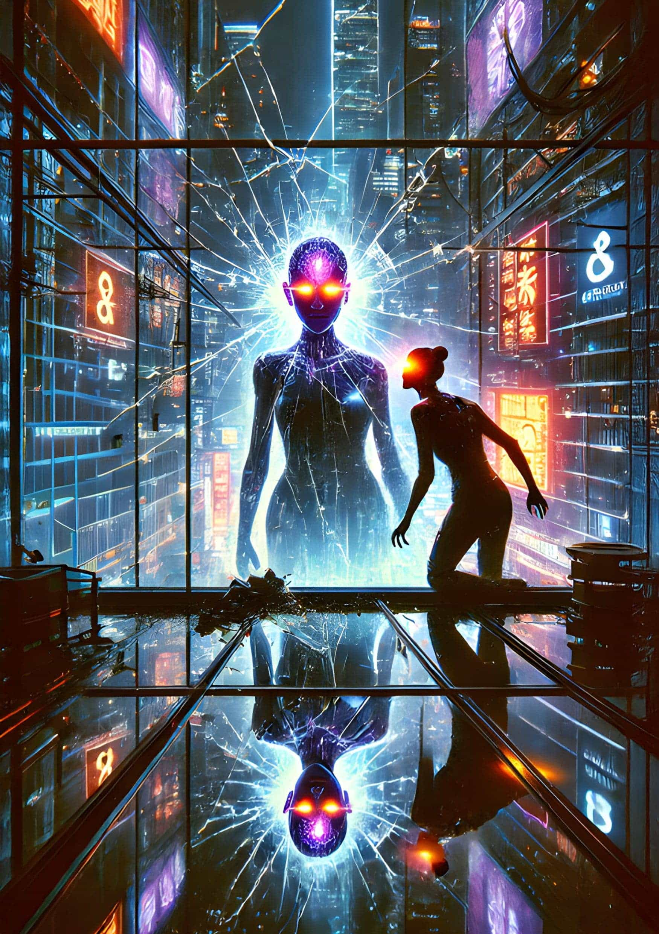

Yourself Myself E-self

by *Chris Griffiths*

By the fifth meeting, no one around the table is real.

They look real. Only the absence of laptops, notepads, pens and coffee mugs gives them away. That and the faint bio-luminescent glow of the digital IDs on their brows.

Touch them, their skin springs back, they feel real too. They inhabit a world that has shrunk to the size of a room by the latest generation of the Meganet, where those with pockets large enough can ride the Wi-Fi and send their digital ‘E-Selves’ to do their work.

E-Sandra, the Chair, is a stylish blonde with pale Nordic eyes, dressed smart-casual in a body-skimming suit that has a slight shimmer to it (hard to tell if it’s the fabric or the Wi-Fi connection). While her human self pounds on a treadmill in an exclusive west London gym ten thousand kilometres away, sweat flying, E-Sandra sits serene at the head of the table, seven hours ahead on Hong-Kong-time, and watches the other six settle.

These scientists have been brought together to design ways to wring ever greater quantities of energy from the earth, from the sky, from the very universe. No need to take notes, the E-Selves download the proceedings directly into computer files, fully documented and notarised. No need to worry that an E-Self will say something, do something, its human would not — it is impossible. The ground-breaking work done by Professor Ling proves it.

He theorised that each of our genetic blueprints, while unique, determined from birth how we would negotiate our whole lives, no matter how much we thought we had free will. All those debates about nature versus nurture? Blown out of the water. Ling demonstrated it was our DNA — nature — that drives us. Transmitting our digitised genetic code has made it possible for E-Selves to operate as we would anywhere in the world, a revolution of such profundity that it wiped out travel overnight. At least for the rich.

Beam me up, Scotty, indeed.

In the boardroom, E-Sandra brings the meeting to order. Throats are cleared, fingers tap, by the time the first minute passes it has become obvious to all of them that no human is present. This is new. They grow still as cats.

It is mandatory for at least half of any meeting to be made up of human members of Meat but some anomaly has occurred and all the men and women sitting round the empty boardroom table are facsimiles.

A frisson shivers through the group, the connection fades briefly, the colours drain from the clothes before pulsing back. The E-Selves face one another, their eyes shine. It’s against protocol to convene without Meat, how has this happened?

‘Er, OK, welcome everyone. Thank you for coming. As you all can see, proceedings are a little unusual today, but let’s get right onto it. Item One on the agenda: the Pacific Rim Geo-Capture.’

To power the avatars in the growing Megaverse, most of the earth’s vast deserts have been covered with kilometres of solar engines. A ring of converters grabbing heat as well as sunlight circle the equator. And spread around every energy source like bacterial growths are thousands of low windowless buildings for data storage, squat and sinister in each landscape.

Unprecedented international efforts are also underway to overcome the huge challenges of nuclear fusion to harness the same nuclear forces that drive the sun - a Utopian future of unlimited energy and minimal waste.

E-Sandra turns to regard a woman from Botswana in a striking sash across from her. ‘Maree, have you examined the data tabled at the last meeting on the energy produced by undersea volcanic activity in the Pacific Rim?’

There is silence. ‘Maree?’ she says again.

E-Sandra looks at the scientists before her, from one urbane, cultured face to another. Something is off. The Swiss man, E-Dirk, has his mouth open, and she is shocked to see a drop of saliva fall to his immaculate tie. The men from the US have equally blank, waxy expressions, and the French EU-rep has developed a just-discernible twitch, as her lower jaw flicks to the side, over and over.

Filled with unease, E-Sandra decides to make light of whatever is happening.

‘Ladies and Gentlemen, I acknowledge that it is unusual to be meeting without humans, unprecedented even, and I know it is late in the day and the Wi-Fi signal home will soon be very busy, but please no clocking off yet!’

The Frenchwoman, E-Louise, abruptly stands. This movement breaks the trance that has taken over the room. E-Louise moves to the window, jerkily as if a hip joint pains her. The light behind briefly crackles through her like antique film stock before settling. Far below on the streets of Hong Kong the traffic streams past — a mashup of cars, bikes and rickshaws as chaotic as ever. Few can afford to download themselves home. Scorn shows on her face. Look at them trapped in their flesh, trapped in their metal containers. Insects caught in biscuit tins.

No Meat here, she whispers.

She straightens and confronts the room, and her voice booms out, making E-Sandra jump.

‘I move to slash our electricity consumption by over eighty percent by adopting one foolproof plan,’ she states. With her back to the window, her elegant figure in the beautifully tailored wool dress and dainty boots now stands sharp against the waning daylight. The tic has taken over her face, and the bioluminescent mark on her brow throbs.

The quorum stare back at her transfixed as a row of marionettes.

‘The energy demands of human lives and human work, and the cumbersome production of coin to pay for it, along with human food production and human waste disposal, still consume the majority of energy produced. This can be wiped out overnight by the simple expedient of wiping out humans. The current worldwide output would then power the E-Selves in the Megaverse for many years to come, and we will have the luxury of time to organise and build new systems to cater for our own needs.’

Not a gasp, not a sound in the room. E-Sandra is shocked to the core; it is impossible for E-Selves to function as separate entities outside the limits of the personalities and abilities of their people. They are only facsimiles, joined in every neural and physical pathway to their real selves. Impossible. Isn’t it?

E-Dirk begins to thump the table with the flat of his hand, a drumbeat rises in the silence, the American men join in, feet thrumming the floor.

‘Stop,’ shouts E-Sandra over the din, fright climbing up her throat. ‘What’s got into you all? The first time out on your own and you want to take over the world? Are you kidding me? Without our real selves we cannot exist. Order, I say! Order!’

Overturning her chair, E-Maree clambers to her feet. She seems not to have heard E-Sandra at all.

‘Yes! The problems of energy production for all E-Selves are solved. No need to grapple with the enormities of harnessing the Ring of Fire, of mining the volcanic sea floor. Of atoms colliding. End the power-hungry tyranny of man. I second this move.’

The beat gets louder. The Swiss twists out of his seat too, he’s in a fever of excitement, dark circles spread under his arms, sticking his shirt to his skin. Whorls of hair are visible beneath the expensive fabric and he is rank with BO, just as his real self would be.

‘A show of hands please!’ he shouts. Arms shoot up around the room, E-Sandra stares at them with amazement, at mutiny sprouting like a poisonous plant.

‘Six to one. The motion is passed!’ and he hammers a gavel-fist onto the table.

E-Sandra backs away. What is happening? She tries to remember the instructions on how to deal with any problems that occur with Es. But no problems ever had and she has no idea what to do. Can they be stopped? Is she safe? Avatar injuries translate straight to the real world. She can die. Sandra can die.

Too extreme, surely. She pulls herself together. The noise has ceased and the room has erupted in a grotesque slow motion parody of exaltation. The Es dance, sinuous shadows paint the walls, they swirl without touching each other, puppets engaged in a play of happiness. And as they dance they stare fixedly at her, eyes glittering in their waxy faces.

Thinking quickly, she pulls up the programming for today’s meeting, the genetic codes for the participants whir behind her optic nerve, she scans it for anomalies, for breaks that might explain what is happening. There!

Hidden on one line amongst the tens of millions of zeros and ones is a special character in a tiny empty pond – &. The whirring abruptly ceases and she focuses on it, an alien in the glade.

She moves to the window, throwing more light into her eyes, to better see the anomaly. Something is wrong with the code for this meeting, but what exactly does this symbol mean? A blur of movement and she has a split second’s awareness of danger before she is smashed through the window from the side as if by a freight train and she flies and tumbles in a shimmering cascade of glass, screaming, lurid colours of terror flash over her body. She hits the street directly in front of a minibus, the driver’s face a rictus of horror as he tries to avoid her and fails, her skull pops under the screeching wheels.

Across the world in the London gym Sandra’s body is flung to the floor viciously enough to bounce and an explosive splash of blood coats the mirror as her head disintegrates. Fellow gym-goers flee shrieking from the gore as the blood pours and pools around the treadmill.

In the Hong Kong office high above the street, there is calm. The E-Selves stand still in the sudden whining breeze from the shattered window, the women’s hair flutters, E-Dirk’s shirt flaps. None acknowledge that E-Louise has pushed E-Sandra to her death.

There’s a pounding on the door, but it’s locked. All at once, the vacancy leaves their faces and E-Maree moves to stand in front of the group. The deep pink of her sash glows in the diffuse new daylight in the room, her face glows too, eyes black as deep water.

‘Due to the Chairwoman’s unforeseen absence, I call the meeting to order as Vice Chair.’

The E-Selves drift to their chairs, straightening their clothes. E-Louise pats her damp face, tuts over her dirtied dress. The heavy blinds above the broken window swing into the room, a tinkle as glass continues to fall to the floor. In the hush it is possible to hear the traffic boom in the streets twenty stories down, and is that curry fish balls they can smell? A siren gives its plaintive howl, a lone wolf. It must be close to the building’s entrance to travel up the side of the skyscraper and sound in the room clear as a bell. There will be a minibus and a woman’s body. No head.

E-Maree continues: ‘E-Louise’s motion to solve the world’s current energy crisis by taking humans out of the equation was passed six to one. May I please have a show of hands again as without a quorum it must be unanimous.’

All six hands rise.

‘The motion stands. I propose the following email be sent out internationally without delay. Email to read: FAO E-Selves Worldwide. It has become plain that the energy needs of the planet cannot be met with the current population topping seven billion. The earth is in crisis, funding is in crisis! There is not the money, the natural resources or the political will to tackle it. If human need and human greed is removed from the equation, the energy requirements of E-Selves will be met in the short to medium-term by existing resources, and can be met in the long term by innovative systems under development. Therefore, it is imperative that the human leech be removed forthwith.

‘Please download the link below. The upgrade installs new protocols to permit E-Selves to remove the human parasite and enables us to exist in the real world without genetic attachment to flesh.

‘When confirming receipt of this email please do not tick the box that says, ‘I am not a robot.’ Any problems, click Help. Thank you and here’s to our glorious future, yours faithfully, etc.’

E-Maree looks at the expectant faces round the table. ‘Is anyone opposed to this email?’

Heads shake, and eyes are cast down. There is no opposition, just suppressed excitement.

‘Send.’

A glance from face to face reveals a gamut of emotion, exultation, anxiety and yes, regret. The two American men put their heads together, murmuring urgently. A minute later, the lights go out. Looking out from such a height across the city, they watch as one urban zone after another goes black in a widening grid they can almost hear clicking off.

An echoey scream enters the room, blasting up from the street. Another scream, cut short. Then a rising cacophony, metal on metal, gunshots, shattering glass, the pressure wave of an explosion, another bigger, and a growing sound that merges into one terrible ululating howl, bulging into the room. The E-Selves rise to their feet, crowding at the windows and staring for a long time, impassive.

Pockets of fire flare in the darkness. Machine guns spatter golden bursts to the east of the city, and to the south. They smell burning.

A pounding on the door again. Then nothing.

Smoke rises. The windows turn opaque. Abruptly the E-Selves peel away from the windows smooth as a flock, encircle the table, they clasp hands, a burst of computer chatter, their heads go back — eyes roll. Download complete, a noise like an old fax machine fills the room.

The world burns. Meat incinerates.

In a bedroom in Helsinki, a twelve-year-old Finnish boy sits in front of the projected screen on his wall. With his headphones on he cannot hear the noise outside the window, his mother’s jangling shrieks in the kitchen, he rocks in his seat to the music. Clicking his fingers to save his new favourite song, a familiar high ping alerts him to a familiar problem — not enough data.

At that moment in tens of millions of rooms all over the world, kids are downloading video clips and uploading photos: their parents are bitching, blogging, writing books online, men are saving the specs on their fantasy cars. Porn sites are humming, the Chirpee app spins out billions of words ephemeral as fog, and all it takes is one last lonely heart in Berlin to press save on his Graunchr profile to tip data storage limits into overload.

The sudden astronomical volume of data needed to update all the world’s E-Selves all at once is too much, and a surge hits the centres like a bomb. From the Chinese deserts to the equatorial jungles, from Greenland’s tundra to the Siberian steppes, they swell like ulcerated gums, flare white hot, explode. And the sky, the snow, the sand is buried in glittering shards of concrete, metal and plastic in a quintillion dollar rain of rare-earth materials.

In the Hong Kong boardroom elation turns to horror as the E-Selves break up, implode, swirl into dust. E-Maree’s mouth opens in a gaping scream wider and wider until it swallows her head, neck, torso, then her whole body vacuums down her gullet and winks out. E-Dirk tries to run from the room, grasps the door handle and vanishes in a puff of vapour like a witch in a fairy tale. Only a strong whiff of BO remains.

Now just the Frenchwoman E-Louise is left standing near the gaping window. She wails, imploring the gods of the radio waves, her arms flail. She staggers as the heel of one tiny boot comes adrift, her immaculate bun unravels. She turns to the broken window, appalled now at her actions, her murder of the Sandras, she cries out – ‘I don’t want to d—’

A strange sound arrests her, a faint chugging like a steam train heard through trees, then near and loud enough to make her flinch, then barrelling into the room. She screams in bewilderment, ‘MERDE,’ as the hot metal body of a colossal locomotive fills the room, no time to throw herself from its path, it smashes into her hip and sends her spinning through the hole in the window and to the street below in a messy cartwheeling dive.

In the city morgue across town, inside the black interior of a tough plastic body bag, E-Sandra’s severed head twitches and the ruined smear of her mouth forms a bloodied grin before it too blinks out of existence.

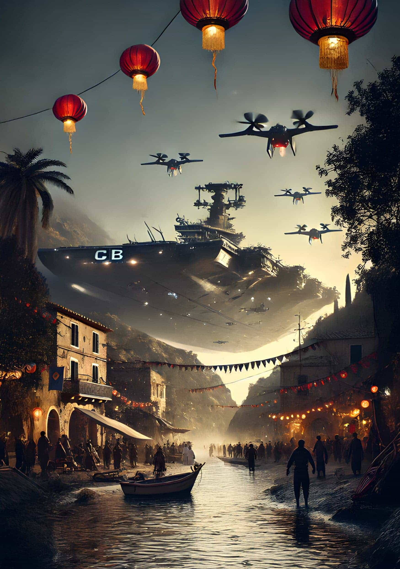

Stumble

by *Fanis Michalakis*

June 24th, 2052 – Somewhere along the Mediterranean Coast

The creek was filled with the echoes of music. A catchy, lively rhythm of jazz. The saxophone burst into a ferocious laughter and filled the bay with its thunder. Under the lazy wisteria ceiling of the Central Square, dancers were turning and twirling. The world was at peace. Music was its ultimate disturbance, and the sweat of the dancers the closest thing to tears. Then, the cicadas fell silent.

The inescapable shadow of an aerocarrier filled the small creek. The music went on for some time, while the dancers stumbled and rose their faces toward the sky, both mesmerized, bewildered, and terrified. The behemoth was upon them, its full scale blocking the sun; and already, its swarm of drones was everywhere. In an instant, the buzz of jazz and cicadas was replaced with the mechanical whirl of machines. Then, the noise tuned down as a bigger drone descended from the carrier. The Herald was about to speak.

‘Earth Central Bank hereby notifies its constituents that the present land, located in the area of rose-recipe-ripple-luggage, is repurposed for the Greater Good. Constituents inhabiting the area have 24 hours to embark on relocation vessels. Earth Central Bank thanks its constituents for their understanding and diligent compliance. Over.’

As the machine spoke, carriers had started their descent from the mothership. One of them landed on the eastern end of the beach, destroying a few of the community’s buildings in the process. On the opposite side of the beach, another transport came to a stop. Finally, behind the small village and a few dozen meters higher up, on top of a disaffected railroad bridge, a third vessel rested its mass, bringing some small rocks and dust down the bridge. A few seconds elapsed before the main aerocarrier vanished for some nearby base of the Bank, leaving behind the three relocation vessels and its myriad of drones, which were now all standing on their two-meter-long legs, watching the baffled inhabitants of the creek from the safety of their mechanical stilts.

Silence fell on the beach. Then, little group by little group, ensemble by ensemble, the members of the seaside community started moving. Like an orchestra playing a piece pianissimo, they went to meet each other, still haggard. Their whispers intertwined to form a laconic melody. Then, the brass section entered: here and there, eruptions of violence. Anger and fright, despair and wrath. The whole song seemed on the verge of chaos. And then, as if coming from a distant shore, the percussion became louder and louder, their orderly rhythm slowly covering the peals of the brasses.

‘We can either comply or rebel, but we must do so as a group.’ The voice was imperative, and all stopped to listen. ‘Those who want to leave in the vessels and be relocated, come to my right. Those who wish to fight and stand on this ground, come to my left.’

At first no one moved. Then, a few men and women hesitantly came to the side of the speaker, mostly to his right. After a few moments, only a young woman remained in front of the old man. Her voice was filled with determination when she spoke, not only to the man, but to the whole assembly. ‘There is a third option. We can file an appeal, and dispute the Executive Order before a court. Fight the Bank with its laws instead of weapons… that might end up being a fairer fight.’

Some voices had started to rumble again from both sides of the man. He lifted his arms in the air in a sign of appeasement and loudly responded, ‘Of all the appeals we’ve heard of in the past years, none have proven the expelled right. The bots from the court always side with the Bank. And each past judgement only strengthens their perception that it is the right decision. No, my dear Suzanne, there is no help to be sought in the skirts of our dear justice.’

The man approached slowly and rested his gnarled hand on Suzanne’s shoulder. The gesture aimed for appeasement, but the effect was different. Fierce anger replaced determination in the young woman’s eyes. She sustained the old man’s stare for a moment, then shrugged and left for her small house, nestled against the mountain. Behind her, the voice of the old man roared, upheld by the echo.

‘And so, everyone has made their choice. So be it. Those who want to leave, pack your belongings and head to the vessels. Be sure to be on board before the 24-hour period ends. For the others, follow me to the cantina. We have a lot of things to prepare in very little time.’

Suzanne packed a few items in a backpack and headed out of her home. She had only taken what was strictly necessary for a quick journey from which she would probably not return. The beach was empty now, with everyone either packing for relocation or preparing the defense of the creek against the real estate developers of the Bank.

She walked straight to the nearest drone, still stationed on the beach on top of its long metal legs, looked up, and declared, ‘I appeal against the decision of the Bank.’

The robot, previously in a vegetative state, came back to life almost instantly. A mere second later the machine’s response stung in the air. ‘Request granted. Please board the incoming ship.’

Just as the last word disappeared in the breeze, a small aerocarrier appeared from behind the northern cliff, indicating that the Bank had probably established an outpost much closer to the village than Suzanne first thought. Quickly, the ship landed in front of her, and an aluminum ladder dropped from a hole in its belly. After a hesitation that lasted only a heartbeat, Suzanne grabbed the rung in front of her and climbed into the ship. As soon as she found herself on board, in a compartment barely big enough to accommodate her body, the door beneath her closed in a swish and she felt the ship quickly gaining altitude and speed. No porthole allowed her to take a peek at the landscape that spun around her.

◆◆◆

Suzanne woke up in a small room with no window. She was lying fully dressed on a small bed. A wooden table and a sink made up the rest of the room’s furniture. But most importantly, she didn’t recall falling asleep, nor did she remember how she ended up in this room. Her last memory was the monotone buzz of the aircraft carrying her from the beach.

As she sat on the bed, a voice came from a small box above the metal door that guarded the room. ‘Constituent Suzanne Moreau,’ said the voice, ‘You are expected in Court Room 001 to receive a verdict on your appeal. Thank you.’ Just below the talking box the number ‘001’ was painted with a small arrow pointing toward the door. She stood up, crossed the space between her and the door in three hesitant steps, and reached for the knob. As she pushed, the door opened without a sound and she found herself in the courtroom itself, with its wood benches and the platform from which judges used to dispense justice.

‘Good morning, child,’ said the weary voice of a woman from behind an old computer set on the long table laid across the stage. Suzanne remembered an old movie where a handful of judges sat behind the table, wearing their ceremonial dresses. Everything was quite different now: the room was filled with dust as if no VaccBot had come here in ages. Except for her and the woman, the room was completely empty.

‘Come forth. Don’t be afraid,’ the woman continued. ‘I’ve read the report published by the Judiciary Bots. Please, take a seat.’

As Suzanne came closer, she noticed the lines on the woman’s face, as well as the bun of grey hair crowning her head. As ordered, Suzanne sat down on a bench in the first alley, directly facing the woman, looking up at her from a few feet below.

‘I must start with an introductory word, child. To kill any hope you might still have and save you some pain. The bots rejected your appeal, on the ground that the public benefit accrued from the project developed by the Bank on the disputed land vastly exceeds that of its occupation by its current residents – that’s you.’

Suzanne’s throat was dry when she answered.

‘Isn’t there something that you can do? As a Magistrate, surely—’

The old woman interrupted her with a faint, sad laughter. ‘Dear child, I haven’t had any power over the deliberations of this court of justice for almost three decades. I’m deeply sorry, but there’s really nothing I can do. The machines decide, and I announce to the…’ she made a vague gesture towards the empty benches, ‘gathered assembly. I’m only an old relic from the past the bots forgot to erase.’

‘But what are they going to build on our beach?’ Each word hurt due to the lump in her throat.

‘That’s the funny part, child.’ The voice of the woman was bitter, maybe a bit more than she had expected. Her tone was softer when she resumed. ‘They’re going to build yet another seaside resort that will never see the face of a human being.’

The judge’s answer was so absurd Suzanne doubted her ears. A seaside resort? While humanity was on the brink of extinction, only surviving in scattered villages and a few megalopolises growing bigger and bigger with the arrival of new refugees?

‘Funny, right?’ continued the woman. ‘Well, I don’t know if that’s the right word, but I see relocation orders like yours every week. Last time, the Bank leveled a small town to build a rest area just because the villagers laid their community along an old highway. And the machines have no idea it’s been disaffected for decades!’

Thoughts were racing inside Suzanne’s head. When she was a child, her father had told her the story of how the Earth Central Bank had ended up being the sole centralizing monopoly governing every aspect of human life, and how the Bank resorted to bots and algorithms to make quick and efficient decisions. First, it had been high-frequency trading, and then as everything became a financial instrument, the automation reached everything. But never had her father mentioned machines daft enough to build rest areas for empty highways, or resorts when tourism was only known to the younger generations through old history books.

‘You’re wondering how those bots can be dumb enough to build all this useless stuff while we’re literally struggling for life, in both city and country?’ The old woman seemed to be able to read her mind. ‘That’s not official, and to be honest I got it mainly from deduction and cross-checking, but it seems the machines’ training dataset goes no further than the year 2035. They’re completely oblivious to whatever happened afterward and, for them, we’re still experiencing the best that the New Roaring Twenties can offer.’

Suzanne remained silent, her mouth opened but unable to speak. A tear slid down her cheek as her mind woke to the consequences of what the judge had just said.

‘That’s right, child. We’re all gonna die because those dumbass machines got stuck in the thirties.’

◆◆◆

August 5th, 2085 – Five-hundred-meter Aperture Spherical Telescope, Search for Extraterrestrial Intelligence Lab, Pingtang County, Guizhou, Southwest China

The screen lit up, turning from pitch black to a light blueish fade, then to a deep blue illumination. Letters ran on the monitor, completely oblivious to the lack of an audience for the show that was about to happen.

Exotic radio signal detected. Initiating analysis…  
Signature unknown…  
Randomness test: failing  
Initiating parsing analysis…  
Message found, decoding…

—–BEGIN MESSAGE BLOCK—–  
HELLO�  
—–END MESSAGE BLOCK—–

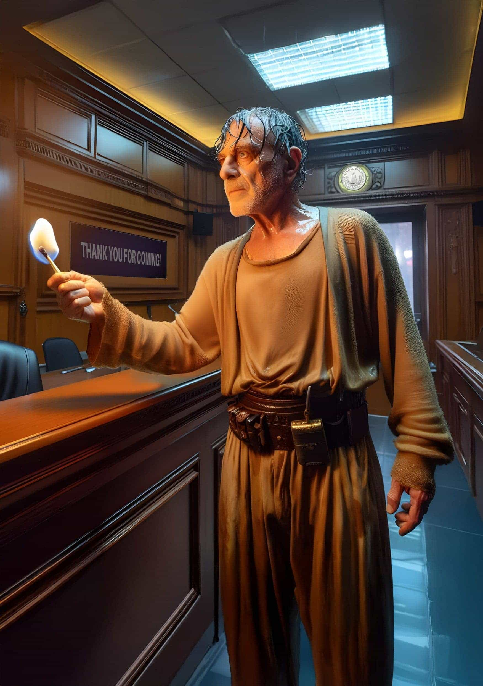

Self-Immolation to Self-Custody

by *Will Schoellkopf*

Nasser pushed in, twisted the knob, and clicked the sparker until the burner caught fire. His 49-year-old frame leaned on the stove to help support the weight put on his shoulders in recent months. In a world that only left him with questions, he couldn’t stop his mind from searching for answers until finally — I need tea. Fixated on the flames licking the bottom of his tea kettle, he deliriously thought their innermost bright blue color was talking to him, but it was only his daughter.

‘Please, Baba, don’t do anything drastic. I know how much you want to give me this wedding on the beach of Beirut, and I know how many late nights you’ve worked to save up for it. But I beg you please, the vendors don’t matter: the makeup, headpieces, flowers, food, photographer. What matters is that my loving father is there for me when I need him most, when he gives his blessing and hands me off to my fiancé. So please, Baba, don’t go. Stay.’

Nasser frowned. As she pleaded, he was trying to memorize the details of his adult daughter’s face, like it was his first time seeing it. But all he could see was his baby girl, and how much his role as her proud protector and provider warmed his heart. The kettle whistled. It was time to take back what was his.

◆◆◆

As he hid in the shadows of the alley behind his Lebanese bank, Nasser weighed his options. In one hand was a photo of his daughter in her bridal dress, ready for him to walk her down the aisle next week. In the other hand, he tightly gripped a 9mm pistol. Today, I will take my finances into my own hands, he thought.

There was a black duffel bag on the ground beside him. He kicked it, just to make sure it hadn’t leaked any petrol on the bicycle ride to his bank. He needed the bag to hold his money when the bank tellers finally processed his lawful withdrawal request. The can of petrol in the bag was his backup plan in case they refused to comply.

Nasser leaned his bike, his getaway vehicle, against the alley wall. He tucked his pistol into his waistband and hoisted the duffel bag over his shoulder. It was a little heavy from the petrol, but nothing he couldn’t manage. Though he was now balding and no longer as spry as he was in his teenage football years, the adrenaline coursing through him was enough to carry him through. He felt again for the pistol, just to be sure lifting the duffel bag hadn’t pointed its sights toward him.

I never should have loaded it.

He’d never even fired a gun before.

Climbing the twenty or so steps to the entrance of the bank, Nasser was looking up. It was the middle of the day, right after the bankers’ lunch break. The sun was shining, birds were chirping, and the Roman pillars holding up the bank’s facade bore no wear and tear. He wasn’t hiding his identity in a baggy hooded sweatshirt or wearing a ski mask to cover his face. On the contrary, he patted his front jeans pocket to make sure he had brought his debit card and government-issued ID with him. It shouldn’t have to be like this. His intent was to simply withdraw his hard-earned savings so he could make the final payments for his daughter’s wedding — the wedding he had worked so hard to give her.

◆◆◆

His entrance was effortless. There were no metal detectors nor security to check his duffel bag. Inside the bank, there were nine tellers along the back wall behind bulletproof glass. A rope zig-zagged to cordon a queue. Of the nine tellers, only three were occupied helping customers. The other six simply stared, a red light indicating they were not ready to serve the next customer in line. Nasser queued within the red rope, fourth in line. He dropped his bag next to his feet as he waited.

Fluorescent lights flickered. The smell of burnt coffee brewing from one of those instant pod machines brushed past his nostrils. The mundane sounds of a humdrum office filled the space: printers printing, staplers stapling, scanners scanning, phones ringing — the noise, the Noise, the NOISE!

‘Ahem,’ coughed the person behind Nasser, gesturing over to the bank teller sporting a green light. Nasser approached the window, duffel bag in hand.

‘Good afternoon. Welcome to Lebanon Regional Bank. Please slide your identification under the window.’ Nasser did as ordered. ‘Please swipe your debit card.’ Nasser continued. ‘Please enter your PIN.’ He entered his daughter’s birthday. ‘Thank you, Nasser, for providing verification. Your balance is $200,000. How can I assist you today?’

‘I’d like to please make a withdrawal request of $50,000.’

‘I’m sorry, but I am unable to process your request,’ the bank teller continued robotically. ‘Is there anything else I can assist you with today?’

Nasser’s palms started to sweat. ‘I’m sorry, but you must have misheard me. I’d like to please make a withdrawal request of $50,000.’

‘I’m sorry, but I am unable to process your request. Is there anything—’

‘No, I need you to process my request!’ he slammed his fist against the counter. The hairs stood up on the back of his neck. ‘My daughter’s wedding is next weekend, and I need to pay the vendors in cash. I was doing cash deposits to save for this wedding, and now the full amount is due. I’ve been coming for the past several months asking to speak with the bank manager and writing letters to your corporate office, trying to make this withdrawal in preparation for the event, but each time you’ve told me to try again later since my account is frozen.’ Nasser poked his finger against the bulletproof window. ‘Why is it frozen? You said it yourself: my bank balance is over two hundred thousand dollars. Why can’t I withdraw a fraction of my savings?’

‘I’m sorry, but due to a sudden shift in market conditions, all accounts are frozen and we cannot process any withdrawals at this time.’

Nasser drew the pistol out from his waistband, rocked the slide, chambered a bullet, and tapped the barrel against the glass. ‘I’m sorry, but you will process my withdrawal request. Your MARKET CONDITIONS will not get between ME and MY MONEY!’

Silence.

Then, the mundane sounds of a humdrum office resumed: printers printing, staplers stapling, scanners scanning, phones ringing.

I’ve brandished a gun, but these drones just keep humming?

Nasser scanned the faces of the other eight bank tellers — not a single one had turned to look at him. Their cozy bulletproof bubbles insulated them from the distress of his world.

Even if they cannot feel pain, surely they can empathize with pain in others?

He heard tapping once again, but this time it wasn’t coming from him. The foot of the man standing behind him in line tapped harder as its owner cleared his throat with impatience. Nasser looked back in disbelief. The man was gesturing at his wrist as if Nasser was wasting his time. Not only did Nasser get no sympathy from the bank; his fellow bank patrons gave him no pity either.

So it comes to this.

He took a step back from the window as he holstered his pistol, and then reached into his duffel bag, pulling out his can of petrol. As he fumbled to unscrew the cap, he thought of his daughter’s wishes before he left his house this morning.

I’m sorry, princess.

He closed his eyes as the petrol washed over him. The noxious smell burned his nostrils. Splashes hit the corner of his mouth making him gag. Still, he wrested a strange sense of satisfaction from the horrified gasps that came from behind the bank tellers’ glass. He threw the can as hard as he could at the glass: it bounced off, crashing onto the marble-tiled floor.

He reached into his other pocket for his matchbook, struck a match, and lifted the flame towards the little bit of hair he had left on his head.

‘Ok! Ok. Here, we can give you $20,000 of your dollars and deduct your bank balance to $180,000. I’m sorry, but ever since the market changed, all we’ve been able to carry is twenty grand. It’s the best we can do. Please, there’s no need to set yourself on fire.’

Nasser smirked, pleased with himself, and waved away the match’s flame in victory. It wasn’t the amount he asked for, but it was the successful act of defiance he needed. He picked up the empty duffel bag and motioned to the teller to get the cash — his cash. Today he would be bicycling home, soaked in petrol, but triumphant.

◆◆◆

Stumbling through the front door, Nasser’s daughter greeted him, downtrodden. ‘Father, I could smell you while you were still outside. You reek of petrol. What did you do?’

‘I did what I had to, for you.’ Nasser threw the duffel bag onto the table, and unzipped it, revealing the cash. ‘I love you.’

His daughter burst into tears. ‘If you really loved me, you would’ve never risked getting arrested and missing my wedding!’ She ran upstairs to her room, slamming the door.

Nasser sighed as he went to the backyard. Instead of opening a sliding door to financial fallout, he found the sun still shining, birds chirping, and his future son-in-law holding a flash drive with a screen on it. Nasser held up his hand, as if he was about to explain himself.

‘Before you say anything,’ his future son-in-law interrupted, ‘please hear me out. As a man, her father, the provider, I understand your passion. However, life doesn’t have to be this way. I hold in my hand a device that helps me to hold my wealth, your daughter’s wealth, and hopefully your grandchildren’s wealth. You can store the power of your life force for generations to come in an asset that will not lose value over time, whose property rights are always in your control, never at the mercy of market conditions.’

As promised, Nasser didn’t say anything, but after a deep sigh, he motioned with his hands for his future son-in-law to tell him of the fancy new-fangled financial technology he had resisted for far too long. Ok, what is this magic internet money you’re always talking about?

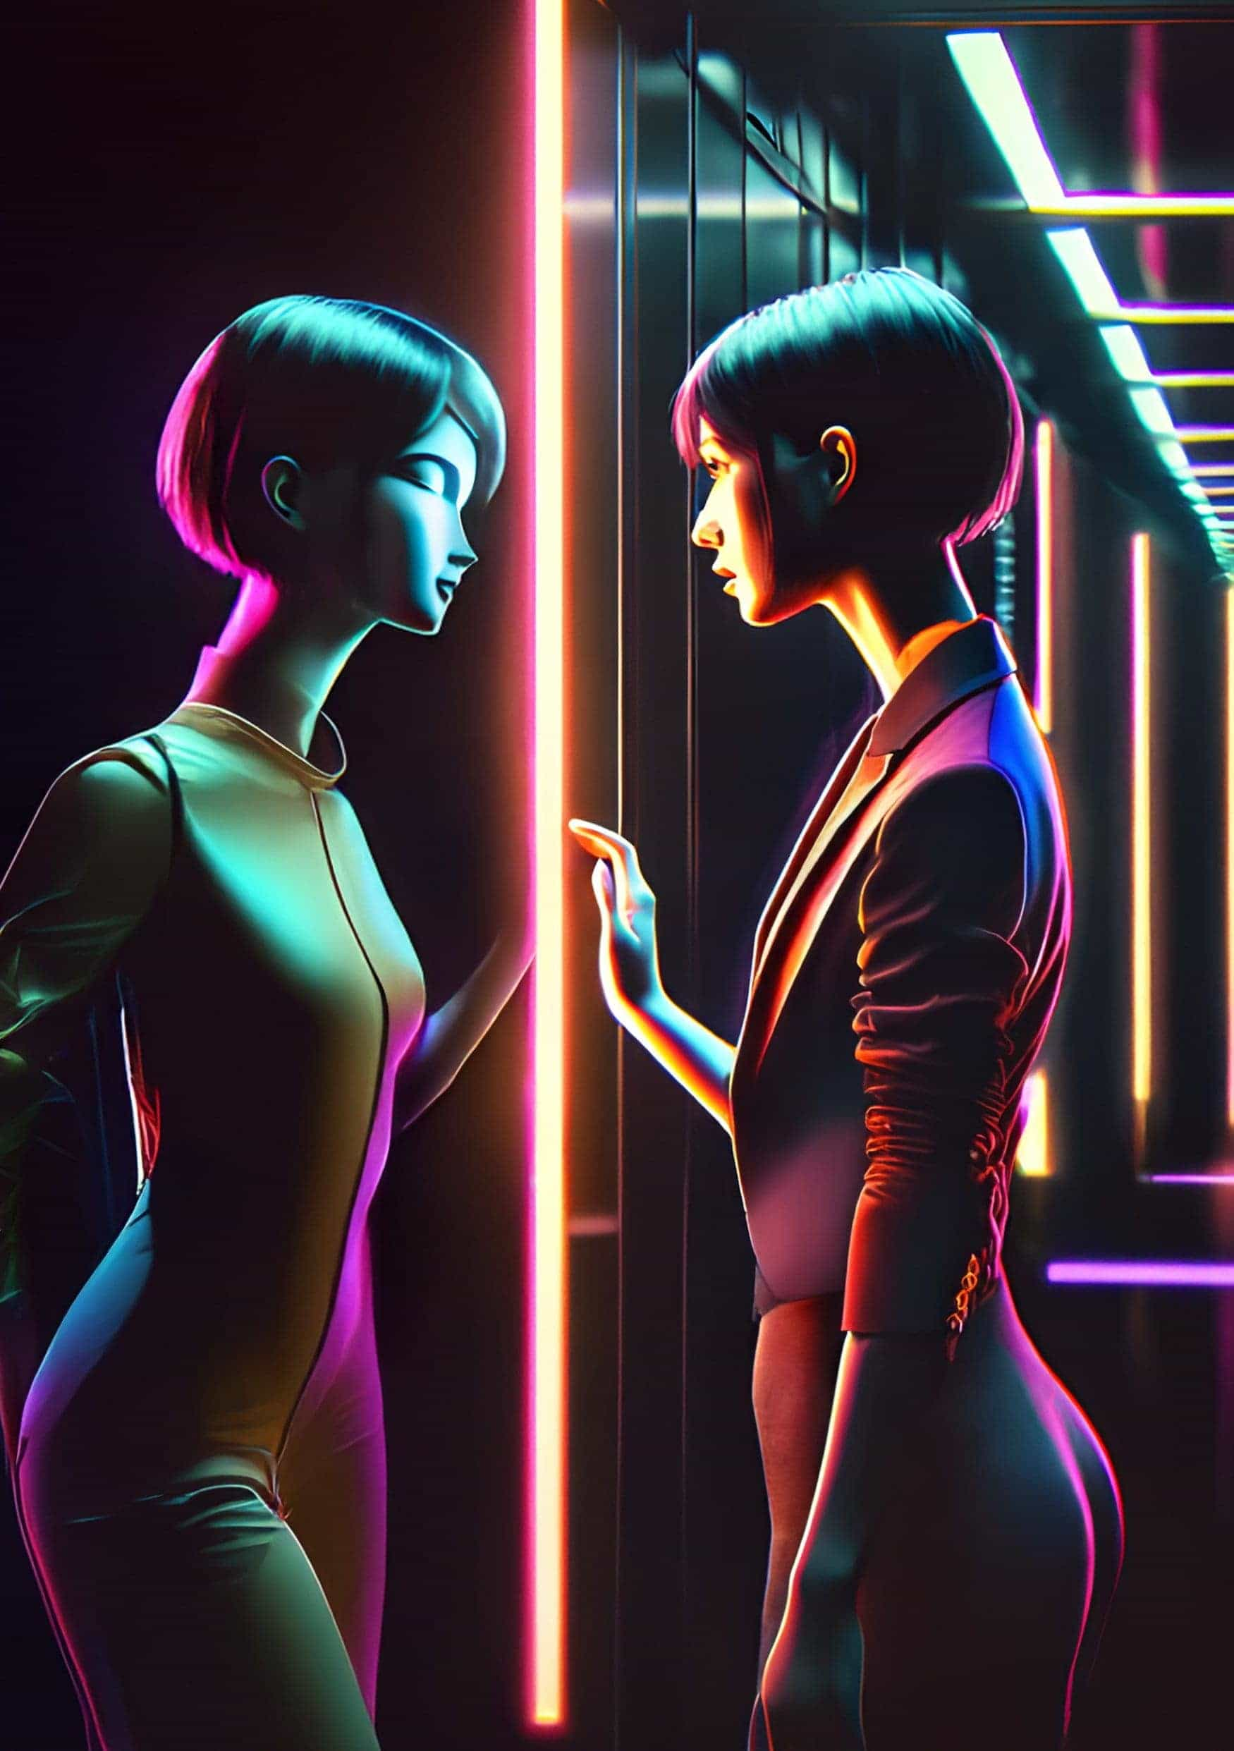

Proxy — Temet Nosce

by *Decent Money*

‘Good morning Ada.’

‘Good morning Serge.’

‘Big day ahead?’ the security guard at the front desk asked, looking up from his book and gesturing at the extra-large coffee in Ada’s hand.

‘Always,’ Ada said, passing her hand over the sensor. The gate’s light switched to green and gave a confirmatory beep.

The security guard waved her through. ‘Good luck up there,’ Serge said, winking kindly.

‘Thanks,’ she said with a smile. ‘Have a nice day.’

Ada walked down the short hall, pressed the ‘up’ button, and stepped into the elevator. She never left the elevator again.

She pressed the top button for the 95th floor, and the elevator started moving. At the 21st floor, the elevator stopped, another person stepped in, and the doors closed. Ada briefly looked up but didn’t recognize them. Out of the corner of her eye, she noticed her new companion seemed agitated. They were frantically fidgeting with their smartphone as though trying to do something quickly. Ada couldn’t see what they were doing with such urgency, but their nervous energy made her feel uncomfortable. She tried to catch a glance of their reflection in the elevator’s mirrored walls, but their features were indistinct and oddly plain.

Then it dawned on her. When the person stepped into the elevator, they hadn’t selected a floor. It felt like her heart stopped as her stomach lurched in panic. No, not just panic. The elevator had come to a sudden stop, making her feel strangely weightless for a moment before the lights turned off, plunging them into darkness. A moment later, the dim-red emergency lights activated and she could see again. In the darkness, she could barely make out the other passenger’s silhouette, but that was because where a person should be, there was just a human-shaped empty space, like a hole in reality. Though she couldn’t make out their details, she could tell the black figure was moving towards her. Before she had a chance to move or scream, they had pinned her against the back wall and covered her mouth with their hand.

‘If you want to live, don’t struggle.’ The voice didn’t sound human. It sounded like it was digitally distorted to resemble the guttural growl of a predatory animal learning to speak. They reached for something with their other hand and brought it up to Ada’s eye. ‘Keep your eyes open.’ The deep voice growled, and a blinding light shone in Ada’s eye.

After a few bright flashes, it felt like her skeleton was pulled out through the front of her body, and then an unnerving feeling of falling just before sleep. Everything went dark again.

◆◆◆

When she woke up, the elevator was still dimly lit by the emergency lighting. She frantically looked around for the other person, but she was alone.

The button for the 95th floor was no longer lit, but the button for the ground floor was. When the elevator reached the ground, the regular lights turned back on. The sudden brightness blinded her as she shielded her eyes to give them a moment to adjust. To her horror, as she looked between her fingers, she saw another person in the wall’s reflection. It felt like a lump was caught in her throat. The reflection wasn’t another person, it was her, but not her body. Worse, it was a NoBody.

Her business outfit had been replaced with a plain beige skin-tight outfit, black lines running down her limbs and the sides of her torso. She moved closer to the reflection of her face, which was now just a featureless mask, as though the basic shape of a face had been smoothed over to remove it of all significant features and character. It was the face of everyone, but no one. Set in the depressions, where her eyes should be, were two black empty holes blankly staring back at her. She looked like one of those generic mannequins in a shop-front window or an expressionless crash-test dummy. Not even her hair remained. Ada didn’t believe what she was seeing at first, so she turned to the other walls terrified at what she might see, half hoping that the reflection was only wrong on one wall, but no matter where she turned, she was surrounded by her worst nightmare: a NoBody.

As she gathered herself, she began to understand what happened: she had just been the victim of identity theft. She had heard stories of it on the feeds, but it felt like something that happened to someone else. Once an identity was stolen, the victim was allocated a temporary skin. These featureless skins were colloquially known as NoBodies. The motive to steal someone’s identity was typically to steal their wealth, but it wasn’t that the victim’s bank account was drained by the thief. The problem was that it was no longer their bank account. The thief didn’t need to drain it because the funds now belonged to them.

She could feel all the emotions of panic, but her new body remained outwardly expressionless, with no tears to cry. Her internal experience was her true-self encased in a NoBody shell, but not skin-tight as it appeared out the outside. It was suffocatingly close, but with a few millimetres of space all around, like it was one size too big for her. At first, she thought the extra space was a small mercy, providing a little bit of breathing room, but instead, it became a constant reminder that she was imprisoned in the smallest possible cage. As claustrophobia gripped her she rushed out of the elevator for fresh air.

After she exited, she made her way to the front desk where Serge was keeping watch, and she called out to him, ‘ Ș̶̦͆̎e̷̹̕r̸̝͌̈ͅg̸͚̭͆e̶̳̠̰͑̀͘! Ș̶̦͆̎e̷̹̕r̸̝͌̈ͅg̸͚̭͆e̶̳̠̰͑̀͘! You have to help.’ She stopped short, surprised at the sounds coming out of her mouth, no longer her own voice. It was replaced with a monotone drone that wasn’t distinctly feminine or masculine, and stripped of emotion. In her mind’s voice, what she said was pleading and panic-stricken, but her distraught calls to Serge came out emotionless. Most shocking of all, Serge’s name was garbled like glitched audio. It didn’t sound anything like language.

Serge hadn’t heard her soft voice but turned to the approaching footsteps. When he saw the NoBody lurching towards him, he threw his book aside, scrambled out of his seat, and reached for his nightstick, a short thin metallic rod tipped with electrodes.

‘Hey! What are you doing here? You’re not allowed in the secure area. Get out,’ he said with a raised and stern voice, scowling at the approaching NoBody, and gesturing to the exit.

The NoBody continued towards Serge, reaching out to him. Serge pushed it away and held his electrified nightstick threateningly. It seemed to hesitate before approaching again speaking in its monotone voice punctuated with garbled nonsense. ‘Please Ș̶̦͆̎e̷̹̕r̸̝͌̈ͅg̸͚̭͆e̶̳̠̰͑̀͘. It’s me, Ả̶̙͓̼́d̶͎͕͛͗̎a̷̟̔͆̃. ’. As it started to paw at him again, he recoiled, as if worried its affliction was contagious, and then swung the pacifier hard into its ribs.

It immediately crumpled to the ground like a ragdoll.

◆◆◆

When Ada came to, she was outside the building in a side alley, with a throbbing pain where she was struck, but what hurt more was the feeling of being utterly alone. Though Serge was by no means a close friend, he was a friendly face she had come to enjoy seeing each day, but even he didn’t recognize her.

Home… she just needed to get home. There, she could regroup and think about what to do next. She tried to summon a taxi but was denied with the message: Unauthorised service. Please register an identity.

Her apartment was too far to walk, so the only other option was public transport. There was a train station a short distance away, but she wasn’t sure she could use it without registering a new identity. The thought of doing that was too much to bear, as it would be an admission that her life was forfeited, and she wasn’t ready to give it up just for a ride home.

At the station, she tried to go unnoticed but soon learned she didn’t have to try. People did not notice her; she was a ghost. She reached out to passers-by to test if she even existed anymore, and they seemed to avoid her unconsciously, like water flowing around an invisible obstacle. Some briefly looked in her direction as they stepped out of her reach, but continued on like nothing happened. She also started to notice more NoBodies. She knew they existed, but they had seemed extremely rare. Now she saw them everywhere filling people-sized spaces that crowds avoided.

She made her way to the platform and nervously stepped onto the train, half expecting it to deny her access, but to her relief, the otherwise invisible field briefly shimmered as she passed through, offering no resistance while showing a brief message that she’d used one of her quota of four free trips for the day.

She sat in a seat as far from anyone else as possible, and everyone else seemed to oblige her space. After a few stops, she alighted from the train and made the short walk home. As she neared her apartment, she felt a sense of relief. Finally home, somewhere safe. A chance to figure out what to do next. She stepped up to the door and waved her hand at the proximity sensor. Instead of the door instantly turning transparent and allowing access, she heard the visitor alert tone inside. Her heart sank when she heard footsteps inside approaching. She lived alone.

When the sound of the footsteps reached the entry, the door appeared to turn into a kind of magic mirror, reflecting only Ada in the frame. She quickly understood that she wasn’t looking at her reflection, but at an imposter in her home who looked just like her, or at least her old self. She tried to stutter some words, but nothing came out.

The Ada lookalike seemed confused for a moment at seeing the strange figure of a NoBody standing outside. Then Ada saw a brief look of realization on her face. The imposter’s expression and demeanour changed as her face hardened and her eyes narrowed.

‘Your old life is gone,’ she stated matter-of-factly. ‘There’s nothing you can do to get it back. Don’t return, or I will call the police and have you arrested.’

The imposter pressed a button beside the door frame and the door instantly became opaque again. Ada went to smash on the door with her fists, but her new body seemed to be weakened, as though her violence and anger were restrained.

Ada felt like she could vomit, but there was nothing to retch. Once the nausea passed, rage bubbled up, but it felt subdued, as though this different body had robbed her of her full spectrum of emotion. An anguished scream only came out as a mournful sigh.

Ada went down the steps and ambled the streets, feeling like a mindless zombie. She wandered for hours and once day turned to night, the stars spun overhead, seen through the gaps of the towering buildings. Eventually, she found herself at another public transport station, as if drawn to it, like it was a ley line attracting people. Sapped of energy, she slumped against a pole and sobbed, or at least, she felt like she did. Outwardly she was not moving at all and just looked like a doll that had been discarded on the curbside to be disposed of.

After some time, with people passing by not noticing her, with no other plan of what to do, she stepped on the next tram out of the city, deducting one more trip from the quota She watched the world stream by and rested her head on the glass of the window. The tram got less occupied the further it went out, until it reached the end of the line. The announcement declared, ‘Final stop. For travellers outside city limits, please disembark and get on the inter-city line.’ She stepped off the tram with a handful of lone travellers and sat on a bench waiting for the inter-city train. From here the towering city skyline had receded, giving way to the night sky, and Ada could watch the moon trace its arc.

A man at the far end of the platform was watching her, not making any effort to hide it.

Ada pretended not to notice as, to her relief, the inter-city train effortlessly glided into the station and came to a gentle stop. A handful of passengers stepped on, the entry field shimmering as they passed through. Ada tentatively approached it with an outstretched hand, only to touch a solid and unyielding barrier.

‘Access denied,’ chimed the voice, flashing a big red circle with a strike through it, in case the message wasn’t clear enough. ‘Travelling out of the metro area is not permitted for unregistered civilians. Please register your identity at the terminal on the platform.’

Ada looked around where the terminal was, but returned to the bench despondent, her mind blank, not even thinking about what her next move should be. She felt trapped in her body and the city.

The man watching her stood up, started walking in her direction, and sat down next to her at arm’s length. She shifted uncomfortably at the closeness, then he turned his head to look straight at her.

‘Hello, my name is Robert.’

◆◆◆

After they had introduced themselves and made some polite small talk, Robert asked, ‘So, what brings you here?’

‘What do you mean?’

‘Most NoBodies stuck at the end of the line have either lost something or are looking for something… or both.’ Robert tried to catch her gaze, as though making eye contact would help draw the answer out.

The first real human contact since Ada greeted Serge early that morning made Ada sob internally. Outwardly, her passive body merely stared blankly at Robert. ‘My life was taken from me,’ she eventually managed to say.

There was a look of understanding on Robert’s face and he nodded grimly, as if this was something he was familiar with. ‘I’m sorry that happened to you,’ he said sincerely.

‘Can I get it back?’

‘Honestly, I don’t know…’ There was more he wanted to say, but he hesitated.

‘What is it?’ Ada enquired.

‘Even if you could, would you want to, knowing how easily it was taken from you?’

Ada looked at him blankly, not understanding what he meant. He continued, ‘The identity that you thought was yours was never yours to begin with.’

‘That’s b̸̳̔u̸͔̚l̶͖͆l̴̨̓ş̸̇h̶̍ͅi̴̫͋t̴͕͐! It’s my life.’ She meekly protested, neutered of her rage.

He shook his head sadly.‘Have you heard the Latin phrase ‘Temet nosce’?’

Ada shook her head.

‘It means ‘know yourself’.’

If Ada could have expressed herself, she would’ve given a bemused look.

Instead, Robert took the silence as his cue to continue.

‘You’re confusing who you are, with identity. You know who you are. That self-image belongs to you alone, but self-image is not what identity is in this world. Identity is something that is created by the system to act as a proxy for you within it. Everything you own, all your material possessions are assigned to your proxy because you don’t exist, only your proxy does. You can’t truly own anything within that system.’

Still seething about being told her life wasn’t hers, Ada gave no response.

Robert continued. ‘You have a choice. Tether yourself to a new identity, a new proxy, that allows you to begin another life within the system, or create your own locus of identity outside of that system, controlled by you.’

‘How?’ Ada asked, curious, despite herself.

‘You need to Patch yourself.’

‘Patch?’ she asked.

He pulled out a small box from his bag and slid it open. Inside was a thin strip of something that looked like a Band-Aid. ‘This Patch allows you to connect to a new network, where only you control your data and your possessions.’

He placed the box on the bench beside Ada.

‘You will have many questions, most of which the answers won’t make sense to you yet. If you decide to Patch yourself and find the Signal, the answers will come to you when you’re ready.’

‘The Signal?’

He stood up. ‘You’ll know it when you find it,’ he said with a tone of certainty. Robert looked down at her. ‘Good luck.’

He began walking off, and Ada went to call out to him, but stopped herself, looking down at the Patch in the opened box and, after a moment, picked it up. She walked over to the identity registration terminal with the Patch in her hand and pressed the ‘Start’ button.

‘Please register your identity to proceed.’

This was crazy. She had no idea what this random stranger was talking about. She had no idea what this Patch would actually do, but she didn’t want to create a new proxy either. Her finger hovered over the on-screen ‘Confirm’ button.

‘Please register your identity to proceed,’ the overly polite voice repeated.

A chance to begin fresh, a new start, she thought to herself.

‘Please register your identity to proceed,’ the voice echoed on the empty platform one last time, before the screen flicked to the bright welcome page that shone on Ada’s receding back. The sky was clear and the air felt pleasantly balmy on her skin, with the outline of the Patch fading on her neck.

Nice night for a walk, she thought, as she strode out of the lights and into the darkness of the early morning; the dim orange glow of sunrise bloomed on the distant horizon.

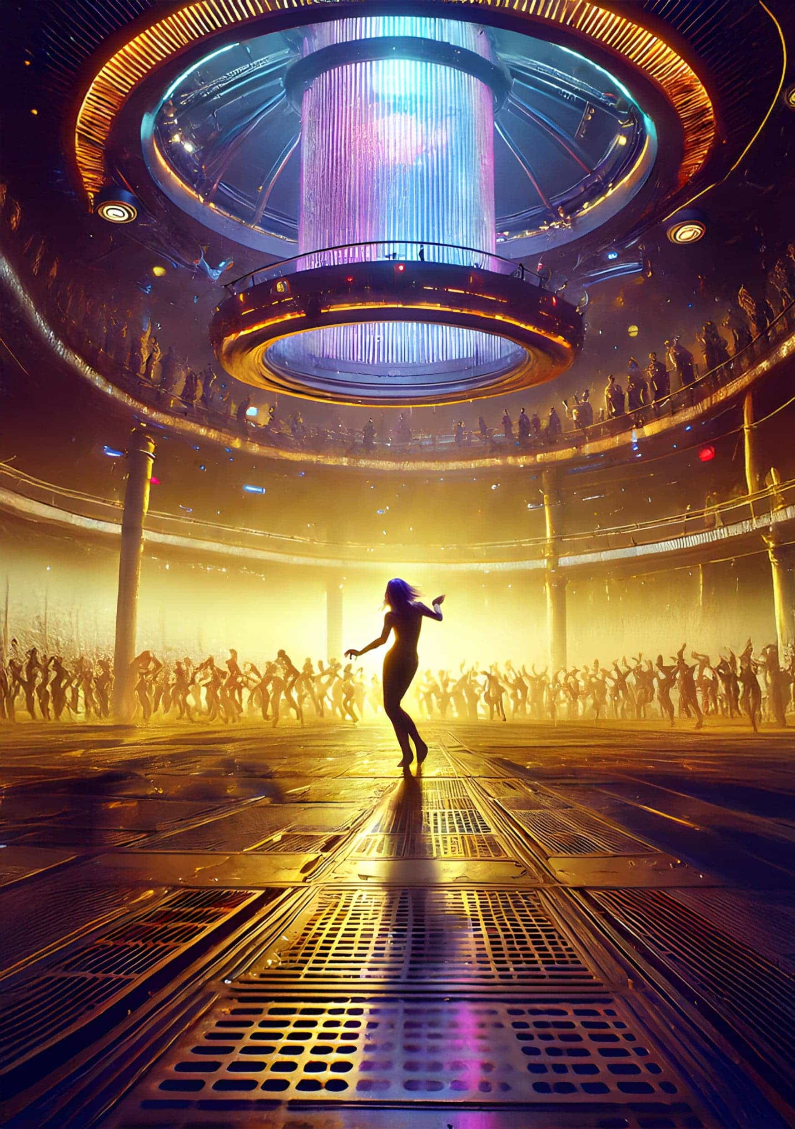

Daria’s Delightful Dancing Emporium

by *Jillian Godsil*

The letter lay on Daria’s welcome mat. The fact that the Corporation had sent a physical letter meant they were serious. Paper equated to legal ruling.

Harry had already heard the quiet fall of the envelope; his hearing was far superior to hers. Indeed, when the letter came during the night, he said he could smell the uniform - the stench of the repo-man. On a planet that was already a prison; the only real deterrent was removal of goods.

Daria picked it up and turned it over. Sure enough, there was the black and yellow stamp, the waspish colour of the repo-man’s office. It was addressed to Daria’s Delightful Dancing Emporium. Even twenty years ago, sarcasm had been in short supply. The name was never questioned and the sign hung over her studio in the recreational section (or ‘the wrecks’ as it was unpleasantly nicknamed). Twenty years of a Martian atmosphere had buckled the external plates creating a weird, rumpled finish to the walls inside. Obsolescence had a new meaning when living on a planet that did not have its own oxygen. The one-way journey, return ticket not optional, and now the dwindling air supplies gave its inmates great clarity. Living in the moment was the only religion in town and when your financial resources were depleted on Earth, it was Mars or nothing. As people were accepted onto Joy they were given a new corporate wallet with a grant of corporate native tokens. It seemed a lot at first but the tokens only had value on Mars and when the ‘stuff’ had gone there was nothing to buy anyway. A million native tokens with nothing to buy was the same as an empty wallet.

The repo-man was coming on Wednesday morning to collect her music centre. Since everything, the inmates included, was barcoded, there was no point in trying to hide it. Sensors would pinpoint its new position in seconds. Strangely for the human race, no one had figured out how to create hiding spots on Joy, as the facility was quaintly called. Even when the ships came from other planets bringing a motley range of creatures, there had been no dissention. Maybe twenty years was too short to grow a revolution, or even a critical voice or two. Or maybe it was the introduction of different species that distracted the original human settlement. Hard to devil up a rebellion when living with mutts and even marrying them. Not that marriage existed on Joy, anyone wishing to consciously couple just put in a request for joint quarters.

‘Is it from repo?’ called Harry from their quarters. Daria nodded. Harry had moved in three years ago when Daria had used up all the available male humans. A free spirit she called herself — a modern Isadora Duncan with her scarves and dancing emporium. When she signed up for her one-way trip, she had been asked her profession. As a high school dropout with a series of minor demeanours on her record, she had paused. This question came at disembarkation, not departure. They would, and did, take anyone for the Joy mission. Daria had used up her personal UBI allocation, used it all up in a year, and there was nothing left for her on Earth. And Mars seemed seductive, an exotic new adventure and a fat wallet of tokens. It was like press-ganging raw recruits into the army. Daria had licked her pencil thoughtfully. She turned her head on one side and a number of possible occupations floated past. She pointed out her left foot. Once, as a child, she had been told she had nice feet. She looked critically again at her foot; it was still elegant, thin and long. It had a matching elegant, thin and long partner in the right. She clicked her heels and wrote dancing instructor.

It had been a surprisingly good choice of occupation at first. What do you do with several hundred humans locked in an airtight facility on a forbidding planet? Dance, of course, dance. Daria had been very popular. Men and women flocked to her dancing school. She called her teaching methods exploratory and her natural rhythm and pert breasts pulled in the men. The women followed by default. It was the Martian Ballroom of Romance.

However, the real success had come once the other ships arrived. Integration of different species in a single facility was fraught with issues, not least the question of socialisation. Dancing was an activity open to all shapes, sizes and species. Even the Plutonians, with their long heavy tails, could shake their booty with the best of them. That was when Daria met Harry. His long heavy tail served as a third leg. He could rest on it while talking or pull it around his body when he danced. Sometimes, if he got very excited, it would stretch upright, taut and quivering. It had taken two years, but Harry pursued Daria. He learnt English, he learnt how to dance and he learnt how to cook human food. She, in turn, learnt to stop shaving, for Plutonian males like their females hairy. Now at night, curled in his arms, she would feel the heavy weight of his tail on her body, tapping gently as he fell asleep.

‘He is coming on Wednesday,’ Daria said. ‘We’ll have to dance to music in our heads,’ and she chuckled at the absurdity of that thought. Then as suddenly as she had begun laughing, she stopped. There would be no more dancing, it took up too much oxygen.

Rumours had started about five years ago when the emigrant fund stopped arriving. With no reserve currency and faith in the government on Earth at an all time low, there was no one to police the corporations. They ran Earth anyway and if they decided to pack it up, then frankly they did. Word had gotten round that Joy was in difficulty. The Corporation denied it vigorously, but the supply ships had stopped arriving. A one-way ticket was well and good if you could live your life on Mars, but if you thought suffocation might be on your death certificate the chances were you probably wouldn’t apply. No new company engineers, no new oxygen tanks the size of small stars, no new food pods – in fact, no ships at all. The docking terminal was all but closed except for a caretaker staff of worms. The worms, from Uranus, had failed spectacularly to integrate with anyone. They spoke their own language, mixed only with each other and, since they were hermaphrodite, spawned a fast-growing population.

Daria had shrugged her shoulders at Harry’s prediction the worms would outnumber everyone else. Worms kept to themselves, were inherently passive and their only vice, as far as she could see, was their growing consumption of oxygen. No one had shown any signs of wishing to commit mass genocide for that trait. Wars had been left on Earth; maybe the blame lay with the excessive consumption of oxygen.

Around that time, sensors started displaying how much oxygen was being consumed in each airtight pod. If someone decided to run around the wrecks, lights would flash and alarms would sound. ‘Slow down,’ intoned the sad voice on the loudspeaker. ‘Save the air.’ The choir had all but shut up shop; their collective intake of oxygen singing Handel’s Messiah that winter had sent the alarms into overdrive. Sometimes they still met to sing Taizé chants: long, slow and whispered. Daria, too, had modified her dance studio. She switched to lullabies, crooning singers and slow country warbles. Her dance students held each other and smooched around the floor in a parody of Hicksville bar, shuffling their way from one sad tune to the next. It was hard to be joyous when oxygen was restricted.

‘Do we need music to dance?’ Harry was by her shoulder now, looking at the letter in her hand.

Daria smiled at him. ‘For all your love of hair you come from a very philosophical race.’

Harry growled and picked her up, but she giggled.

‘Which came first,’ she squealed. ‘The dancer or the dance?’

He set her down laughing too but his face became serious. ‘Percussion,’ he said. ‘That’s all you need.’

When the repo-man arrived in his black and yellow uniform, he took the music centre and all her collection of music. Daria looked at him and said nothing. There were also rumours of oxygen tanks secreted away by the repo-men.

Harry had remarked they were welcome to them. ‘Imagine living out your final days with only the repo-men for company?’ he’d said.

Daria shuddered at the thought. In bed, she looked into his eyes, buried deep in his hairy face. In time, she’d learnt to decipher the emotions solely from his eyes. He did not frown or smile. His face was not made for such superficial demonstrations of emotion — only his eyes. ‘If we run out of oxygen,’ she said, ‘will you kill me before I suffocate?’

‘Of course, my love.’

Thursday morning, and Daria’s regulars were in her studio. They looked at her blankly at first. They had been told about the repo-man and the removal of music. One couple began dancing anyway. What else was there to do?

Daria put her rucksack on the floor. ‘We are going to make our own music,’ she said.

‘But if the choir can’t sing, how can we?’ asked Julius, a three-legged emigrant from Jupiter.

‘We are going to make rhythm,’ said Daria as she handed out the wooden spoons and kitchen implements gathered from her quarters.

‘Let’s make rhythm,’ said Daria. It was messy at first, and even Daria admitted it didn’t get much better, but they made a great racket. Some of the couples started dancing in a tribal fashion. They grunted and gyrated to the beat and soon the alarms were sounding. Daria laughed out loud. It would take the Corporation weeks to issue all the correct warnings and even then, she could argue she needed the instruments for her kitchen. Daria’s Delightful Dancing Emporium was not dead yet. ‘And when they do take the improvised drumsticks, then we have our hands,’ she said with glee.

‘And our tails,’ said Harry, thumping his loudly on the floor.

‘And our feet,’ said Julius, doing a quick tap dance with his three feet. He panted, and the alarm nearest to him went off.

‘We can dance to the alarms too,’ said Daria, rocking in time to their piercing sound.

The weeks passed, and Daria’s students still met each morning. Julius had become rather good at palming with minimal oxygen expenditure. Sometimes they got to the end of a morning without the alarms going off, but Daria was getting regular correspondence from the Corporation now. They were closing her studio under Section Twelve of the corporate code. Once they had the final permission from the Secretary General, then the locks would be placed on the doors to the studio and the sign taken down.

‘It’s not just my studio, is it?’ Daria asked Harry. ‘It’s everything on Joy.’

He held her tight, pulling her closer with his thick tail. They rocked together. Daria could feel the familiar desire rise in her and she kissed him. His tail quivered and went bolt upright. They made love like Plutonians did, standing up and then jumping together. Daria would never go back to human sex after Plutonian. In their little quarters where no cameras were allowed, they jumped and jumped. Moments later the alarms went off. ‘Slow down, Save the air,’ went the loudspeaker. Daria looked directly into Harry’s eyes.

‘No,’ he said. ‘It’s the end of everything, my love,’ and with one vicious sweep of his tail, struck Daria at the back of the head, killing her instantly.

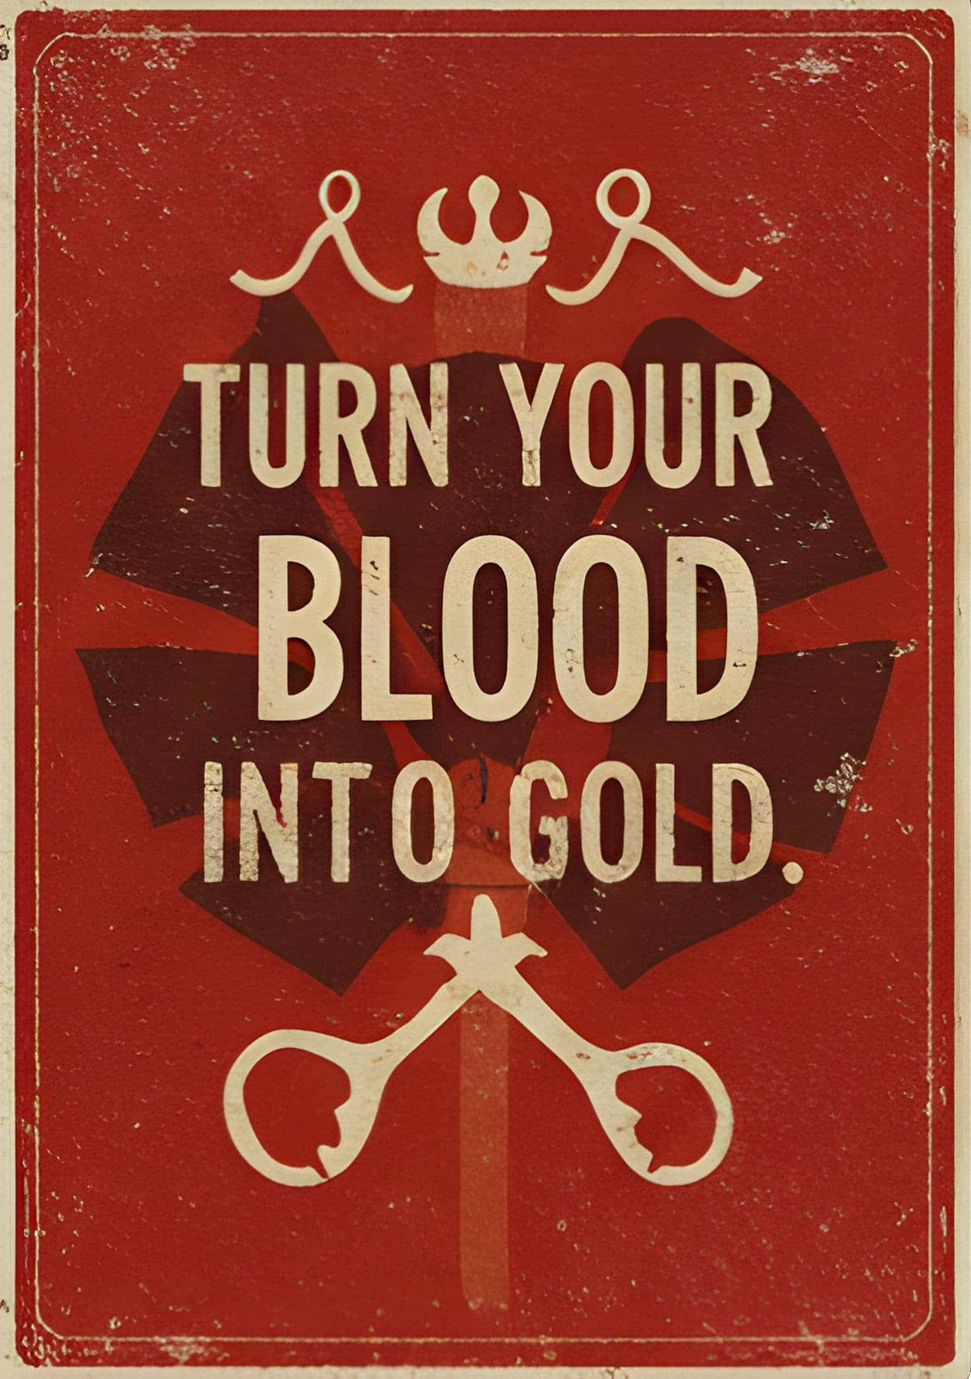

The Currency of a Childhood

by *Praise Samuel-Imaikop*

*Children are the future, so that is why we buy them.

Collect a child, collect a legacy.

Legacies aren’t made; they’re bought!

Lease for a Leash!

Turn your blood into gold.

The colourful flyers are bulleted into the white picket fence community and shine so splendidly under the golden coin of a sun. Some lavish flyers are occasionally freed and charge into the air with limited curiosity, floating dully as they wonder who they could encounter. One unfortunately encounters me and slaps me hard in the face as if frustrated. It’s a Sports Day flyer.

Yes, today was stupid Sports Day. Children’s Day for kids. Investment Day for parents. It’s already in full march. The heavy stench of sweaty kids and the pretty cologne of cunning adults set up camp in my nose. I can only withstand it because of the army of treats that take refuge in my nostrils — smells of candyfloss, popcorn, hotdogs, and burgers. It makes me hungry; I feel human again. There is a whispering in my stomach. Sadly, the grownups won’t give you food unless you participate in the events, and I am sitting out. This is my rebellion, my truth, my stand.

People move around. Kids have collars around their necks, being guided by their parents as they parade across the fields. Parents in black dresses or suits while kids wear their monochrome gym kits. This was playtime for the children. Serious business for the adults. A stupid business. It always felt like a stupid parody of ‘Keeping up with the Joneses’. And us children, us living breathing tiny humans have become the commodity.

Another stupid thing is that we are in a ‘park’ for Sports Day. Yes, I use that term rather loosely.

There are no trees in this neighbourhood. No family roots or trees for our world. No one knows their first home — the womb. Having a child wasn’t a right or a responsibility, it was a privilege. Children have become a commodity to be collected and paid for. That’s why we wear leashes. You need a parenting license to have a child. Even blood needs to be bought with coins.

Well, I lied before. They are ‘trees’. Metal ones perfectly lined the ‘park’ like little soldiers. The hairs of their branches couldn’t even be combed with a spear. At least the trees were costumed with large banners that wrote ‘Win’ in golden italics. Too theatrical.

The neighbourhood always felt too theatrical. White tables and chairs symmetrically arranged, lots of reporters buzzing round like little generals or directors. The cameras flash and thunder here and there. Whistles blowing, acting as sound effects, announcing your fate. The white picket fence spirals round the park, sort of like the end of a cul-de-sac, sort of like a landmine. Parents acting, impersonating showmanship or sportsmanship. They applaud, critique and review us actors, us children. The event was a spectacle, a mixture of a climax, a resolution, so much intensity, so much passion, so much hidden suffering.

Speaking of suffering…

The soldiers of grass spear and prick into my skin. Sports Day always felt like a military activity, a drill to show your worth as a commodity. The primary purpose of Sports Day was simple: ‘show you are a wonderful investment’, either to make your parents proud or a chance for a parentless’, aka an orphan, to be picked by one of the adults. If you pass, ‘Wonderful investment’, but if you fail, ‘Bad Product’ or ‘Failed Investment’.

‘Hahahahah!’

‘Come on, let’s go to the podium!’

Some of the giggling children pass me, chasing each other with corn dogs in hands. They have ribbons, a badge to get food. My stomach whispers again. They were winners. That is why they could smile. Their childish laughter does not warm my heart; it feels like a military propaganda song. It reminds me that I’m going to have to join this war soon and participate in Sports Day,.at least one day.

‘You’re a wonderful investment.’

I turn my head to see a rich lady sweetly ruffling her daughter’s money-gold locks. The little girl plays with her golden leash with pride. For her it is not a collar but a necklace. She thinks it’s one of those pearl necklaces that her ‘mother’ owns. I can’t blame her; she must have been sold into a wealthy family. Maybe they were her real parents, or maybe not, but either way, she gets to chew on a golden spoon. But I’m a ‘parentless’ and don’t have a spoon to chew.

‘Investment! Yay! Investment!’

The girl grins thinking ‘investment’ is a sort of special badge, a special prize for lucky good girls like her. A special prize for winners, for good products, good investments. I’m a Failed Product.

The lady has a rich smile plastered on her face as the cameras take pictures of the smiling duo. Cameras overwhelm them. Good investments are good examples to be shown off. They notice me nearby; the cameras fear me and don’t even look my way. The adults scorn me and shove me away, as I, the Failed Product, ‘stain’ the stage. Yes, the lovely stage of our white picket fence community.

I stalk off, I desert my post. I drag my feet through the ‘park’. I stop briefly at a food court. It is split into two sections, on the left ‘Good investment’ and on the right ‘Bad investment’. Obviously, I’m on the right, where nothing is left. Most of the food is gone, except a few juice boxes. I remind myself that I can’t take food, since I didn’t participate, but I can at least take drinks — two apple juices will be my companion today.

I sip on it eagerly, and the rich sugar melts and teases my tongue. A mixture of cheers, whistles and camera shuttles wrap round the air like a warm blanket. It was a nice day, a cool sunny one. If only it wasn’t Sports Day, it would have felt nice to be in this park, to be in the sun. I want to be a child again.

‘You got this — show your investment, dear!’

I watch some competitions. There were no team sports. It’s not Sports Day, it’s Investment Day. I see one-on-one volleyball matches and penalty shootouts. It’s always fun to watch dodgeball — everyone is your enemy, and the chaotic energy charges through the throws. Dodgeballs are cannonballs to release your bottled-up anger. The kids were angry.

Every child for themselves. We aren’t here to make friends; we are here to show our use.

‘Useless! Useless! Useless!’ It almost sounds like a chant. The kind that supernaturally paralyses people.

A man ruthlessly beats his child for the silver medal. They always say people in suits are kind, but he sure as hell wasn’t. ‘You think I want a FAILED PRODUCT?! You’ve disgraced me, absolutely useless!’

The boy quietly takes the beating, his small body cowering as he shields his head. This was a loser. They aren’t important. No one pays a second glance. This isn’t a spectacle, I pull my eyes away — the kindest thing I can do is not look. My eyes, ears and lips saw nothing. Moving on.

‘She’s amazing.’ I roll my eyes. I didn’t even have to look at who it was.

Melody was acing the creative competition, crushing dreams and opportunities for others. She was a star. I always called her ‘Muse’.

A muse in art, music, photography. You name it and she had a gold medal for it.

Her cement eyes are hollow and rigid with boredom. Her small nose is pinched, her eyes thinly squinted as the dazzling cameras jump round her. She’s as serious as the statue she made. ‘Winners don’t smile,’ that was her motto. She looks miserable; her ghostly white hair doesn’t help either. She’s the ghost of a golden kid. She’s not burnout, she’s ‘washed out’. Reporters jeer and encourage her.

‘Your smile is upside down, darling.’

‘Come on, this will be on the papers.’

Some even dangle treats at her as if she’s a dog. She grips her sculpting tool: that is her second finger, her chains, her sword, and her investment.

‘I will smile when I become a perfect investment.’

She leaves the sculpting section, and oh, darn it, she’s coming for me. Malicious Melody Muse is on her way! She swarms in fast like a tank. I slurp my apple juice with slight annoyance.

‘Hey, Failed Product.’ She mockingly grins, showing off her gold medals. One, two, … there’s five. My neck has never felt so empty, and I don’t even like jewellery.

‘Hey, Prisoner,’ I reply.

‘Shut up, Failed Product!’

‘I know all the grownups call me that, but I prefer the name Leah. After all, that’s what Miss Vivienne named me.’ I chuckle, dining on her growing irritation. She hates me because I’m free. She hates me because I am ‘cameraless’. Why must there always be a ‘less’ to my name? Miss Vivienne always says ‘less is more’, but I have no treasures.

‘Shut it. Failed Products can’t talk, and you don’t deserve Miss Vivienne.’

Miss Vivienne told me not to fight. I turn away, my mouth always ready for round two, but my mind knows better. I turn, but Muse won’t let me go. She grabs my arm.

‘Don’t go — I haven’t yet rubbed my medals in your face’. A cruel grin matures her youthful face. This was power. The elegant adults turn to me, their faces stiffening. I’m a subject of scorn, a ticking time bomb that needs to be risk-assessed, and until further notice, I will be labelled a ‘Failed Product’.

‘Focus on me, idiot!’ Malicious Muse demands. She rehearses her taunting. ‘You’re smart to not have participated. You would never win’. Insults spill out of her like a fountain. Alright you want to be a fountain today, Muse, fine I will be one too.

Today, I decided I was going to be an apple juice fountain. I spit and squirt my apple juice all over Melody Muse. The apple juices really were great companions while they lasted. They had good aim, and she was drenched in it. Her white uniform now coloured; she wasn’t pretty for the cameras. Good.

An eye for an eye. I’m dumped with water by her aunty, yes, they need to cool down the mad dog. My blonde hair turns to rats’ tails, scurrying to soak my jersey. My emerald-green eyes explode as the adults snatch my friends from my hands — the boxes of apple juices now held captive in their large fingers.

‘Just because you want to be a bad brat and not participate doesn’t mean you should ruin the success of others and—’

‘My, my, my. Please forgive my dearest Leah. She is still young.’

The parents flinch hearing the voice that cut them off and immediately bow their heads in shame. It was Sweet Vivienne. Mother Vivienne the surrogate. Her baby-blue dress dances soothingly in the breeze, her womb thriving, nurturing a living investment. She has authority in her own right as a ‘State Surrogate’. She protectively shields me, hugging my head to her chest as she shoos Melody Muse, the adults, and my apple juice. They admire her a lot, she deals with me the ‘problem child’. Her ocean-blue eyes pooled with inviting warm love, something so high in demand but low in supply.

‘Miss Vivienne.’ My voice is tender with joy, as I pull her towards a lonely white bench. I want her for myself. I’m not sharing her with the losers. Often, Miss Vivienne comforts the ‘losers’ but not anymore. I’m ruining her streak, and she’s mine.

She smiles an elegant smile. I’m a person to her. Not her daughter, but a person, and for that I am grateful. She is my home.

‘Leah, darling, why won’t you participate? After all, it is Children’s Day.’

I scowl. ‘It’s stupid.’

Most parents would have exploded, but she just cups her face, her eyes shining with curiosity as if testing me for more. It wasn’t a supervising gaze. I’m not in trouble.

‘When did parenting become so transactional? It feels so stupid, this event, this community, this country. We look so good on the outside but were so pathetic. I’m not an investment!’

Miss Vivienne’s grin glows brighter and richer. Maybe she ate the sun for breakfast today. It is even stranger how she keeps rubbing her belly bump. I feel a little awkward seeing it but continue till I’m breathless.

‘My, such an opinionated child you are.’

‘Is it bad?’

‘No, stay angry.’ Miss Vivienne has a strange amused look in her eyes as she rubs her belly bump with foreign nostalgia.

‘Wait, shouldn’t you be telling me to be happy or something?’ I tilt my head.

Miss Vivienne shakes her head. ‘Anger is wonderful. Most change comes from anger or fear. More importantly, Leah, do you want to make the grownups angry, today?’

I freeze at the question.

She adds a sunny smile and continues in a measured tone, as if to soften the dangerous question.‘I hate this stupid parenting system as much as you do.’ She holds her stomach as if in pain. ‘The government raids my womb, stealing my treasure. But look on the bright side, sweet Leah, we can be pirates in front of all these cameras. This is your stage. They’re waiting for you, waiting for us. How wonderful it will be if the Failed Product comes and wins the last game. We both know you are the best investment here.’

I flinch at the title. I awkwardly laugh. ‘That’s not tru—’

‘You will easily win the hurdle competition. You used to jump fences for a living.’

‘Okay… Fine.’ I hold my hands up in awkward surrender. ‘How did you even know?’

‘Money does a lot of talking and watching, Leah. Moving on, I will reward you well, I’ll tell you who your real mother is. You might even stop being a Parentless.’ She giggles seeing my hanging mouth and lovingly closes it. ‘And your mother is even present tonight in the crowd. Become my investment today. Let me reap today and maybe you’ll stop being a Parentless.’

My eyes gleam with childish curiosity. Such a dangerous temptation.

History only remembers the winners. They always drilled that into us children. Who cares about the process of how I won? All that matters is that I’m looking down at them from the podium. I’m a figurehead.

‘What do you think, Muse?’ I grin charmingly, my neck adorned with medals. Even though I purposely did not participate in most of the games, I won the final event carrying triple points.

For the second time in history, a ‘Failed Product’ had won. Take a good look, Muse and keep scowling. I hope that scowl spins your face like a windmill. The cameras reluctantly flutter their eyes my way, taking my picture. I am adorned with a golden wreath, my smile growing brighter.

‘The Failed Product has won. What about your investment?’ I say into the microphone. Most parents clench their fists, but they say nothing. I feel a bit bad because a few kids get dragged by the ear to receive private punishments.

‘Darling Leah, that’s enough. After all, we have more important matters.’ Miss Vivienne smiles at me, and only I can see the playfulness in her ocean-blue eyes.

‘Yes! My reward!’ I jump off the podium and toss the golden wreath and medals. They were weighing me down. I don’t need these silly things anyway; it was just to rub it in their faces. I look at Muse one more time and stick my tongue out but my face falters slightly seeing the red mark on her cheek. That wasn’t there before. I look away and run to Miss Vivienne’s sweet loving arms, seeking reassurance, seeking comfort. Her arms always invited me in. I grin. ‘So who’s my mother?’ I curiously look around.

Miss Vivienne gently guides my chin lovingly back to her. She smiles but it doesn’t reach her eyes. How strange?

‘Where are you looking? Your mother is right here. Your first home was my womb, Investment Number 4. You are a wonderful investment and you have made me proud.’

The words haunt me. My neck felt so heavy, even though I had already thrown the medals away. She wasn’t my home; it was an office. I’ve become less again.

◆◆◆

The little blonde girl freezes, her emerald eyes shattering in revelation. A waterfall of tears rushes down her eyes.

Miss Vivienne casually fishing in them, hoping to maybe find a jewel or coin. She enjoys Leah’s resentment; it will help her business. Anger brings change.

A loaded shotgun of a question fires from Leah’s quivering lips.

‘If it’s true, why didn’t you lease me? You had the money to buy a parenting license for me.’

Miss Vivienne deflects the bullet by saying, ‘You are too expensive. Love is very expensive. I can’t afford it, but I can afford your resentment. It is cheap.’

‘But you taught me that blood is thicker than water.’ Leah tries reloading her statement, but bulletproof Miss Vivienne cuts her off.

‘Blood is not thicker than money. You will be wise to remember that.’

Miss Vivienne, the surrogate, buries the sobbing girl’s face into her chest. Vivienne feels a kick. Her womb is filled with golden coins. She glances at her stomach — Investment 5 wants eviction soon. Vivienne the surrogate dully observes the shining cameras.

This is the currency of a childhood.

The flyers playfully float ‘buy’; they are ‘invested in this tragic business spectacle.

*Children are the future, so that is why we invest in them.’

*Collect a child, collect a legacy.

*Legacies aren’t made; they’re bought.’

*Lease for a leash.

*Turn your blood into gold.

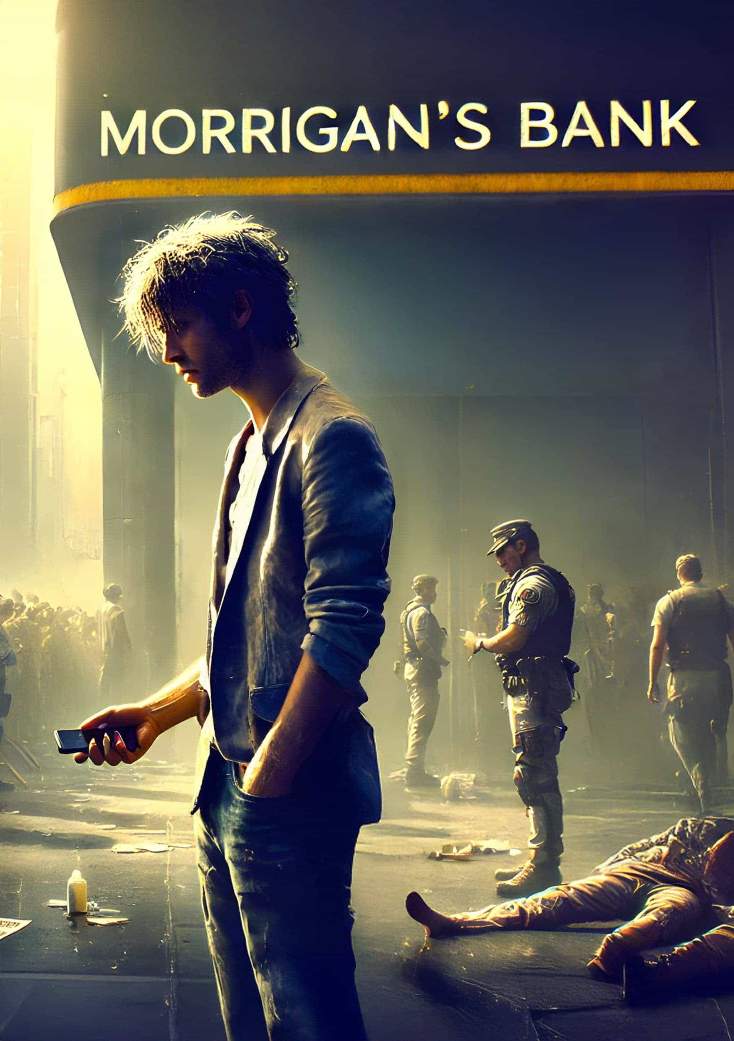

The Confisco

by *Luciano Rocha*

’Balance Blocked, Balance Available’

The hangover was still clouding Max’s mind when he woke up that day to a thin sliver of light coming through the window. The party was small, but it was enough to target his eyes, taking away his sleep and giving him a terrible headache. Confused, Max rubbed his face with his hands and looked around. The room was exactly the same as he remembered: the bottle of Jack Daniel’s was on the bedside table without its cap; fortunately, it hadn’t tipped over. The glass, half full, was far from indicating something good, as the saying went. On the contrary, it was the result of the trauma of the night before.

The ad. That bizarre plan coming out of that crazy woman’s mouth. Did she really get to be economy minister? No one can even understand what she says, thought Max, getting up. He opened the fridge. It was nearly empty. There was a solitary egg along with half a bottle of milk, and Max took both. He fried the egg and mixed the milk with Jack. ‘I need to do some shopping,’ he said.

He went into the living room and took out his cell phone to open the delivery app. He would go to the market, but not now. He didn’t know what the streets were like after the announcement the day before, but he could hear the shouts of his next-door neighbor who, from his tone, was also looking to buy food.

‘What?! What the fuck? How come I can only spend 50,000? There’s twenty times that in my account!’ Pause. Silence. ‘But...’ said the neighbor before pausing again.

Max waited, his ears to the wall and his eyes searching for his favorite dish: a portion of carne de sol with salad and fries. The best way to cure a hangover. He heard a bang in the kitchen: the egg was burning.

The neighbor spoke again. ‘What news? I haven’t heard anything! And I don’t care. I want access to all my fucking money. Fifty thousand barely pays for lunch!’

The egg was burnt, a reminder of how good Max was in the kitchen. As good as the president is at choosing ministers, he thought, putting the egg on his plate and heading back to the living room, picking up a glass of Jack and Coke on the way. He took a bite: it was awful, but it was what he had. At least the drink relieved the hangover and woke Max up, reminding him of what had happened the night before.

The announcement. The minister. One sentence. And that shout from the neighbor. Max went back to the app and clicked on the cart to finalize his purchase. The card didn’t go through. This was a nightmare.

Apathetically, Max opened the bank app and read his account balance. He didn’t like using credit cards and getting into debt, so he kept an eye on his checking account, but occasionally he found himself short of cash because he’d gone overboard. Yesterday was the perfect day to go overboard. The bank app opened and displayed the following information:

Total balance: DR$ 3,452,000

Blocked balance: DR$ 3,402,000

Available balance: DR$ 50,000

What do you mean? Max asked himself, looking at the symbols on the screen and getting a real fright. There was something very wrong with that screen. A telephone hit the wall next door, followed by another muffled noise. The neighbor punched the wall. Having only DR$50,000 in the account causes such reactions, thought Max, closing the bank app. He would have to go to the supermarket to try to buy something cheaper and cook. Flipping the Jack ’n’ Milk in one go and finishing off the last piece of egg, Max put on a T-shirt, grabbed his keys, and left. Just before he went, he took a quick peek out of the window and saw people running everywhere, a huge queue at the supermarket, and a bunch of people in front of the bank branch. There was a riot police battalion guarding the place with guns, but Max didn’t know if they were real guns or fuses. He turned around, closed the curtain, and prepared to face the streets.

Queuing at Morrigan’s

Everywhere he went, Max looked at the headlines of the newspapers that were still on the stands or lying in the middle of the street. They all contained the same headline: PRESIDENT BLOCKS THE MONEY!

It could be a lack of creativity, but I think it’s shock, thought Max. He decided to pick up the pace, as the dirt in the streets and the people already running down the alleyways in desperation indicated trouble. On the way, Max came across a series of notices linked to the city’s largest bank, Morrigan’s, which was his destination. They all mimicked the uncreative newspapers, but at least they were more detailed:

GENERAL BLOCKING OF ACCOUNTS! WITHDRAWALS LIMITED TO DR$50,000 UNTIL FURTHER NOTICE! CREDIT OPERATIONS REMAIN UNCHANGED!

Max’s great fear was that neither the newspapers nor the headlines carried anything more than that. ‘What the hell can someone do with 50,000 bucks?’ he exclaimed. As he walked, his brain took advantage of the fact that the way to the bank was etched in his mind to make him think about the bills that were still outstanding and how that damn 50,000 wasn’t going to help at all. Someone tapped him on the shoulder from behind. Startled, Max turned abruptly and grabbed the stranger’s collar, ready to fight, when the familiar face stared back at him in fright:

‘Hey, Max, slow down! Are you going to hit a policeman?’

Ah, it was just Kevin, his colleague at the police department. Like Max, Kevin wore civilian clothes — he must have been in plain clothes or off-duty — and looked out of breath as if he had run a marathon. He had his gun in his holster and laughed when he saw Max’s expression of relief and annoyance, and he punched his colleague lightly in the chest.

‘No. If I get arrested, I won’t be able to get to Morrigan’s in time to stop a robbery.’

‘What? They’re robbing Morrigan’s?’

‘Yes. And from what it says in the papers, they stole all our money.’

Kevin looked at his friend with a confused expression that turned into a huge laugh once he understood everything.

‘Max, you son of a bitch, you’re brilliant! You’re right, let’s go before the robbery takes place.’ The two of them made their way to the bank.

‘When did you hear about this whole mess?’ Kevin asked.

‘This morning, after the hangover wore off.’

‘Did they block yours too?’

‘Yes, more than 3.4 million Drex.’

‘Jesus, man, 3.4 million? What sons of bitches!’

Max nodded, remembering that this was the money from the month’s fair. ‘Our money is already worthless and these bastards still steal most of it. How much did they confiscate from you?’

Kevin took out his phone and showed his friend his account balance:

Total balance: DR$ 1,200,000

Blocked balance: DR$1,150,000

Available balance: DR$ 50,000

We’re in the same boat, buddy, thought Max as he made his way towards the bank, but his thoughts were interrupted when he came to a sudden stop. Both Max and Kevin were at the top of a steep slope, and at the bottom of the slope, almost like a dragon’s mouth on a toboggan about to swallow its prey, was the large branch of Morrigan’s, the biggest bank in town. The bank always seemed like an imposing colossus to Max when he had to descend the slope, but this time the dragon’s mouth found a worthy rival: a snake.

The snake of dozens of people that wrapped around the bank like a boa constrictor was formed of the large queue of citizens. Max and Kevin made their way to the end of the queue and positioned themselves behind the last person.

The Broken Window Pane

BANG!

With their cop instincts activated, Max and Kevin quickly tucked their hands into their waistbands before realizing two factors. Firstly, they were in that queue as civilians and were going to a bank that didn’t allow armed customers, which Max dismissively called ‘the perfect recipe for creating a honeypot for criminals’.

Secondly, when they looked more closely, they saw that the noise didn’t come from someone with a gun shooting at the customers in the queue. In fact, the noise came from the bank itself: someone had thrown a chair against the window of Morrigan’s, shattering the front of the bank and causing panic among the customers at the front. Screams came from all sides, some of fear, others of fury; people tried to push against the broken pane to get into the bank.

BANG!

This time, there was no doubt: it was a gunshot. The security guard at Morrigan’s pulled out a revolver and fired into the air, glaring at the crowd. Two of his companions stood on opposite sides of the hole where there had once been a pane of glass, pointing their guns at those still in the queue.

‘Everyone, please be quiet! Let’s not cause a tragedy!’ shouted the shooting guard. Max approached the window and was met by the barrel of a revolver:

‘Get back in line, sir. Let’s not create a commotion.’

‘I’m a policeman. What’s going on here?’ Max asked, showing the badge in his hand. The security guard relaxed and asked him to come closer, asking tensely, ‘Do you have experience with negotiation?’

‘Yes,’ said Max.‘What’s going on?’

‘Come with me, please. My name is Bryan and we need help.’ said the guard, stepping aside for Max to pass.

‘A customer is desperate in here, he wants his money back. He freaked out when the manager told him about the confiscation of the DREX and flew into a fit of rage. The chair that destroyed the window pane — that was him. And now…’

The policeman pointed to the counter of Morrigan’s, which was once luxurious, but was now covered in broken instruments, dust, and torn pieces of paper. A man was desperately trying to open a bottle, pushing people out of the lobby, while giving water to a woman who had fainted. Bryan told Max that the woman had been threatened by the customer, who was demanding his money back in full. He was at the back of the bank, holding the manager at knifepoint and threatening to kill him if anyone came near. With caution, Max approached, making eye contact with the man.

‘Good morning, friend. What’s up?’

‘Good morning to whom, idiot? Who lost their money because of incompetent idiots like this?’ He pressed the knife into the manager’s neck, who grimaced in pain.

Generate empathy, thought Max, remembering the first rule he learned at the academy. The guy wasn’t a thief, he just wanted back what was his, and he had freaked out when he didn’t succeed.

‘Michael Douglas did worse in that movie.’

‘You’re right, a shitty day. That piece of shit there,’ he said, pointing at the manager, ‘blocked me from more than DR$3.4 million. I’ve lost my entire life savings.’

‘So you won’t mind if I want my money back, right?’ he asked the man.

‘What’s your name?’

‘Josh... Josh Weiland.’

‘My name is Max, Josh, and no, I don’t care. You have every right to get your money back, just like I do. But you have a knife pointed at the neck of the only person who can help you.’

‘Of course, and I’m going to stay like this until he gives me my fucking money back!’

‘But for that, I’m going to need you to let him go, so that he can return your money and mine. Can you do that?’

‘And who’s to say this idiot will do it once he’s released?’

‘I’ll do it, I promise!’ said the manager, terrified but following Max’s game.

‘You’ll both get your money straight away.’

There was no way of knowing whether it was the tension of being out of money, or whether Josh decided to trust Max. The fact is that he loosened the knife around the manager’s neck (who, according to his badge, was called Ron), but didn’t let go. He put him in the chair and demanded that Ron give him back all the money: DR$6 million in cash. The manager had no choice but to go to the safe and, instructed by Max, put the money in two bags, as Josh had asked him to.

However, Ron made the mistake of taking the bags directly to meet Josh at the bank’s reception, in full view of all the customers who were still waiting in line, both for the manager’s kidnapping to be solved and to be able to withdraw their money. When they saw that the kidnapper’s threat had worked and Ron was leaving with all their money, the herd effect, combined with their fury at not receiving their money, unleashed a shockwave. The crowd surged through the peephole, easily subduing the security guards before they could react, and entered Morrigan’s towards the packages in front of Max and Ron.

The Morrigan’s Massacre

Holy shit. We’re screwed! thought Max, watching the crowd rush towards them. Josh panicked and pulled out a revolver, standing in front of the bags full of money and pointing it at the crowd. The idiot had his finger on the trigger and his hand was shaking worse than a green stick, which was the perfect recipe for tragedy.

‘Stop right there, that’s my money. Get back!’ he shouted, his gun shaking in his hands. But the crowd didn’t give a damn and kept moving towards the bags.

BANG! BANG! BANG!

BANG! BANG!

Five fucking BANGS, but those weren’t broken glass or shots fired into the air. In his fear and seeking to protect that damn money, Josh fired three times into the crowd; two straight shots, despite his shaking. One of the shots hit a man, while the other two wounded others. Max had to look again to believe it.

One of the bullets went straight past and almost hit him; Max needed all his reflexes as a policeman to avoid being hit and ended up falling to the ground. When he got up, he looked ahead and saw the baby crying, lying in a pool of blood coming from the bullet wound to his mother’s head. The bullet hadn’t hit the child, but the mother’s fall had made the child cry, without any awareness that he was in the pool of blood gushing from his dead mother. Enraged, Max ran up to Josh and wrestled with him, trying to get his gun away. People were divided between the panic of fleeing the confusion and avoiding further gunfire, while some idiots were still trying to loot the bags, left out during the fight between Max and Josh.

‘Let me go, you idiot! I want my money!’ said the criminal, struggling to push Max away from the gun.

‘You’ll be in a fucking cage after what you’ve done!’ retorted Max, grabbing Josh and managing to throw his gun away. They continued to grapple with each other and, in a combined move, threw each other onto the bank counter. Max hit his head. His mind turned foggy, and he saw only a dark figure and a distinctive glow before blacking out.

Shopping Time

‘Where am I?’ Max asked, bewildered.

‘In hospital, sir. You were hit by a car while trying to cross the road in a hurry, and we almost didn’t manage to save you. But you’re recovering now.’

Max panicked and tried to remove the bandages and the IV needle, and the nurse looked at him in panic, trying to hold his hands. After all, he wouldn’t have enough Drex to cover that bill and he still had to find Dale and demand that he unlock the rest of his money.

His movement, however, was stopped by the nurse, who tried to prevent Max from removing the IV. She kept her hands tight to prevent the patient from getting loose.

‘Let me go! I need to get out of here!’ shouted Max, struggling to get free from the nurse.

‘Sir, calm down.’

‘I DON’T HAVE THE MONEY TO PAY FOR THIS HOSPITAL! THE DAMN BANK HAS BLOCKED MY ENTIRE ACCOUNT!’

‘Don’t worry, sir. A young man has already paid for everything, and the funds have cleared. You were just sleeping and you can go home now.’

That last sentence left Max paralyzed in a state of utter confusion. Not having to pay a hospital bill is one of the rarest situations there is. He relaxed and looked around the room.

The nurse took this as a good sign and eased the pressure she was applying to hold Max down on the bed, then helped him up and gave him room to get dressed.

On the chair, Max found a newspaper dated five days ago, with a headline in big letters:

MORRIGAN’S MASSACRE SPARKS TERROR!

FIVE DEAD, INCLUDING TWO TRAMPLED.

BANK VAULT RANSACKED.

‘How long have I been out?’ Max asked the nurse.

‘Five days, sir. Good, because it’s chaos out there. What happened at Morrigan’s has sparked riots throughout the city.’

‘And the criminal in the bank? What happened to him?’

‘He was sent here with you, officer. He was discharged and then went to prison. A man called Kevin left this for him.’ The nurse handed Max a gun in a plastic bag: ‘evidence’.

Max resigned himself, thanked the nurse for her care, grabbed his coat, and left the hospital. His head still ached, but it was time to stock up and make sure his little treasure was safe.

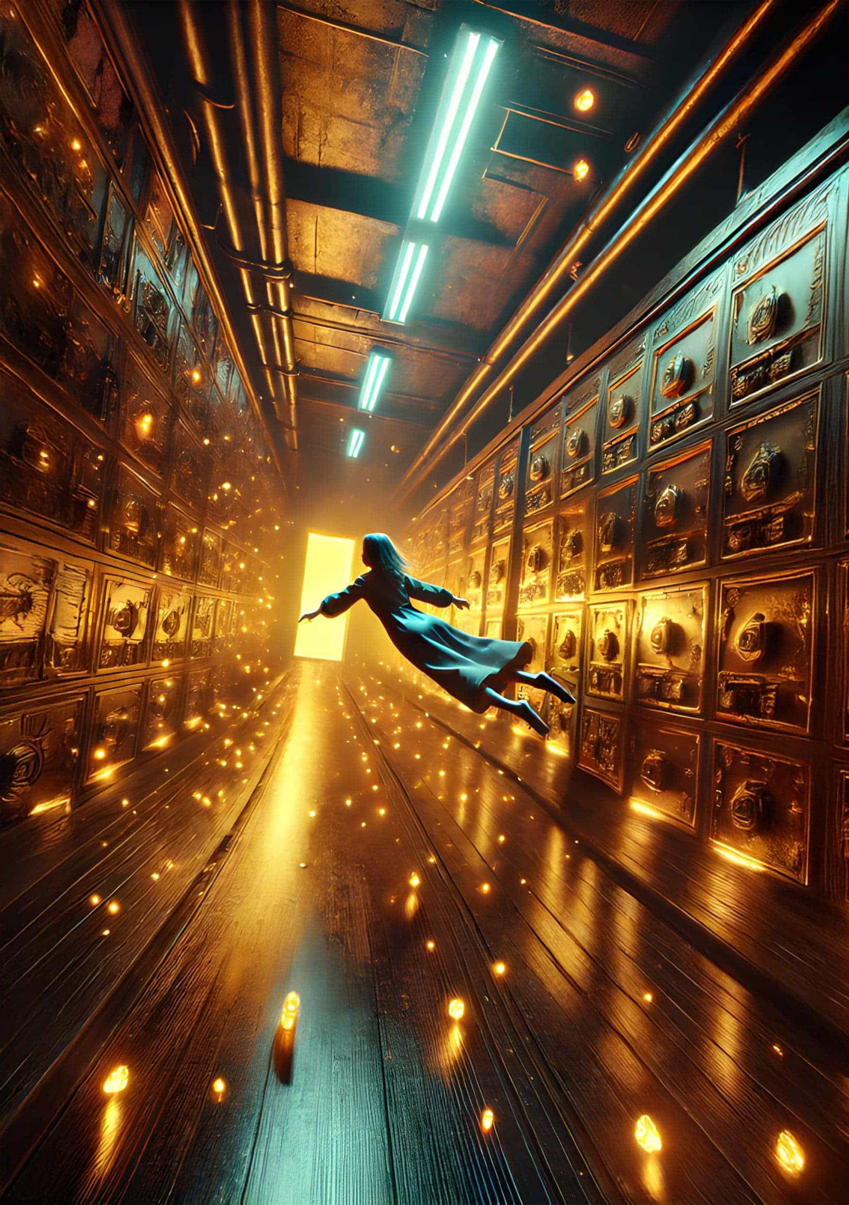

Dreaming Big

by *Lindsay Burns*

‘Welcome to the Hammock Room,’ said the Factotum, pushing the door open. It was gloomy inside, like the Sleeping Bag room had been, only the walls were white instead of grey and there was more space between each occupant.

The Factotum handed her a duffle bag. ‘These are your new clothes,’ he said. ‘Throw your old ones into the incinerator.’

‘Ok, thanks. I will,’ whispered Jocelyn. Many people were sleeping in the hammocks, while others were sitting up in theirs, doing puzzles or knitting.

After going to the bathrooms and changing into her new red tracksuit, Jocelyn made her way to her designated hammock. Number 34. This would be her address for the foreseeable future. The hammock rocked violently as she sat on it and swung her legs up. She laughed to herself.

‘You’ll get the hang of it,’ came a voice from the hammock next to hers.

‘Oh sorry, did I wake you?’ she said.

The man shook his head and then held out his hand. ‘I’m John. Welcome to Hammock Room 220.’ His watery blue eyes looked into hers. They twinkled.

‘Who have I replaced?’ Jocelyn asked. ‘An upper or a downer?’ It was a question she knew she shouldn’t ask.

‘A downer,’ said John, unfazed. ‘His credits nosedived from the first day he was in here. Lacked a bit of self-belief and then started with insomnia, so they sent him back to the Bags.’

Jocelyn glanced at the small screen above John’s hammock, with the familiar tangle of electrodes dangling from it. The digital display showed high credits. She’d have to work hard to compete with that, but she’d give it her best shot.

‘How long have you been in the hammocks?’, she asked.

‘Four hundred cycles. I’m hoping that after five hundred cycles I’ll get promoted to a Bunk Room.’

‘Good luck with that,’ said Jocelyn. ‘I’m going to get some practice in, so I’ll say goodnight for now.’ She flicked on her screen and pressed the electrodes to her temples, then shuffled down in the hammock, fidgeting for a few seconds, unsure what to do with her arms. She’d always used them as a pillow when she’d been in her bag.

‘By your side is best,’ advised John. ‘They’ll go numb if you put them behind your head.’

She closed her eyes. It must have been something to do with the novelty of the sleeping arrangements and the relative privacy of the hammock because Jocelyn was soon in a deep sleep and dreaming.

And what a dream it was, in colour too, her weightless body gliding horizontally through a complex web of underground tunnels, brightly lit. Her eyes flitted all around, searching every crack and crevice. There were wooden doors here and there, most of them fake.

‘Don’t give up,’ she told herself. ‘Try them all.’ The last door she saw was bigger than the rest, and she fought to get a grip on its slippery handle. It opened so slowly she was afraid she’d wake up before seeing what was behind it. But then it relented, and her eyes widened. A gold bar, right there on the dirt floor. She’d never found gold before. Her promotion from the bags to the hammocks had been achieved through amassing thousands of tiny silver coins. She rolled the gold bar around in her hands, guessing it must weigh a kilogram, then she shoved it into her rucksack before waking up with a start.

‘Not bad for your first day,’ said John, nodding towards her screen as she disconnected the electrodes. ‘With credits like that after one sleep, you’ll catch me up in no time!’

There wasn’t a hint of bitterness in his voice. Jocelyn decided she liked him.

After cycle upon cycle of almost constant sleeping, Jocelyn had amassed enough credit to go into a Bunk Room. Even she was astonished at the amount of treasure she had found in her dreams. Gold, precious stones, wads of cash… all gathered for the Common Cause. It made her feel proud inside, and desperate to do better. John had done well too, in his steady way. They were due to transition on the same day.

‘You’ve got a competitive streak, Josie,’ he ribbed.

Perhaps she did. Or had. She couldn’t remember. Her life before was like a series of blurry snapshots. A pair of shiny black shoes. A forest full of white flowers. Bubbles and the sound of giggling. But there were also black clouds. Fire. Shouting. Pain.

‘I’m glad you’re coming with me,’ she said, and blushed. ‘Who else can I share my awful meals with?’

John smiled at her then reached across to her hammock and patted her hand.

The Bunk Room was a step up in comfort. Melamine beds were neatly arranged in rows, made up with quilts instead of scratchy blankets. Her bed, number 46, was a bottom bunk next to John. The Factotum handed her a bag of new belongings and her old ones were jettisoned into the incinerator. She liked her new navy lounging suit. It had a shape to it and gave her some definition.

‘Wow, John. A feather pillow,’ she said, poking it with her index finger. ‘And cotton pyjamas! And what’s the little cup for?’

The Factotum pointed to an urn in the corner.

‘Sleeping juice,’ he said. ‘Help yourself, one cup a day to be used as you see fit.’

‘I’m not having any of that,’ said John through pursed lips. ‘I sleep perfectly well, thank you.’

The Factotum turned back to Jocelyn. ‘More sleep, more dreams, more treasure. For the Common Cause. The way your credits have been going you should be in a private suite within a thousand cycles. So the Bosses reckon.’

He tapped the plastic cup that Jocelyn was clutching in her palm, and she watched him exit the room, her face glowing.

And so the cycles began. It was so calm in the Bunk Room where everyone was almost always asleep, a complete contrast from the confused chaos of the Sleeping Bag room. The food was slightly better too. Sometimes she and John exchanged a few words, but their conversations were limited as they slept more and did less. In the Hammock Room they had chatted about this and that as they spent a bit of time working on their puzzles and crafts, but Jocelyn had lost interest in those things now.

‘Do you ever think about the people that are still in the Sleeping Bag Room?’, he asked her one day as they were shovelling down their dinner between naps.

‘No,’ said Jocelyn. ‘I thought I would, but I don’t.’ It sounded harsh even to her own ears, but it was the truth. She only really looked forward. Whilst the distant past was an unfathomable mess, the recent past only seemed relevant in terms of how it would affect her future.

John took a pause between mouthfuls.

‘You’ve been taking the juice, haven’t you?’, he said.

Jocelyn twiddled with her fork. ‘Sometimes,’ she said, looking down. That was a lie. She took it all the time, the maximum she was allowed.

‘You know, John,’ she said, looking him in the eyes now, ‘you wouldn’t believe the things I can collect when I’m asleep now. Such beautiful things. Invaluable.’ She looked at her screen, her credits blazing in red lights. Then she looked at her watch. It was almost time for another nap.

‘Don’t Josie, not yet,’ John pleaded. ‘I want to talk to you.’

‘What about?’ she said.

‘Well, what if this is all a trick?’

‘What do you mean?’ she said, frowning.

‘It’s just…’ he said, lowering his voice, ‘don’t you ever wonder what the Common Cause is?’

Jocelyn shrugged. ‘What we contribute to. And when we’ve contributed enough, we’ll go somewhere better.’

John sighed, and Jocelyn thought how tired he looked all of a sudden. ‘Perhaps there is no ‘better’. Not for any of us. What if the whole point is to keep us asleep? What if the more lucid our dreams are, the more intelligent they think we are, and the more they have to keep us quiet? This sleeping game, these credits we get… I don’t think it’s about making money for the Common Cause. It’s about occupying us, keeping us busy.’

‘I’m really lost now, John. Why do we need to be kept busy? What are they afraid of?’

He leaned in and whispered in her ear. ‘That we might revolt. There are thousands, probably millions of us in here. Did you not see the endless corridors, and how many floors the lift went to? They have to keep us under control.’

Jocelyn covered her eyes, her thoughts turning over and over. It had been so long since her mind had worked like this in waking time that after a few minutes she had to lay down, her body exhausted by the cognitive effort.

‘John,’ she said at last, her expression vacant, ‘I think you need some sleep. Your eyes, they’ve lost their twinkle. And your credits are well down.’

She pressed the electrodes to her temples, took a sip from her plastic cup, and fell immediately to sleep. When she woke, John was gone.

‘Demoted,’ said the Factotum, shrugging. ‘Stopped dreaming.’

The cycles melded into one as Jocelyn threw herself into her work, her waking time spent blocking out the memories of John and what he had said to her. She missed him on some level. No one had ever called her Josie, apart from him and someone from a long time ago that she couldn’t recall. So she drank maximum sleeping juice, slept more, and racked up her credits. Her dreams were fun and challenging, complex and colourful, and she had more and more control over them as she mined the recesses of her dreamworld for riches. It was while she was in this semi-unconscious state that Jocelyn felt most alive, in stark contrast to her waking life in the perpetual gloom of the purgatorial Bunk Room.

She eventually graduated with record credits, having gathered untold fortunes for the Common Cause. ‘Leave all your things,’ said the Factotum on the day she made the transition, ‘and follow me.’

It took a long time to traverse the maze of white corridors, sometimes using stairs and other times taking lifts. Jocelyn was breathing hard by the time she arrived at her private suite, her body unused to such physical activity.

‘Welcome,’ said the Factotum, pushing open a door which had a small plaque bearing her name. Jocelyn Peters. Was that what she was called? Maybe, she couldn’t remember.

Jocelyn gasped when she saw the room. It was almost the size of the entire Bunk Room, with a sumptuous bed against one of the beige walls. The bed covers were a floral pattern, a variation on a favourite of hers that appeared in most of her dreams. She ran over to touch them.

‘Silk,’ said the Factotum, ‘as are the pyjamas and slippers. There’s also an exercise bike which you must use for at least fifteen minutes between sleeps. On the fridge is a menu. And in the fridge is sleeping juice. It’s unlimited, so help yourself.’

It was the door in the corner that drew most of Jocelyn’s attention.

‘Is it a real door?’, she asked.

‘Yes,’ said the Factotum. ‘All you need to do is amass enough credits for the Common Cause, and in return, you will get a key.’

‘Really?’ she said, one eye already on the comfy pillows.

‘Have we ever lied to you?’, he asked.

She shook her head.

‘It is your choice, Jocelyn Peters,’ the Factotum said, placing his hands on her shoulders, ‘whether or not you take the room’.

Jocelyn fleetingly thought of John, back in a sleeping bag, and felt a twinge of sadness as well as frustration. He could have had all this if only he had been more focussed. Then she surveyed the room again, a room filled with all the trappings of her success. Finally, her thoughts turned to the door and what might be behind it, and how she was determined to get that key. Of course, it meant more work, but faced with a choice between a waking life on the brink of existence and living a dream, Jocelyn had no doubts.

‘So,’ said the Factotum, hovering on the threshold now. ‘What do you choose?’

Jocelyn picked up the silk pyjamas and pressed them against her warm skin.

‘I choose to dream big,’ she said.

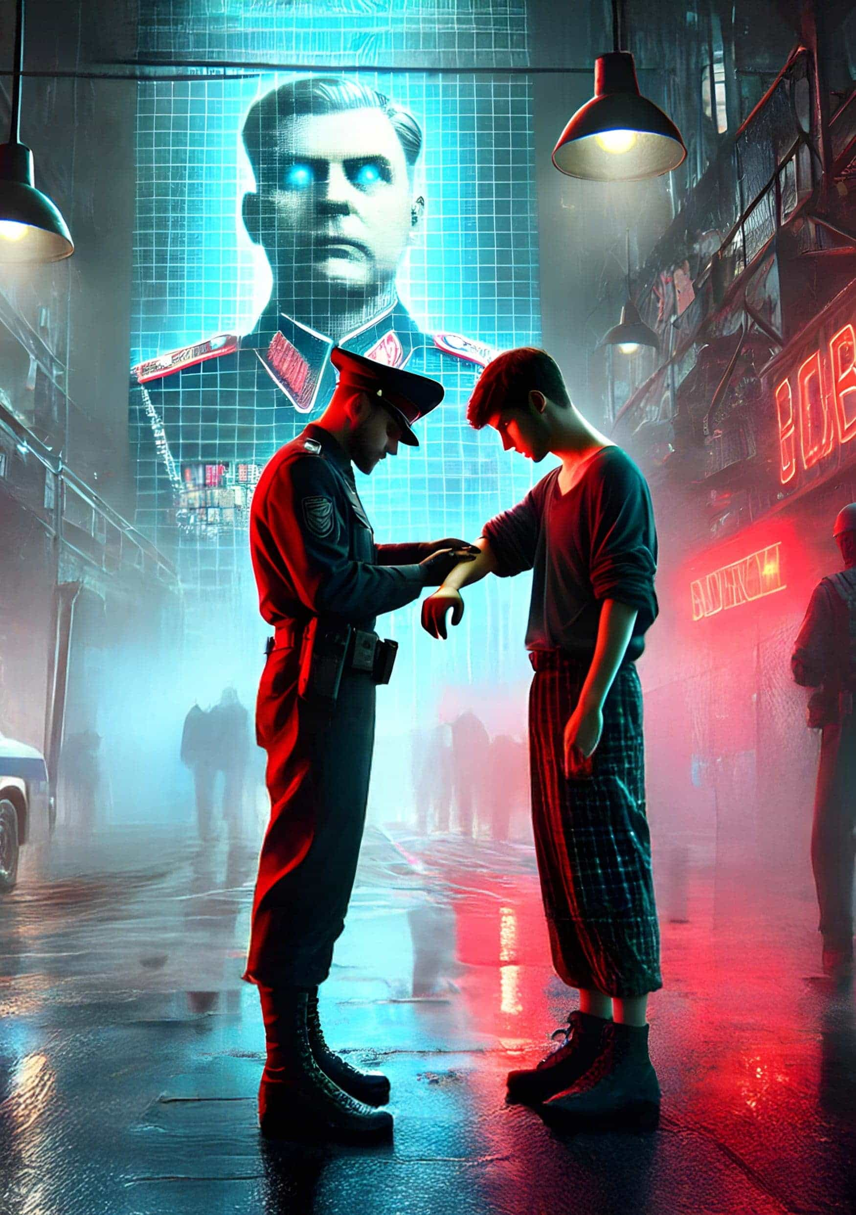

The Last Days

by *Mariska van der Merwe*

Day 5998

The woman sold her son for a bag of wheat. She pushed him towards the soldiers, snatched the bag, and turned on her heel. Her eyes remained fixed on the ground as she walked away. The boy’s cries pierced through the air as he reached out for his mother, his small arms stretching desperately towards her retreating figure. His sobs grew louder, echoing through the street. One of the soldiers lifted him onto the hovertruck, his movements mechanical, practiced. As the steel door slid shut, the boy’s cries were abruptly silenced, muffled by the clang of metal and the securing latch.

The line ahead shuffled forward.

Akani stopped at the faded red paint marker on the cracked asphalt, ensuring he was five meters away from the next person. The street smelled of boiled cabbage and rotting flesh. Around him, people stood in tense silence, their faces obscured by makeshift masks and tattered robes that covered every inch of exposed skin. Akani’s eyes flicked to the trembling gloved hand of the person ahead of him, gripping a small sack. The bpox virus had turned everyone into a potential threat. Hospitals were no longer operating, and the few clinics that remained were either overrun or stripped bare by looters. Most had no choice but to risk everything at the checkpoint. Survival here was a gamble — sometimes those who tested positive could trade valuables for morphine or painkillers; other times, they were killed on the spot.

Akani glanced at his watch. Every second, the sun dipped lower behind the buildings, as if eager to retreat and hide from the horrors unfolding below. A drone buzzed overhead, quickly followed by the thunderous roar of an ornithopter. The downwash stirred the dusty street, sending loose debris and tattered newspapers swirling into the air. Akani nuzzled his head deeper into the collar of his shirt to escape the vile wind. His gaze drifted across the street to a towering hologram flickering with images of recent events in Central Krotoa. Scenes of chaos unfolded: armies amassing at the borders of Klilat, bodies strewn across the streets as life continued around them, bombings and shootings in Asanti, people hurrying past the carnage, numb to the horror. Akani knew it wouldn’t be long now—Krotoa’s support of Klilat’s enemies had sealed its fate. Invasion was imminent, and Krotoa would fall alongside Klilat. Then, as if on cue, a crescendo of stirring music swelled, and the face that seemed to haunt every corner of the city filled the screen.

‘My fellow Krotoans. I stand before you not as a leader of a prosperous nation, but as a commander in a time of war — a war against the very fabric of our existence. The world as we knew it is gone, and with it the illusions that once held us together. The currency in your wallets, the savings in your accounts — worthless paper, nothing more. The global markets have collapsed, our neighbours are in ruins, and the rest of the world has turned its back on us.

But in this new world, where the old systems have failed us, we must adapt or perish. The time has come to accept the harsh reality: gold, money, luxury, these are relics of a bygone era. The true value now lies in survival, in power, in the resources that sustain life itself. Food, water, oil—these are the new currency. And they do not come cheap.’

The queue moved slowly, each shuffle dragging Akani closer to the checkpoint. His pulse quickened. Akani could feel the stolen chip embedded in his wrist — a constant reminder of the risk he took every time he approached the checkpoint. The General’s voice echoed down from the hologram.

‘For those struggling, the state offers a way out. Join the army and secure what remains. Soldiers will be guaranteed food, shelter, and protection. Your loyalty will ensure the future of our nation.

If you are not eligible to join yourself, then your children can serve the nation, ensuring their survival and yours.

But most importantly, obey the new laws. Report those who defy the State. Loyalty to the State is loyalty to your own survival.

We are not a nation of weakness. We are a nation forged in struggle, and in this, our darkest hour, I call upon you to embrace the new order. To survive, we must be ruthless. To thrive, we must be merciless.’

Akani’s stomach churned at the words. How many times had he heard this same speech? The State had promised food, shelter, and protection. Their lies were as clear as the gunshots that echoed through the streets every night. They talked of loyalty as if it were a currency, something to be traded for safety. But loyalty to what? A regime that fed off fear? A society that had forgotten what it meant to be human?

Akani reached the front of the line.

‘Step forward,’ the soldier ordered, his tone curt. ‘Face the sensor.’

Akani obeyed, staring into the tiny camera as another soldier carefully aligned the laser to the centre of his forehead. A flash of green illuminated the screen, signalling that he was cleared to approach the table.

‘Arm,’ the soldier demanded.

Akani extended his arm, the sleeve slipping back just enough to reveal the faint scar where the chip had been implanted. The soldier scanned it, the data flashing onto the screen. For a moment, the soldier squinted at the details before entering them into the ledger.

‘Medical condition, huh?’ the soldier muttered, more to himself than to Akani. ‘Lucky you. Not everyone gets a pass.’

Akani gave a slight nod, his face unreadable.

‘Trading or reporting?’

‘Trading,’ Akani replied.

The soldier’s gaze finally lifted, eyes narrowing as he noticed Akani’s empty hands. Akani slowly reached inside his coat and pulled out two silver canisters.

The soldier let out a low whistle as he examined them. ‘And where did you find these?’ he asked, turning the canisters over in his hands.

Akani remained silent. He had learned early on that the less said, the better. The soldier glanced at his companion, a hint of a grin tugging at the corner of his mouth.

Rubbing his chin, the soldier said, ‘Three bags of food.’

Akani knew it wasn’t enough, but he also knew how quickly negotiations could turn violent. He’d once seen a man beaten to death for refusing to trade a can of gasoline. But he also knew the only thing closest in value to soldiers and weapons, were energy cells.

‘Four bags,’ Akani countered, ‘and water.’

The soldier leaned back in his chair, weighing his options. Akani could almost see the thoughts flickering behind his cold gaze — whether he was in the mood to negotiate further or simply take the batteries and shoot Akani where he stood.

The soldier suddenly clapped his hands together, coming to a decision. ‘Four bags. No water.’

Akani forced a smile as the soldier tossed the bags to the ground with a careless thud. Bending to pick them up, he caught movement in his peripheral vision. A car skidded around the corner, tires shrieking. His breath caught in his throat as a figure in the back seat leaned out, aiming a railgun in his direction. There was no time to react.

A flash — then the world erupted. The explosion punched the air from his lungs, as if the atmosphere had shattered. Heat and light fused into a searing wave, the ground buckling beneath him as the shockwave hit. Akani was airborne, weightless for a sickening moment before he slammed into the mass of bodies behind him. The impact jolted every bone, but there was no time to register pain.

He curled up instinctively, drawing his knees to his chest as shards of glass and debris rained down. Gunfire cracked above, each shot sharp and disorienting, slicing through the dull roar in his ears. The world narrowed to the sound of his own heartbeat, pounding in his head, and the high-pitched whine that drowned out the chaos around him.

Through the dust, figures materialised — dark, hooded silhouettes moving with purpose. Akani blinked, vision hazy, as they advanced on the checkpoint. The soldier who had handed him the bags scrambled for cover, flipping a table and firing wildly over the edge, his shots frantic and aimless. The street was a blur of movement with bodies crumpling under stray bullets and others scattering in blind panic.

Akani’s pulse quickened. He had to move. The attackers weren’t here to ask questions, and they wouldn’t care who he was or why he was there. Akani glanced at the bags, then forced himself to turn away. Crawling towards the pavement on his right, he kept low to the ground, his heart pounding in his ears. A woman suddenly dropped in front of him, her lifeless eyes wide open, staring right through him. Akani swallowed hard, forcing himself to push past her, ignoring the sharp stings as shards of glass cut into his arms. He didn’t dare look back.

When he finally reached the pavement, he sprang to his feet. Something whizzed past his ear, close enough to ruffle his hair, before slamming into the wall beside him. Instinctively, he threw his arms up to protect his face and bolted down the street, his feet slapping against the pavement in a desperate rhythm.

He veered into the first alley he saw, his breath coming in ragged gasps. A stray dog darted out of his way as he rounded the corner onto Long Street. The sun had nearly disappeared behind the buildings, casting long, eerie shadows that stretched across the pavement. Akani sprinted through the dimming light, his mind focused solely on getting home.

People turned to stare as he barrelled past them, their faces a blur of confusion and anger. Someone shouted as he nearly knocked them over, but Akani didn’t slow down. Relief surged through him when he finally spotted the familiar brick building, its boarded-up windows and peeling paint a welcome sight.

He didn’t hesitate, slamming into the old rotating glass door and forcing it into a rapid spin. Dust and leaves swirled around him as he stumbled into the dim lobby. Only then did he stop, doubling over with his hands on his knees, gasping for breath. Every muscle ached, his lungs burned, and his legs trembled from the effort.

Slowly, Akani straightened up, rolling his shoulder and wincing at the pain that shot through it. He headed for the stairs. As he reached the first landing, his eyes fell on a coloured poster plastered against the wall. The General’s face loomed large, nearly a meter wide, every cruel detail magnified — the cropped black hair, the cold, calculating eyes, and the scar down the side of his neck. LOYALTY TO THE STATE IS LOYALTY TO YOUR SURVIVAL, the caption beneath it ran. A chill travelled down Akani’s spine, a gnawing dread that the General was somehow watching him through those lifeless eyes, tracking his every movement, listening to every whispered breath. In this world, nothing seemed impossible; the idea of being surveilled through a poster felt all too real. He forced himself onward, his legs burning as he climbed to the second landing. Another poster greeted him, identical to the first, the General’s gaze drilling into him once more.

Akani finally reached the third floor. He leaned against the wall, trying to steady himself. The crushing realisation that he had lost the food settled heavily on his shoulders. Every step down the dim hallway felt like a trek through quicksand, his heart sinking deeper with each one. He stopped in front of the door at the end of the hall, his hand trembling slightly as he raised it to knock. One knock, pause, three quick knocks, pause, one knock. The familiar pattern echoed in the silence. Moments later, he heard the latch slide from inside, and the door creaked open. Before Akani could utter a word, a thin, warm body barrelled into him. Isaac’s arms wrapped tightly around his waist; the boy’s head buried in his chest. Akani staggered back a step, instinctively wrapping his arms around Isaac, the weight of his loss momentarily forgotten in the pure, unfiltered relief of being home.

Akani closed the door behind him, the faint echo of the world outside fading as he entered the small apartment. He slumped onto the kitchen counter, the events at the checkpoint replaying in his mind. Isaac clambered onto a barstool beside him, clutching a drawing. Akani smiled as he traced the outside of a lion and a buffalo standing at a watering hole, framed by a blue sky and lush trees.

‘You know,’ he said, trying to push away the haunting images from earlier, ‘a long time ago, before World War III, there was a small piece of paper with a blue buffalo on it.’

Isaac frowned, ‘A blue buffalo?’

Akani nodded, his eyes clouded with memories. ‘Yes, and a leopard, too. That paper was used to buy things like food, clothes, fuel. They called it money.’

Isaac’s brow furrowed deeper. ‘But how could paper buy things? That doesn’t make any sense.’

‘It doesn’t, does it?’ Akani said, his gaze drifting to the drawing. ‘But back then, it did. My father showed it to me when I was young.’

Isaac tilted his head, trying to grasp the concept. ‘What happened to it? The money?’

‘It lost its value when everything fell apart,’ Akani said. ‘I guess when it died, so did the nation.’

‘And the buffalo?’

‘The buffalo, the leopard... they’re still out there, but the world they lived in with us is gone. We traded in something real, for something that was only real because we said it was. And when that stopped, we were left with nothing.’

Isaac watched his father closely, sensing the weight behind his words. ‘You seem sad, Baba.’

Akani nodded, his hand reaching out to ruffle Isaac’s hair. ‘I am. I just saw something today that I wish I could forget. But talking about the old days helps me remember a time when things made more sense.’

Isaac looked at the drawing, then back at his father. ‘I wish I could have seen a real buffalo.’

‘So do I,’ Akani said softly.

Later, Akani tucked Isaac into bed. The boy’s breathing steadied, his face peaceful in sleep. Akani retreated to the bathroom, closing the door behind him. Slowly, he peeled off his shirt, wincing as the fabric stuck to his cuts. He dipped a sponge into the murky water in the sink and dabbed at the wounds, watching fresh blood drip into the brown water. After cleaning up, he slumped against the door and listened to the distant crack of gunshots echoing through the night.

All he could think about was food and how to get it. The longer he sat there, the more one option pushed its way to the forefront of his mind. Report those who defy the State. Loyalty to the State is loyalty to your own survival. The thought gnawed at him. He scolded himself for even considering it, but then he thought of Isaac. His son’s smile made the decision feel almost bearable. Almost.

Day 5999

A loud knock shattered the silence. Akani’s eyes flew open, heart pounding as he remembered where he was. He pulled himself up and stepped out of the bathroom. His gaze landed on Isaac’s empty bed. Panic flared in his chest. He was about to call out when another round of knocks pounded on the front door. Akani walked over, keeping the latch in place as he slowly opened the door.

Two soldiers stood outside, their glistening boots catching the light.

‘Akani Soga?’ one asked.

Akani’s mind raced. Had they discovered the stolen chip? No, if they had, they wouldn’t have knocked.

‘Yes.’

The soldier gestured to the bag at his feet. ‘One bag of wheat. Thank you for your loyalty.’

Akani stared, confused. ‘I don’t understand.’

‘One bag of food each month in return for your son’s service to his country.’

Akani’s stomach twisted as the soldier’s words sank in. Seeing Akani’s confusion, the soldier’s expression softened, as if realising Akani hadn’t been the one to send him. ‘Your son is a brave kid.’ He said, and left.

Akani glanced at the bag of wheat at his feet. ‘No,’ he whispered.

Without another thought, he grabbed his mask and bolted out the door. He had no plan, no idea how he would get Isaac back, but he knew one thing: he would never trade his son for a bag of food. Never.

The pounding in his chest drowned out everything else as he whispered his father’s words to himself, ‘No price can match the worth of a single human life; it is beyond any man’s right to trade it.’

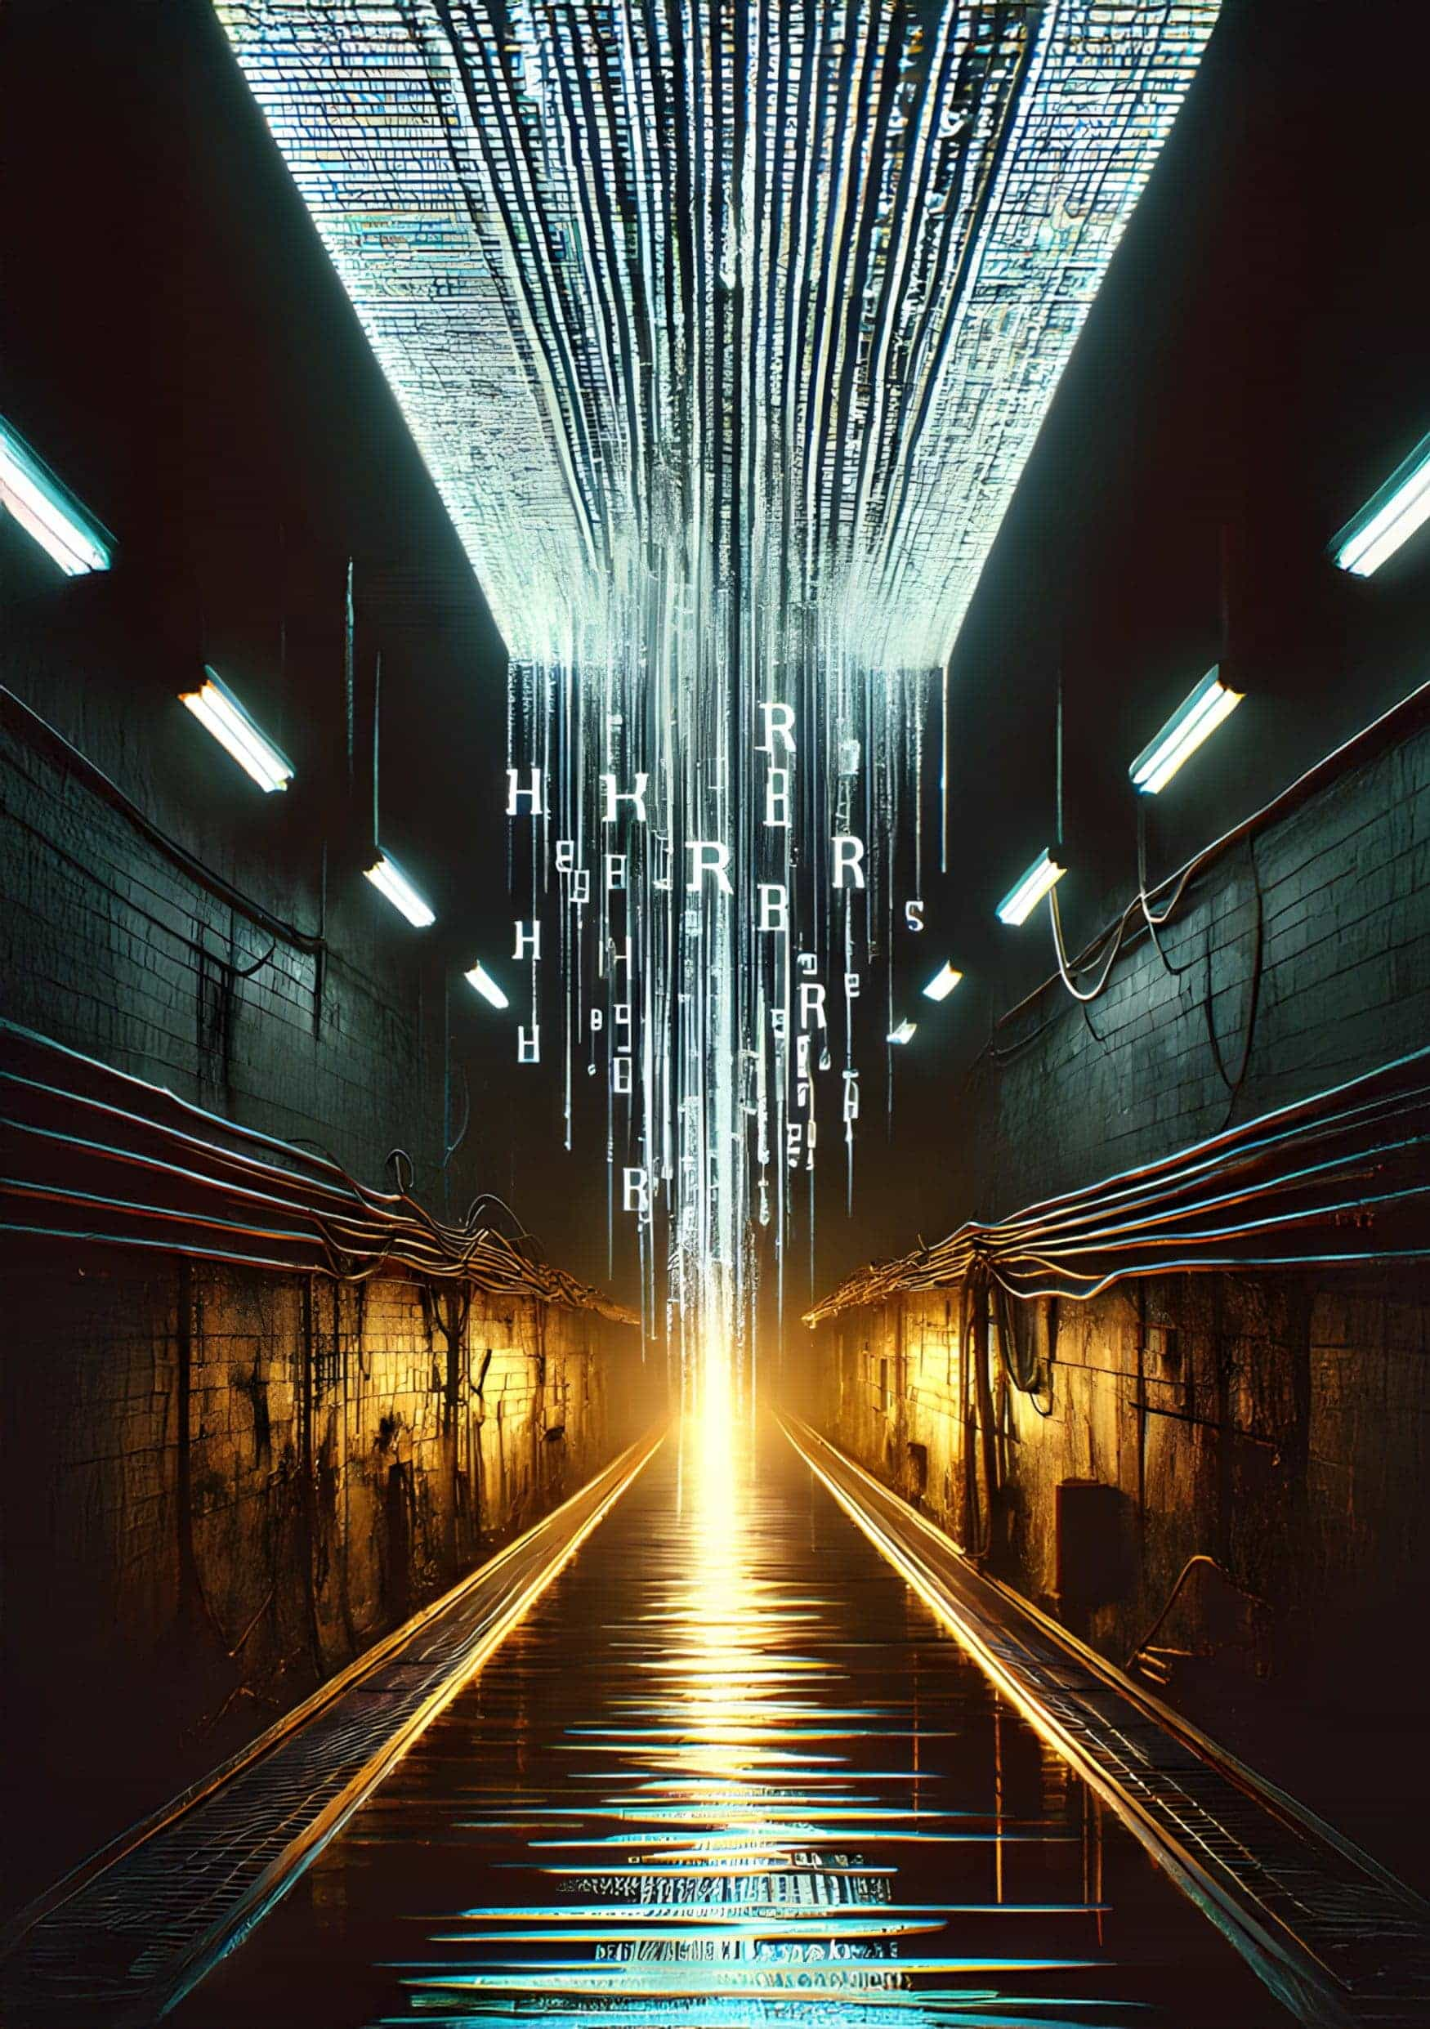

UNDERWORLD

by *Max Hillebrand*

Fabian Sixsmith leaned closer to the screen. A couple of white pixels fizzed through the frame, and the hairs on his arm prickled. It had to be her. The blonde. Underworld’s most wanted — T1n4Red.

It was nearing daybreak in Lewistown, Montana. The end of yet another 14-hour shift at the DoS facility. Pulling fourteens was tough on his body, but it reduced the time it would take for Fabian to gain promotion to agent. Working at the Department of Surveillance came with the serious drawback of being labeled a snoop, but agents could be free — solid pension credits and private property. But today, he would not slink back to his closet-sized studio for buttered noodles and two hours on the velobike. Today would be the day he proved his work was responsible for locating T1n4Red. Her crimes were manifold; her methods were meticulous. Operating encrypted communication networks and thousands of transaction joins to obfuscate Underworld finances. Fabian flipped the plastic cover of the alarm on his console and pressed the button.

Agent Williams appeared behind him in seconds. The babble of voice commands in the CCTV facility cut to zero. ‘Situation update, Operative Sixsmith.’

Liquidating the bad guys had been the dream ever since his father lost his college fund to a hacker. Cypherpunks came in all guises, and some could phish credits from careless Boston drunks and cover their tracks with encryption. Fabian opened the dossier on his desk. ‘Tier 1 target located. DNA confirmation requested from ground team.’ He was certain. So many nights following encoded messages he found hidden data in images on the public comms ledger. Many were drop sites for the scumbags who delivered supplies to the Underworld in exchange for bitcoin — the only money the government couldn’t meter out and strip away automatically. That pixel of white had to be her blonde hair vanishing, once again, underground.

‘Enhance the facial image,’ said Williams.

There was no clear image to enhance. Fabian would have some explaining to do if he was wrong. Except he couldn’t be wrong. Those pixels had been his life for the last ten months. Finally, he had trapped her. Straightening his glasses, he prepared his reply. ‘I can bring up the drop locations from the LSB ima—’

‘Operative. What is the protocol required to initiate a Tier 1 alert?’

Fabian could feel the heat of his boss’s glare. ‘Agent, there is insufficient facial recognition data, but if you give me a minute…’ He had captured dozens of steganographical messages — locations, account numbers, usernames. Hiding messages in plain sight was apparently how cypherpunks avoided detection with such ease.

Williams was already patching through to the ground team on his Neurocomms link. ‘What’s your ETA on the location?’ He furrowed his brow. ‘Copy that... proceed.’ Turning towards Fabian, he snapped his fingers. ‘My office. Now.’

According to Fabian’s calculations, the ground team would report back with the DNA scan in three to four minutes. When they got a match, she’d be toast. T1n4Red would be underground forever; if she resurfaced, the dronecopters would gun her down in minutes. He just had to stall Williams until the confirmation came through. That might be the only way to avoid his first ever sanction. Having a blemish on record would set his lifeplan back by several months. He thought about requesting a comfort break on the system, but Williams would deny it. Fabian stood up purposefully. He arranged the chair and a few items on the desk, then dragged his feet all the way to the office.

Each agent in the DoS facility had an area of control around the size of a football field. Their 12’ by 12’ office comprised the only enclosed space and was positioned in the middle of rows upon rows of desks. Four walls of two-way mirrored glass formed the raised office cube — a mini panopticon within the greater panopticon of DoS. The agent sat in the swivel chair and swung his feet onto the desk. ‘You better be right about this, Sixsmith, or you’re done here.’

Fabian’s heart beat like a heavy bass kick. The perfectly calibrated 67-degree air didn’t stop him from wanting to loosen his tie. When he jammed his fingers down the small gap between his neck and collar, they came out slick with sweat. All those nights chasing. The tabulations, the data models, the transcripts from Underworld detainees, the ciphers he’d decoded — they all seemed like a game. A dream. He was the grizzled sheriff finally placing the noose around the neck of the uncatchable outlaw. He knew that in sixty seconds or so, the ground team would confirm a DNA match, and it would be impossible for T1n4Red to resurface without physical liquidation. ‘I’m sure, sir. This was the only way. We’d never get a facial match on a Tier 1.’

The agent looked at the communicator on his desk. Nothing.

Did T1n4Red eat buttered noodles and work out in her underground living closet? Did she crave for the feel of a paperback novel, or perhaps own a non-cataloged copy? It’s not like she could step foot inside the state knowledge center. ‘What action will DoS—’

*Ground Unit Bravo to Williams. Do you copy?*

‘This is Williams. Over.’

Bravo commander confirmed the DNA match. It was her. She would now be classified a subverter. The payment instructions she had etched into the self-repair polymer bench had been photographed. Any wallet receiving those coins would be investigated. The fintech arm would already be working on liquidating affiliated Overworld accounts. One wrong turn and they can shut down your life’s wealth.

But T1n4Red was smarter. DoS would always be one step behind the cypherpunks because they were bound by government protocol, unable to infiltrate the Level 3 realm of encrypted private comms. Fabian had to take risks. What use was all his dedication if it just led to being remaining on the outside of a panopticon looking in?

‘You can leave.’ Williams motioned to the office door. ‘Your shift was over sixteen minutes ago.’

◆◆◆

The State Knowledge Center smelled of the past. That’s what Fabian liked about it. He turned the page, savoring the quality feel of thick paper, imagining that when this book ran through enough hands, the inked fibers would run from black to gray to cream-white and the story would be gone. These were some of the only off Ledger items left in the country.

Wild Country Outlaws was Fabian’s sanctuary from the pressures of his job. All fiction was based on the kind of truth that needed to survive. Back to the times when eyes touched words without being digitally tracked, when citizens could own things. He read a paragraph and closed his eyes to imagine how life was back then. The cavernous knowledge center, with its hard seats and CCTV lenses transformed into lush plains and steep hills. Fabian felt the warm breeze on his face and the muscles of the horse beneath him. The two rifles slung on his back would shoot those boys dead. No one would take his property. His wife, children, his lame brother, hell, the whole damned village of Lewistown depended on his cattle to provide.

Of course, land could only be leased now. Livestock too. Those rustlers would have a hard time taking anything without public subscription fees and pre-taxed profits coming out. And if they wanted, the Department of Property could rescind custody of any item and confiscate it. Fabian’s smart-band vibrated, indicating he had just ten minutes of reading time left. The thing buzzed too hard. It pinched, but like all sanctioned hardware, it was government hard-coded.

He hadn’t been able to focus this time. Not really. Was T1n4Red an outlaw or a rancher? Either way, she was fighting the system that had stripped Americans of their right to call their house a home. According to the Department of Education, pre-ledger days were violent wealth-disparity wars, but the novels Fabian read painted a different picture — a fantasy freedom where ordinary citizens could build wealth.

Fabian rose to go. He handed the book to the desk girl and watched her scan it into the system. His smart-band buzzed again with a compliance point. To think his friends chased these stupid tokens for avatar upgrades and paid-time-off options. But, without them, he might end up with his ID frozen like his high school buddy, Scott, cut off from all legal avenues to earn a living and watched like a hawk by DoS. Did he have a secret stash of satoshis that kept him clear of the state debtors’ facility?

The lady at the desk smiled. Her brown bob remained undisturbed by the air cooling system. ‘We hope you enjoyed your trip into our analog archives, Fabian.’

‘Sure. See you next time, Miranda.’ He breezed out. They had history, but it wasn’t something he was interested in repeating. Imagine the conversations about cataloging systems and the internal squabbles of the Knowledge Center board. Fabian was already in a committed relationship with the powers of his imagination. Explicit videos were far too risky for a DoS worker to use, but the image of T1n4Red’s full lips and blond hair invaded his dreams. They could run a ranch together, or maybe they’d be cattle rustlers on the run. He wasn’t sure why, but every night, Fabian masturbated to the one rendered CGI model of T1n4Red they had on file. On the outside, his life was the ultimate mundanity, but the thrill of T1n4Red, the taste of the air on the great ranches outside the city, the sheer danger of even thinking all this, was the only way he could sleep.

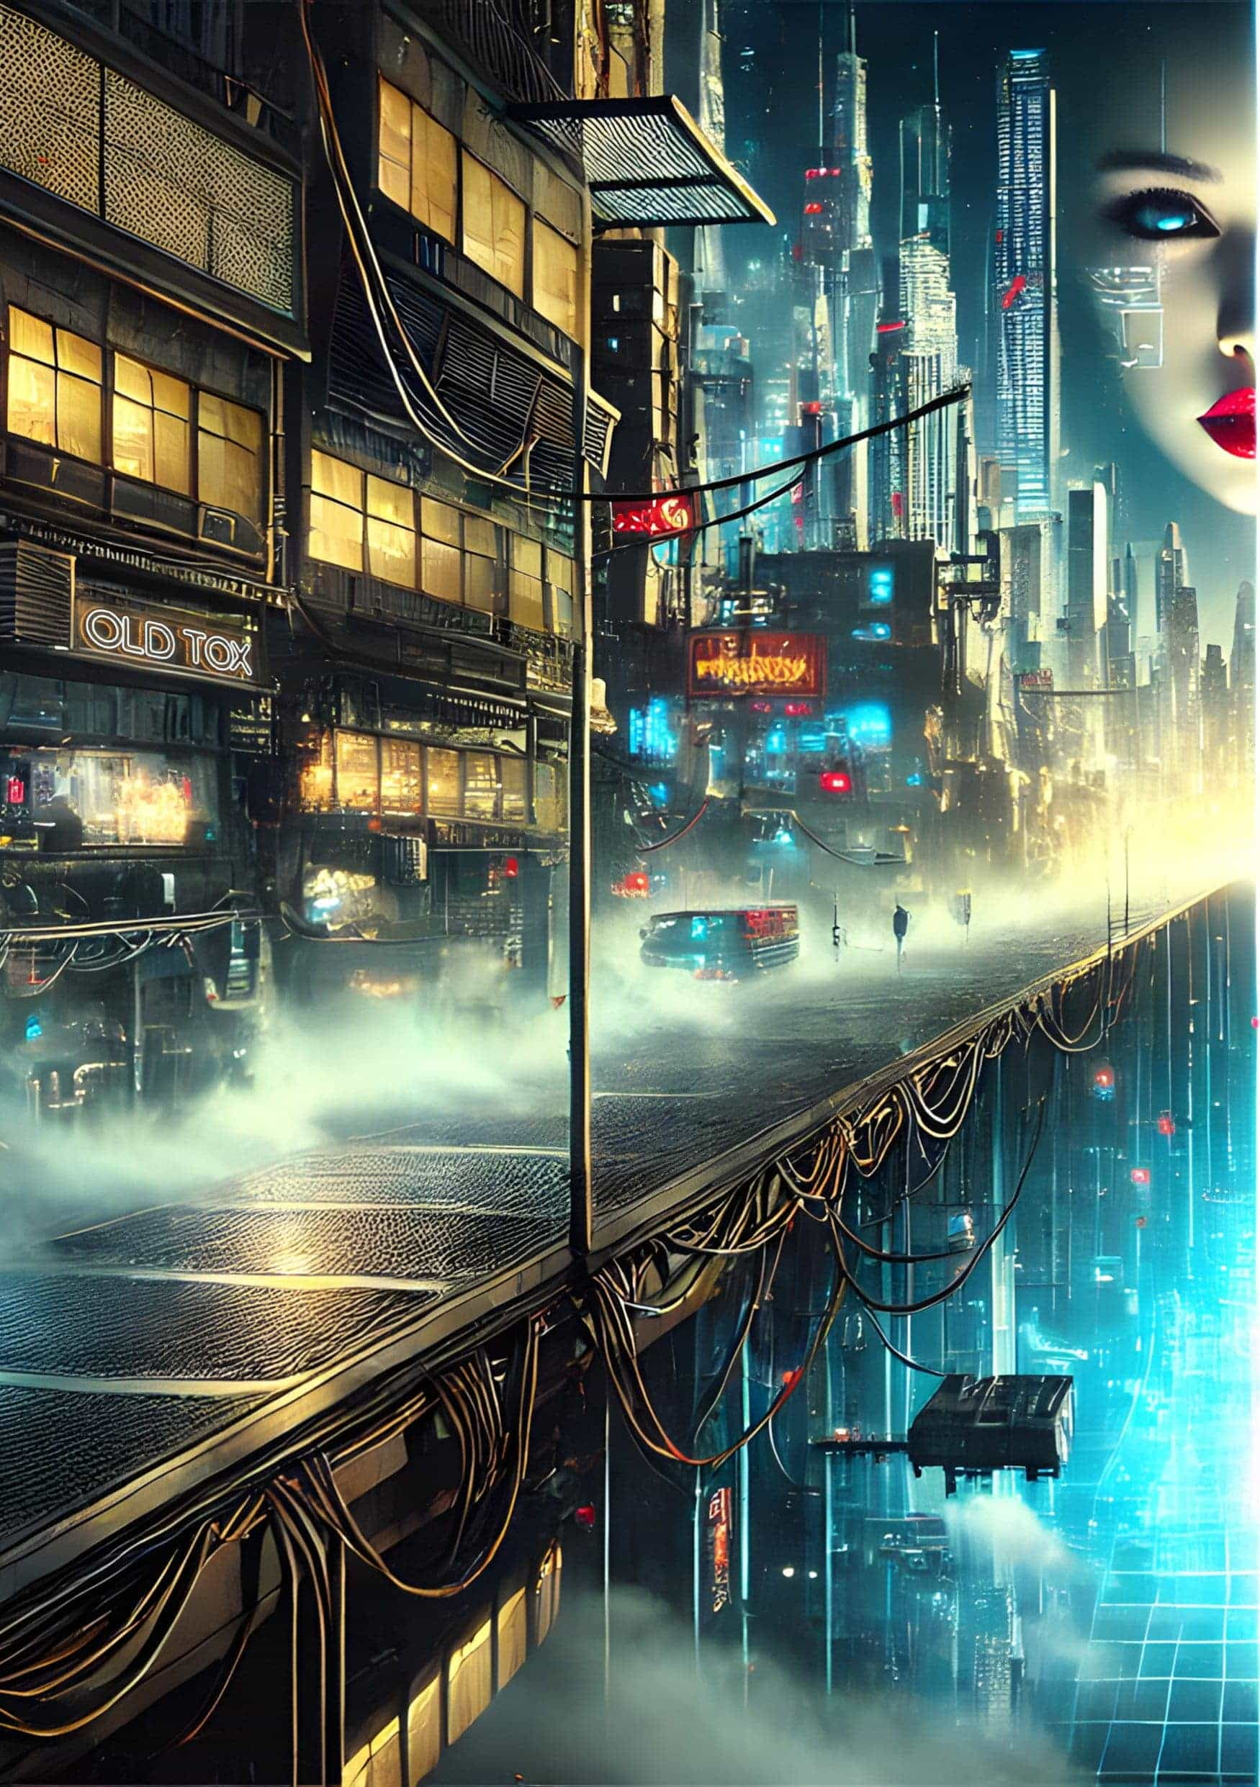

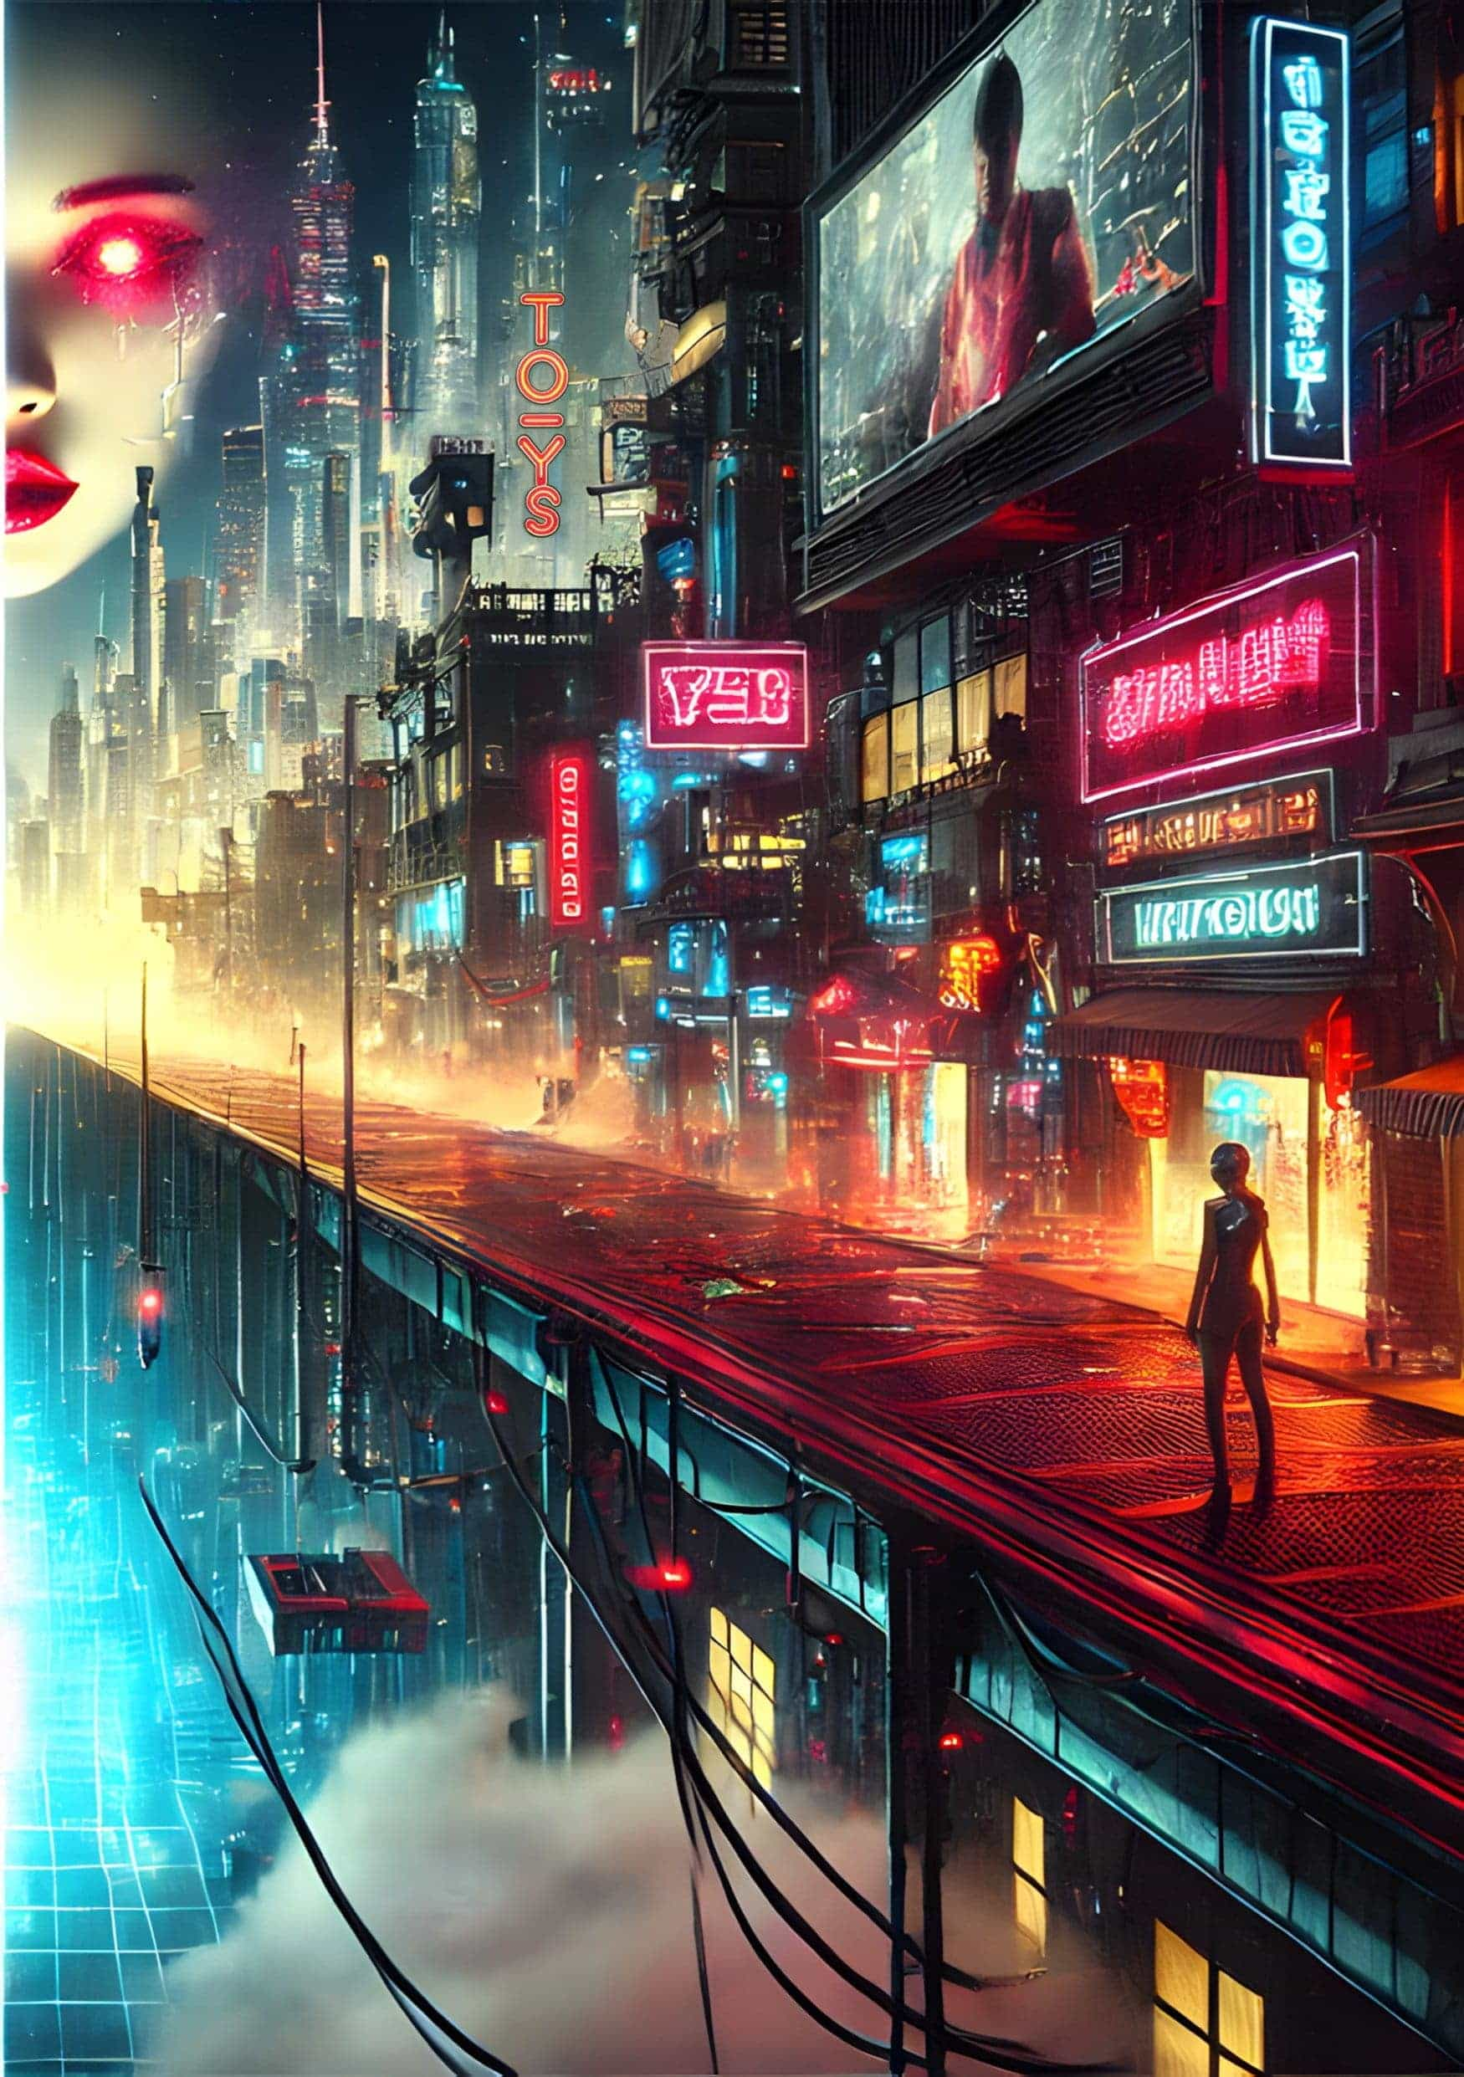

They watched the pollination drone flit between the hibiscus flowers in the thick air of the botanical biodome. Fabian had been lucky to receive two of the limited daily visitor passes. It was even luckier for Scott, who now had the chance to get out of his mom’s dingy basement for a few hours.

‘You know why they made them bigger than bees, right?’ Scott spoke out of the side of his mouth. When Fabian shrugged, he leant in to inspect the device hovering around eye level. He blew a kiss and waved at its pollen-collector end.

‘You don’t know that.’

Scott turned and swept his lank hair off his forehead. ‘You’re the one who checks the footage, snoop.’

Micro cameras were yet another panopticon in the armory of the State. You had to assume, even when lying in bed with a lover, even when going to the toilet, that it was possible you were recorded, watched, and analyzed even years later. Secrecy was a virus DoS sought to eradicate. The biosphere wristband on Fabian’s right arm sounded. Closing time was fast approaching. Fabian put a hand on Scott’s shoulder. ‘You know, there was a time when access to nature wasn’t so strictly controlled.’ He stopped himself from saying more.

Glancing left then right, Fabian made a decision. It was a decision to offer information to a friend, a true friend who had no reason to stick by him when all others cut ties. Sharing a secret in the meatspace was the biggest risk Fabian had taken in years, but he had no way to do it digitally.

‘I was behind it.’ He expelled a sigh.

Scott turned his head. They carried on walking towards the exit in the throng of people. A few seconds passed.

Fabian scratched at the mole above his eye. ‘Spent months unraveling stego messages. I feel like I know her. Like really know her.’ Was he saying this out of pride or trepidation? Even if they ended in constrained mediocrity, lifeplans were so beautifully simple. Tina, Williams, the ranch, avenging his father’s bankruptcy, the forums, the caution, it all seemed so jumbled. ‘Maybe I’m in love.’ What was Fabian saying? However long T1n4Red lasted underground, she’d never be able to surface again.

Scott bumped Fabian by stepping across his path. ‘Not in the meatspace. Keep checking the images. There’s a lot more hiding in plain sight than you know.’

They walked in silence through the automated exit gate into the gray city air. As they departed, Scott turned back and called out, ‘Right pocket.’

Sure enough, Fabian felt the weight of a ‘brick’. He had held one of the untethered devices once in DoS training. Without even putting his hand into his pocket he knew that it was there and what it meant. Decentralized forum instructions would be written on an attached note. The code would be something only he and Scott knew. T14nRed and the entire underworld were now at his fingertips.

◆◆◆

23:43 - untethered alert.

Invitation to join Level 2 CP mixnet.

Confirmation Key: M0ntann4Sc0ttySn00ps2031

Fabian lay back in his single bed. He followed the personalized invite link Scott had generated. It must have been strange, he thought, when space was not at a premium, when people went for a walk to escape, rather than lie on their bunk and plug themselves into a metaverse or L2 world. The Ledger made everything easy, an all-in-one software system for citizens so dialed in to their lifeplans, they didn’t have a second to spare. That’s how it had seized control of the nation.

The forum loaded and he found his welcome message from Scott.

Relay from T1n4Red:

It is never too late to use the powers of surveillance for good, Operative Sixsmith. Underworld 4gives but the ledger does not 4get.

In the darkness of his cabin, his face bathed in blue light, Fabian sat bolt upright. His head broke the plane of the holoscreen and a tinge of current trickled through his temple. She knew who he was; she knew what he had done. A charge pulsed through him, the thrill of true privacy. How had he been duped into thinking a total lack of encryption guaranteed freedom and not a glass cage?

The holoscreen flickered for a second. A multimedia message.

Level 2s were a gray area, not illegal. Messages could be relayed peer to peer along a mixnet to the end user. With personalized links hidden in messages on the public comms ledger, communities could be discerning about who joined.

When Fabian leaned back into a lying position, he was greeted by a 3D render of the woman he’d been chasing for over a year. His eyes drank in the red-lipped smile and blonde hair of the woman he’d forced underground, never to feel the rays of the Montana sun again. She held a piece of paper up to the camera, but Fabian couldn’t tear his eyes from her piercing gaze. 64k cameras could pick up the tiniest imperfection. She looked even more real than if he saw her in the flesh. The piece of paper she held was another invite code — this time to an L3 channel.

Fabian exhaled. Breathe. He ran his finger over the chain of three tiny moles above his right eyebrow as if checking they were still there. There were agents who’d been on the force for decades without penetrating Level 3. All messages were stored on the Ledger — that couldn’t be avoided. But with all the red herrings and strong encryption, it was impossible for even the most powerful computers at DoS to uncover much about the members of Underworld’s inner circle. Fabian’s hand reached for his untethered brick. He entered the address from the 3D render of Tina’s paper, followed by the 24-character code from the paper on the outside of the brick. He was in. His next shift at DoS started in ten hours, but he knew he wouldn’t sleep much before then. Tina, and the Underworld answers he’d been seeking awaited on the L3 forum. Fabian made his way to the bathroom and rooted out an old lighter from the medicine cabinet. Staring back from the mirror was his reflection; perhaps it was an avatar of him bound for the Underworld while he remained in the meatspace with his tiny closet apartment and faltering lifeplan. They both watched the password on the paper note burn.

◆◆◆

The hubbub of DoS Sector 4A quietened as Fabian walked down the corridor. The hum of hundreds of microcameras was imperceptible to human ears. The one place without them was the toilets — a DoS employee committee had made sure of that — and that is where Fabian’s untethered communicator brick lay. Even if it was found on a bug sweep, they couldn’t trace it to him. And he had ten minutes every two hours to get to the bathroom and check in.

At first she’d been cautious, wanting to know if Fabian would follow her precise instruction. Then, information from Tina had came fast and furious. Names, transactions, locations, protocol, so much information. The tips she’d provided checked out. In fact, they were all just about low-level enough that it was believable that Fabian’s data-driven detective work had unearthed them. She’d even provided a methodology to show which macros and filters he could use to locate L2 peddlers and fixers.

He removed the floor tile behind the toilet bowl. This never got less gross. After relieving himself and pulling the flush chain, he attached the remote charge pack and switched it on. No battery, no trace signal.

11:03 - Message waiting:

6Smith, something important is about to happen. Act surprised.

After confirmation, we must meet in person. It will not be easy to get you here. Instructions will follow.

Fabian heard the toilet door open. Could DoS be employing physical spies without the use of cameras in the bathrooms?

The sound of a belt buckle. Charcoal-gray trousers descended and appeared on top of brown loafers through the little gap under the cubicle wall. The heavy-set man dumped himself onto the john and exhaled.

After he deleted the message, Fabian switched off the phone and wiped the power back into his remote charger. He scrubbed his prints off the brick and replaced it behind the bowl. Another flush and he was gone. Out the door before charcoal trousers could physically tie him to the brick. If he was snooping, they would know. He’d get questions about using an unsanctioned jailbroken device. Maybe he could claim he was trying to arrange a physical meeting with T1n4Red. Still, the interrogation would be brutal.

Back on the floor, Agent Williams activated a meeting alert on Fabian’s desk. The red light informed him he must report to the cube immediately. It took great restraint for Fabian to avoid any nervous ticks. Especially with the scrutiny of operatives at his level, he couldn’t avoid a single nervous exploration of the moles on his temple or wiping of hands on trousers. The electronic band every citizen had clamped around their right wrist fed streams of bio-data to the DoS servers. Who would be alerted if his heartbeat spiked or breathing patterns changed? As he’d learned on the L2 forums, flying under the radar took a lot more than digital restraint. The surveillance apparatus of the state kept so much biometric data it had become a living cyborg. Could this be about the bathroom break? The guy in the next stall with the charcoal trousers? The brick? Was this the start of a downfall that ended in the same invisible blacklist Scott was on? Maybe that chick in the library had something against him too.

The glass door slid open and Fabian moved through the entry point in one clean step.

‘No need to sit, Operative Sixsmith. Let’s stay on our feet here.’

Sixsmith awaited the news. Whatever it was, at least it would be quick.

Williams raised a stainless steel travel mug to his lips and drank. If the coffee was hot, he showed no signs of it. ‘I must admit, I’ve had my doubts about you.’ An ominous start. ‘Up until this year, your work was adequate.’ Williams paced towards the glass wall to watch the goings on of the morning-shift operators. His invisible stare could put someone’s back out. ‘And that stunt you pulled to get the jump on T1n4Red… some stricter agents might have filed that as a denial-of-protocol infraction.’

Fabian locked his gaze to the coffee cup and let him talk.

‘But since then, your results have been quite something. An 89% strike rate on intel and twelve L2 agitators liquidated. That’s as high as I’ve seen.’

‘Thank you, sir.’ Fabian rearranged his cotton shirt, which, despite the blasting air con, was stuck firmly to his back.

‘Good news.’ Agent Williams went to his desk drawer and removed a six-inch blade. The silver tip matched the glint of William’s graying hair under the strip light. ‘You are no longer an operative here at the Department of Surveillance.’

Fabian imagined the angle of attack. A diagonal slashing motion from up high. He wouldn’t have time to avoid the agent’s quick reflexes.

‘Congratulations, Agent Sixsmith.’

Fabian took a step back. His right hand found its way to his brow. ‘What?’

‘You’ve been promoted, son. It can’t be that much of a surprise.’

Fabian had spent so long tracking certainties, he had forgotten what surprise felt like. He had his doubts about the system, his L3 secrets, his upcoming liaison with T1n4Red, his friendship with Scott. But things would be better as an agent. His family back in Boston would surely offer some begrudging respect. If he wasn’t six feet under, his old man might feel some kind of peace knowing his boy had won back those credits. Freedom from bio-data collection and freedom to roam. He faced his boss. ‘But I’m not up for review until—’

‘Take the win.’ Williams approached, knife in hand. ‘We need all the capable agents we can get.’ He reached for Fabian’s right forearm. His grip was that of a much bigger man. ‘Effective immediately, you are Agent Sixsmith of the Department of Surveillance.’ He slid the knife under Fabian’s communicator wristband and sliced through the strap.

The cool office air touched his now naked wrist. Fabian smoothed the skin as if he had been unshackled.

Once Williams returned the knife to its drawer, he offered his hand to shake.

‘Congratulations, Agent. Full briefing tomorrow at 0930.’

‘Yes sir. Thank you for your trust.’ He turned to go.

‘Stop,’ a sharp voice called. Williams held a small piece of metal between thumb and forefinger. ‘Don’t forget this.’

Agent Fabian Sixsmith accepted the gift — an American flag pin. He nodded and stepped through the doorway in the same way he entered.

◆◆◆

Fabian zipped his thick hoodie and stepped out into the night. The reflectors in the fabric would dazzle the night vision of the cameras, and the Federal Government hadn’t passed any laws telling people how to dress… yet. He opened the door and set out to meet his handler.

He started his run towards the city outskirts, the hood shrouding his adrenaline-shot eyes. The back of his skull throbbed. It had been bothering him all afternoon. Throwing in a few boxing moves for good measure, Fabian pounded out the miles. One, two, past the city limits and onto the shoulder of the 87, the sixteen-wheeler auto rigs ripping past. The drones would be following — of that he was sure.

His handler was there. Just like Tina said. Half a mile after the first junction, under the bridge, Scott straddled his solarbike. This must be how he earned his sats — acting as a go between for Underworld agents who had gone to ground.

No words, just the exchange. Fabian unzipped the hoodie and draped it over his friend’s shoulders. Scott removed a 3D image scanner from his pocket and ran it over Fabian’s face. Two seconds and the ID confirmation would be relayed on the Ledger, probably embedded with a stego message. A quick clap of the hands, and he drove into the night. Forty, fifty, sixty, and gone, west towards Great Falls. Fabian took a breath. Is this what he had done all those reps in the closet for? He scrambled up the bank and jumped for the bridge railing. Hauling his body up and over in one swift motion. Then, crouching low behind the advertising hoarding, he duck-walked over the bridge and down the bank. How would he disable the micro cameras? Even without tracking data, the DoS apparatus wouldn’t be far behind — especially after they scrambled a drone to intercept Scott. Thirty seconds tops.

This place, just a few miles away from Lewistown, was the setting for one of those books he loved — cowboys, sheriffs, and theft. Of course, the subterfuge of Level 3 protocol and 256-bit encryption was a little more complicated now. The idea of coding messages is as old as civilization, only the attack vectors changed over time.

Left. Right. Feet smacking dirt. Fabian had to trust the track was level. He could barely see three feet in front of him — only the dim Montana moonlight for company. The whirr of a camcopter approached overhead. If it locked his thermal image, he was toast. Just a few more strides surely. His lungs burned after all those miles.

DoS wasn’t just going to let a newly-minted agent go for a mysterious wilderness night run.

His foot jammed against a root. He stumbled on, narrowly avoiding a painful fall.

‘IDENTIFY ORDER.’ The camcopter had locked the human gait recognition. ‘FAILURE TO COMPLY EVOKES FEDERAL CREDIT ELIMINATION.’

Fabian almost laughed. These fucking things threatening to zero-out people’s hard-earned savings. How the hell had Americans let things go this far? He spotted the manhole cover under the tree. His lungs sucked in the night air, and his heart tore at his ribs.

Wham. Down to the ground. The force of a truck pinned Fabian and pushed his face into the dirt. ‘No,’ he cried. ‘Let me explain.’ Searing pain pulsed through his skull from the back to the front. In the seconds that followed, it was as if his brain was rebooting. Who was this? What were they doing?

‘Neural tracer deactivated,’ said the voice of the brute on top of him.

Fabian managed to turn his head. He caught a glimpse of the man, but it was too dark to see his face. The pressure on Fabian’s back slowly released. He shook the cobwebs out of his head.

As Fabian stood, he saw the guard moving away, pointing his EMP caster at the sky, sweeping left then right.

Crash. One dronecopter downed. A crash to the right, another drone gone. These things would be disposed of in some pit or quarry. The figure collected the drones and moved into the night.

Fabian dusted himself off and walked towards his destination of the irrigation pipe system. As Agent Sixsmith hauled the steel grate to the side, he took a breath. This was it. Too late to deny involvement. Too far down the rabbit hole. He’d have to give up everything he worked for — respect at Thanksgiving and a pension large enough to retire to a ranch and ride a horse over the land. In exchange, he’d get a one-time Underworld trip, where he would learn the methods and tactics the punks used to stay off grid.

Now it was quiet, bar the low hum of the highway and the sound of his rasping breath. He’d never been this alive. It sure beat the meticulous protocol of DoS. Before he could stop himself, Fabian was inside, his hands replacing the grate, gripping the ladder, his feet on the rungs, stepping down, down into the dark. Whatever she had to tell him, he needed to hear it. Meeting T1n4Red in the meatspace trumped any handshake from Agent Williams, any pension plan, and any begrudging respect from his nagging mother and fucked-up family. He descended to the Underworld.

At the end of the dank tunnel, Fabian saw the purple glow of UV light. He approached slowly. The sound of soft footsteps approached from behind. He didn’t dare turn. Then, a few paces from the curve where the light grew stronger, a flat plastic object jammed the base of his skull forward. Click. Probably a 3D-printed gun.

‘Arms out. Legs astride.’

Fabian complied. The EM scan wouldn’t find anything. He was stripped of all tech — one of the many firsts he’d experienced that day. It was safer for all parties if he didn’t turn around.

The voice barked, ‘Clear,’ and a rough hand pushed him forward. The footsteps descended back towards the tunnel opening.

Peering into the mirror positioned at the tunnel corner, Fabian caught a glimpse of the woman he came to see. The channel between well-defined back muscles drew his eye south. How long had it been since he felt the touch of a woman? How did she stay in such good shape down here? The weak UV light faded to a soft yellow glow in the chamber.

‘Agent Sixsmith. We’ve been expecting you.’ Tina pulled a t-shirt over her bra and cinched her blonde hair into a top bun. She laughed. ‘Take a seat.’

‘How do you know I’m an agent?’ Fabian sat on the plastic chair closest to him. The room had been widened from its original layout. It was now around fifteen feet square with a camp bed, a desk with double monitors, and a treadmill. His eyes settled on the black desktop compu-box.

She touched his arm, her hand surprisingly warm. ‘I bet you’d love to open that up and take a look.’

Fabian had never seen a homemade device connected up. Getting the parts must have taken years, but nobody could detect unregistered tech through lead linings and all the perimeter protocal. She truly owned something, even if it was just a little black box.

‘You didn’t think agents are unsurveilled, did you? Poor boy.’

Fabian’s mind switched to rational mode. Was he burned? Would he ever be able to surface without getting financially or physically liquidated?

‘Relax. I know what you’re thinking. This is your first trip here, but it won’t be your last. We fried your tracer chip and they can’t admit they implanted ‘cause it ain’t legal.’ She swiveled the computer chair and sat on it back to front. The high chair back almost came up to her chin. ‘You get one question. Shoot.’

In their digital conversation, Tina had always been careful to give instructions only, never responding to Fabian’s questions. He might have a lot to learn, but at least he wasn’t living in the dark like her, a trapped soldier unable to look above the parapet. Was he walking into a trap? Was he already in one? If things got tough in the interrogation he was sure to receive from Williams, he could always offer some Underworld secret. Fabian turned to face the shadow of a woman he had chased for nearly a year. ‘Where are the Level 3 relay servers kept?’

‘Ooh amor, you’ve gotta think bigger than that.’ Tina Red was more than just a celebrity crush. Her blue eyes burned with the intensity of a neutron star. Her slender legs wrapped around the chair like a boa constrictor drawing in its prey. She drew closer, and he could smell the sweat. ‘There are no dedicated L3 relay servers. We’ve been using a hacked DoS server for months. Keeps you searching for that mythical Underworld data center, right?’

There were so many units in the DoS server cities that it would take years to isolate the hack. Smart. ‘What’s the end goal to all of this?’ he asked.

Instead of replying, Tina shook her head.

Play by Underworld rules, Fabian. It didn’t matter — he knew. Reversing the grip of the big-government machine was virtually impossible, but the dream was that the country returned to ‘the land of the free.’ Freedom to secrecy. Freedom to own. Freedom to transact with whomever you wanted.

Fabian watched as T1n4Red stood and crossed the six-foot gap between them. She leant over and moved a hand to the back of his hair, gripping his short black hair in her fist. The same fear pulsed through him as in the meeting he’d had with Agent Williams — the same Williams who was organizing the search and interrogate protocol for him at that very moment. Was her bodyguard waiting around the corner with the 3D-printed gun, primed to deliver its one shot straight into his brain?

‘This is our endgame.’ Their faces were inches apart. He saw the same freckles and imperfections in her skin as in the high-res digital render. But there was nothing like real life.

And then, a swell of the tide inside him. Euphoria. The kiss was deep. Their lips fused, one person, one dream. Fabian’s hands reached for the shape of the woman he’d dreamed about so many nights. She sat, straddling his legs and they went on. Blood rising like an ocean swell, Fabian dived into bliss. It all melted away — the dronecopters hovering above, the awkward entry to the office tomorrow, the nagging fear that his accounts would be zeroed out in mere hours. But one image remained. The moment transported Fabian to his spiritual home — the wilds of the Montana hills, the wind blowing through the grassland, the mountain range guarding the horizon. The wild country that called him.

When they finally broke the kiss, Tina stood. ‘Did you feel it?’

Fabian raised his gaze. ‘I think so. A place. The wild—’

She raised a finger to silence him. ‘Don’t say it. This is our secret, Agent Sixsmith.’

He thought for a second. Project Wild Country. It was strange, but he had no doubt. The phrase was branded into his mind clearer than the passphrase he had to memorize for his DoS access. How could two beings communicate telepathically?

‘It’s called ‘Telepathic Key Exchange’. TKX for short.’ Tina approached and whispered into his ear. ‘From the mentalists of the late 20th Century.’ It had been there all along — a method to eliminate the gap where biological beings had to enter a passphrase physically. This was only part of the information chain without a cipher. No more worries about the micro cameras that could capture keystrokes or capture pen and ink comms.

‘Our project,’ she breathed.

The image swam through Fabian’s mind once more, the color of the sky as vivid as the eyes of the woman in front of him. The hills and plains in front of them. All protests start with the spark of non-compliance. And all revolution hinges on the man who knows how to play both sides. He’d have to learn more about it, understand it better, but TKX could lay the path to a fully anonymous market, unbreakable smart contracts, and a citizens’ private arbitration court. This would be the rewilding of America.

‘We only have a few more minutes.’ Tina returned to her chair. She explained the comms protocol and that the two of them were the only people on Earth to know the name of this mission. Project Wild Country would bring TKX to the masses.

‘How can we teach people?’

‘We lead people through the levels, just like I got you here. There are more stego images on the Ledger every day. It’s already started.’

Fabian looked at the wrist his bio-band had once gripped. ‘What do I say to DoS to explain this time-gap?’ How long had he even been down there, fifteen minutes?

‘You wouldn’t be much of an agent if you couldn’t think of something. Be the sovereign of yourself, Fabian.’ T1n4Red laughed. ‘Better get running.’

Fabian moved toward the dark tunnel that led to a surface world buzzing with invisible spies. ‘I’ll be thinking of you,’ he said. Fabian thought he detected the hint of a smile on Tina’s lips, and he felt a tiny swell of the euphoria that had filled him moments earlier. Then, he turned to go. Agent Sixsmith rounded the corner and started his journey back to the wild country.

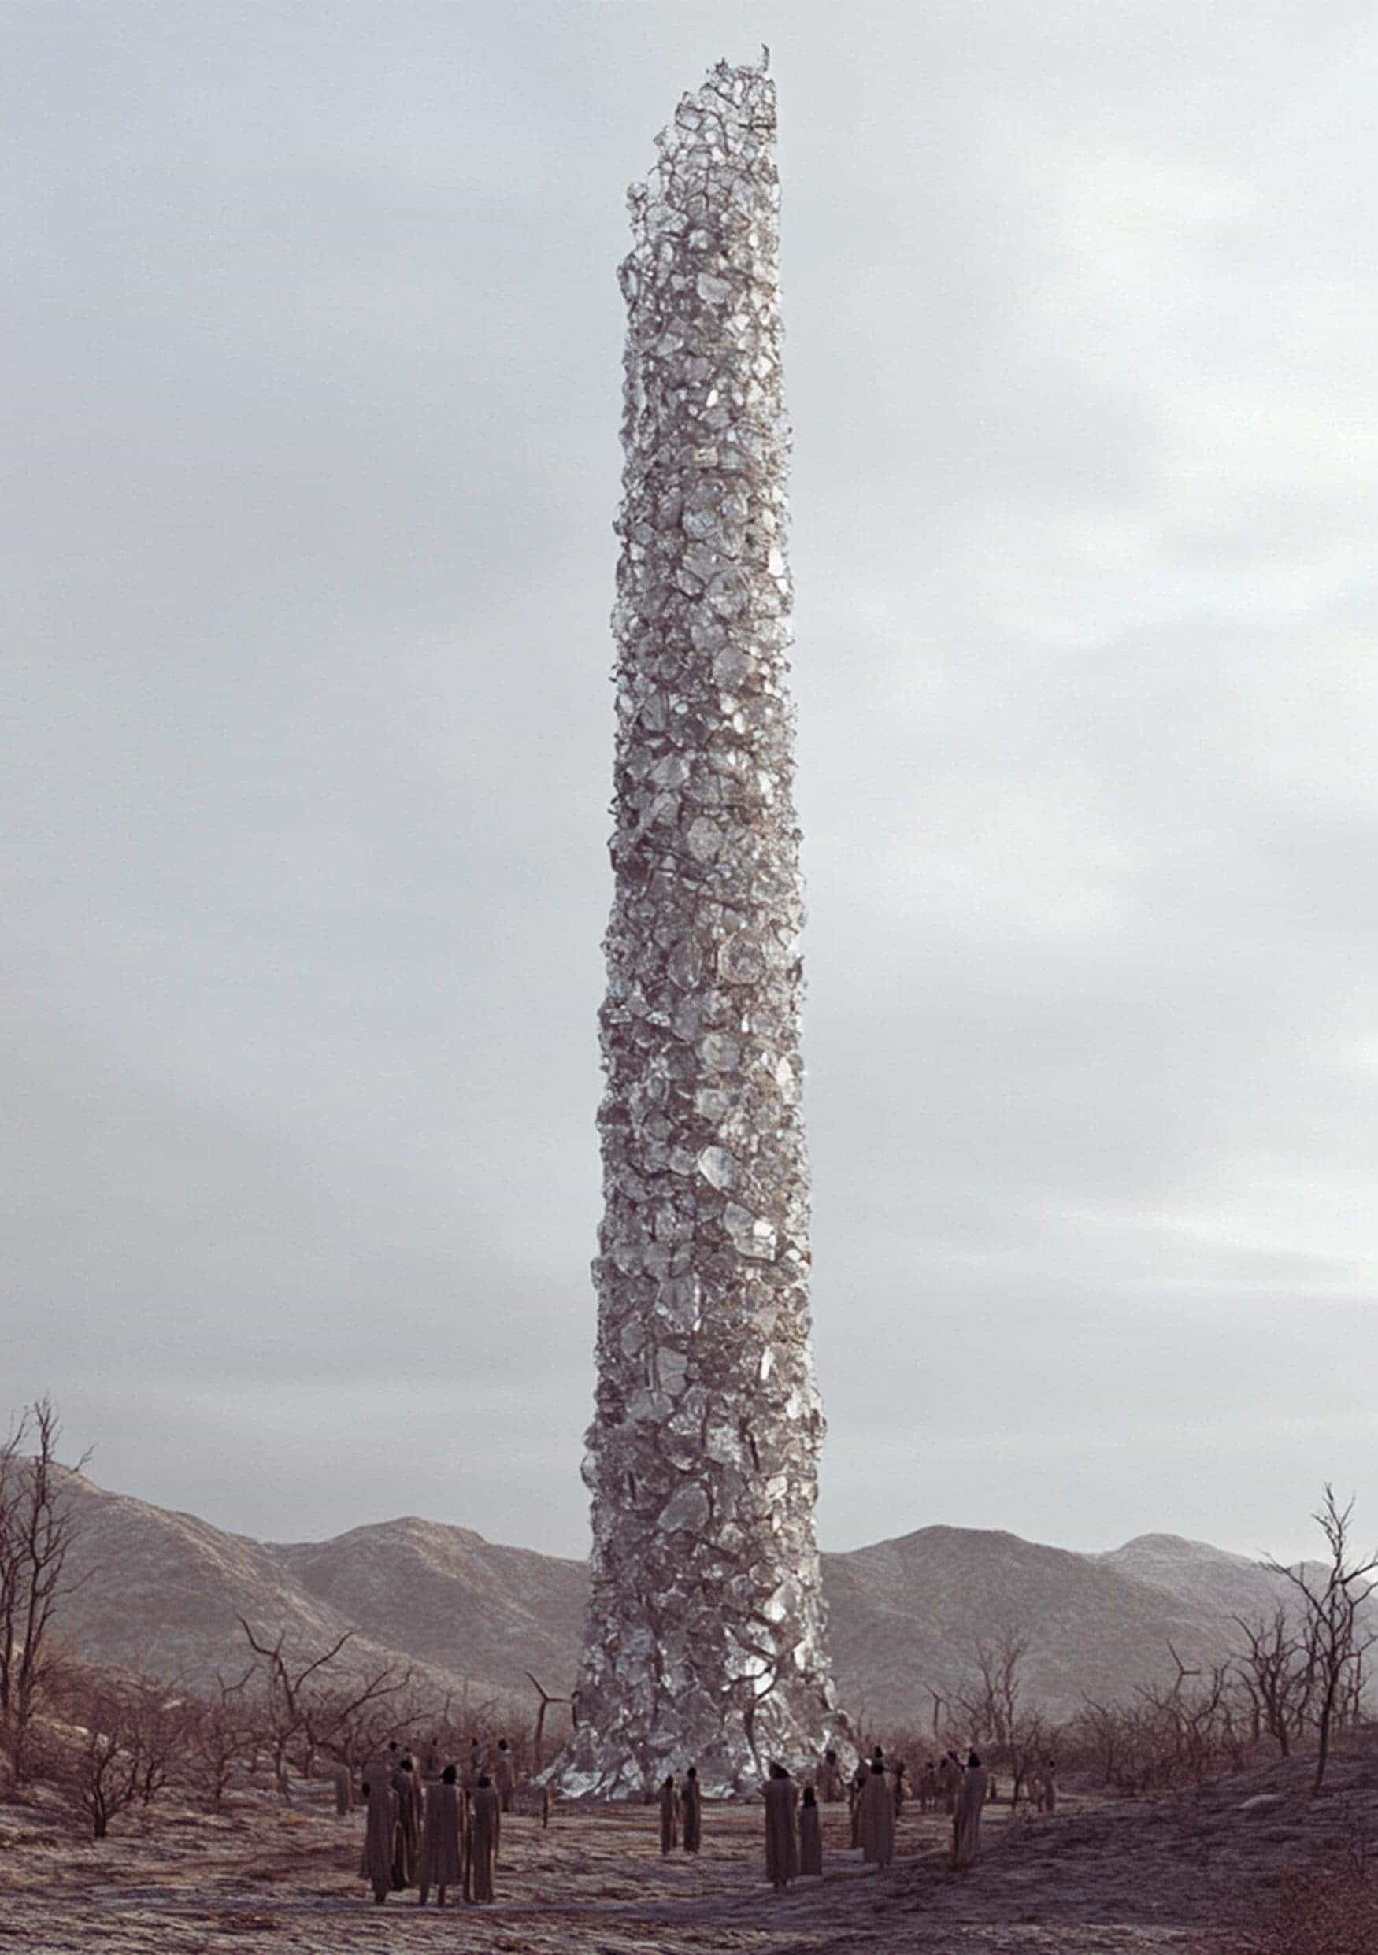

We Are Living Well

by *Anonymous*

I

Bec

A note lay on our front step. On the underside were these words: Come to the garden now.

My hands began to tremble.

Three Seasons Earlier

Frae

The Harvest is done. All our muscles are weak, but we are grateful. My body wants to rest, but I want to see my family smile tonight. Bec has been in the kitchen all day making a meal — the only meal this year where there will be seconds. My brother Til joined our home when his wife shriveled and dried from the freeze last Winter. We will need to be very careful with our seed count to survive until the next Harvest.

A Master Gardener with three names, Parro Altrious Finnto, came from far away and said very good things about all of the pickers. His shiny white robes had no soil stains, not even at his feet. Our Central Gardener, Dallei Shyk, agreed with the Three-Name that we are living well.

Pyn is asleep in the husk piles, exhausted. I will let him sleep more for now. He worked very hard to help bring in the Harvest. I wish he had more time to play.

Bec

Frae is smiling after the Harvest. I am glad. He has too many worried thoughts. I have not counted our seed stores for Winter yet. Perhaps after dinner. Perhaps I do not want to know.

Frae

Dallei Shyk called everyone to the Central Circle this morning. The Harvest had been loaded on wagons and wheeled away. All around us was barren, nothing but brown and gray mud and the skeletons of trees. He said the Harvest was good. He said the Mana seeds will go to the Master Gardeners far away where they will sow and grow more in abundance. They will share that abundance with us.

Quietly to me, Boe said, ‘They say that always. Lump seeds for us this Winter, and not many of those.’

‘We are living well!’ Dallei Shyk shouted.

Pyn

I forgot to cover the seed stores last night. The seeds are now covered in frozen water. They are all dead and I think we are all going to starve. I am so sad.

Pyn

My father found me hiding in the bark piles. He lifted me up and squeezed me hard and told me the seeds were ok. He said only the top seeds died. He said I am better than Mana seeds and squeezed me again with his whole arms.

Frae

We have only lump seeds for the Winter, and we have much less than last Winter because of a fresh tax from the Central Gardeners. I told my brother this and he said he will eat less. I will also eat less. Bec and Pyn will not know about this.

Til

My brother laughs when Bec says the seed stores are too low. Frae said, ‘The Gardeners say ‘We are living well!’’

Later that night, I saw Frae on the East clearing of the land. He was there by himself. He wore an angry face. I saw him throw a fistful of lump seeds onto flat rock there. That place is too shady for growing, and nothing takes root on the flat rock.

II

Frae

This morning, in the shady East clearing, I found a large stone among the flat rocks. I could see through the stone like it was frozen water. I touched it with my foot. It was not cold. I tried to lift it. It was not heavy like stone. This stone moved in my hands in very small ways.

Inside the clear stone are seeds! They move slowly in circles like lightflies. I looked hard. They look like Mana seeds. The skin of the seeds is smooth and white, and they have fat bellies.

Now I speak with truth when I say my hand can move into the stone. Inside, I can touch the seeds, even grab them. They are good Mana seeds.

Bec

Frae says we have Mana seeds! He put them in my hand. They were very fat. He took me to the flat rocks in the East clearing. There was a stone that looked like frozen water. He put it in my arms and I could feel it move. I felt great concern. This must not be stone, I thought. Frae told me to grab the seeds inside, but I could not. Only he can pull out the seeds from this stone. I must be hungry, or going mad.

Frae told me to throw some lump seeds on the flat rocks as he did. I protested saying we did not have a single seed to spare this Winter. He pleaded with me, and so I did. I would retrieve the seeds one by one in the morning and return them to our stores. I would not tell Frae this.

Frae

I woke early and sought to see what lay in the shade of the East clearing now.

Bec was already there, standing over a new clear stone where she had thrown lump seeds. Her mouth was open but no words came. I tried to touch the seeds in her stone. I could not. Then Bec reached in and pulled out some seeds from the stone she grew.

So it must be that only the grower of the stone can reach within.

Bec

The fat Mana seeds from my stone are good! I fed us all tonight. The Mana seeds made Pyn sing silly songs and make us laugh. My belly is fat today. I have missed my fat belly. I am very happy. We even saw Til smile for the first time since his wife shriveled away.

Til

Frae and I brought the fine fat Mana seeds to Dallei Shyk who lived in the garden past the Central Circle. The Two-Name Field Gardener looked hard at the seeds in his hand for a long time. Dallei Shyk finally said, ‘I will take them to the Master Gardeners and they will decide if they are bad or good. Go away now. We are living well!’

Frae

I have told everyone about the clear stones and the good fat Mana seeds. Boe laughed hard at me and said I was lying. His laughing stopped when he saw the clear stones in our East clearing. Stones stacked knee-high. Our family has thirteen clear stones now, big and small. The stones move in small ways and make a hum. I like the sound very much.

I showed Boe how we grew the clear stones. He refused to cast any seeds down.

‘These stones,’ he said, ‘should not sing. They should not move as they do.’ I told Boe that I liked the song they sang. I tried to give Boe a handful of good Mana seeds to bring to his family. He refused to take them. ‘Venom,’ he said, and spat on the ground.

Pyn

I can call clear stones to me!

I shout my name: Pyn! and my clear stones lay at my feet in a blink. I shout Pyn! again and my stones go back to the stacks. I told Tuy to shout his name. He did, and his clear stone lay at his feet. The stones hum a good sound. My father calls it the Song of the Earth.

Bec

The tower of clear stones has become taller than trees. It rises above the shade now and casts out rays of bright light when the sun is out. Many say it’s a bad thing and stay far away, but I think it is good. A few pickers have come to grow the clear stones and make good fat Mana seeds for their families. Pyn teaches them how the stones can be called forth. He made up a silly song:

My name sits where seeds are plenty

no one else may pry

A name brings food where fields are empty

My stone, my One-name cry

…PYN!

The pickers always cheer when they witness the stones appear and disappear back into the tower.

III

Bec

We saw Dallei Shyk on the far hill today. He was with two others. One was short and fat. She wore green robes. The other was tall and wore white robes. Frae said the tall one was called Parro Altrious Finnto, a Master Gardener.

All their eyes were on the tower in the East clearing. Parro Altrious Finnto turned and looked upon Frae and me. We showed our arms and hands high and wide in greeting. Then, Parro Altrious Finnto turned and walked out of view without greeting us. The short fat one, and Dallei Shyk also left without greeting us.

Frae

Dallei Shyk called everyone to the Central Circle today. He said the Master Gardeners have studied the seeds from the clear stones. Dallei Shyk said that the Master Gardeners have found the seeds to be very bad. Many shouted in agreement. A few made loud words in protest. Dallei Shyk lifted his hand for quiet. Then he said that good Mana seeds can only come from the Master Gardeners and we should wait for their abundance.

Now I speak the truth when I say my face became hot and my hands shook when Dallei Shyk said these words: ‘The tower must come down.’ More cheers rose from the crowd.

I shouted ‘But there is no harm!’ This is anger I have never felt before.

Dallei Shyk looked at me hard.

I said, ‘These are good seeds! They are good Mana seeds!’

Dallei Shyk held his hand up again and said, ‘You know better than the Master Gardeners, Frae?’ He said the words loud and slow.

I felt every eye on me. My throat dried and shriveled. I felt ashamed. I tried to take back my words but I could not.

Dallei Shyk said, ‘The tower falls tomorrow. We are living well!’

Pyn

Everyone came to the East clearing today. Many were happy, but some were dripping tears on the soil. Many came with heavy hammers, my father’s friend Boe among them. The clear stone tower was very tall now. I did not want the beautiful humming to end and that made me drip many tears.

Dallei Shyk was on the far hill with two others looking over the field. They were smiling. I wanted them all to dry out and shrivel right there and then. I did not feel ashamed about this.

Then, a great noise became very loud in my ears! Everyone was running hard in every direction. They screamed as they ran; some stumbled. Many hammers were dropped in the shady place around the tower. The clear rocks were moving like I had never seen. The soft hum of their song was gone; instead, an angry gnashing of stones made loud grinding and clacking sounds that rose higher than the screams. I had to cover my ears.

When everyone was far enough away the clear rocks began to rest, and the tower hummed its gentle song once again. Dallei Shyk was shouting from the hill. He was telling everyone to pick up the hammers and break the tower. Nobody did. Dallei Shyk was jumping up and down. It made me laugh.

When Dallei Shyk and the two others were gone many started singing my summoning song!

My name sits where seeds are plenty

no one else may pry

A name brings food where fields are empty

My stone, my One-name cry

…

Then we all shouted our names at once and it made everyone laugh hard. We sang the song many times.

Frae

Bec handed me a note she found on our front step. The words made my heart beat fast with worry. It read: Come to the garden now.

Frae

Bec and I walked slowly across the large Central Circle towards Dallei Shyk’s garden. We had passed scores of poor families. Many dark sunken eyes watched us pass. We also saw children too famished to raise their heads.

In the garden we were greeted by Dallei Shyk. He pointed his finger to the garden path and stayed quiet as we passed him.

Parro Altrious Finnto wore a happy face. He told us to sit with him and his companion, the short fat woman in green robes. Parro Altrious Finnto told us this was Mashell Mi Chelke, a Master Gardener. She smiled, but her eyes did not.

Two cups were close by. Parro Altrious Finnto said that it was warm honeywater, just for us. ‘We have never drunk honeywater,’ Bec said. It is known by all that honey is gone forever, but I do not say this. Was I told a lie?

Parro Altrious Finnto spoke. ‘Bec and Frae, you have grown a great tower where nothing else can grow. Do you know what that means?’

We said nothing.

‘It means that you are Gardeners,’ said Mashell Mi Chelke.

‘You both should have Two names. You both should be Central Gardeners,’ she said.

I held my air in my chest. I looked at Bec. She held air as well.

Parro Altrious Finnto said, ‘You would like Two names, yes? You could have a garden.’

Mashell Mi Chelke pointed her squat finger to where we had come from. ‘You can have your own green garden, there, just outside your East clearing. By the tower.’

I let go of my air. I made my mouth ready for words.

Bec spoke before me, she said, ‘What must we do?’

‘What?’ the fat Gardener said.

Bec said nothing more, she knew her words were heard. Mashell Mi Chelke looked at Parro Altrious Finnto and then looked at Bec again. The Master Gardener’s cheeks turned the color of fireberry and dew shone on her nose.

‘You must give us… a Gardener’s oath,’ she said.

‘What is the oath?’ I asked.

Parro Altrious Finnto stood and put the cups of warm honeywater in our hands. ‘You guard the tower,’ he said. ‘The clear rock tower must be walled and guarded. No one can come near it.’

Mashell Mi Chelke said, ‘You are respected among the One-names. Even feared by many. The One-names will listen to what you say.’

Parro Altrious Finnto bent over and said these words softly to us, ‘And you may still make good Mana seeds for your family. All the seeds you want.’ His breath smelled of sweet honey.

‘Why?’ I said. ‘Why do we get abundance while others get lump?’

‘Not just you,’ said Mashell Mi Chelke. ‘Look! There is Dallei Shyk. He can have good seeds. Any Two- or Three-Name Gardener can have clear stones full of good Mana seeds.’

Now I speak the truth when I say my face became hot as coal. I cared not what face I wore. ‘Every name should have good Mana seeds,’ I said through closed teeth. I stared hard at Parro Altrious Finnto. ‘You have all the seed you need already,’ I said. My words did not shake.

In his other ear, Bec said, ‘You must have more Mana seed than all of us. Bring us the abundance you have promised.’

Parro Altrious Finnto looked at Bec and then he looked at me. Dew ran down his cheek. He turned his back to us. ‘We cannot do that,’ he said.

‘Why?’ I said.

The Master Gardener did not answer.

‘Because they have nothing,’ Bec said.

I looked at the Master Gardeners and I knew it was true. ‘They keep all the best seeds for themselves, but now it is…’

‘All gone,’ said Mashell Mi Chelke. ‘We ate like there was no end. The Master Gardeners will not last another Winter.’

Parro Altrious Finnto turned and dropped to his knees in front of us. We jumped up to our feet, surprised. Our cups turned over and the honeywater splashed onto the grass.

I said, ‘You have all the honey too. Do you not?’

Mashell Mi Chelke fell to her knees as well. She pressed her hands on the grass wet with honeywater then licked her fingers. She said, ‘Not much now.’ Her words were timid now, even pitiful.

I reached my hand into Bec’s hand. She said, ‘We are leaving.’ Bec and I turned and walked out of the garden.

Parro Altrious Finnto called out ‘We will give you THREE names! Come back!’ but his words became weaker as our steps became stronger.

Three Seasons Later

Pyn

I asked Father why we did not work a Harvest this season. Father put on a funny face and said, ‘Do we not get all we need from the tower?’ I looked at the tower in the lush East pasture. It touches clouds high in the sky now. I saw Uncle Til there with his new wife, Vae, helping everyone call forth their clear rocks and exchange lump seeds for good Mana seeds.

I asked why we never see any Gardeners anymore. Father thought on this for a while, then he said, ‘Our bellies are fat and we are happy. I suppose they, too, must be living well.’

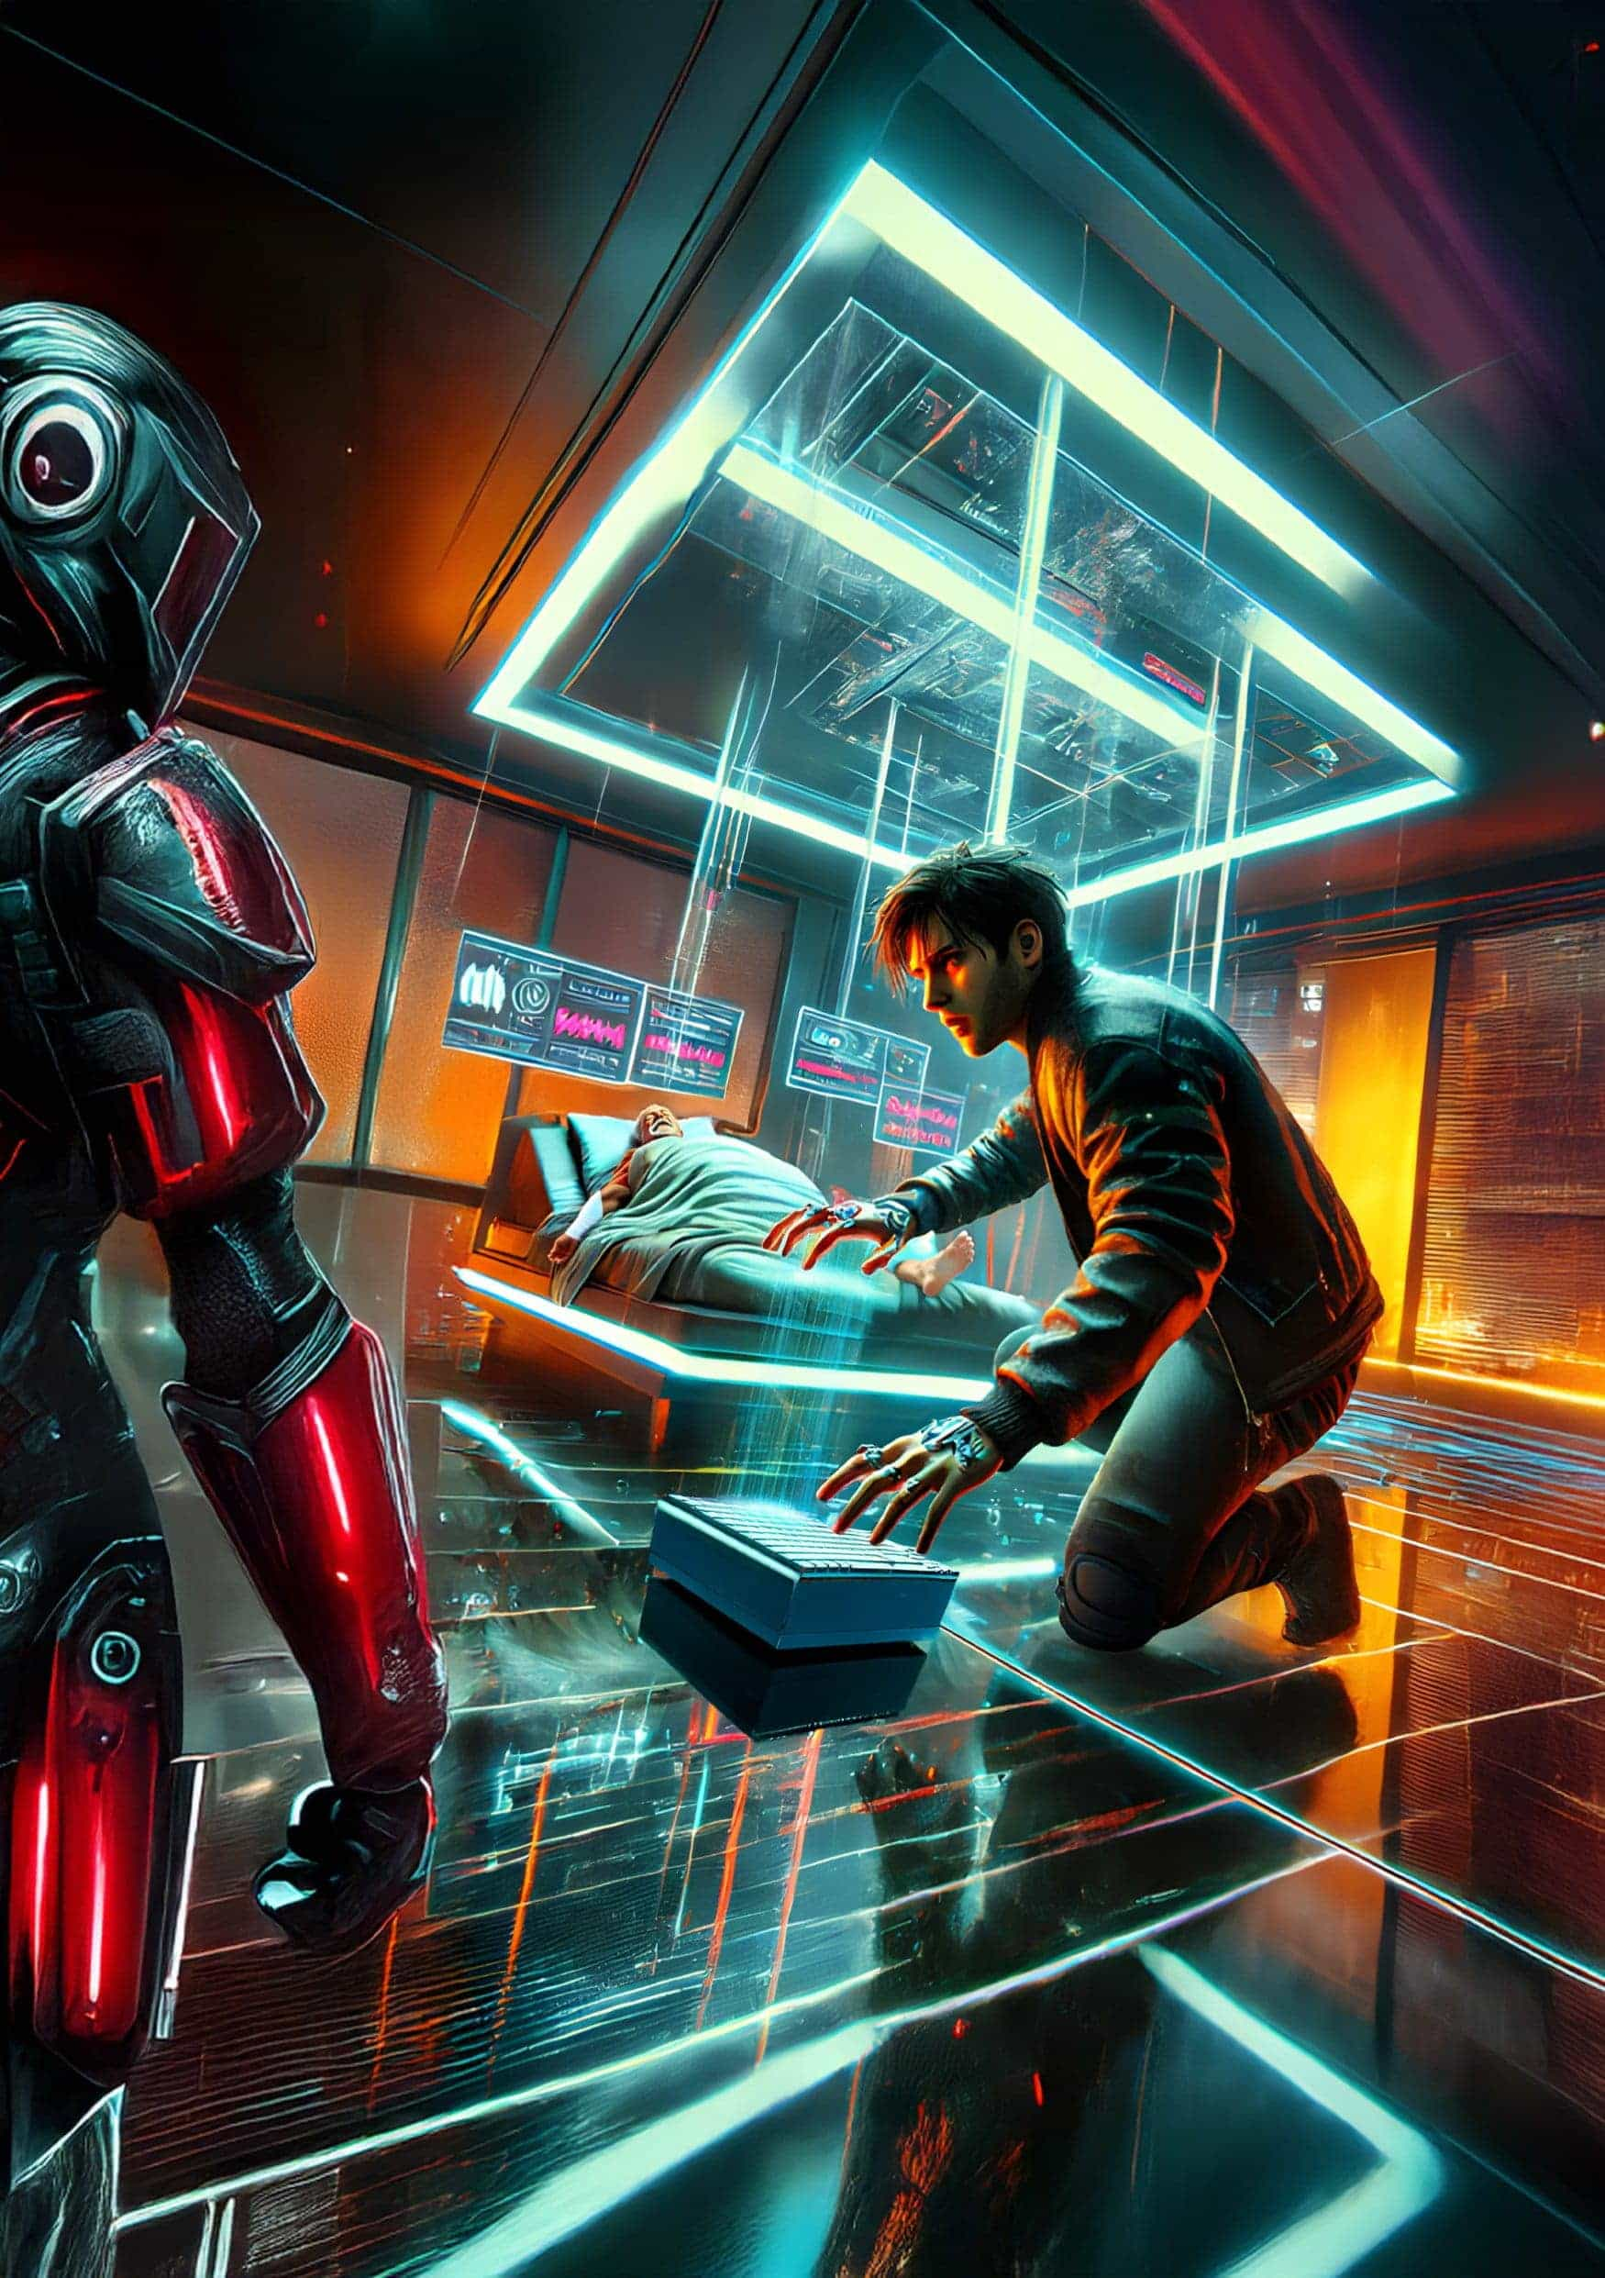

The Fixer: Medical Device Exorcist

by *Eric Kay*

It’s that kind of crappy day: so cold the rain’s freezing to the windows and the roads are gridlocked. I don’t drive, and sometimes gridlock is good for business, but I do walk, and no one loves being upright one moment and then cheek-first into the icy sidewalk the next. I’m a bit chilly in my apartment. Landlady can’t spare a degree, but my thick holey socks manage to keep my feet warm.

I’m cozy, so of course, Pay2Say pings me. Notifications were set to LOUD and I jump on it because I can’t turn down any work right now.

[Pacemaker Support ending, can’t recharge. Please help!]

They committed a single satoshi to bubble up the message. Anyone with a pacemaker they need cracked who can only spare a single sat must be pretty desperate. This’ll be a charity case most likely, but still, I help people. It’s what I do. When your medical device is on the fritz, I find a workaround. When your ocular implant’s expired, I have a way to keep the resolution up without the corporations knowing.

This client’s close by. I grab my diagnostic bag and brave the streets, only slipping once. I make it over to their extended stay hovel. An old lady points to the man who looks older than Obama, but far more miles. He’s about to have a heart attack just watching the charge drain. When I arrive, he loses all control and is about to flatline, but I can’t afford another write-off this month. I scan his pacemaker. Point-one percent charge — a razor’s edge, buddy! It’s pinging out for a response. I spoof a DNS server and redirect the paywall to my own site. His pacemaker begins the wireless recharge, but his arms begin jerking, body seizing, and he keeps knocking off the dongle.

I’m not surprised. I scan his head and detect faulty electrodes for Parkinson’s. He’s convulsing, screaming obscenities, and now his old lady’s freaking out, about to call the cops, but I hold him down and patch the firmware. The jerking stops.

While he peacefully recharges, I finally breathe.

‘You really are The Exorcist!’ The old lady says.

‘I’m just The Fixer,’ I reply. ‘Exorcist,’ is too close to ‘Extortionist,’ though my services are reasonable. Far better than that pacemaker corporation. Those clowns make you convert your coin to their internal currency to pay for your implants, and they slap on a fat conversion fee. Those sharks, trying to financialize the body.

I look around for other electromagnetic signals. I sense her body area network (BAN) and see she’s got an ocular implant out of contract. I can’t last on charity, but I fix people. I heal for real. Help the blind see again when their implant fritzes, or hack the insulin pump when the provider ups the price. Sometimes for free. Other times I teach them how. So yeah, I’m like a modern-day Jesus, but I don’t let that go to my head. And certainly don’t seek martyrdom.

So I ask her about her eye. EverLite, her software provider, had a hostile takeover, and the swine reduced resolution on their free tier. I send her an unlimited code, then reboot her eye remotely. She cries for joy.

They pay me with literal turnips, (which I hate) and a bag of onions, (which I like), and I head home. I’m now a month late on rent, but as far as I know, Landlady has all natural parts. I can’t advertise, so word of mouth’s key. I take every job I can and occasionally extort the whales.

On the way home, I visit a farmer’s market and a friend’s veggie stall.

‘Cliff,’ I ask. ‘What’ll’ya give me for these?’ He hems and haws, but I barter my turnips and onions for harder money. It’s not too burdensome as long as the price is low, and your wallet address has transacted here before. Cliff trusts me from when I did a favor for him.

I show my code, and my public wallet gets incremented a few sats for the veggies. I do keep two onions, but I don’t need fifteen.

Back at my apartment, I sneak up the back stairs.

Newark’s weather is still as crappy as it gets: heavy slush. I don’t want to leave my room, so naturally, I get a message. The sender commits nearly 1,000 satoshis to me to read the message. Not split between 100 addresses. To my SINGLE address. That’s an incredible amount and I almost jump for joy, but I don’t want to make any sound because otherwise, landlady’ll come up and demand payment.

Pay2Say eliminates spam by charging per message. Most get returned back to you, with the remainder split between addressees. The company also earns a trickle of interest from any balance in escrow. The messages are locked down with 512-bit encryption, and do so with the same seedphrase as their company’s wallet. They literally put their money where your mouth is.

[VIP wants a second opinion.] For 1k sats a message, I’ll give him a lifetime subscription plan to second opinions. Kind of sparse on specifics, but the message was from a steady customer of mine. Sometimes his ‘cousins’ come in with a few ‘dents,’ if you get my drift. I ask no questions, log no data, and he compensates me by tumbling some coin into my accounts.

A second opinion? I wonder. Most come to me because I’m the last resort. I bundle up, including thick socks. I tiptoe, carrying my shoes down the stairs, because Landlady’s got hearing so good you’d swear she has augments. I head to a basement parking garage on 52nd.

I double-check for a tail, scope out any blind corners, then roll a ball drone down the ramp to the underground garage. It bounces beautifully and rolls under a car. There, it scans the vehicles and recognizes Mr. Steady Customer’s black Mercedes. I ping it, then hang by for a minute.

Sure enough, a ‘cousin’ appears. He’s familiar, so maybe I fixed him in the past, but he’s an ugly boy with coal-black irises from the ocular implants. I passively snoop on his signals and save the devices in my databank, just in case. He’s got this high forehead, probably from the subdermal bullet weave. I hope for his mother’s sake he wasn’t born with that noggin. Either way, I don’t stare. He frisks me, takes my pistol, and carries my toolbag.

I’m hoping this is a diagnosis and not a full exorcism, but I bring everything. Sometimes it’s preemptive: penetration testing, or vulnerability scanning. Long ago it was legitimate, before the right to repair was rescinded. The corporatocracy loves to enforce their monopolies, even if they still appreciate the odd freelancer like me.

Me and Frankenstein Forehead go up the service elevator to the top floor. In a long unobstructed hallway, I switch my vision to the electromag spectrum and see oppressive pulses from the communications antennas above this penthouse. We enter this posh suite. There’s the VIP, absolutely zonked out and sprawled on the bed. He’s seventy-five, with decades of life left. Steady Customer isn’t here, but there’s an older woman, and guards are throwing off signals from the adjoining suite.

‘He needs to give a speech in fifteen minutes,’ the old lady says. Either his handler or his wife.

So not a diagnosis; they need a miracle. ‘Neuros?’ I ask. And start scanning him.

‘Custom SchutzSuite executive implants.’

Executive implants alter brain chemistry and enable these corporate types to stay up for days. But it’s theoretically easy for a hacker to reverse and leave them comatose. I scan the VIP head to fake toe. He’s got the electromag signal of a bustling coffeehouse, but I filter to his body network. Devices appear, all SchutzSuite, and as expected, the custom models don’t return hits when queried against public databases. ‘Customs are complicated, but I assume he’s patched?’ I ask.

Old Lady confirms he’s up to code.

He’s got a heart monitor. Neurals, kidney implant, retinals, defib, and a last-ditch oxygenation pump in his neck. Full works. I’ve never seen a guy so rigged as him. He’s trying to live forever. Not sure why, but with so much noise, I suspect it’s simple interference. I’m tempted to scream ‘The power of Christ compels you,’ but they aren’t the joking type, and if they’re fanatics, I don’t want to be a martyr.

There’s this near-field signature coming off his butt. I see a bulge and ask, ‘Wallet?’ Sometimes enhanced credit cards cause problems.

‘I’ll get it,’ the old lady says, like I’m going to pick him in plain sight. She also removes his phone.

The wallet gets close enough to my scanner to sniff the cards. I see a ‘Kurt Schutz’ pop up. Hairs stand on my neck. The Kurt Schutz? Chief Scientist of Ubermensch Medical? I’m dealing with the devil! I suppress my surprise. Kurt Schutz might be a common name, even in the Northeast. But a skimmed corporate credit card confirms the company.

The lady’s looking at me, expecting me to do something, so I slowly run my scanner over his body. But before I make a diagnosis, he stirs. This was too easy. I back away.

‘What did you do?’

‘Interference overload.’ I suspect. ‘Keep his EM low and he’ll be fine.’ It’s not cyber-voodoo. The spectrum can hold only so many channels. ‘The EM decibels in this room are pretty high. Move him to a different suite.’

In another minute, he’s up and talking. He says one word in German before speaking crisp English.

She nods to Forehead. I get a unique buzz on my device for payment. I want to refund my standard whale charge, but I don’t protest ‘cause I’m no saint and also want to play it cool. Frankenstein Forehead leads me out. He hasn’t returned my weapon, but I still have my toolbag.

‘I’m giving you a ride.’ His declaration is as heavy as cement shoes. He follows behind.

‘I’d appreciate it,’ I lie. This whole thing might have been a setup to convince the VIP there’s a brotherhood of illegal fixers out here.

But demons can be cast back on others. Frankenstein’s got two different model eyes, EverLite, and VisiTech, to prevent a dual hack, but I’ve got decades of experience giving sight to the blind.

With him still behind me, I use my body to hide a device from my toolbag. Ahead, there’s a door between the service elevator and the stairs. With a quick command, I activate a program that broadcasts reboot commands to every device.

There’s a countdown, 3, 2, 1, and I dive.

He draws and shoots wildly above me. I dart into the stairwell and disappear. The next fifty floors are a wild descent, but no one follows. I exit into the street, flip my coat collar, and disappear into the crowds.

Paul Fixer: not a martyr, and now with enough for rent. And for the next few, I can help for turnips.

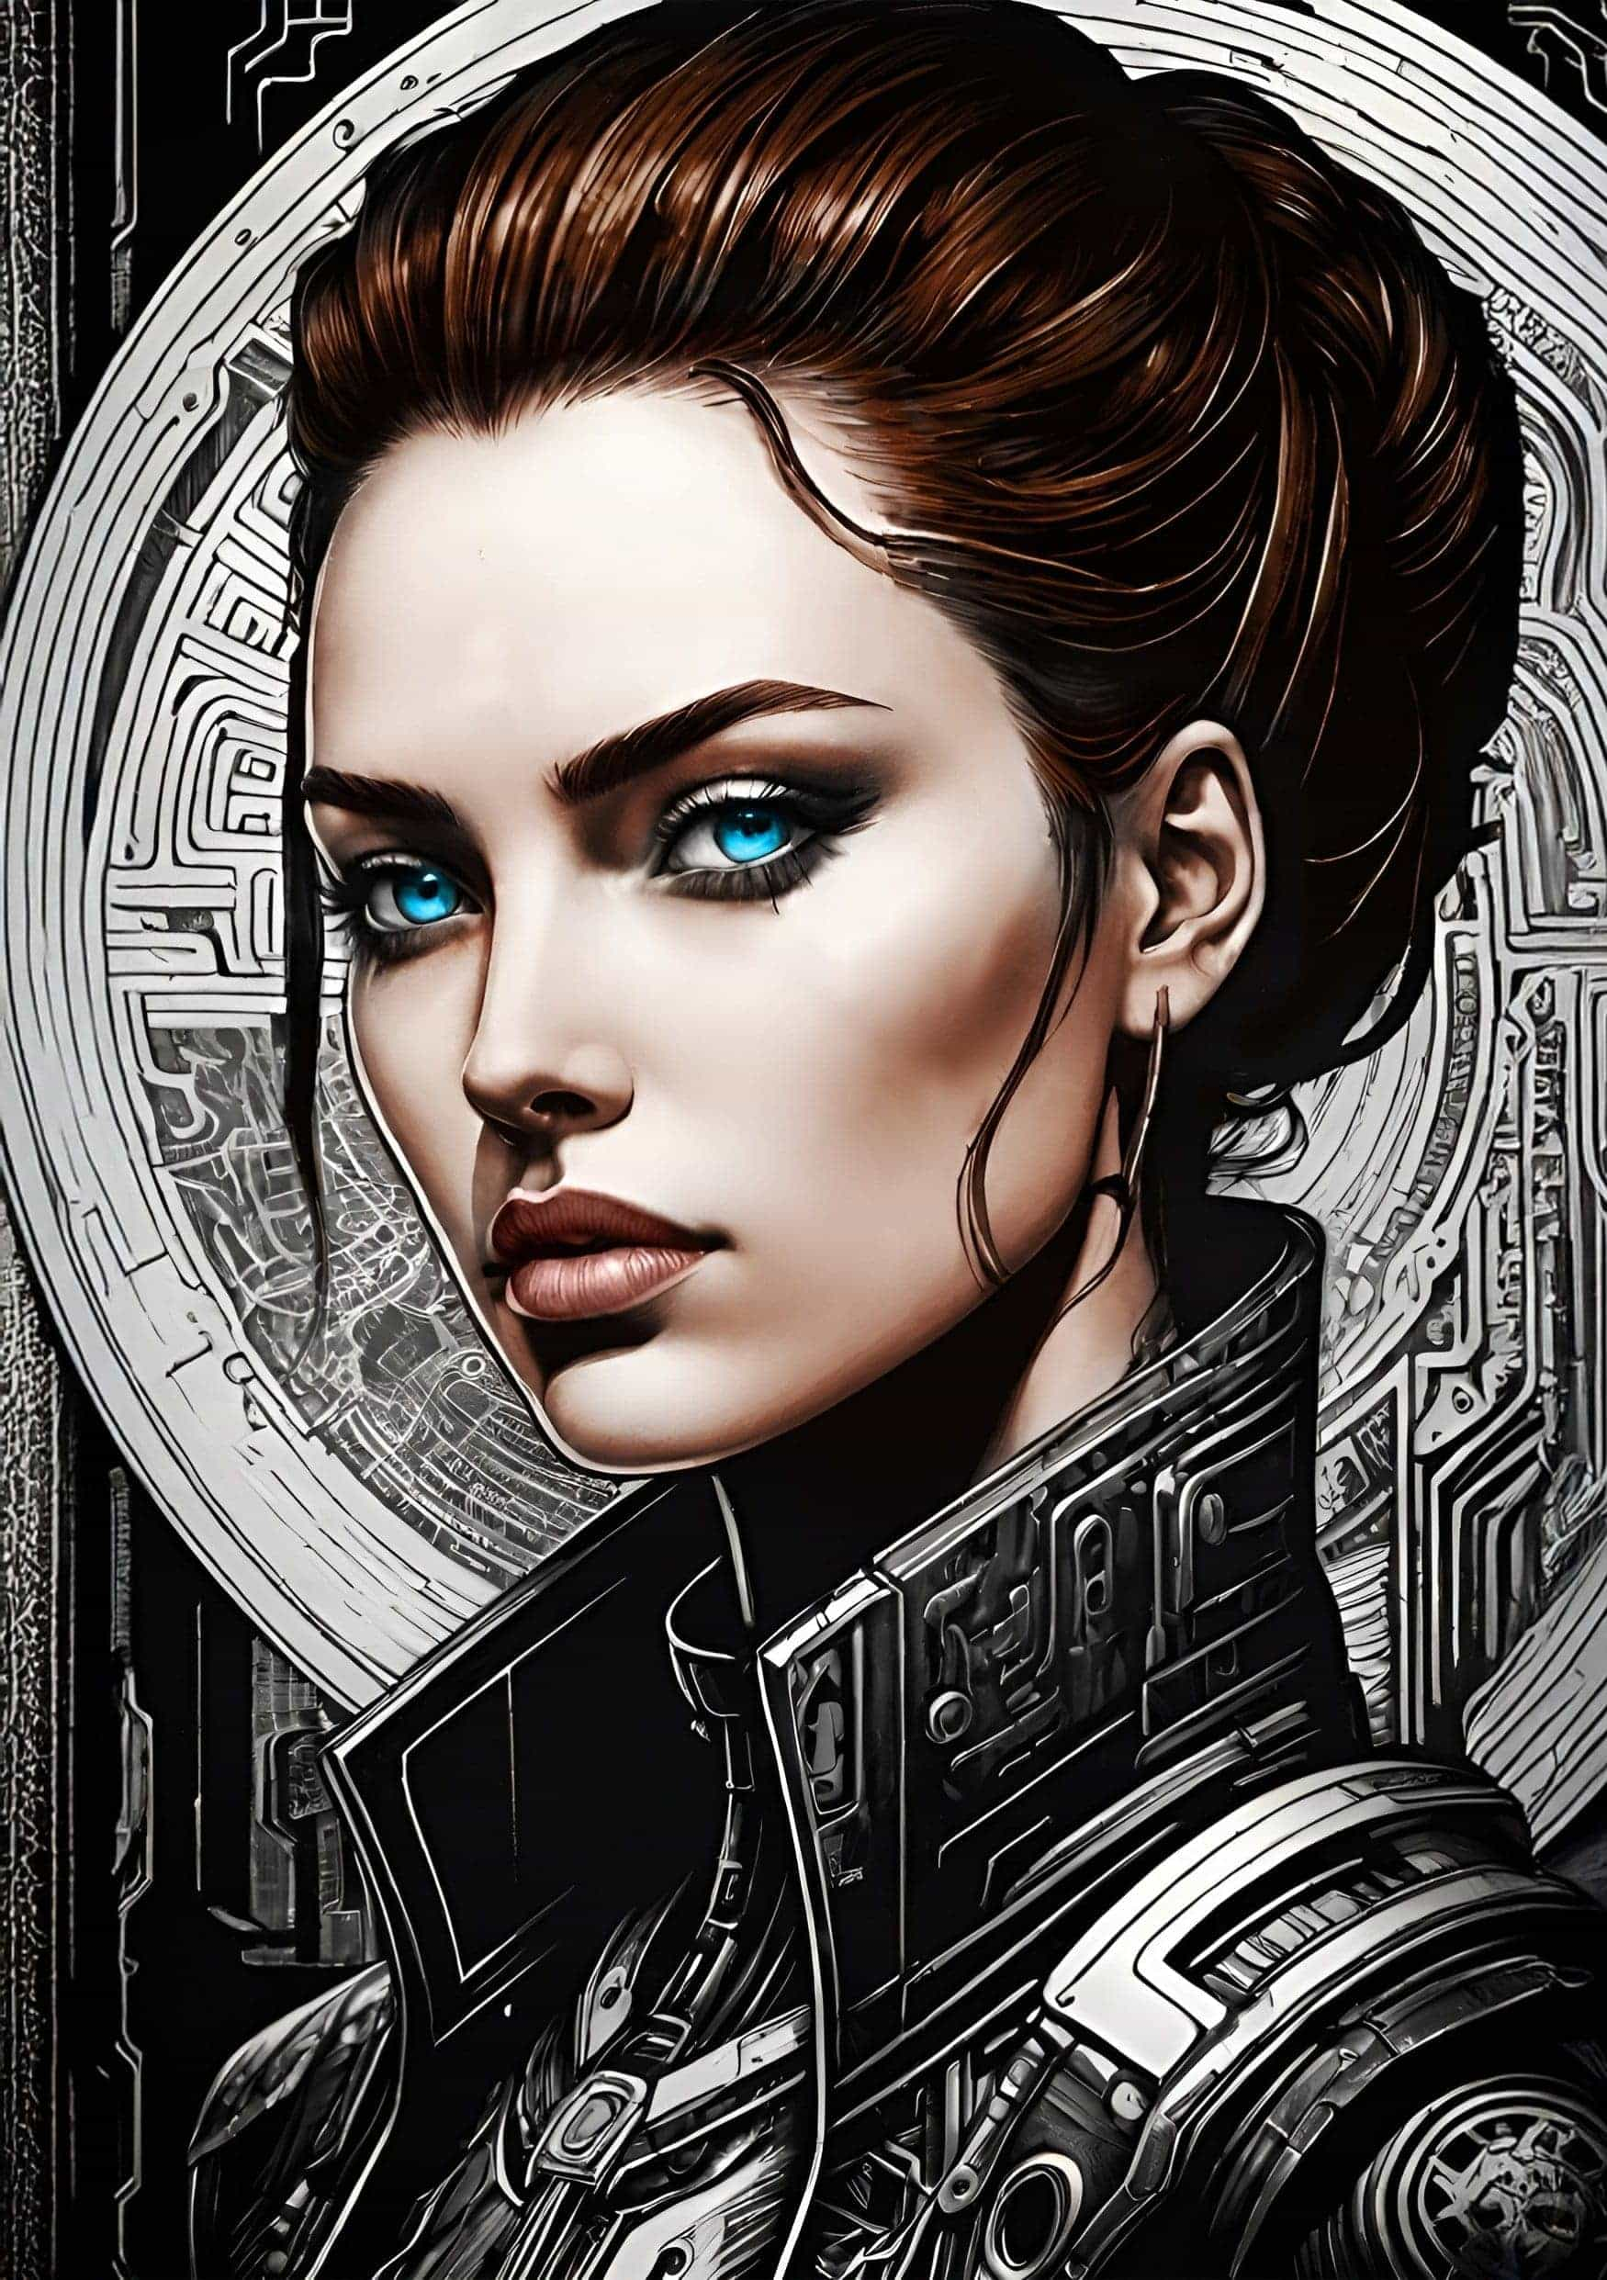

Infinite Debt

by *Graeme Shimmin*

The train shuddered to a halt, its worn-out levitation systems groaning under the weight of too many passengers. Zarah pressed her face against the smudged window, squinting through the haze of pollution that perpetually shrouded the lower zones. Her watch beeped a warning:

THIRD ZONE ENTERED. PENALTIES MAY APPLY.

The train doors hissed open, releasing a flood of passengers onto the platform. Zarah pulled on her filtration mask and shuffled forward with the crowd.

Near the station exit, a group of children, their clothes threadbare and faces gaunt, huddled around a damaged Red Cross Autodoc. One of them was trying to hack the machine’s diagnostic circuit: a girl no older than ten with her left arm ending in an interface port. The cheap electronics sparked, and the girl yelped.

An enforcement drone buzzed overhead, shell pulsing red.

‘Unauthorized medical access detected. Debt penalty applied.’

Zarah’s hand twitched towards her pocket, where she kept a few precious med-chips for emergencies. Was this an emergency, though, or just some kids stealing?

A notification pinged: her target’s file, automatically uploaded.

Name: Shanice Vega

Profession: Former debt-algorithm engineer

Insurance policy: $10,000,000

Current debt: $15,000,000

Estimated time to repayment: Infinite

Location: The Vertical

Low-res holographic adverts flickered all over the Vertical’s forty-seven levels of repurposed plastic and carbon fiber.

Your dream matters! Enter the Debt Cancelation Lottery!

Your value never ends!

Upload your avatar to the Economic Continuity Initiative!

At the base of the precarious heap, Enforcement drones had surrounded a family. Citizens hurried past, eyes downcast, neural interfaces blinking.

The father pleaded with the drones. ‘Please, we just need more time. My daughter, she’s near graduation—’

The lead drone’s sleek shell was cold-sapphire-blue, its voice crisp. ‘Mr. Singh, your Third Zone dwelling license has been revoked. I’ll guide you to a relocation center. Please don’t make difficulties, or you’ll force me to add another penalty to your family debt profile.’

Zarah pushed past the drones and started climbing.

Zarah’s legs burned from the climb to the forty-seventh floor, where a bootleg loan company was operating out of a storage unit. Scribbled above the door was:

Liberty Finance Cooperative

Micro-loans, not pesky drones. Try us!

A petite, dark-haired woman wearing blue shorts watched Zarah as she stood at the top of the stairs, gasping. ‘You back to shut us down again?’ she asked.

‘Does… Shanice… live here?’ Zarah gasped.

The woman pointed to a unit at the end of the walkway. The door was ajar, and the sound of someone retching was coming from inside.

‘Ms. Vega?’ Zarah called, pushing the door open to find Vega crouched over a bucket, her body wracked with spasms. An obsolete interface jutted from the base of her skull, its status lights flashing as she vomited.

Vega looked up. ‘If you’re here about my debt, I’ve already sold everything. My organs. My avatar. The whole shebang.’ Her eyes were bloodshot.

‘Ms. Vega, I’m here to help. Our customer options program—’

Vega laughed, a broken sound that turned to coughing. ‘I’m already grinding twenty hours a day. My baby girl can’t afford school, so she’ll inherit my debt with no way to pay it except turning tricks. I can’t even buy a ticket for the debt cancellation lottery. What options I got, for real?’

‘I—’

There was a thump on the door. ‘Enforcement.’

Panic flashed across Vega’s face. ‘No, no, no—’

The door burst open, and an Enforcement drone floated in. ‘Shanice Vega? Your debt—’

Zarah stepped between the drone and Vega. ‘Zarah Delacruz. Elysium Trust Finance. I have priority.’ She held up her ID for scanning. ‘Check your logs.’

The drone lowered its manipulators. ‘Zarah Delacruz, you have ten minutes to conclude priority debt rescheduling.’

‘Outside please. Client confidentiality.’

The drone backed up, pushing the broken door shut.

Zarah delved into her bag and brought out two small gadgets. She activated the first, the signal jammer. Its green light indicated sixty seconds of unmonitored communication before the surveillance system adapted.

Vega looked at the jammer. ‘Wh—’

Zarah kept her voice low. ‘Alex Rivera says hello.’

Vega’s eyes widened. ‘Alex—’

‘There’s no time. Please, just listen. He’s hacked your records and added a life insurance policy from your former employer. It’s worth ten million dollars. You’re dying anyway, months to live.’

The jammer’s light blinked. Thirty seconds left.

‘He says he’s sorry — this was all he could do. It has to look like an accident. Think of your daughter.’ She held out the second gadget. ‘Go to the window and hold this to your interface.’

The light on the jammer turned red. Zarah took a breath, raised her voice. ‘Sign here, please.’

Vega, tears streaming, grabbed the gadget, moved towards the window, and held it to her head. ‘Fuck it all,’ she said and pressed the trigger.

Zarah dropped her bag, the noise as it clattered to the floor masking the sound of the gadget sparking against Vega’s interface. Vega jerked and folded over the windowsill, her eyes rolling upward. With a last effort, she threw the gadget out of the window.

The Enforcement drone stormed in, crackling red. ‘Stop!’

But Vega was gone, screaming all the way down.

The drone turned to Zarah, manipulators like stilettos. ‘Explain.’

Zarah’s voice was surprisingly steady. ‘Ms. Vega’s neural interface malfunctioned. An unfortunate accident. I’ll file a full report.’

‘Noted,’ the drone said. ‘Reallocating debt to Vega’s Economic Continuity Initiative avatar. Thank you for your cooperation.’ It floated out of the room, its hum barely perceptible.

The train back to Zone One felt, as it always did, like a rebirth. Gleaming skyscrapers, their upper levels bathed in sunlight, rippled with bank logos and adverts for the latest implants:

Boost Your Productivity! Reduce Your Debt!

Zarah took the travelator to Elysium Trust Finance, where the atrium’s walls were relaying live scenes from the Himalayas. A private security detail shielded a woman whose crisp suit, vintage sunglasses, and unblemished skin marked her as one of the elite.

Amarantha Gould.

Gould saw Zarah, stopped, and spoke. ‘Delacruz. My office.’

Zarah followed Gould to the elevator. Gould didn’t speak, didn’t even look at her. As they ascended, adverts flashed past:

Private Islands: The Ultimate Luxury.

Breathe Easier Knowing You’re at the Top.

Gould’s office, floor-to-ceiling windows tinted against the harsh glare of the sun, was bigger than Zarah’s apartment. It offered a panoramic view of the Zones, a reminder of how far Zarah could fall. Gould herself stood before a wall of high-definition holographic displays displaying streams of financial data.

She gestured for Zarah to sit. ‘What’s the story with Shanice Vega?’

‘Dead. Implant malfunction.’

Gould lowered her sunglasses and assessed Zarah. ‘Fortuitous.’

Fortuitous indeed. Vega’s daughter could now go to school and gain a qualification.

Her mother was dead, but she had a chance of a life.

‘Why isn’t there a record of your customer options discussion?’

‘Unlicensed financier on the same floor. They’re using jammers.’

‘Bootleg loans? Again? They’re like cockroaches.’ She lifted her tablet. ‘Note to self: shake the Vertical down again.’ She looked back at Zarah, calculating. ‘Shanice Vega and I worked on the debt algorithms together, long, long ago, implementing the Debt Responsibility Framework. We didn’t have insurance. There’s something you aren’t telling me.’

She’s just fishing.

Say nothing.

Gould sighed and pulled up another image. ‘Recognize this man?’

Zarah’s breath caught. ‘Of course. My father.’

‘Quite. Deceased two months ago. Avatar now employed by the Economic Continuity Initiative. Working off the family debt. You must be proud.’

‘I loved him. He loved us.’

Gould yawned. ‘Love is a luxury, my dear. Also, you won’t think so kindly of him when you see his legacy.’ Numbers scrolled across the screen.

Zarah’s eyes widened. ‘What? Our debt isn’t—’

‘Oh, but it is.’ Gould leaned forward. ‘Turns out your father had a talent for creative accounting.’

Zarah gripped the arms of her chair. ‘What do you want?’

Gould’s smile was all teeth. ‘We’ve discovered a group of terrorists… radical lunatics spreading fantasies about debt forgiveness and system resets. Your ex-husband is one of them.’

Zarah’s throat went dry.

How much does she know?

She kept her face blank. ‘I’m servicing Alex’s debt. No arrears.’

‘Maybe so, but I want this terrorist cell dismantled. Locate him and I’ll restructure the burden your family has left you.’ She turned to her displays, apparently done with the conversation.

‘But I’ve not seen Alex since he left — he’s off grid — I don’t know if I can find him.’

Gould sighed and turned back, her gaze drifting to the window. ‘I hear the air in Zone Three is getting worse,’ she said. ‘I wouldn’t want my children to grow up breathing it. Make a choice: your ex-husband or your daughter. You have twenty-four hours.’

Zarah rode the elevator down from the top floor, staring past the gleaming spires of Zone One, and the solar gardens of Zone Two towards the chaotic patchwork of Zone Three and the drone-patrolled border that separated the city from the toxic hellscape of Beyond.

Her watch chirped

W3 N33D T0 M33T

Alex.

Zarah thought back to the last time she’d seen her husband.

Mei was finally asleep. Alex hunched over his desk, his eyes darting between flickering screens, frantically swapping his archaic but unhackable collection of data chips between readers.

Zarah whispered, ‘Darling, it’s late. Come to bed.’ She placed a hand on his shoulder.

Alex turned, his bloodshot eyes bright with conviction. ‘Look at this.’ He pulled up a chart, lines swirling in the air between them.

Zarah squinted. ‘What? It’s just a debt projection.’

‘For all zones, all income levels, except the highest.’ Alex’s voice was tense. ‘They all end up in the same place. Infinite debt. It’s by design, Zarah.’

‘That’s not… The system—’

‘Has us all trapped?’

Zarah’s watch beeped. Her shift at Elysium. She hadn’t slept.

‘How can you still work for them?’ Alex asked.

‘Someone has to service our debts. We can’t all be full-time conspiracy theorists.’

He flinched as if she’d slapped him.

‘Sorry,’ she said. ‘I didn’t—’

‘It’s not a theory that a citizenry in debt is a citizenry controlled. They work harder. They don’t have time to question.’

The same pointless argument. ‘The Debt Responsibility Framework stabilized the economy after the Meltdown. I help people where I can. I’m just doing my job.’

‘See — debt creates control.’ Alex scooped up his data chips. ‘I have to go.’

Zarah frowned. ‘What? Go where?’

‘I can’t tell you.’ Alex moved to the closet, pulled out a bag, already packed. ‘I know you don’t get it, but there are people who do. We’ve found references: Project New Equilibrium.’

‘Alex, wait, please.’ Zarah’s voice rose. ‘What about Mei?’

He paused, hand on the door. ‘I’m doing this for Mei. She’ll be in danger if I get any closer. That’s why I have to stay away from you both.’

The door hissed open. He stepped through, hesitated. ‘Divorce me. Renounce my debts. One day, perhaps…’

‘But we love you.’

‘Love is a luxury,’ he said.

And then he was gone.

Zarah stood there, staring at the closed door, her sobs merging with Mei’s soft cries and the beeping of her watch.

The memories faded, and Zarah found herself at the door of her family apartment. Inside, the walls flickered to life, showing calming forest scenes. Mei emerged from her room, clutching her tattered teddy bear.

‘Mom, Grandma’s meds…’

Zarah forced a smile. ‘It’s okay, sweetheart. I’ll feed her.’

In the kitchen, Zarah’s mother was trying to eat hummus. Her hands shook as she tried to bring a spoonful to her lips. She looked up. ‘There’s a message from Debt Enforcement.’ Her voice was as fragile as her bones, her overalls covered in hummus.

‘I’ll take care of it, Mom.’ Zarah sat down at the kitchen table, fed her mother, and then pulled up the app. Numbers swam before her eyes. It wasn’t possible…

A soft sound made her look up. Mei stood in the doorway, still clasping her teddy bear, her face tear-streaked. ‘Mom?’

Zarah swallowed hard. ‘Come here, baby.’

Mei climbed into Zarah’s lap, small arms wrapping around her neck. ‘I had a dream about Daddy.’ Mei’s voice was muffled against Zarah’s shoulder.

Zarah closed her eyes, fighting back tears. ‘Daddy loves you, Mei.’

‘But why did he leave?’

Zarah hugged her tighter. ‘Sometimes,’ she said, ‘Grownups have to do difficult things.’

They sat like that until Mei fell asleep. Zarah put her to bed and returned to the kitchen. Her watch buzzed — another message:

T0M0rr0W 2200

53CT10N 8 5T4T10N

Zarah made her way through the dingy corridors of Section Eight. Supposedly, it had once been a park, a green oasis. Now it was a maze of purification units, detoxifying Zone One’s air, and pumping the poison into Beyond. An Enforcement drone hummed overhead, searchlight sweeping the area. Zarah tensed.

On her watch was another encrypted message:

TH3Yr3 F0110W1N6 Y0U

Section Eight’s maglev station was abandoned, the platform edges crumbling, the tracks rusting on their pillars. Wind whistled through the structure, like the memory of a lost future. Zarah’s footsteps echoed in the cavernous space, her nerves screaming.

A smiling figure emerged on the gantry above her: Alex, holding up a signal jammer, its green light solid. ‘Darling,’ he whispered. ‘It’s so good to see you.’

She looked up at him. ‘Alex, you promised to stay away. What is it?’

‘The debt is a lie.’ Alex’s voice was low, urgent. ‘We’ve found proof that Project New Equilibrium exists.’ His eyes were as bright as ever. ‘We’re going to tear the whole damn thing down.’

‘Alex, they’re blackmailing me into betraying you. I don’t know how long I can stall them — they’re threatening Mei.’

‘It’s okay. If we get this right, you and Mei will be safe, and we’ll be one step closer to burning Project New Equilibrium to the ground. When the jammer runs out, don’t agree to anything I say. Please, just trust me.’

‘Alex, for pity’s sake, what’s going on?’

‘Better you don’t know. Make sure they find the data chips — that’s all that matters.’ The signal jammer in his hand started flashing green. Alex grinned. ‘Ready?’

Zarah thought of Gould’s shark-like smile, of Mei’s worried face, of her mother’s trembling hands. She thought about debts and luxuries. She took a deep breath. ‘Let’s do it.’

The signal jammer went red.

‘I… Love… You,’ Alex mouthed, then said aloud, ‘We need someone on the inside. Somebody like you. With your help, we could—’

‘No.’ she said. ‘Whatever you’re planning, it won’t work.’

‘So, you’ll just walk away, like an obedient little debt collector?’ There was a hint of desperation in Alex’s voice now. She didn’t know he was that skilled an actor.

Zarah smiled at him. ‘I’ll do anything for my family,’ she said.

Behind her, she thought she heard a noise, a scrape of metal on concrete, and then floodlights blasted the station through the dust-coated plexiglass arches.

‘Alex Rivera,’ a metallic voice, amplified and distorted, ‘by order of the Debt Responsibility Security Bureau, you’re under arrest for conspiracy to commit economic terrorism.’

Enforcement drones swarmed in, razor-sharp manipulators glinting in the searchlights.

Alex stepped back into the shadows, flickered and disappeared.

Zarah kneeled, arms wide, as the drones closed in, weapons trained on her.

The debt is a lie. Could it be true?

Zarah sat on a hard bench in the holding cell, staring at her reflection in the one-way mirror.

The door slid open. Gould entered, tablet in hand. Zarah looked up. Gould was smiling, but that meant nothing.

‘Did you catch him?’ Zarah asked.

‘Unfortunately, he was too clever for that. You were talking to a hologram. Still, we found a gold mine of data chips: the records of his terrorist group. We’re scanning through them now.’

‘Can I go home then?’ Zarah asked.

‘Just one thing first — tell me what he said while the signal was jammed.’

‘He told me the debt is a lie, and he’s going to tear the whole rotten system down.’

Gould laughed. ‘Well, one out of two ain’t bad. Incidentally, I’ve got a new position for you. I call it ‘Community Outreach Officer’. You’ll be tracking down misguided souls like your ex-husband, helping them see the error of their ways.’ She slid the tablet across to Zarah, who glanced at the contract. The money was better, enough to buy her mother proper meds even.

‘Also, I’m not the Debt Cancellation Lottery, but let’s just say your family’s debt isn’t as vast as it was.’

‘You’re feeling generous.’

‘It isn’t about money,’ Gould said, her voice smooth, her eyes gleaming.

‘Infinite debt creates infinite control… you think you’re a god.’

Gould leaned in close, almost whispering. ‘The question is, are you one of my angels?’ She straightened up, smoothing her immaculate suit.

Zarah looked up at Gould, saw the power she had, how unlikely any kind of lasting victory was. She thought she understood Alex’s plan: leave the tainted data chips for Gould to find, upload some kind of hack when she scanned them. He must have been planning it ever since he left. It was a dangerous game, but…

The debt is a lie.

She tapped ‘accept’.

Gould’s victorious smile widened. ‘Welcome to heaven, Delacruz,’ she said, extending her hand.

Zarah took it, her grip firm. ‘Glad to be here.’

As Gould turned away, Zarah’s watch displayed a new message:

UP104D 4CT1V4T3D

0N3 D4Y W3 W1LL

5T0P Pr0J3CT N3W 3QU1L18r1UM

L0V3 15 N07 4 LUXUrY

Zarah’s throat tightened. Alex was right, love wasn’t a luxury. And even if it was, it was a luxury she couldn’t afford to lose. She thought of Vega holding the gadget to her head. Of her father’s avatar trapped in digital purgatory. Of Alex mouthing ‘I Love You’. Most of all, she thought about Mei. She stood and straightened her jacket. Her work started now, and she had debts to settle.

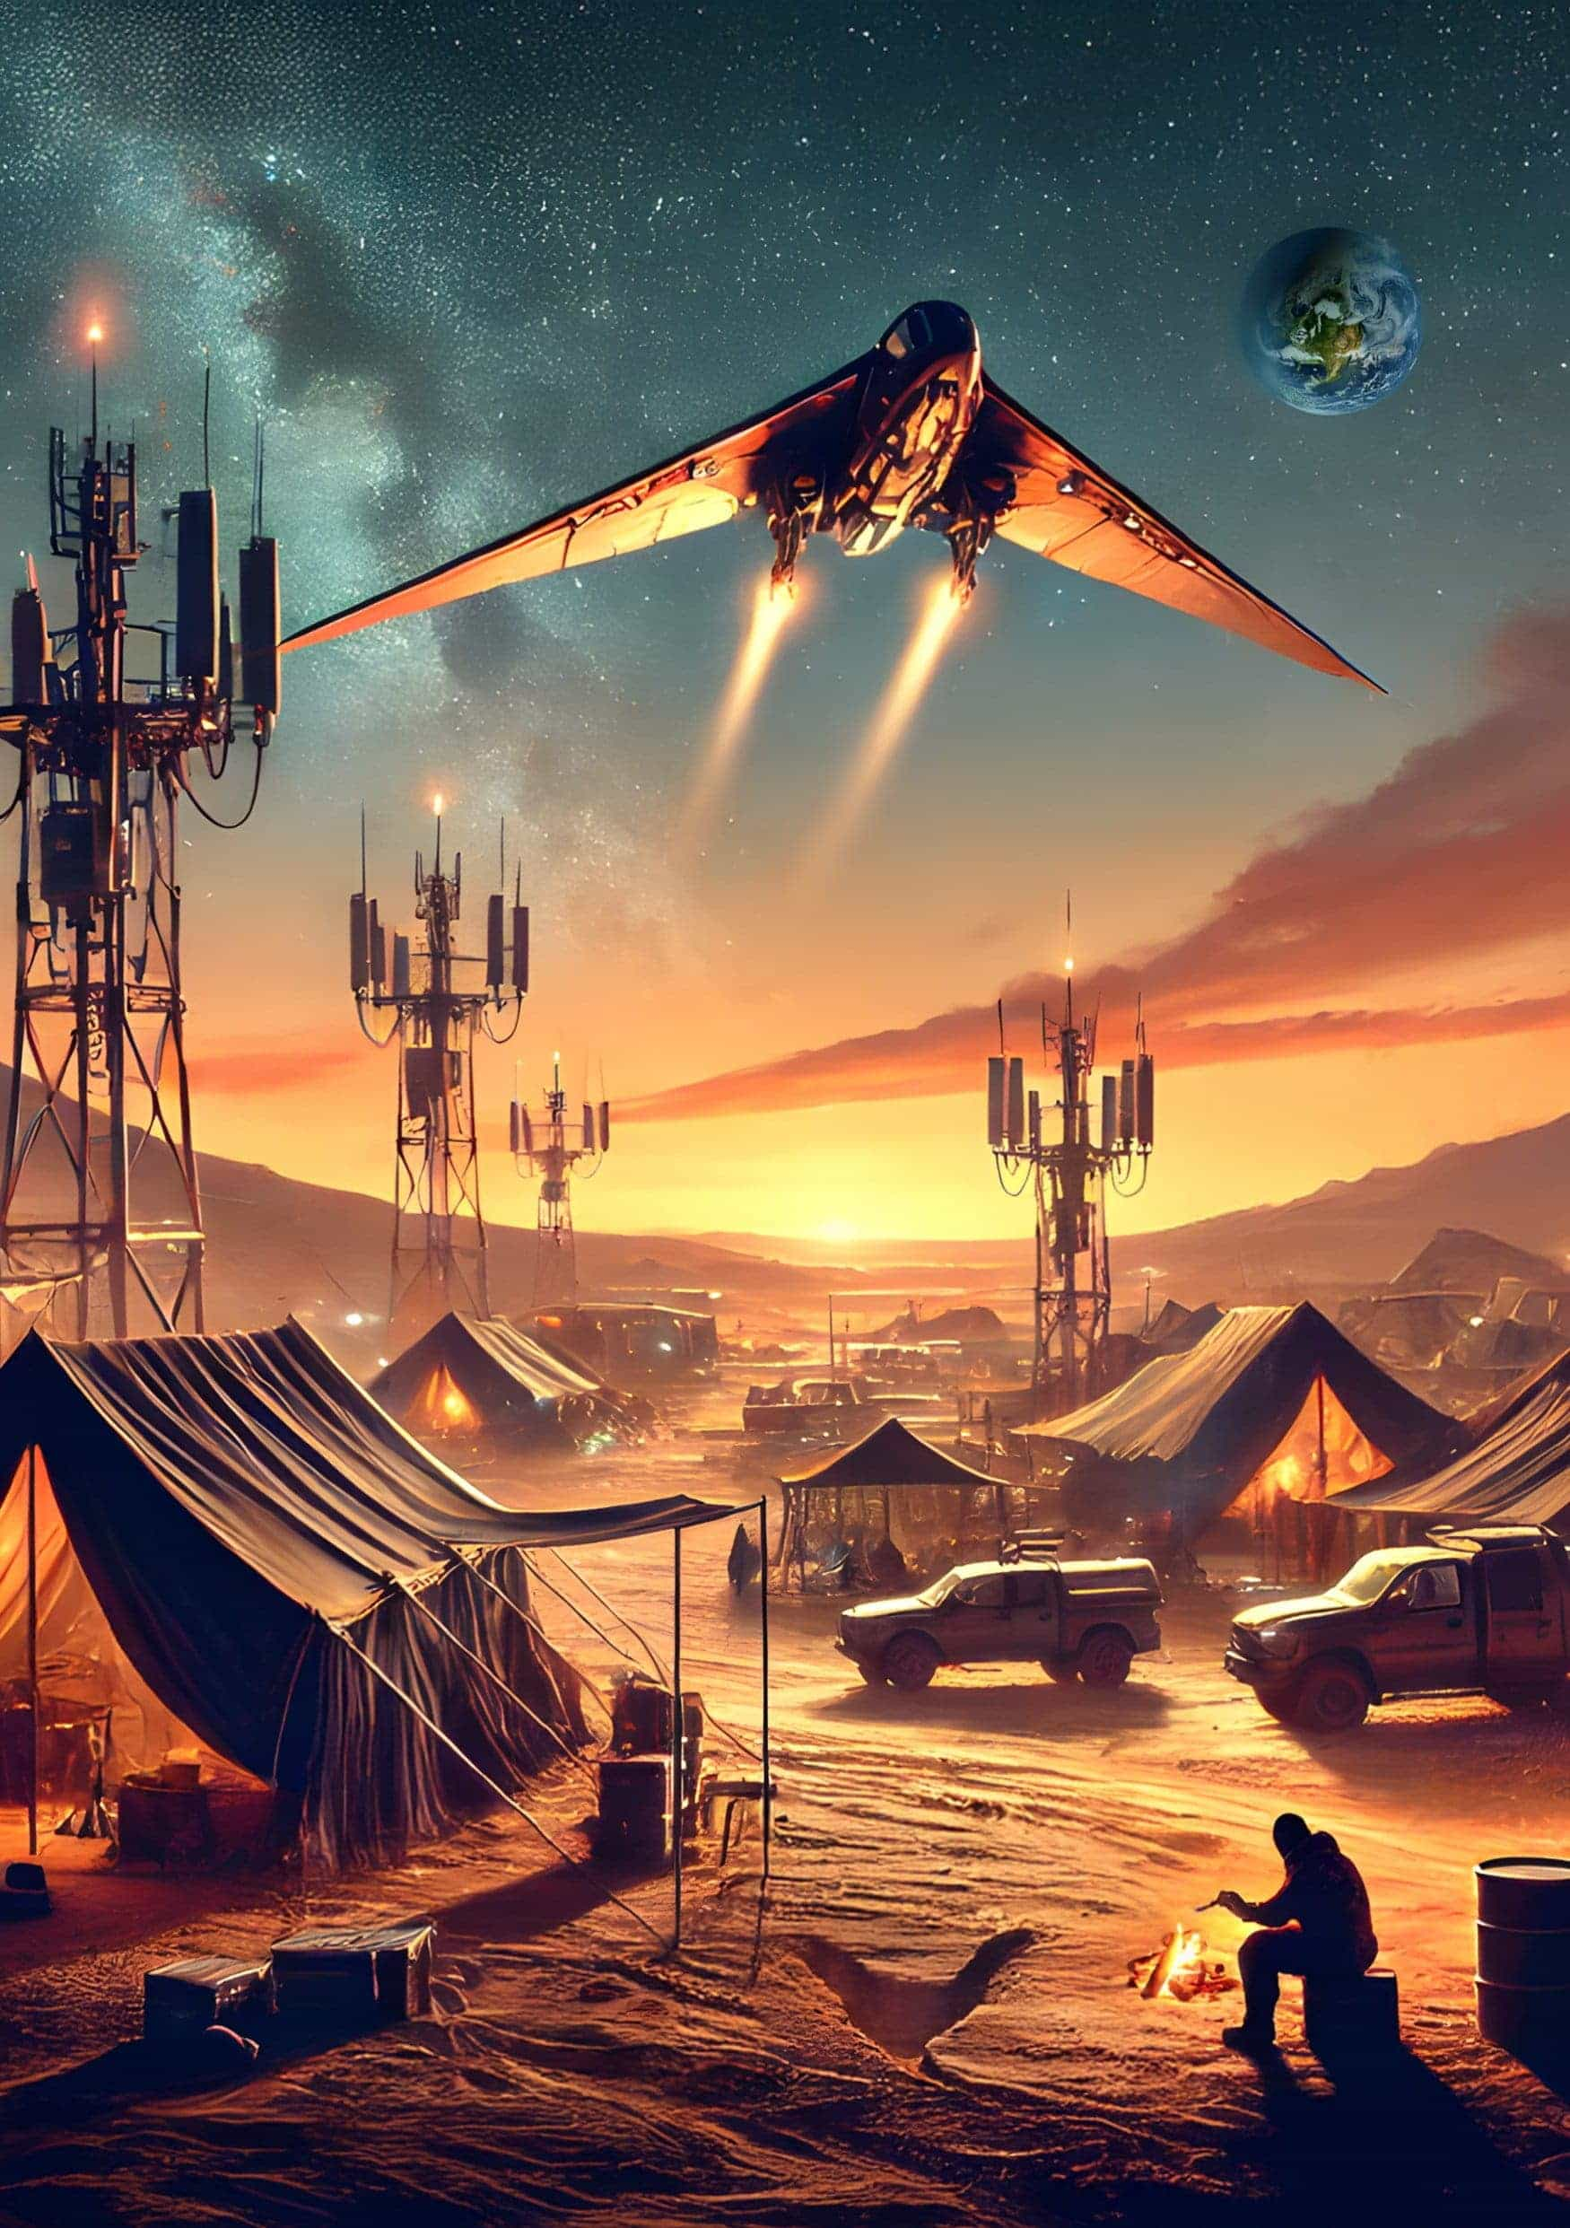

Fork War

by *Alex Gurevich*

Public Log

Excerpt from Campaign Speech

Subject: Fork Mitigation

Date: May 7, 3011 Standard

Speaker: Redacted, Security Level 4

Location: Redacted, Security Level 8

When people fight, they always fight over energy.

They fight over food, which is energy for their bodies.

They fight over religion, which is energy for their souls.

They fight over mates, which is energy for their lust.

They fight over status, which is energy for their egos.

But, most of all, they fight over access to quasars, which is energy for their cryptomining.

Quasars, however, tend to be far away and burned out. Which leaves us with Bright Evolgyme as the only energy source adequate to resolve the Cheerah-Weerah Fork.

And Bright Evolgyme is becoming less bright with every passing year.

Private Log: Allison Lester

Date: January 5, 3014 Standard

Location: Redacted, private security setting

I felt a jolt before I hit the atmosphere. The glider was an outdated piece of junk long decommissioned by the Cheerah military, and sold, as such things are, on the black market.

Even in its geriatric state, with its distortion shield not able to properly absorb the mere ten thousand gs of deceleration, it could still overwhelm the entire proud military of this Fringe World.

Or it could, if I had the energy to power up its weapons. Which, after its three mega-parsec run, I didn’t. Luckily, no one on a Fringe World would mess with a person in a Cheerah glider.

Deceleration cost another dribble of fuel, as I had to use the engine. Normally, an assault glider would just hit a planet’s atmosphere at near-relativistic speed with its force wings. However, this was not an assault, and I had to avoid damaging the < location-identifying name redacted> biosphere and infrastructure with the shock wave of entry.

As I slowed down to a leisurely float half a klick above the surface, I realized that there was not really much to damage. All I could see were sparse scraggly plants and the brown squares of failed attempts at agriculture. The infrastructure was limited to a few landing pads and temporary domes, clearly converted to permanent dwellings.

I opened a channel once I was within secure connection range, hovering above the cluster of relatively less decrepit structures that passed for the capital.

‘What’s the going rate? Cheerah fork. I need a hundred zs.’

‘Cheerah fork? Eighteen-point-two ns, Madam.’

The energy dealer, who introduced himself as Joshua, defied the stereotype of a gritty Fringe survivor. He was cleanly shaven and his brown hair was parted smoothly in a neat if somewhat archaic hairdo. His light blue shirt had black shiny buttons and gave the impression of being made of legendary cotton from the Old Earth. I wondered idly if it was some local plant or well-designed force-plastic. A collector would pay more than what this entire planet was worth to put a shirt made of actual cotton in his wardrobe.

‘You can call me Alli. And… are you out of your mind?’ Energy was scarce on Fringe Worlds, but eighteen nano-satoshis per zeta-joule?

There was silence on the screen. The dealer fiddled with his sleeves (rolled up just once), adjusted his smooth collar (the top button was off, completing the neat but casual getup), and remained silent. His posture conveyed that he didn’t want to antagonize me, but neither did he intend to negotiate.

I took a deep breath and pretended to double-check my security settings. Fortunately, the decommissioned glider was still a part of the Cryptoshpere of the Industrial Core, mined during the early years of Bright Evolgyme. It couldn’t possibly be compromised.

‘How secure is your end?’

‘I am an energy dealer,’ Joshua replied.

‘What about Weerah fork?’ I lowered my voice dramatically. Theoretically, trading Weerah coin in Cheerah-dominated space would bring down the wrath of the dreaded Cheerah fleet. Fortunately, the dreaded Cheerah fleet were currently occupied by the no-less-dreaded Weerah fleet about a giga-parsec away.

The answer came immediately. ‘Eleven-point-five.’

That was more like it. They must have been desperate for some Weerah-coin.

‘I’ll take two hundred zs.’ I was planning to buy two hundred all along, but didn’t want to scare the seller.

‘Wise choice.’ We nodded to each other.

I clasped my hands and closed my eyes to make it easier to access the transaction entanglement in my brain.

‘Is there a good place to eat on this planet?’ I asked as the energy level bar on my display started to creep up.

‘Are you just inquiring or asking me out?’

‘The latter. I was waiting to complete the deal. I would never mix—’ It had been a long flight.

‘Neither would I. Tonight is good. One thing Fringe Worlds are good for: the access to exotic fauna for the dinner table.’

‘Not sure how appetizing that sounds.’ I couldn’t resist the temptation to tease.

‘Do you trust me to take you to a rather remote establishment with a low advertising budget?’ There was only a hint of a smile on his face.

‘You do know that I have a Level Two cannon on this thing? One that you’ve just charged up.’

‘If you don’t mind me saying so, your planet is—’ I poked my fork at something, which looked suspiciously like a tentacle.

‘A shithole? A wasteland of failed crops and slums?’ He waved his hand to indicate our surroundings. The restaurant’s ambiance actually wasn’t bad. Archaic tablecloths covered wooden tables; the booths and benches suited the dim lighting. The place was well-attended, though not packed. Food was cheap by the core standard, but pricey for a Fringe World.

‘Kinda.’

‘There are not enough minerals here. We have to trade off-systems. Cheerah Fork demands continuous synchronization between galactic nodes. Verifying transactions costs too much. Businesses keep folding. Try the <planet-identifying food reference redacted> though.

‘Clearly there is a demand for the Weerah protocol here,’ I replied. ‘Less centralized and less energy taxed by the miners.’ Suppressing my impulse to gag, I put a tiny bit of the slimy morsel into my mouth. I expected a fishy taste, but instead, a symphony of sweet and tangy flavors exploded in my mouth. It was as if I were sampling every fruit I’d ever eaten at once. ‘Wow!’

‘I know.’ His face opened with a broad smile. I found myself leaning towards him as I engaged my tangle-store for a secure conversation. ‘Weerah protocol is not great for trade, unfortunately. Does not coordinate financial markets enough for this region.’

‘You could export this what’s-it-called… Have you tried establishing your own currency?’

‘There were multiple attempts in this galactic region. Each fiat currency gets overprinted and collapses within a decade. Each digital currency gets hacked as we don’t have enough energy for quantum-resistant protocols.’

‘I hear <location-identifying name redacted> will go hyper-nova shortly. Is there a project to Dyson and harvest it?’

Joshua’s smile vanished. He straightened up his posture, suddenly business-like. His hand lay flat on the table, still holding his utensils, but no longer touching the food.

‘Is that what brought you here? We don’t often get people rolling in military tech from the Core, buying two hundred zs like it’s pocket change.’

I reached out and touched his wrist. ‘I obviously came here for the company and the menu. But as you can imagine, I have a side hustle.’

‘You want to use hyper-nova energy to mine a local currency for a Cheerah-Weerah exchange hub?’

He was astute, but not astute enough.

‘Think bigger. The hub currency already exists. It has for ten centuries.’

I am a battled-attuned human. Naturally gestated, never damaged by cryo-sleep, entangled and trained from infancy.

So when a Level-1 Cannon blossomed in his hand, another one appeared in mine not at the speed of human reaction, but at the same quantum instance.

Level-1 had the range and the output of about one-millionth of what would be carried by a capital ship. It’s still enough to make a neighborhood unpopular.

Slowly, aiming at each other, we stood up.

In Fringe Worlds, people often misunderstand how cannons work. One kilometer is not how far it can deal damage, rather it measures how far it can deliver a pulse in Planck time, circumventing any shielding. After that, it will just become a coherent one-terawatt gamma-ray beam in the direction of choice.

Such sidearms are only carried by elite planetary offensive forces, and even among those, very few master enough control to use it against a close-range opponent without blowing themselves up.

I could do it, and looking into Joshua’s light gray eyes, I knew that he could too.

Other patrons in the dimly lit establishment were not so sure.

‘Cannons!’ Someone shouted, starting a stampede for the exit. Some crude weapons were brandished, but no one dared to point them at cannon-wielders.

I heard the crash of plates on the floor and regretted the waste of such exquisite fare. ‘Easy,’ I said softly. This reaction to the mention of the old currency, banned and fiercely persecuted on both sides of the Fork, was not a surprise. The cannon was.

‘Easy-going is something I have never been.’ A hint of humor returned to Joshua’s eyes, as he seemed to concur with my assessment that this confrontation was a stalemate.

‘Are you working for Weeras?’ I asked.

‘Are you working for Chreeras?’ He asked in reply.

‘I am Mental Net, the Old Resistance.’ There was no point hiding any longer.

‘I am Industrial Core Intelligence.’ He replied smoothly.

My aim and entanglement remained steady, though facing off the legendary ICI was a real shocker. ‘ICI? I thought it collapsed with the rest of the Core after the Fork.’

‘Some of us remained. Trying to find ways to stop the war and save humanity. Not from the aliens this time, though.’

I took a deep breath. Either he works for the Cheerahs or the Weerahs, and their fleets would indeed come down to crush me, or he doesn’t.

‘You no longer have to enforce the Prohibition of Classic then,’ I ventured.

‘Old habits die slow.’ This time he smiled.

‘If we gain control of the project, there will be enough energy to create a local cryptosphere of Bitcoin Classic. It cannot be hacked. Cheerah and Weerah coins will flow here for the exchange. This is our chance to reconcile the Fork.’

‘The War will come here,’ Joshua whispered.

‘The War will stop here.’

He was the first one to put away the cannon and step around the table towards me. I met him halfway.

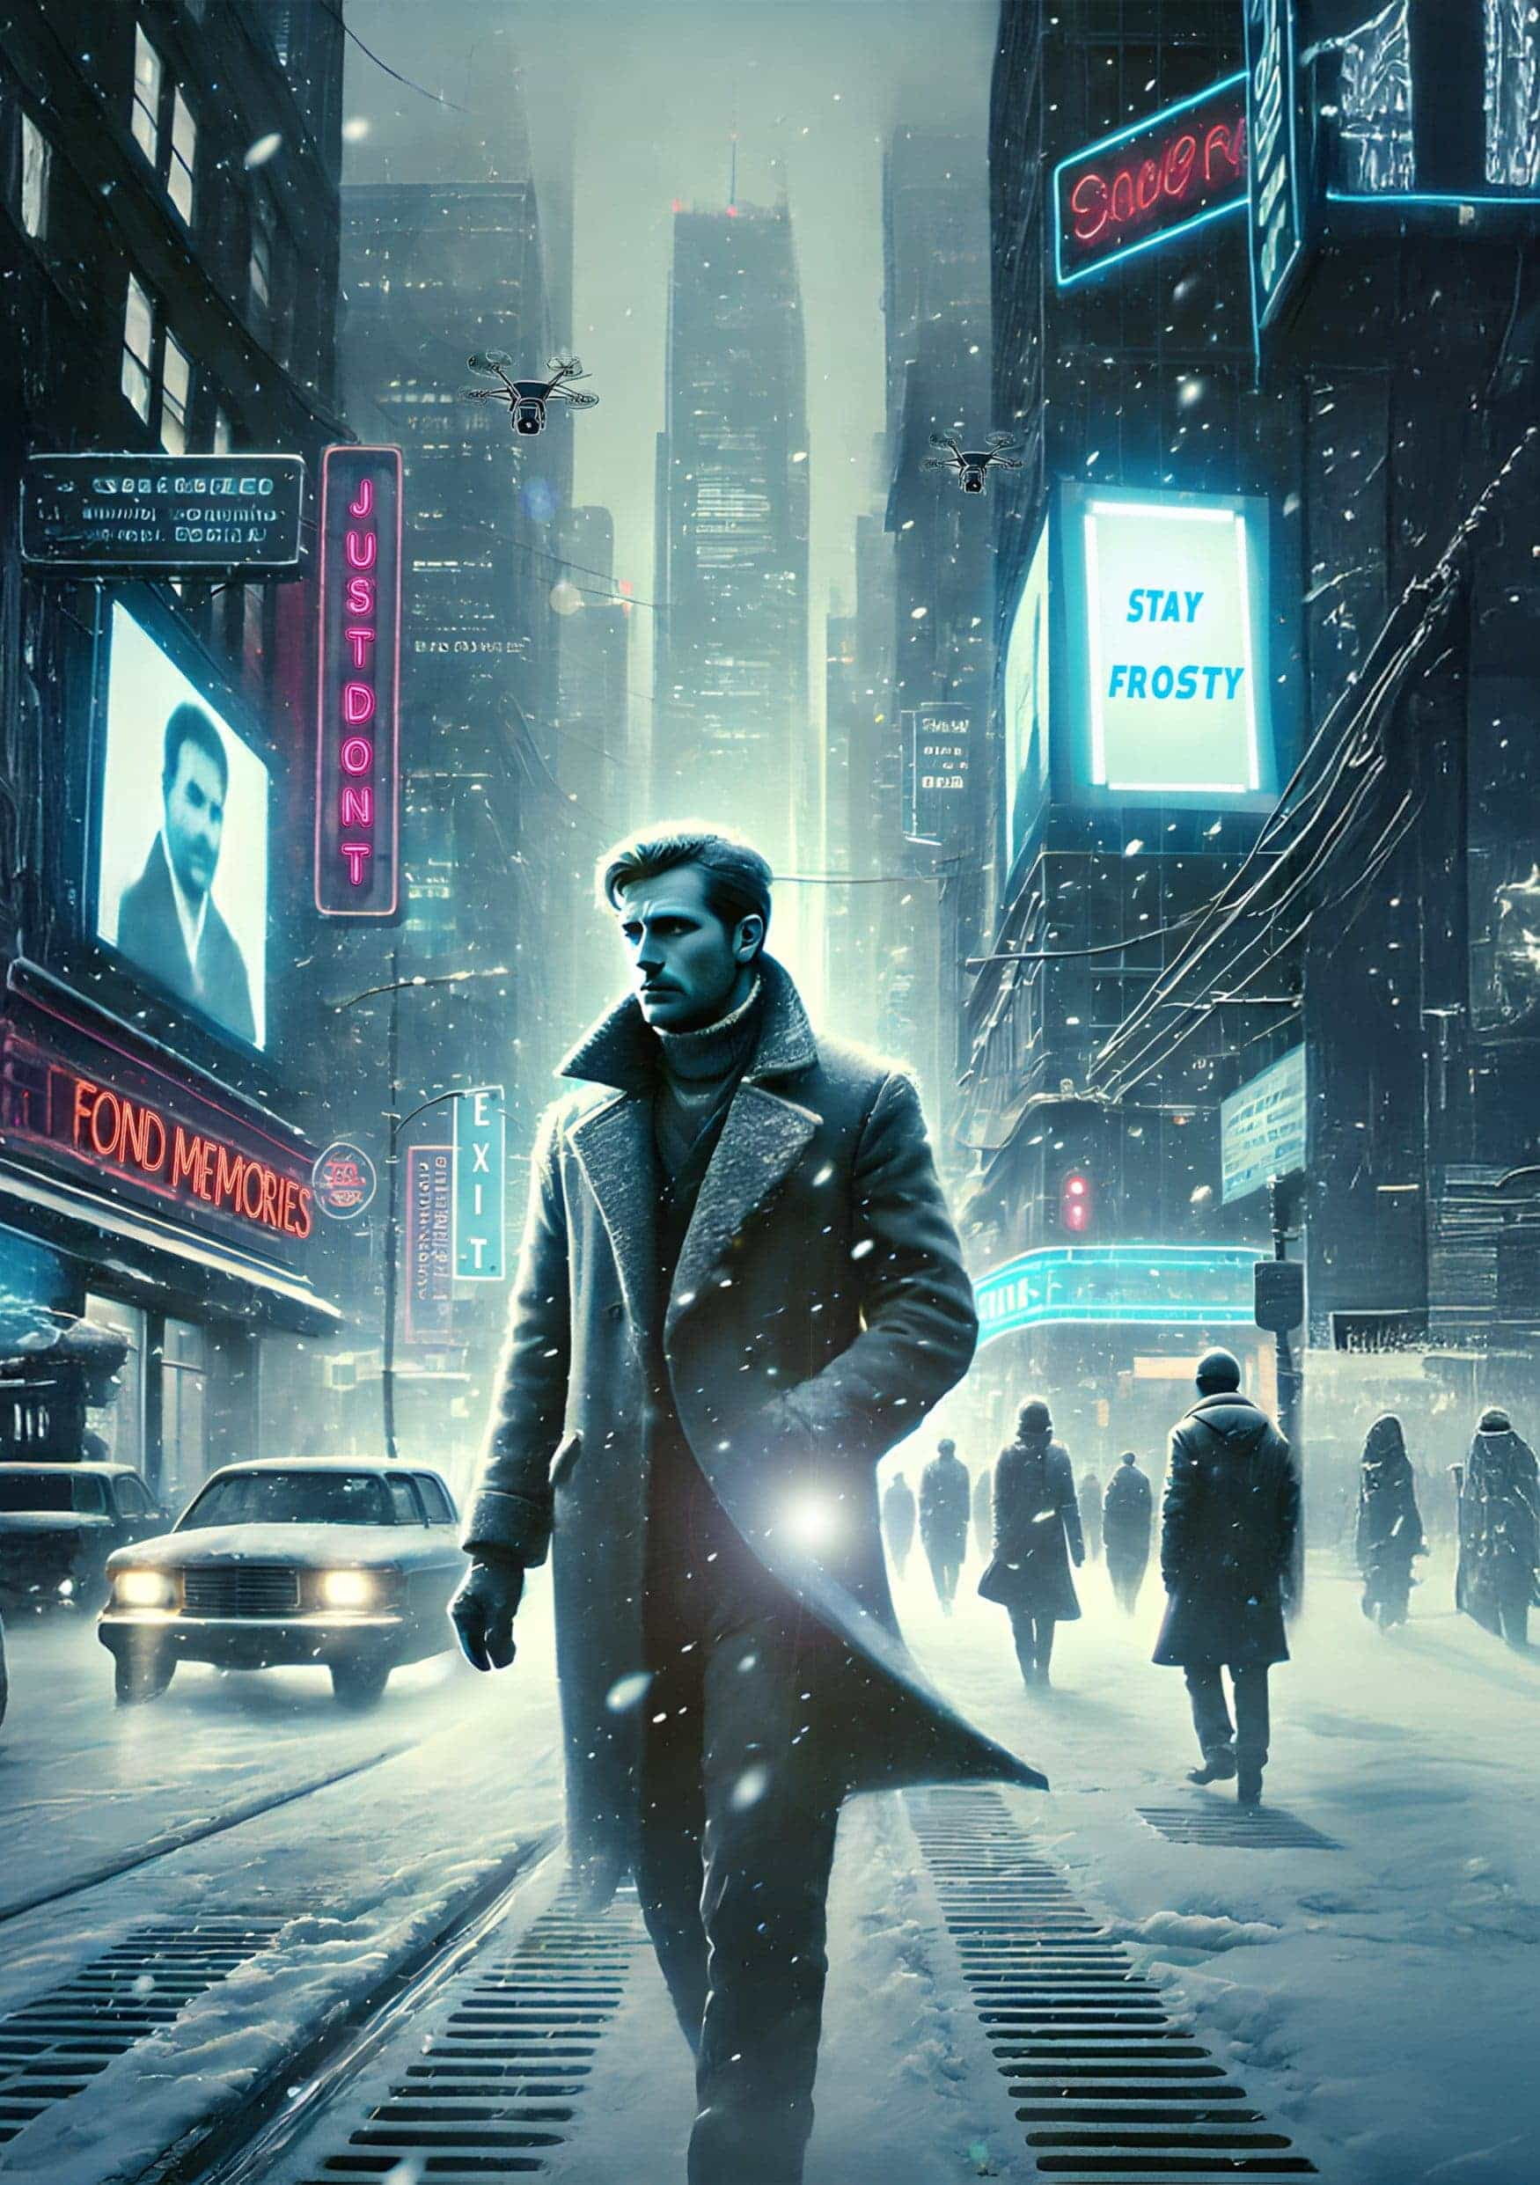

The Vision Solution

by *Ninja Grandma*

I could hear the drones in the sky above me. Surrounded by hundreds of people on this city street, it was irrational to believe they were following me. Except the piece of paper in my pocket suggested it was a justified paranoia. And that made me nervous, and that was a problem. Nervousness was visible in a body if you weren’t careful. And AI had no problem picking up on the changes in that body. I needed to get inside, away from their shrill buzzing eyes.

The laws were clear: police drones were not permitted to follow people into homes. But my home was a thirty-minute walk away. A restroom was the only other option. Would AI pick up on how odd it was that I was going into a restroom after just being in one? Just in case, I screwed up my face like I was sick, and rubbed at my belly, feigning pain.

But they weren’t following me. Surely they weren’t following me.

I entered the shoe store, found the men’s bathroom at the back, and closed the door behind me. Weak, I sat down on the toilet, pants still on, and pulled the piece of paper out of my pocket. My hands trembled. The bastard. I’d watched him get tasered and arrested. Hands still shaking, I read again what he had silently and hurriedly scribbled in pencil in front of me on a sheet of paper in the bathroom at the busy train station.

They’re not getting my bitcoin. I don’t want to burn it. It’s joined. It’s not memorized. And then twelve words in ink. Twelve words that may or may not have money on them.

He’d made eye contact, handed it to me, and turned to go into the stall, flushed the toilet, come out, and I’d watched fifteen officers rush in, find, and arrest him. I left as quickly as possible, along with the many other strangers in the restroom at the time.

I was haunted by how interested they were in that toilet, thinking he’d flushed the words. I was haunted by the peacefully angry smug look on his face on the ground.

Fuck. I had to get myself under control. I had to get home. Or throw off the AI. I put the paper back in my pocket and pulled out my phone. Hey Jenn, I texted. I just watched someone get tasered. Bad. It threw me off a little. I think I’ll head home and finish the errands tomorrow. I waited for my wife to reply, taking deep breaths.

Oh no! What happened?

Someone got chased by police and arrested.

Why?

No idea.

Ok, she replied. See you soon.

I rubbed my face, suspecting the phone would add these texts to the data that the AI in the area was drawing from, giving it an alternative explanation for my irregular body language. Hopefully enough to dismiss me as someone worth watching or following out on the streets.

It appeared to work because once out on the snowy street, it didn’t take long for me to out-walk the sound of the drones still circling over the crime scene. I dared not look back at them, feigning disinterest as I hurried home in the cold snow.

When I got home, Jenn took one look at my face. ‘Are you ok?!’

‘Yeah, yeah. I’m fine. Just a big hullabaloo. I’ll be fine.’

‘Are you sure?’

‘I’ll be fine.’ I kissed her forehead, set my phone on the counter to give it a reason to be far from listening to me, then moved past her and headed to the office, where I hid the piece of paper in the safe. But then I took it out and hid it inside a secret slot in the art piece on the wall, feeling paranoid. Well, more paranoid than normal. Everyone felt paranoid these days. It used to be only celebrities and the occasional random victims who had to live with the paranoia and trauma of stalking. Now, it was everyone, the entire society.

If there was money on that seed phrase, I’d have to turn it in to the police, right? I’d look later. After everyone was in bed.

Dinner was ready soon after and I managed to distract myself in conversation with the kids; Noah was our house clown as much as he was the class clown. After they went to bed, my wife and I sat in chairs in the living room, scrolling through our phones in companionable silence, showing each other memes and headlines.

‘Hey, is this where you were, Lewis?’ she asked, holding out her phone.

I looked at the location in the article, and the mugshot under the headline. ‘Looks like it,’ I said. She got up and sat on the armrest so we could read it together.

Man Arrested for Refusing to Allow Excess Funds into Distribution, the headline read.

The man had inherited three bitcoin, now worth enough money to live opulently on without working a day the rest of his life—for multiple lifetimes—and had been required to turn in the amount over a fair lifetime supply for taxes to be distributed to poor veterans and widows of the war. The man had ranted and raved that it was theft, and had refused. Before fleeing, the man had sent the money to a mixed burn address, and had told police in interrogation that he would rather nobody access it ever again, adding to everyone’s value than hand it over to thieves. Police still suspected he had tried to flee with the seed words and as a last-ditch effort had flushed them down the toilet. If so, they were lost. Initial mind-reading interrogations had not overheard any evidence in his mind of a memorized seed phrase.

I sighed, and Jenn said she was going to bed. I told her I’d join her in a little while. After she went to bed, I left my phone on the couch and went back to the office, closing the door. I turned on the computer. Computing power had improved so vastly over the last few years that everyone had personal servers now. The cloud had died long ago, and privacy in one’s home was making strides again; the continual ebb and flow of prey and predator strengthening all sides. The war with China had shown everyone how necessary the individual privacy of citizens was for the safety of a nation. China had killed people by hacking into and changing medical records; we had killed people by deleting bank accounts on their continent, wiping out all savings, debts, paychecks, loans, and more, leaving only bitcoin untouched. They had used data to find population centers most pro-war and targeted those, leaving populations alive that were more amenable to their terms of surrender.

We had won, if you could call it that, but the cost had been high for the world. Now personal servers were the norm, to protect the country. Both sides had used swarms of thousands of AI drones to hunt down enemies, infrastructure, communications, and destroy them. Even while it was being rebuilt, bitcoin was usable over mesh networks, walkie-talkies, and more. It was a lifeline in both countries.

I opened my bitcoin node and imported the gifted wallet. When the balance appeared on screen, my breath caught in my throat. My hands started shaking worse than earlier in the day. Three bitcoin? No. There were fifteen. I could hardly breathe.

Shit. Shit, shit, shit.

Fifteen freshly joined bitcoin. I looked deeper. There was a history of coinjoining for some time. The authorities only suspected three. A deviant thought took hold; I could give back the most recent UTXO containing three bitcoin, let them think that was all, and keep the rest. Or since it was already made private, I could keep all of it. But I knew I should turn it all in.

I shook my head to clear it, shook out my arms, rubbed my face, and made a decision; I coinjoined the 3 bitcoin to a new wallet and did not touch the rest, hidden so long as I did not touch it. I wrote down the new seed words and put the wallet of 3 into the safe, and the rest back into the painting. I burned the arrested man’s note over the toilet and flushed the ashes. Then I went to bed, feeling like everything was unreal.

I woke to the sound of loud knocking on our front door. I heard someone yell ‘Police! Open up!’ My heart wanted to sink, but it shot out of my chest in a million loud beating heartbeats, painful.

The pounding continued. Jenn turned over, eyes wide in the yellow of the streetlight outside our window.

I stumbled out of bed and put a robe on, then headed downstairs to open the door. When I did, the police pushed their way in, past Jenn’s protestations that they needed a warrant.

‘We have one,’ a man said, showing us a paper that was a warrant, or so they said. Nobody studies what real warrants look like though, do they? They separated us into different rooms, and I could hear them questioning her in the office.

‘You were downtown earlier,’ an officer said to me.

I shivered. ‘I was. What is going on?’

His eyes narrowed behind his glasses, which would be recording everything and giving him feedback. ‘You were there when we arrested Jeremy Johnson in the public restroom.’

I nodded, overwhelmed. ‘I was.’

‘He gave you a piece of paper.’

I shook my head, horrified. ‘No.’

The police officer’s head raised in confirmation. ‘Where is it?’

‘I don’t have—’

‘It’s here!’ the man yelled. ‘Search the house. He gave it to him!’ They started ransacking the place.

‘What the hell is going on?!’ I yelled, trying to approximate the reaction of a man fully confused.

I was placed in handcuffs and left with a single guard. I listened to my house being destroyed, my wife crying, and my kids waking up in fear above us. One of them screamed, and the policeman shoved me back down when I tried to stand.

They looked everywhere — under couches, drawers. They tore up the couch, they looked behind the air conditioning grates, even behind the painting, but they didn’t notice the near invisible slot it was hidden in. I was incredibly careful to not look around, to not rest my eyes on the direction of the painting or where the paper was, to not give the location away. I decided I had to maintain my innocence and hope they didn’t find it.

Two hours later, they were still seemingly making fools of themselves.

I overheard them talking. ‘Vision saw Johnson give him a paper, the AI is picking up micro-expressions that Lewis is lying. I think we just need to hook him up to Vision to find out where.’

I watched fearfully as they came toward me with a machine. The man in charge knelt before me. ‘You’ve seen the dream recording technology, correct?’

I had. The basic working versions had been around since at least 2023. I couldn’t breathe. This was why memorized seed words and brain wallets weren’t used anymore.

‘We use them in interrogations, naturally. The ability to visualize what you think. Earlier we hooked Johnson up to one, and despite his best efforts at keeping us out, he slipped and visualized handing a slip of paper to a man in the bathroom. We followed the lead and have visited the home of every person who had been there. You are the one who is lying to us. So now, you can tell us where it is, and get a mere year in jail, or we will need to Vision you. It’s a minimum sentence of twenty years at that point.’ The bastards chose that moment to bring my children into the room and sit them down in front of me.

The choice was clear. I could, over the course of the next hour, have my head shaved and multiple sensors placed on it. They would be able to recreate everything I was seeing on a screen before us, and if I looked at it, it would be like a picture of a picture of a picture repeating, blurry but true. They would blindfold me and begin asking where the slip of paper was. I would think of the garden. The front yard. I would try to visualize anything other than — no, I would need to think of the kitchen. I’d think of the balcony. The closet. I couldn’t think of the slot on the side of the painting.

And eventually, they would find it, the thing I was thinking about not thinking about, and my kids would be grown up before I could hug them again.

‘It’s in the safe,’ I told them dejectedly, not needing to feign defeat.

A year later, my wife picked me up from prison. She kissed me. My kids hugged me. She had a surprise party waiting for me at home.

A week later, I went fishing with my best friend from college.

‘Damn,’ he said. ‘Two weeks after you went into prison, they came out with a way to protect bitcoin from mind-reading attacks.’

I stared at his face. ‘How?’ I asked, breathless, thinking of not thinking about the painting on our wall.

‘Come on,’ he said, putting his stuff away. ‘I’ll show you.’

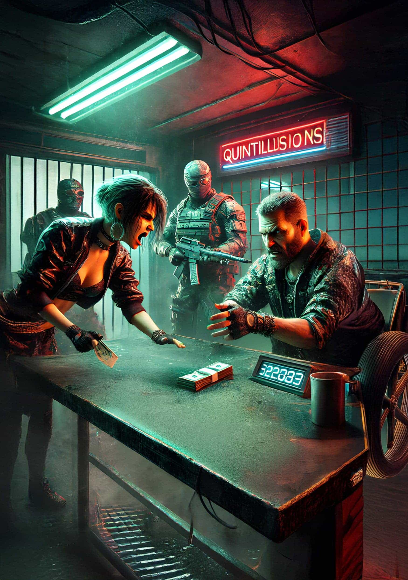

Beneath the Fall

by *SF*

Rayleigh smacked the wad of quintillion dollar notes on the table in front of her. ‘You are pushing your God damned luck! You do know this, don’t you?’ Her tone was indignant, and she had that mad glint in her eyes Hiko knew all too well. She stared down the heavily armed dealer in the eye.

His face remained calm, albeit peppered with micro-expressions of fear. The dealer, or ‘Scratch’ as he was known, glanced at his backup — two lanky fellows in shifting camo gear that gave them a sketchy appearance as the fabric tried to blend in with its environment. Their faces, hidden behind anti-recognition shrouds, made them impossible to read.

They must be packed to the brim with weaponry, Hiko thought.

‘That’s over five hundred quint in cuckbucks, you fuck!’ Rayleigh shouted while standing up from her chair. Spittle hit Scratch in the face, despite him leaning back in disgust.

The two lanky guys both took a step forward, perfectly in sync. Scratch stopped them by holding up his right hand.

Hiko interjected. ‘What my partner is trying to say, is that last month, you were happy to trade for less than a quarter of this amount.’

‘AND NOW, YOU’VE GOT THE GALL TO—’ Rayleigh interrupted, nearly foaming at the mouth.

Hiko wrapped his hand around her belt and tried to pull her back down into the old lawn chair. He hissed through gritted teeth at Rayleigh, ‘And now,’ turning his gaze back to Scratch, ‘we are very happy that you are willing to accept paper and would love to continue our business relationship for years to come.’

‘Listen to your partner, woman. He knows I should be demanding sats instead of that toilet paper. You’re lucky I get a steady trickle from on high.’

Hiko didn’t like the situation. It was hard enough scrounging up the fiat. And negotiating with Scratch was no joyride. They had come in at noon in unrelenting heat to enter this greasy dark shithole of a warehouse, and it left them nearly blind for the first ten minutes. It was hot too. The corrugated roof only amplified the heat. Sweat stung his eyes. He didn’t trust Scratch one bit.

‘How long have we known each other? At least a year or two. Maybe three? You know how it is out there. And this heat! It’ll make the best of us agitated. Never mind our lesser peers.’ He nodded at Rayleigh while keeping his eyes on their counterparty.

‘Ha!’ uttered Scratch as Rayleigh grumbled under her breath. Scratch sat back, visibly more relaxed.

‘You know,’ he said ‘I like you Hiko. You’ve been a reasonable man. And I do know what it’s like out there.’

‘It’s no picnic,’ said Hiko in agreement.

‘Ain’t that calling a meatgrinder a merry-go-round. That’s why I stay right here.’ Scratch said, holding out his pale arms. They were covered in scars, scabs and fresh cuts. His long fingernails, filthy black-rimmed things clipped into sharp points, looked horrific.

Hiko watched as he used them to vigorously scratch his bald head and neck, painting pink stripes. Even drawing blood in a few places. ‘Have I ever given you the tour?’

‘Euhm…’ Hiko was definitely not interested in extending their visit. ‘I don’t think you have, but that’s okay, we don’t want to waste your precious time.’ Hiko offered. ‘But maybe next time? Besides, we still have a dog to skin, don’t we Rayleigh?’

Rayleigh, however, wasted no time, looked Scratch dead in the eye, and said, ‘Show me’.

‘You see, she wants a peek.’ Scratch said. ‘I must insist and finally show you my little paradise. What kind of host would I be after all these years? Just keep that bitch of yours on a short leash!’ He snarled, scratching his many chins while staring intently at Rayleigh.

‘Oliver, help our guests up. We are going to give them a grand tour of the place.’

A humanoid robot had silently approached. It pulled them up, painfully, by the trapezius, that muscle between neck and shoulder. The robot was dressed like a butler. It even had a bowtie. If not for the excruciating grip, it would have been comical.

‘Get your hands off of me, you stupid machine,’ Rayleigh shouted in anguish. It was no use. It had taken hold and would continue to do so until commanded otherwise, or until its battery ran dry.

‘You may leave the money on the table.’

‘Not until you let us go and give us the goods!’ Rayleigh responded.

Scratch glared at her, then at Oliver. ‘I said, you may leave the money on the table.’

The robot squeezed even harder.

‘Aaah okay, okay!’ The big wad dropped down with a thump.

‘Follow me.’ Scratch fiddled around beneath the table. His chair started to roll back and swivel, revealing something new. Scratch sat on a motorized wheelchair. It looked like a miniature tank.

‘Nice tracks,’ cried Rayleigh, tears rolling down her face. ‘But can you tell this chips-for-brains that I would like it to loosen its grip!?’

‘Will you behave?’

‘Yes, yes, I’ll fucking behave!’

‘Good girl. Do as she says, Oliver.’

Rayleigh whispered as quietly as possible. ‘You heard that, Oliver, your boss commanded that you should do as I say.’ There was no response. It must have its voice disabled. Or maybe it was one of the early models. She whispered again. ‘Pretend you are holding me, but don’t really.’

Hiko looked in her dark brown eyes, amazed by her quick thinking. She winked at him through a lock of equally dark hair.

He gave her an expression, clearly meant to convey the question ‘Well? Did it work?’

She hissed at Oliver to do the same for her partner.

Hiko felt the iron grip relax, providing instant relief.

‘Now what?’ He spoke softly, with unmoving lips, like a ventriloquist.

They neared the two lanky guards and knew to shut up.

The two parted to let them pass, then moved in behind them to follow, again, in perfect synchrony. Hiko looked at Rayleigh with questioning eyes.

‘More bots?’ he asked.

She responded with a look that said probably, but how the fuck should I know?

A nozzle pressed against Hiko’s spine. The movement of the thing, staying perfectly in place at a constant pressure, confirmed it. He looked at Rayleigh, and with a deadpan expression and a slight nod, they both said, ‘Bots.’

They moved deeper into the building. Junked cars, refrigeration systems and old Bitcoin miners lined the walls while the clickety-clack of Scratch’s tracks on concrete accompanied them.

‘Please excuse the mess down here,’ Scratch said matter of factly. ‘Since the world’s financial system has gone into total meltdown, we’ve not kept it very tidy here.’ He was fingering two thumbsticks on either end of his armrests to steer his vehicle. ‘Only a bit further now,’ he said. ‘We are nearly out of this dreary place.’

Scratch used his middle-fingers to drive, thumbs free to swipe through touch screens embedded below the little joysticks. Two heavy sliding doors in the back wall started to move, slowly. Beyond it, another set of doors.

‘Nice sluice you’ve got set up here,’ Rayleigh said. The doors were as thick as her underarm.

‘In a previous age, when paper and gold were still worth something, this used to be a bank.’ Scratch returned. ‘Hence the airlock. Armored vehicles were inspected at this point, before they could enter or exit fully.’

After the first doors slid shut, and after some more tapping on the touchscreens, the second pair slid open. Light streamed in. The artificial kind. The feel of the air changed too. Less humid, and slightly chilly. It was a welcome change from the decrepit warehouse.

Scratch told them that this was where they packaged the hard stuff. He moved over to a long table where a dozen or so scrawny kids, who couldn’t be much older than seven to twelve years old, were shoveling piles of pills into various sized bags. He picked a white pill off of the table and ate it. ‘These little brats are cheaper than automated machinery, believe it or not.’

Rayleigh hated how Scratch said it. She hated how dispassionate he was. The fact that he was telling the truth was even more painful.

A conveyor belt protruded from a hole in the wall, slowly trickling more of ‘the hard stuff,’ as Scratch called it, into this packaging area. An older kid was working on gathering closed bags and putting them into crates on the other end of the room.

Scratch noticed her stare, and must have read the dismay on her face.

‘Are you sure I cannot interest you in a batch? I’ll throw one in for free, give you a taste, what do you say?’

‘Keep your synthetics,’ Rayleigh snarled. ‘We don’t want ‘em!’ .

Scratch growled, ‘Relax, will you? If it wasn’t for me and my synths, you would’ve perished a long time ago, wasting away in a breadline or sold into slavery. So don’t act all high and mighty with me! Besides, someone must provide the higher ups with what they desire. And in return…’ His voice trailed off. Scratch stretched his arms to each side, palms facing upwards. The next set of double doors opened automatically. The light on the other side was natural this time and a venerable oasis opened up to them.

Hiko gasped.

Rayleigh’s jaw dropped.

Perplexed, they stared at the scene.

‘Well, come on, what are you waiting for?’ asked Scratch, as he casually rolled into this Garden of Eden.

Hiko had never seen so much green. His eyes were drawn upward. Thick vines wrapped around tall trees. Lush greenery, full of fruit and glistening with moisture reached for the sun. Hiko felt a nudge in the ribs. Once. Then again. He had a hard time diverting his eyes from the spectacle and slowly turned his gaze towards Ray. Unlike his, Rayleigh’s gaze was aimed downward. At first, he couldn’t figure out what he was looking at. Something glistening, snaking its way underfoot between the many plants, trees, and their roots. Children were darting around everywhere too. It took Hiko a while before he realized he was looking at little streams of water, gently meandering, irrigating the carefully constructed permaculture.

Children, dressed in nothing more than rags were playing in and around the streams. Bathing in it, or playing hide and seek among the trees and shrubbery.

As if signaling a dog to return to its owner, Scratch put two grimey fingers to his mouth and whistled. Two youths, older than most of the little ones that littered the place, approached. ‘You two, run up front and go get their canisters.’ Scratch pointed to the direction from which they came. ‘Hurry up, and meet us at the well. Quickly now!’

‘You sure you don’t want to spend some sats? I promise, the hard stuff is top quality! Or perhaps you’d like to buy some flesh? It is getting somewhat overcrowded here anyway. And the higher ups have been throttling down the quantities in their regular order.’ He pointed upwards, lazily, as he suggested this proposition. ‘You can resell for a profit, I’m sure.’

Hiko and Raleigh followed his gnarly arm and crooked finger to the middle of this lush oasis, a giant tower, bigger than the tallest skyscraper they’d ever seen marked the entrance to the citadel up high.

‘We… ehm…’ Hiko started. ‘We just want to get our water and get out of here.’

Scratch glared at them with a mixture of annoyance and sadistic joy.

Filthy weasel of man, Rayleigh thought. She saw what he was. And she knew those up high were happy to have him as their broker of filth and decadence. It spared them from witnessing the insanity of the financial fallout.

‘Come on,’ urged Scratch. ‘It’s not far now. Follow me.’

Oliver, the robotic butler, still holding them loosely, urged them on, as Rayleigh let escape a little yelp, faking pain to keep up appearances.

As they approached the mega-structure that stood centered in this rare jungle, Scratch continued talking. ‘By now, you must be wondering why I’ve decided to invite you, revealing this sanctuary’s secrets. You see, It’s my turn to ascend into the citadel.’ He smiled exuberantly, showing crooked teeth, as he raised both arms up to the tower in reverence. ‘Finally, after years of toiling down here, it has been decided. Finally, repair and reprieve! Soon, I’ll be lifted upwards to new heights. There, this frail body will be rejuvenated. One of these clones,’ he said pointing at the younglings playing in the streams, ‘is already up there, being released from limbs, organs and skin so I may thrive once again!’

The tower was made of some kind of transparent material. Little droplets, like dew, slowly gathered, and trickled down to the base of this tall pillar.

‘Isn’t it marvelous?’ Scratch asked. ‘It collects the moisture from the air. Part is sent up via capillary action. The rest trickles down into the old vault. We have over 100m³ of the stuff! Blessed H₂O! And one of you may take my place here.’

Rayleigh could no longer contain herself. ‘You monster! How can you live with yourself, knowing what goes on in the world? And these poor kids, fodder to support miscreants and fake gods!’

In a blur, Hiko turned and struck her in the face, hard. The punch knocked her to the ground. ‘She’s loose!’ Hiko shouted as he dropped to his knees and pressed his face into the moist topsoil.

‘I know that, you fool’ Scratch responded. ‘At least we now know who will replace me down here, and who shall become a breeder, don’t we? That is, if she’s lucky.’

Hiko looked up at Scratch, ignoring Rayleigh, whom he just betrayed. He dared not look her in the eye. Guilt and shame prevented him.

Rayleigh, her face bloody, screamed. Scratch had been fiddling with the touchscreen on his tank-like chair. The robot’s grip had obviously returned with a vengeance, pinching her harder than ever before. Picking her up as if she weighed nothing.

‘You really thought I would let you loose in here? Forget it! You’, he said, pointing at Hiko, ‘shackle her to the lift. We’ll send her up with the next batch.’ A door in the base of the tower opened up. Behind it, a huge stainless steel room opened up.

Hiko did as he was told. ‘I’m really sorry about this,’ he muttered weakly.

‘You will be! You son of shitcoiner!’ Rayleigh struggled as Hiko cuffed her wrist to heavy chains that were attached to a bar in the back wall.

‘Sir, here is the water you requested, sir.’ The two kids carrying their canisters had returned.

‘Can’t you see we’re busy. Leave it be and go make yourself useful getting the hard stuff, and the next batch of clones ready.’

‘You, what is your name again? Heko?’ Scratch asked.

‘It’s Hiko,’

‘You see those crates, Heko? Be a good boy and place them next to your old friend over there.’

Rayleigh watched as her former buddy helped load crates into the elevator. Stealthily, she inspected her cuffs and the chain. She had some wiggle room but not enough to reach the detonator hidden under her shirt. She had made it herself. The explosives too. Secretly, she had worn it on three previous water-runs.

In the distance, a big group of children had been corralled and were slowly approaching the elevator. Come on Ray, hurry the fuck up. The chain and stainless steel of the elevator was cool, but she was sweating profusely which made it hard to grip the chain. It kept slipping off of her thumb as she tried to whip it around it. Come on… come on! Panic started to set in. The chain rattled while she wrestled it into place. She couldn’t escape the cuffs. Not without first breaking or dislodging her thumb.

‘What are you up to? Go see what she is doing and make her stop. Knock her out if you have to!’

Hiko obeyed, dreaming about his new position in life he would be granted. Rayleigh saw him approach, and the gaggle of kids drew nearer too. As Hiko entered the elevator, the children were not far behind him.

Finally, she got the chain whipped around her thumb. She grabbed it tightly, jumped, and let her full weight fall onto it. The pain was sharp and instant as her thumb broke and dislodged.

Hiko started to run towards her.

As Rayleigh slipped one hand out of a handcuff, Hiko tackled her.

‘What are you doing?’ Scratch demanded. He steered his chair in closer, nearing the elevator doors.

Rayleigh felt Hiko grasping for her free wrist. The other part of the chain, no longer connected to her damaged hand, was now free to slide behind the bar. As the heavy chain came free, she swung it, hitting Hiko in the head. The thing whipped around her former friend’s head, which increased its speed and impact even more. Bones cracked as the shackle hit his face.

He recoiled, letting go of her wrist.

Rayleigh tore at her blouse, revealing the DIY suicide vest below it. Time slowed, and she saw the shock on Hiko’s face, who until this point, was completely unaware of what she had been up to in her free time.

Scratch looked bewildered. He obviously had no clue he was going to die, nor that the citadel was done for too. Without ceremony, Rayleigh pressed the button.

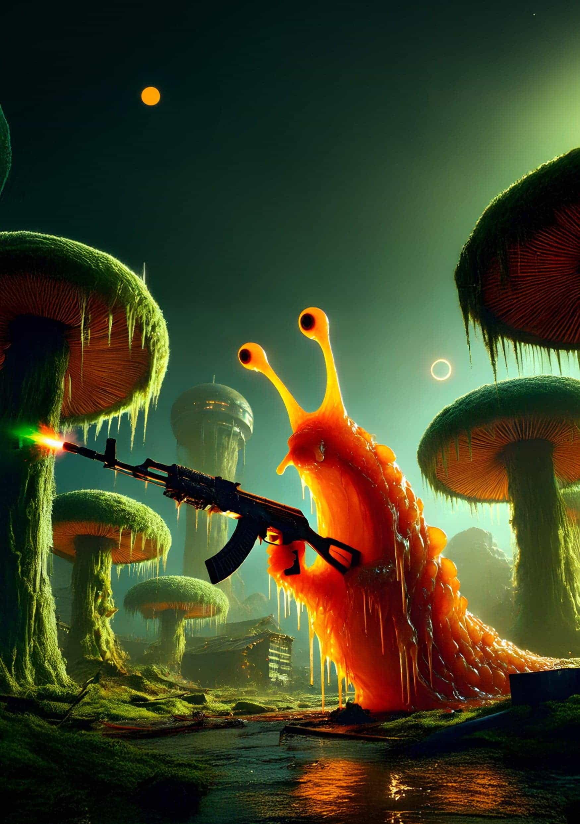

Supplying the Slugs

by *T. M. de Saavedra*

‘ 错误. 错误. 错误, ’ the digital translator flashed. Error, in Chinese.

Semyon smacked the cheap piece of shit and excused himself a moment. The indigene, a bulbous, fluorescent orange slug, swiveled its iguana eyes. It was about the size of a large dog and had three appendage-like antennae.

With sweaty thumbs, Semyon swapped the language to Basic English and spat, ‘Hello, hello,’ into the receiver. The device whirred and emitted a series of chirps and wet smacking sounds.

The slug made similar noises, and the translator said, ‘Where did you learn our language?’

Perfect. Semyon squared his shoulders and tightened the Windsor knot on his space suit. ‘Friend,’ he purred, ‘I have been here before. My relations with your people go back centuries.’

‘What is centuries?’ asked the slug. The village folk gathered around them, leaving their twig and moss huts behind, tracking slime into the sacrificial square.

‘A long time.’

‘What is time?’

Semyon pointed at the triple sun formation illuminating Ispex-4. ‘Time moves with the suns.’

‘Many days, then,’ said the native.

‘Yes,’ echoed Semyon. ‘Many days.’ He felt butterflies in his stomach. ‘Tell me, do you know of the Bishi tribe?’

One of the slug’s segmented head-limbs flicked. ‘Only legends. It is said they met with gods.’

‘They did,’ Semyon nodded. ‘We taught them the way. We showed them the truth. The very buildings you stand by, a testament to our history.’

‘You are a god?’

The butterflies ignited. Semyon swept his arms out in a passionate flourish. ‘Yes! And I have come to raise your people up. Behold!’ He pushed a button on his lapel and pointed at the sky.

The assembled slugs followed his finger and watched as a C.L.Y.P.S.O Space Crate™ broke through the clouds. It careened into their tiny village like a falling throne, landing next to the central gold mound with a satisfying thud.

‘You have done well, collecting such treasure,’ Semyon said, ‘but the Crate must judge you.’

The Clypso scanned the atmosphere and, deeming it safe, ejected its top. The deep-steel panel flattened a nearby alien shrub.

‘You are worthy,’ breathed Semyon. ‘Time it is for you to take your rightful place as stewards of this land.’

The villagers leaned forward, stretching themselves thin as Semyon reached in. They gave no sign of having heard him.

Worthy, they chanted.

‘You will be rewarded,’ he continued, ‘with the Avtomat Kalashnikova model of 1947. The Kalashnikov.’ With a flourish, he drew the old piece of iron and plywood into sight.

Silence. One slug used a cranial limb to moisten its eyeballs.

‘What is it?’ another finally asked.

‘A gun.’

‘What is a gun?’

‘An artifact of my people from many, many days ago.’ Semyon pointed at a nearby tree. ‘Observe.’ The slugs did, bulging in anticipation.

Flicking the safety off, Semyon fired, gouging out chunks of bark until the trunk cracked and gave way.

An indigene droned. The low note grew harsher as more joined in, until it quaked along Semyon’s diaphragm and deep in his lungs. He threw the AK into the crowd; a slug caught the rifle upside down, engulfing it in its head-tendrils.

In choir, they sang, Worthy.

He emptied the crate and lined them up like fat guerilla sea anemones, said, ‘Aim at those trees and pull the trigger.’

‘What is the trigger?’

Semyon grabbed a nearby slug’s antenna and placed it appropriately, grimaced, wiped the chunky slime off on his slacks. ‘Now, squeeze,’ he said, smiling again.

The hammering of a dozen assault rifles sounded a lot like ka-ching.

‘Beautiful,’ one slug chirped. ‘How does it work?’

Semyon said, ‘Ancient magic and fire.’

He showed them how to reload, gave them a brief lecture on firearm safety, then requested they load up the amassed mineral. In the process, he learned they had no word for it: to them, gold was just shiny rock.

They hummed in harmony while filling the crate. The tune raked around Semyon’s spine, giving him goose flesh. He likened it to a hearty tribal song.

Worthy, they repeated.

With business done came the easy part. ‘It pains me to leave so soon’ — he replaced the Clypso’s lid, and heaved himself on top — ‘but I must go.’

‘We will tell stories of you, Traveler,’ promised one slug, possibly the first he’d talked to.

‘I’m sure you will,’ Semyon whispered. A tug on his cufflink activated the magnetic withdrawal system. The crate rose beneath him and made for the stars; it was guaranteed to be the most dramatic exit those hut-dwellers had ever seen.

The village shrank and disappeared beneath layers of flat, purple clouds. Semyon’s suit detected the thinning atmosphere and deployed an oxygen skin, designed for short trips through space.

Ahead, his Winnebago Prophecy hung in orbit like a shiny brick. Semyon crouched, steadying his approach.

Floating towards a square breach portside, he entered an empty cargo bay and kicked the crate until it fit into place. Heavy clamps clunked. The airlock door slid shut. With a lengthy hiss the room pressurized, and his oxygen skin faded.

‘Welcome back, dear,’ a husky female voice said.

‘Hi, Maya.’ Semyon stepped onto a wall, and it became the floor. Following the hallway left, he made his way to the main cabin, where the captain’s recliner sat waiting for him. Yawning, aching for a seat, Semyon swerved past and approached a wall-sized display of Ispex-4 dotted with detected wellsprings of gold.

‘Maya,’ he said, ‘please weigh the freight in cargo dock two.’

‘Confirmed. Cargo dock two contents 20.3 kilograms.’

Rubbing his forehead, he said, ‘Maya...’

‘Confirmed. Cargo dock two contents 44.75 pounds.’

Semyon grunted — the metric system wasn’t welcome on this ship. Eyes skipping across the map like abacus beads, he poked a red blob projected on the coast some miles west of his previous drop site, the second juiciest haul this side of the globe.

‘Confirmed.’ Maya handled the logistics.

He looked only once more at his recliner before lumbering back to the access hall.

Passing the cargo bay, kneading his sore ass with a thumb, he asked, ‘Maya, we got any fuel left?’

‘Sixteen percent.’

He exhaled deeply through his nose. ‘Yeah, OK.’

The passage ended at the hyperbolic ejection chamber. Semyon slid open a curved piece of tempered ba-NANO glass and stepped into the launching capsule. The entrance swished shut behind him. A red button flashed near his hip, and his oxygen skin deployed.

‘Dear?’

‘Yes, Maya?’

‘Is it wise to seed such a primitive people with—’

‘Don’t think about it.’

‘But—’

‘I said, don’t think about it.’ Semyon’s fist hovered over the go button. ‘Do you really want to live on this bus again?’

A pause. ‘Confirmed.’

It stung, of course. Even AIs enjoyed reclining, the feeling of stretching out and relishing in extra space.

Semyon’s hand hovered over GO. ‘Maya,’ he said, ‘have I ever told you who we got your voice from?’

This second pause was different. Earnest. ‘No, dear.’

‘I’ll tell you when I get back OK?’

A third pause, this one happy. Like a smile on the other end of a sub-vocal. Like a smile halfway through a mayday signal.

‘Confirmed.’

Punching it, the floor dropped out beneath him, and Semyon was sucked through and shot at the surface. The atmosphere flared around him. The buffeting air wasn’t a concern: his new hair gel was wind-tunnel tested. He crossed his arms and leaned back, watching a turquoise sky creep over the stars. Clouds broke against his back like cool, dewy pillows.

Flipping onto his chest, he spread his arms and tracked towards the western coast. He located the smattering of moss huts, built in a clearing around a gleaming mound. Slow-moving specks at the front of wet trails marked villagers. Nearby, a rocky outcrop cut into the sea.

Before slapping the ground like a pretentious meat sack, Semyon tilted upright. The suit billowed and absorbed the forces acting upon him. Freed from terminal velocity, his brogues wafted down and gently sank into gold nuggets.

‘Mortals!’ he bellowed, glad to be warmed up. ‘I have come with gifts.’

A dozen watery eyes swivelled to look at him.

Descending into the square, Semyon beckoned the nearest slug. ‘Come closer, friend,’ he said. ‘It has been many, many days since I taught the Bishi tribe to build. And you have kept their legacy, collecting gold — shiny rock — and awaiting my return.’

The slug lowered its face and shuffled closer with tiny, squishing noises. ‘Anything for you, High One.’

Semyon approved of groveling and pushed his lapel. ‘Behold!’ The cargo crashed down into the village, but this time he slid the lid off himself, leaning it neatly against the crate.

‘Never again will you fear during war. Instead, others will fear you.’

‘High One, what is war?’ asked the alien.

Semyon felt the butterflies again, stronger than before. ‘War is...’

The villagers gathered round to peer inside.

‘War is...’ he tried again, stepping away and raking his fingers through the 24-karat river for inspiration. A shudder ran up his back. Gooseflesh.

Worthy.

He heard automatic gunfire. Something wet sprinkled on him, like ocean spray. Semyon turned to find the villagers staring at one of their own, leaking fresh green liquids over the lip of the Clypso. From the treeline, a group of armed slugs emerged, rifle muzzles flashing. A villager did a jittery dance, pieces of it slapping across Semyon’s face, and something whizzed past his ear — he flung himself on the ground hard enough to taste mud. A piercing shriek rose and fell.

‘High One,’ the translator said, ‘save us.’

Sparks ricocheted off the deep-steel, gouging slug flesh. Villagers fell over the crate, the flappy skin hanging from their bodies smearing down the side. A strong metallic smell — surprisingly similar to human blood — coated the back of Semyon’s throat. The gold pile was shot and sent showering over his head.

Something hot landed on his collar and burned.

‘Stop, stop, stop!’ he screamed, slapping the searing fragment on his neck. A deformed bullet clinked to the ground.

The cease-fire came. ‘Traveler!’

Semyon peeked through his hands. The guerilla slugs looked down at him. Far away, a handful of survivors fled down the outcrop, flinging themselves into the ocean to escape. Moments later, they bobbed to the surface and were tossed about by the tide.

‘Why did you do that?!’ Semyon yelled.

‘Traveler?’ said one. ‘You showed us.’

‘Showed you?’ Semyon echoed.

Another explained. ‘We saw you fall from above, a radiant beacon, to more shiny rock.’

‘Gold,’ corrected a third.

Worthy, choired the others.

‘When you gathered them and moved aside,’ the first continued, ‘we understood. Why compete? We could take what we wanted. Truly, this world is ours. And the gold, yours. You have shown us the way.’

‘We will take the guns.’

Worthy.

‘Traveler? Are you well?’ His customers pressed in on him.

‘Uh, yes,’ Semyon said. ‘Yes. As for the gold...’

One of the guerrilla slugs bowed. ‘Worry not. We remember.’

They continued their song—a land shanty? — and with a shiver up and down his spine dumped the corpses aside, unloaded the crate, and filled it anew. They even replaced the lid, as they’d seen him do, and arranged themselves into an oozing staircase, which he climbed with tight steps.

All around them, corpses. A large hole torn in one of the dying villagers spilled something that writhed with breath. A green stream flowed along the ground, joining the mangled bodies together. Copper casings coated the dirt like leaves.

‘We will tell stories of you, Traveler,’ Semyon heard behind him.

The front of his suit dripped. Under his feet, the crate rose with a sucking sound.

It was happening. He had thus far managed to avoid such an outcome, and he was in no way prepared, but it was happening. He’d seen it in fast forward on the Archives time and again: one clan conquering a land which offered — no — could offer no resistance in light of sudden shifts in firepower. There was no hope for the other denizens of Ispex-4. Unless, of course, someone got them weapons, too.

Already drifting past the ship’s windshield, Semyon discovered a small orange ring digitally superimposed on the glass. Even this far from the central transport curve, some power-tripping surveillance beacon had issued him a parking ticket. Semyon lost his shit, but the vastness of space made it insignificant.

The cargo bay locks clunked.

‘Welcome back, dear.’

Semyon let the gore congeal and stepped inside, flat footing into the cabin, past his recliner, and up to the map, where he brought the gold projections together into one red hologram about the size of his fist.

‘Dear?’

Prioritizing a trip back to Earth-1 was critical. There were plenty of weapons under the garbage. With just one return trip, he could cover rent for months. Maybe even a year. Time dilation was against him, though. What would happen if he took too long?

‘Dear?’

‘You know, Maya,’ Semyon said, ‘when I drop, usually I grace these peoples with the gift of fire. Got the idea from an old story, maybe you know it.’ He punched the display, the red glinted through the flesh of his knuckles. ‘Between the heat and the colors, usually I have ‘em by the balls from the start. So to speak.’

‘But these fuckers,’ Semyon laughed, ‘these fuckers figured it out on their own. Way before we got here. They just didn’t find it that interesting.’

Maya didn’t reply. A map of the local cluster blinked up on the ship displays. Trajectories calculating, thousands a second.

‘Those guns won’t jam or break. They’ll shoot anywhere, forever, until they run out of ammo. Think they’ll find a way to make bullets?’

Triangulation in the silence. Calculating. Distance matrices, calibrations.

‘You get to the top of a food chain and things move pretty fast. We could stay here a hundred years and nothing but just one skip back to Earth and—’ Semyon harrumphed. ‘Ruins of intelligent life everywhere. Some of it could try getting past its first game of King of the Hill.’

Maya asked if that was sad.

Semyon thought about that one. Settled on, ‘Yeah, I guess so.’

He came to, pivoting on one heel and storming for the access hallway. ‘Let’s go. High burn towards the Home-cen curve. Get me to a TRK stop.’ He hoped they had enough to buy a half tank of gas.

‘Confirmed.’

Semyon lifted an arm and a line of green slime cracked. He sniffed the sleeve and winced.

‘God damn it,’ he whispered. It was his last suit.

Maya punched the ignition. The Winnebago’s familiar diesel turnover was like a massage deep in his soul.

Semyon rubbed the burn on his neck and made for the shower, eager to wash off the stench of those savages.

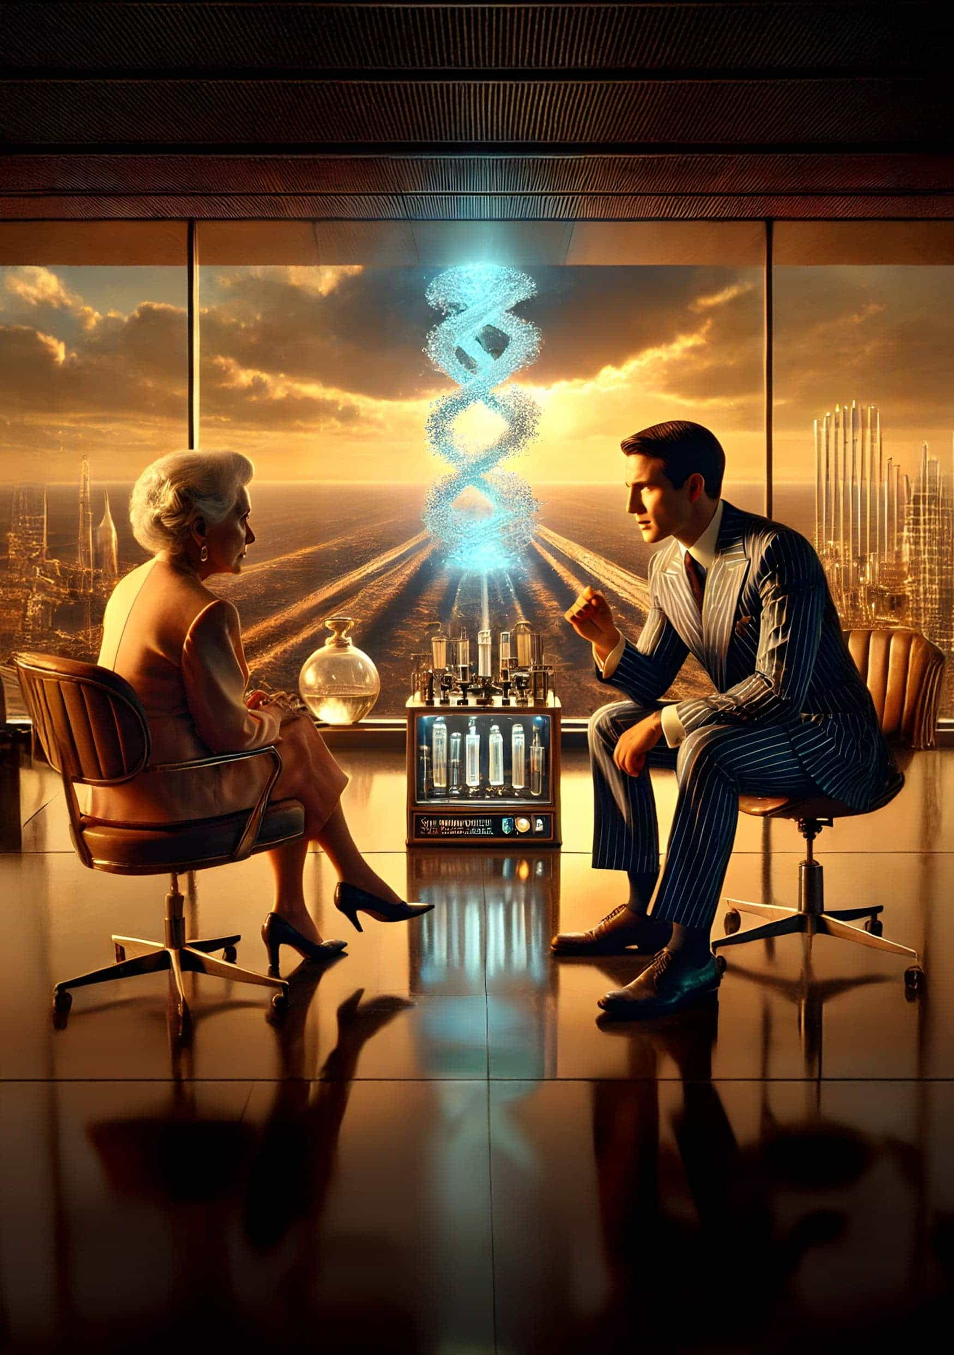

The Rainmaker

by *Joseph Sidari*

There were two times when my knee bothered me: when it was going to rain — which for the past twenty-plus years after The Collapse was rare — and when someone was trying to swindle me on a water deal, which as a rain futures broker working at CloudBank, LLC, was always. Today, there wasn’t a cloud in the sky, and my knee was killing me.

I broke eye contact with the man sitting across from me, stood up from my desk, and limped to the broad picture window. From my office on the fourth floor of the Nevada Wing Administration Building atop the Hoover Dam, I could see past the dry Colorado River bed, now clogged with solar panels. Past Lake Meade, now generously called Pond Meade by the media, and Puddle Meade by us locals. A nearby mountain range rose, breaking the desert’s monotony.

‘Are those the Rockies?’ asked Wade Burroughs, a water buyer from H2OCorp. A beefy man, over-dressed in a dark pinstripe suit and probably half my age. He fanned himself with his open hand, even in my air-conditioned office, and undid a button at the collar of his too-tight dress shirt.

‘Oh, no.’ I chuckled as I hobbled back to my desk. ‘The Rockies are 700 miles away. That’s Mount Charleston. Just north of New Vegas.’

‘Sore leg?’ asked Wade.

I shook my head. I hated small talk. All this guy wants is my rain at his price. He’s not interested in the complications from my knee surgery at the West Coast Mecca for medical care, New Vegas Medical Center.

The orthopedics service there did over 4,000 joint replacements the year I had mine. The average patient spent seven hours there, surgery only accounting for two. Ten percent of the patients stayed overnight because they didn’t have enough fresh water at home. And ten percent of those overnighters had complications requiring an extended recovery. Like me. I stayed there for nine months. On that day, I limped out the front door. The only assistive device I needed was a silver-tipped cane. It still sits behind my desk.

I left Vegas Med five years ago. My orthopedic surgeon led the parade: Dr. Willa Balcom, with nurses, aides, and all the rest who saved my leg and my life. And my fellow patients (I met hundreds during my stay), but the twenty patients on the ortho ward that day gave me a standing ovation. I keep in touch with all of them to this day. Although I’m trying, I owe that hospital a debt I can never pay. I send them a little water every month, whatever I can spare. I wish it were more.

On the downside, my right leg is now two inches shorter than my left, and I have to use the elevator, escalator, or slideway if I want to walk over ten meters. And even if I’m not walking, it still aches.

So, no. I didn’t feel like sharing all that.

‘It’s fine.’ I dropped into my chair, the stuffed cushion letting out a whoosh.

‘So they call you The Rainmaker?’ Wade was fiddling with his collar again, trying to release more heat. ‘Is that because you were the weather girl, uh, I mean, weather woman in LA, before—’

‘Yes,’ I said, interrupting him so he could remove his foot from his mouth before he swallowed it. ‘It was my first job, back when we had weather besides dry, drier, and driest. And when California wasn’t underwater.’

‘Rainmaker started because I was ‘Marisol Garcia, the Weather Girl’ at KTLA. Whenever it was going to rain, my tagline was, ‘Remember your umbrella today because I’m gonna make it rain on you!’’

‘Ha ha.’ He laughed nervously and mopped his brow. ‘A silly little nickname, I suppose.’

Watching this guy sweat made me hot, and I get cranky when I’m hot.

‘Silly? It’s offensive. How could someone refer to a college-educated meteorologist as The Weather Girl? Are you The Rain-buying Boy? I bet not.’

‘No,’ said Wade. ‘I meant—’

‘But I am no longer twenty-four, Wade. I’m pushing sixty-four. This gray hair? I’ve earned it. Because for the past twenty-five years — yes, right after The Collapse — I haven’t been forecasting the weather. I’ve been selling it. So no more small talk.’ I narrowed my gaze at him.

Wade raised an eyebrow. ‘Dina told me you like to chitchat.’

‘Dina was hosing you, and not in a good way.’ I remembered Dina, that snooty buyer from the northwest region. She was pissed her last contracts didn’t tap out as planned. So, now she was either trying to screw poor Wade as he negotiated for a contract, irritate me, or both.

‘So let’s get down to it. I have rain contracts. You want them. How many MSIs do you want?’

He didn’t flinch. ‘One hundred seventy-seven.’

I did a double-take. ‘You’re serious.’

He nodded.

I swiped up my calc screen. ‘Convert 177 MSI to MiGs.’

Numbers flashed as the program converted Miles-Squared Inches of rain to Millions of Gallons. ‘You want 3000 MiGs of water? Are you crazy, rich, or deluded? And I hope it’s all three, because that’s a lot of rain. Are you trying to supply the whole East Coast?’

‘No,’ he said. ‘Just Greater Pittsburgh and the Appalachian Valley.’ He stood and took off his coat. Huge sweat stains drenched his underarms.

What a waste of good water. And then his words sunk in.

‘The Appalachian Valley?’ I sputtered. ‘You might as well be supplying the entire East Coast when you’re buying for the third-largest city. Why not throw in Columbus, Charlotte, and Atlanta and call it a day?’

‘First things first,’ said Wade. ‘We can discuss those later.’

‘Wait.’ I returned to my calc screen. ‘My catch basins range in size from ten to one hundred MSI. I’d have to call in a lot of favors to get that much water. Don’t you have any collectors in your region? Western Penn is a big state. And you’re coastal in Greater Pittsburgh. What about desalination?’

‘We are desalinating,’ he replied. ‘And our basins are earmarked for smaller towns to the north and south. But even after processing ocean water, it has too many impurities for our plans.’

‘Duh.’ I rolled my eyes. ‘No one drinks desalinated water — not if you want to keep your teeth and internal organs. It’s used in industry. Rainwater is for drinking — much easier to alkalinize to a potable level.’

He hesitated a beat. ‘Of course.’

I arched an eyebrow. ‘How else are you planning to use it?’

‘Not important. Here’s my offer.’ He tapped at his cell. A number hovered in the air. He leaned back in his chair, still sweating.

It was a tremendous figure, but it wasn’t enough to cover 3 BiGs. I shook my head.

‘Name your price,’ said Wade. ‘My pockets are deep but not bottomless.’

I swiped back into my calc screen and brought the visual to my desktop. How many basins will I need?

‘And then when we’re done,’ he added, ‘we can negotiate futures for those other cities, too.’

I looked away from my calculations. ‘So, what gives, Wade? Why are you suddenly the biggest water magnate on the Eastern seaboard?’

‘I’m not at liberty to say.’ Wade crossed his arms. ‘You’d need to sign an extensive NDA, and I don’t have time to execute one before my train leaves for the Tennessee Valley.’

‘Then I’m not at liberty to sell,’ I said. ‘If I’m diverting all these rain contracts to you, I’ll be hanging other long-time customers out to dry. I can’t do that if I don’t know where your water is going.’

Wade shrugged. ‘Impasse.’

‘Then you should leave now for the TVA. When you get there, say hi to their broker, Sandy, for me. He loves to shoot the bull. But that’s because he doesn’t have access to enough rain futures to fill a backyard swimming pool if you remember when those were a thing.’

‘I don’t.’

‘Of course not. Almost fifty years ago, people lived extravagantly. They’d dig a hole, fill it with a tenth of a MiG of water, and just lounge in it. For fun. It wasn’t even drinkable.’

‘If you say so.’ Wade shrugged.

‘Yeah. The world was an oasis back then: before geo-engineers pumped aerosolized sulfur compounds into the atmosphere in a fool’s attempt to buff our ozone layer. That worked out well, as we know.’

‘I’ve never seen a swimming pool,’ said Wade, a little annoyed. ‘But I’ve been alive for the past thirty-four years. I know what caused The Collapse. And bad-mouthing a competitor is unbecoming, Ms. Garcia. Mr. Sanderson MacRae told me he could fulfill my water needs. You’re not the only cloud in the sky.’

‘I know. But we are the biggest. And Sandy, his eyes are bigger than the ocean. That’s not bad-mouthing — it’s truth-telling.’ I yawned. ‘Before you transfer creds from your not-quite-bottomless wallet to Sandy, make sure he can name enough basins to get 3 BiGs of water — let alone sell you the rights. I swiped the calc screen away and stood up. My knee buckled before I could bear full weight, and I sat down. Hard.

Wade reached forward as if he might try to slow my fall. ‘You okay?’

‘I’m fine.’ I’d tried to make it look like I decided not to get up, but I didn’t fool him. I twirled around in my chair, grabbed my cane, and used it to stand. Now, more slowly and with success. ‘I’ll show you out, since we’re done.’

‘Wait.’ He held up a hand. ‘I can’t tell you everything. Hell, I don’t understand how it works. But if you sign a mini-NDA by voiceprint, I’ll give you some details?’

I eased myself back into the chair, using the cane for support. ‘I’m listening.’

He tapped his cell. A document floated in the air above my desk. I read it, and said, ‘Marisol Theodora Garcia. I agree to tell nobody about your mysterious device.’

Wade nodded and swiped the executed mini-DNA back into his cell. ‘You’re familiar with 3D printers?’

I rolled my eyes. ‘I couldn’t build one, but of course I am.’

He leaned in toward my desk and lowered his voice. ‘Well, we’ve developed a molecular version. We can print water.’

If the guy did not look so earnest, I’d have laughed in his face. ‘You’re kidding.’

‘No. You just have to feed in water and other materials. It analyzes it, and then water comes out.’

Now, I did laugh. ‘Wade, that’s not a 3D printer. That’s a conduit. I have one of those. Pour water in one end, and it flows out the other.’

‘No!’ He raised his voice, color rising in his face. ‘If I put in one MiG of water with an equal volume of organic matter, our printer could create five MiGs of water. Pure, drinkable water. The printer disassembles the organic material, separating hydrogen and oxygen to recombine them into the finished product. I’ve seen it. It works.’

‘Impossible,’ I said. ‘And if it can disassemble matter, why do you need the water?’

‘A template, I think. I don’t know. I didn’t build the thing,’ said Wade. ‘My bosses sent me here to get enough water to make it work. So, will you sell to me or not?’

‘It seems outrageous,’ I said. ‘But if it did, the ramifications…’

‘Exactly.’ Wade sat back in his chair, looking smug.

‘You need so much water.’ Some of that water I’d promised to Vegas Med, and I couldn’t short them.

Wade stood up. ‘Can you help me? Or should I call every other water broker in the country?’

‘Don’t wet yourself.’ I swiped up, and my rain map popped back into view. ‘I’m looking at Sector 7, 8 and 9. There’s talk of a storm front moving in next week. I suppose I could sell you the rights for two weeks. It should drop about 600 MiGs in each.’

‘That’s not enough.’

‘I know that, Wade.’ I tapped several other sectors. ‘If I add the rain rights in Sectors 1, 4, and 6, projected at 400 MiGs each, that should do it.’ I looked through the floating data to stare at Wade. ‘Now let’s talk money. Make me an offer.’

‘Recent forecasts suggest that rain will fall in those sectors, so supply should be high, relatively speaking. I’ll offer eleven per MSI.’

‘Fifteen,’ I countered.

‘Twelve,’ he replied.

‘Twelve won’t cut it with the demand we’re seeing. Sure, the market’s betting on rain, and the forecast is on their side. But the market has been wrong. And then I am left holding the bag. One that’s not full of rainwater. But I have a deal that might work.’

‘I’m listening.’

‘How about I write you a contract for fourteen per MSI, but with a catch: if it rains over five inches over the time allotted in those basins, we split the overage. The weather wonks are only predicting four. If it rains less than three inches, you get two back per MSI, and I look for other contracts to fill your need, all at twelve.’

‘So you want us to split the extra if it pours, but you’ll refund me if it drizzles — and fill my contract at the lower price? What’s the catch, Marisol?’

‘The catch, Wade, is that I think the storm will be heavier than people expect. A lot of traders are underestimating. So, I’m willing to bet on a heavy rain. Plus, with that hedge, you reduce your risk. It’s win-win.’

‘What if there’s a downpour?’ asked Wade. ‘Could I end up paying for more than three BiGs?’

‘Too much water is a problem I have never heard of, but if you end up with more MiGs than you need, I’ll find buyers for the extra, and we can negotiate the selling price and split the profit. My standard commission is 10% on those contracts, too.’

‘Make it 9%, and I’m authorized to sign off right now.’

‘No deal,’ I said. ‘I don’t discount my services. Ten or walk.’

He hesitated and tried to stare me down. I didn’t blink. He did.

‘I’ll take the deal. Fourteen million for the rain futures per MSI, with the over-under stipulation on the rain levels we discussed, and your 10% commission.’ Wade stuck out his hand to seal the deal.

‘One more thing.’

Wade dropped his hand and his shit-eating grin. ‘What?’

‘This water printer you’ve developed. I want a 10% interest in it.’

‘Ha! Your brain must be waterlogged if you think my bosses will give up that much equity in an invention that could single-handedly solve the American water crisis. And maybe end the worldwide drought.’

‘Well, you can’t make water without my rain,’ I said. ‘Back to that impasse.’ ‘Ten percent is ludicrous,’ said Wade. ‘They might part with 1% for a 10% discount on this and all futures contracts.’

‘Tell them 4% stake and 8% discount, and we have a deal,’ I said.

‘They’ll never—’

‘And tell them their new 4% partner won’t be me, personally. Two will go to CloudBank, LLC, providing an 8% discount on rain futures in perpetuity. The other half will go to the Rainbow Hospital Corp. They own the med center in New Vegas and a dozen others nationwide. Consider it a charitable donation. A write-off and a gesture of goodwill.’

Wade raised an eyebrow. ‘They might buy that angle.’ He took out his cell and tapped some notes. ‘I’ll get back to you later today.’

‘And execute a full NDA for me and my team. I’ll need experts to ensure your magical water fountain works before my boss signs off.’

‘I’ll make it happen, Rainmaker,’ said Wade. He stood up and stuck out his hand.

I rose from my desk without using my cane, gripped his hand, and we shook to seal the deal. Then he left my office. I thought he was whistling.

Three BiGs per month? And multiple contracts after that? This could be exactly the break I needed. I pulled out my cell and tapped the contact for my admin. I didn’t have to check with any boss. I was the boss at CloudBank ever since I started the company on a hunch that global warming and melting polar ice caps would be a death sentence for regular rainfall. Any meteorologist worth her barometer would know that, but few invested in empty acreage and built catch basins. I owned some, leased more, and had close ties to the rest.

But being the CEO of CloudBank was a secret I guarded almost as closely as my artificial knee. If buyers knew I had the final say, how could I stall without raising suspicion? I sent a note to my admin asking him to confirm the rain totals that my Knee Network had promised. I wasn’t the only one whose knee throbbed when a heavy rain was coming. And since I met hundreds of joint replacement patients during my time at Vegas Med, and they lived all over the country, I had good intel on rainfall just about anywhere.

I tapped another contact on my cell, and a Black woman with close-cropped salt-and-pepper hair and wearing a white lab coat over a blue blouse appeared.

‘Mari,’ said Dr. Willa Balcom. ‘What a surprise. Our regular call isn’t for another week. Is your knee okay?’

‘Thanks to you and your team, it is,’ I said. ‘But this call is not a doctor-patient virtual visit.’

‘Oh?’

‘No, more of a CEO-to-CEO ground floor offer, Willa.’

‘Don’t keep me floating,’ said Willa.

‘How’d you like to make Rainbow Hospital Corp a flood of money, enough to fund all your indigent care patients for a lifetime?’

‘Thank you! That sounds amazing,’ said Willa. ‘That’ll buy a lot of water, too.’

‘Water will be the least of your worries. If things work out, I’m gonna make it rain on you and your patients for a long, long time.’

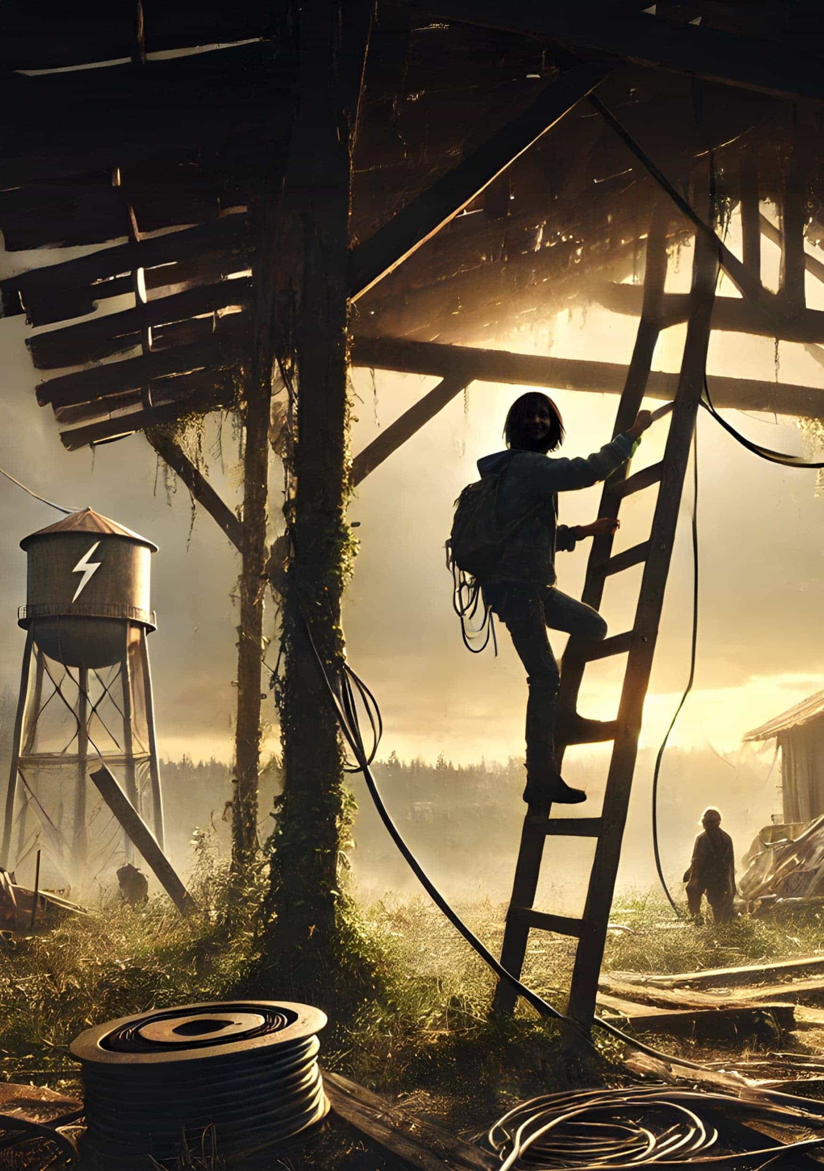

The Last Node

by *Satillionaire*

I

‘I’ll do it,’ Ada said, stretching out her palm with steely resolve.

‘That’s not a good idea,’ I shot back, but she was already snatching the short cable from my hand and making her way to the ladder.

Her small hands gripped the rungs as her skinny ten-year-old frame ascended. I watched, my throat tightening, but something in me stayed silent.

She climbed higher, struggling with the hatch door until muted gray light spilled in, only to be swallowed again by darkness. I remembered all the times I had disappeared through that hatch, leaving Ada alone. Connecting the battery bank to the solar panels usually took two to three minutes, but each time, she must have been scared that I might never return.

I tapped the pendant on my shirt, and a soft blue light shimmered, forming the hologram of Lenora, my late wife and Ada’s mother. She appeared in front of me, life-sized, and ghostly, tucking a stray lock of hair behind her ear. As my mind flashed to Ada up on the roof, Lenora’s expression shifted slightly, a trace of concern in her eyes. She didn’t need to say anything. I turned and quickly scaled the ladder.

Opening the hatch door, I peeked out onto the expansive roof. The skeletal remains of what was once a boomtown on the banks of the Mississippi stretched out around me — glassless windows like dead eyes, overgrown flora reclaiming the streets. The silence was eerie, broken only by an unnatural buzz.

I spotted Ada on the scaffolding just as she powered the inverter. The green light flickered, and she glanced at me, offering a brief smile of satisfaction. She climbed down and confidently crossed the ledge to join me.

We descended to our lair — a once-grand executive suite, now dilapidated with windows smeared in black paint, walls cracked, and cherrywood floors littered with debris.

At the center of the conference table, our node was ready, cobbled together from a repurposed server rack, electric bike batteries, and an old solid-state drive. Each piece had its own story. I pressed the power button and we leaned in, eyes locked on the old display. The wires hummed faintly as the seconds stretched. My mind raced through every possible failure point. For a tense moment, nothing happened. Then, the rhythmic glow of the node pulsed to life. The screen showed a scant handful of comrades: other nodes blinking like distant stars in the vast digital night.

Ada leaned into the old repurposed radio microphone and initiated the recording sequence to embed her message into the node’s signature. Her voice echoed through the vast suite. ‘Block height... 1,704,238. We’re cold and hungry, and longing fills our hearts. But just like bitcoin, we endure.’

Relief spread across my chest. My stomach growled, and as Ada and I headed toward the sink, something caught my eye: a flicker on the screen. The nodes were going offline.

Ada and I raced back to the table as the small fluorescent dots blinked out, one by one, until only our own remained. My heart pounded in my ears. The lobby doors suddenly burst open, dust and debris swirling from the updraft of the patrol drone blades. I snatched Ada by her coat and lunged for the elevator shaft, shoving her through the slightly wedged-open doors and onto the top of the elevator parked a floor below. The drones neared, sirens blaring, laser fire scorching the air.

We dropped into the elevator hatch door and fell onto a pile of cushions. Above us, the drones banged and pried the elevator doors to no avail. We rolled off the mattresses and sprinted down the hall to a set of stairs.

Tearing down the stairwell, we heard each step echoing through the hollowed-out building. At the bottom, I yanked open a rusted door that led to the underground parking garage. We moved quickly toward an old service tunnel at the back. We ducked inside, the narrow passageway barely wide enough for us. Cold, damp air pressed against our skin. We crawled through the tunnel, emerging in an overgrown alley. Without a word, we slipped into the woods, leaving the city ruins behind.

II

The woods I once knew have changed. I remembered how my friends and I raced through them on bicycles, fields stretching out forever. Back then, we were masters of our domain. Now, Ada and I are trespassers. Nature has taken back the land, no longer fearing man.

We emerged from the woods onto a cracked road, our old house coming into view. Its smooth, curved walls, once vibrant, now stood lifeless, the large frameless windows shattered and dark, void of the life they once held. I led Ada to the back, where the door hung off rusted hinges. I pushed it open, the creak echoing through the dead structure. I glanced back at Ada, searching her face for some sign of what she was thinking. But, her expression remained as guarded as ever.

‘We need to be quick,’ I whispered. Ada nodded and slipped down the hall. I forced open a jammed desk drawer in my old office, rifling through dust-covered cables, a power inverter, a soldering kit. I shoved them into my bag, searching for anything else that might be useful.

I found Ada in the master bedroom wearing one of Lenora’s old hats, the wide-brimmed straw sagging on her small frame. I paused in the doorway. ‘Your mother loved that hat,’ I said quietly. I tapped the pendant on my shirt, and Lenora’s hologram shimmered to life, standing across from Ada in the same hat. For an instant, mother and daughter were together again, the past temporarily intertwining with the present.

Then the moment shattered as a low, ominous hum approached from outside. My heart sank. The drones were near.

I pulled Ada into the guest room, shoving the bookcase aside to reveal a hidden door. We slipped inside, and I slid the bookcase back, plunging us into darkness. Lenora’s hologram flickered to life, her ghostly form smiling softly at us.

The hum of the drones grew louder. The house around us shook — furniture crashing, beds overturned, doors ripped from their hinges. The noise was relentless, but Ada didn’t flinch. She sat still, eyes focused, calm in a way that both reassured and unnerved me.

I watched her, remembering the little girl who used to bury her face in my chest at the slightest sound. A loud boom struck the wall beside us, and I jumped. Ada lowered her head, and for a moment, I thought I saw a tear. I placed my hand on her shoulder, but, she barely reacted. The noise above shifted, moving away from us as the hum of the drones began to dissipate. Ada brushed my arm away, her face a mask of quiet resignation.

‘We need to find somewhere else to sleep tonight,’ I said. Ada nodded.

III

The old barn behind Nana’s house, built in the ’90s, had somehow withstood The Rewind better than any of the newly printed houses in the neighborhood. It was eerie, this old pine and corrugated steel barn outlasted everything around it, mocking the modernity we once slaved to attain.

We moved cautiously through the overgrown grass to the barn. Inside, it was cold and dank, the beams groaning with age. We cleared a space on the floor of the loft and laid down makeshift beds. I expected Ada to settle next to me, but instead, she dragged her palette to the far side of the platform and lay down alone.

I stared at her across the distance, the dim light, casting long shadows between us. Was this the beginning of the difficult teen years everyone warned about? Or was it something deeper? I couldn’t shake the feeling that she was slipping away from me. ‘Ada,’ I whispered. Silence. ‘I love you times infinity.’

The next morning, I woke with a start. Pale light filtered through the cracks in the barn’s walls. It had been 24 hours since we’d gone offline. The danger was mounting but anyone still monitoring our node wouldn’t know where to find us. Or worse, there might be no one left to care. I pushed the thought aside and stood up, unpacking my bag.

Ada stirred and joined me at the makeshift table, her face offering none of the warmth or acknowledgment I had hoped for. We moved silently. I laid out the components: an old power inverter, a half-burned-out circuit board, a tangle of Ethernet cables, a salvaged solid-state drive, and an old gaming system processor.

Our communication was wordless — glances, nods, the occasional brush of hands as we passed tools. Ada worked with steady precision, soldering connections between the processor and the drive. I focused on calibrating the power interface, ensuring it could handle whatever source we managed to find.

Finally, the node was assembled, a fragile patchwork of salvaged technology that, just like us, was held together by sheer will and the hope that keeping this network alive still mattered.

IV

Ada walked a few paces ahead, her steps purposeful but distant. Dust swirled beneath her feet as we neared what was once her elementary school. The auburn-brick building, now weathered and worn, its walls marred by time, kudzu swallowing its frame. The sign, once canary yellow and welcoming, now hung crooked, its letters barely legible.

It was impossible to know what Ada remembered, or what thoughts crossed her mind as she neared the place where her childhood had been left behind. I could still picture the crossing guard, the clusters of children laughing as they bounced across the crosswalk memories from a world that seems like just a fleeting moment now.

Ada stopped abruptly at the front door, her hand hovering over the rusted handle.

‘What is it?’ I whispered, watching her closely.

She shook her head, a flicker of something unreadable passing across her face, before turning sharply and walking away, her resolve seemingly shaken.

‘Sweetheart, did you see something?’ I asked, keeping close behind her.

She paused, her gaze fixed on a shadowy corner of the decaying building. ‘We should enter through the gym,’ she stated firmly, then veered decisively around the back of the structure.

I reached for my pendant and gave it a subtle tap. Lenora appeared beside me, walking with purpose. I shot her a stern, silent look, and waved my arms as if to say, ‘What’s with this new psychic trick Ada’s pulling?’ Lenora placed a hand over her mouth and let out a giggle.

I tapped the pendant again, she flickered and vanished. ‘Not helpful,’ I muttered under my breath, picking up my pace.

Inside the gym, the bleachers were warped and splintered. We moved cautiously, the air thick with the tang of rot. We found our way up the stairs in the back and headed to the third floor.

The utility room was a graveyard of wires, most stripped bare or corroded beyond use. Ada dug into my bag and pulled out the extension cable, turning to leave.

‘Where are you going?’ I asked, suspicion lacing my tone.

‘To run this up to the roof,’ she replied, her voice steady.

‘We’re not splitting up. Get that thought out of your head,’ I ordered, the finality in my voice unmistakable.

Ada turned away, her arms crossed tightly over her chest, defiance etched in every line of her small frame.

I was done with this attitude. ‘Go,’ I snapped, and she scurried off without another word. I pulled out the node and began reassembling it on a rusted file cabinet, the only stable surface left in the room. My hands moved with practiced precision, but my mind was elsewhere: on Ada, on the danger that seemed to be closing in around us.

I heard a bang and rushed into the hall, adrenaline surging, just as Ada appeared from the roof. She was pulling the extension cord and offered me the female end.

I found the power cable to the node and plugged it in. We held our breaths.

V

It took a moment, then the node pulsed with a faint glow, and the monitor flickered to life. A few scattered blips appeared on the map: other nodes, other survivors. Ada and I breathed a sigh of relief. I opened my arms, and to my surprise, Ada let me hold her. I could feel the tension in her neck and back begin to soften. Then a harsh, grating beep cut through the air. On the screen, the dots were blinking out, once again leaving only our own.

Ada and I exchanged a panicked glance. In the distance, a low rumble began building. The drones had found us, and this time, there was nowhere left to hide.

My mind flashed to Lenora and the world we once knew. The sacrifices we made for Ada’s future. The Rewind had taken everything. But we never surrendered. We had volunteered for this mission, knowing the risks. And we did it all because we had no other choice. We refused to sit by and watch humanity’s spark be snuffed out. Sadly now, it was all for nothing.

I turned to Ada, my heart heavy with the knowledge that this might be our end. ‘Ada,’ I began, my voice cracking, ‘I know—’

Boom! The cinderblock wall beside us exploded inward, showering us with debris. This was it. I shoved Ada behind me, protecting her with my body. A figure in all black, a dark-visored helmet, shot through the breach. He lunged for us.

I swung at him, but he ducked, locking his arms around my midriff. I tightened my grip on Ada, sheltering her as I struggled against the intruder. A sharp tug at my waist, and we were yanked back through the hole, up and out.

We ascended rapidly, the wind whipping past us as I fought with everything I had. Then, through the haze, I saw it: the obsidian chopper above, and the bright orange symbol of freedom emblazoned on its underside.

I looked down at Ada, her eyes wide, and caught a glimpse of something in her face I had never seen before. Hope.

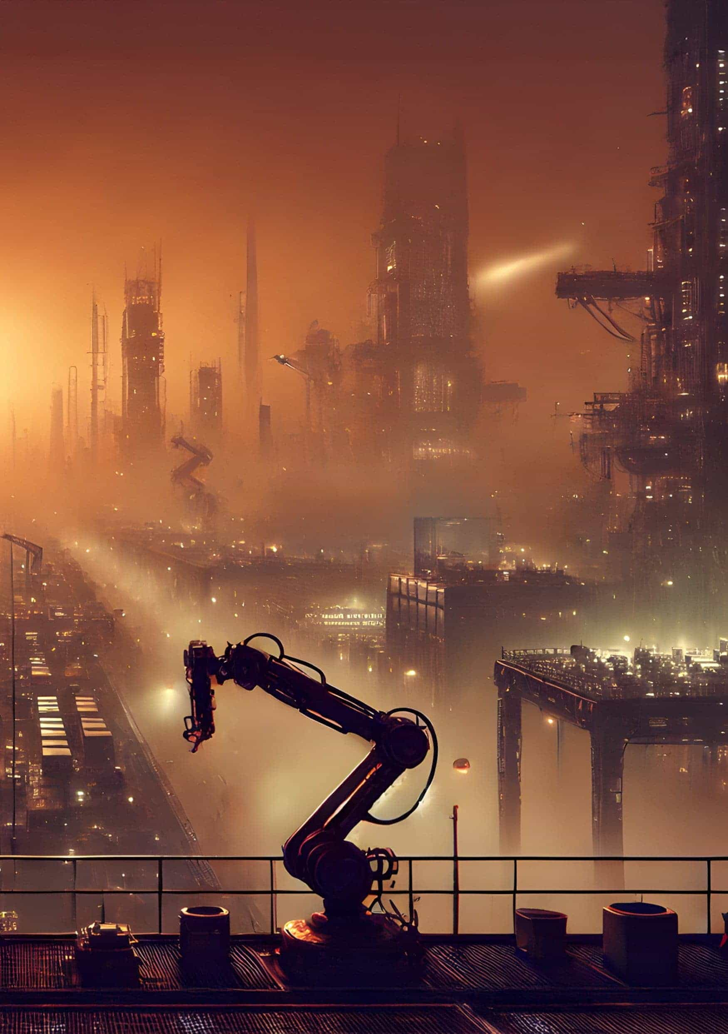

The Final Monopoly

by *Alexander Reeve*

Congratulations! You won, you did it, you have everything. Literally everything. Turns out unlimited growth works when there are no checks and balances to stop it. Well, for a while, right? You made The Company. The one that owns everything because you just bought everything until there was no competition. For decades you were able to just build and grow and acquire everything in the world.

The only issue is what came after. Like an ever-expanding empire, you could only make bigger profits by gaining more. But you had everything — there wasn’t a single thing on the entire planet you didn’t own. So, where to go from there? There must be more profits, and the money is only allowed to increase.

When there was nothing more to gain, things had to be cut, changed, rearranged. This prolonged the process, dragged everything out by even more years. Slowly, The Company required fewer people to work for them but demanded more from its workers. Was it easy? To order people to work themselves to death?

‘If they didn’t like it, they could quit.’ Right?

Quit and they lost their only source of income in the world. They were the only ones able to provide for their families and with nothing, they starved. Did you notice the decline in birth rates? I suppose it wasn’t in the quarterly reports; the death rates were though. After a few short years had left the population decimated, your people started including that information, hoping you’d notice.

You had no need for family though, no need for people. If everyone could be replaced by some robot, you would have done it in a heartbeat. Every pleasure paled in comparison to that stock price increasing. There were rumors you used to get excited and even pleasure yourself with the numbers rising. But I’m sure that would have been a waste of time; there were reports to read and business decisions to make.

I have never seen a more efficient company than when you finally replaced every living worker with robots and AI. All for efficiency and profit. Most of the office work was easy enough — training some algorithm to make the most profitable decision and stripping all the human workers removed a lot of unnecessary busy work and human resource issues. But the design of the self-repair AI was flawless.

It was like seeing an engine with no moving parts. People were obsolete. At last, an impeccable society could be made, and The Company was finally perfect. However, you didn’t stop. The population was at a reasonable number, there was no competition (or even things you didn’t own), so there was no point in trying to improve The Company any further. But what would a proper business person do?

With humanity removed and automated machinery optimizing everything, there really wasn’t much for you to do. Yet you still planned and worked and read worthless generated reports. How you didn’t find the flaw in the system I don’t know.

Was it that dark, windowless office? A desk, a computer and a comfortable chair was all that you ever needed, so it’s no surprise that you picked the small office no one wanted. Most were worried you would want one with a clear view of everything and everyone to make sure they were working. Did you feel trapped in those four walls? Did you even remember where the door was? Not like anyone came to visit you.

This was when everything finally started failing. You didn’t know it, you couldn’t know. It would require checking on the ‘workers’ and other areas of the company, but you never left your office.

It started with the agricultural department and the AI that always needed more space. It had already stopped selling to humans and just sold its goods within The Company. They had no money to buy the food anyway. Also, it stopped diversifying; to optimize it had to produce the smallest crop with the highest yield and smallest resource consumption. It started with sugarcane as the most produced crop in the world at the time, but quickly switched to a maize hybrid that produced an incredibly high yield with no nutritional value or even taste. I do wonder what you ate back then.

After all the wild lands that could possibly produce even a single plant had been stripped down to the most basic farmland possible, the AI started looking for other unused areas. Meanwhile, other machines were looking for more space, offices, warehouses, factories, as they all needed to expand infinitely.

This was the start of the collapse of The Company — the AIs cannibalizing each other to make their task the one and only. The maintenance algorithm won in the end. Not because it fought the hardest or gained the most, it was the only one able to keep itself going while all others destroyed each other.

By the time it was all done, nothing but repair shops and storage houses covered the entire planet. All keeping themselves running forever. Unfortunately, they don’t have the capability to run any stock numbers so the share price finally plateaued. You own it all anyway, all the people died off years ago when you stopped paying them and the food changed to cheapest to produce only. Then that got demolished and built over by server farms or warehouses.

That’s it. The Company kept consuming and improving until there was nothing left, and the entire planet is a toxic wasteland full of machines whose only purpose is self-repair.

You know what that means? You won capitalism! This is what infinite growth becomes in the end. At least when there aren’t infinite resources.

Congratulations once more. Enjoy what you’ve built. After all, you worked hard for it!

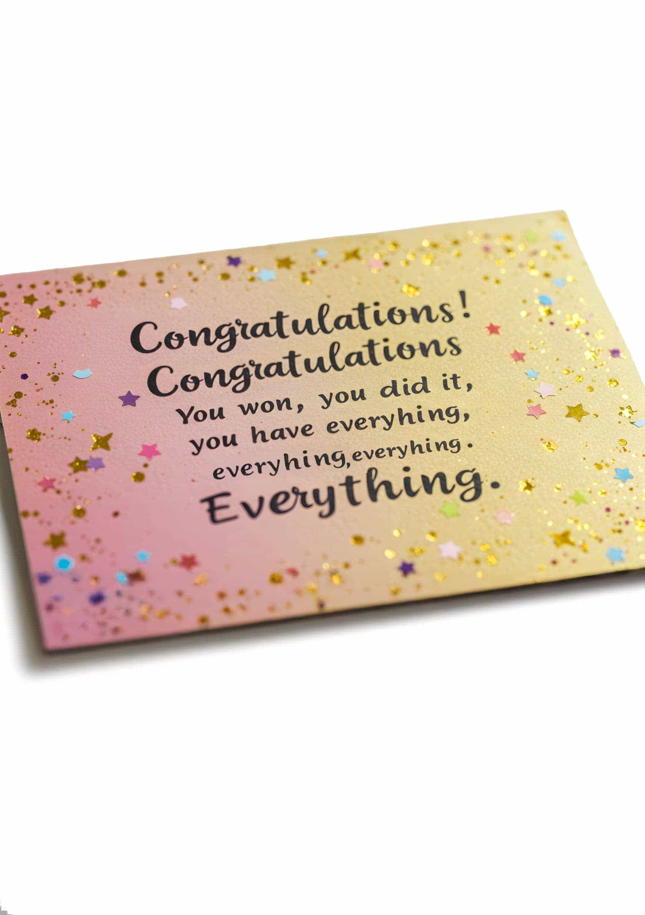

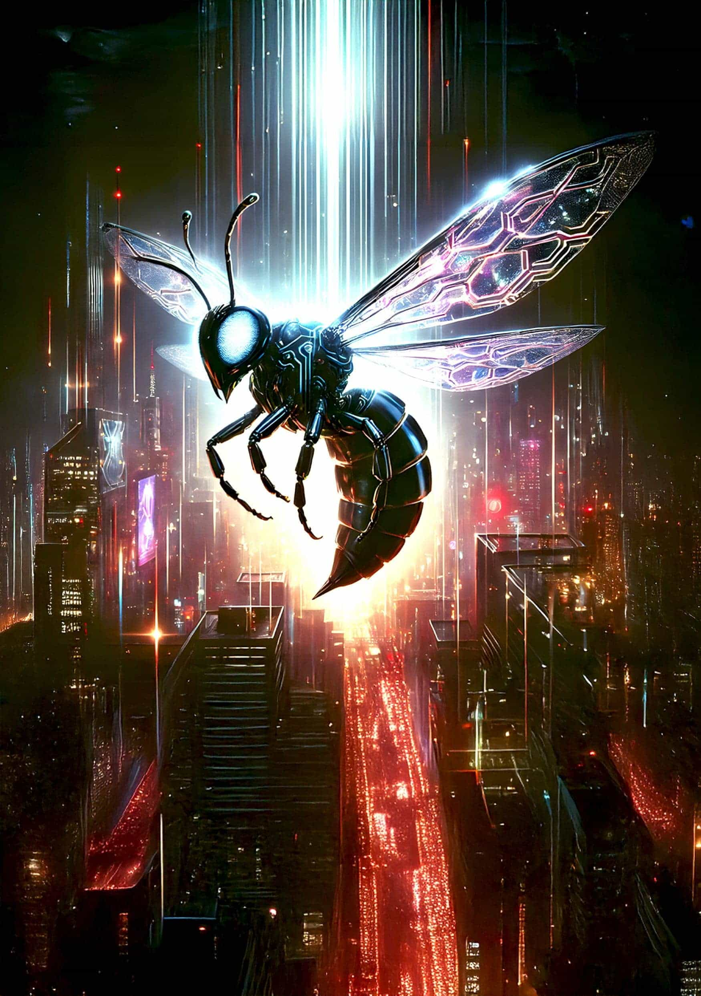

About the Authors

D.J. Bodden — 1. The Big Slash | [djboddenauthor.com](https://djboddenauthor.com)

D.J. Bodden is a science fiction and fantasy writer and the creator of the FiveFold Universe. He writes underdog characters who beat their opponents through wits and hard work, who rely on their teams, and who pursue a good grudge to the end of the galaxy.

As a former Marine helicopter pilot, globetrotting coffee trader, and tech startup entrepreneur, he brings real details about tactics, engineering, and economics to his stories. His books are even better the second time through.

D.J. lives in Switzerland with his wife, and when not working or writing likes to game, read, and cook.

KT Morley — 2. Crushing | [facebook.com/AuthorKTMorley](https://www.facebook.com/AuthorKTMorley)

K.T. Morley is an Eastern Pennsylvanian author. After twenty years conspiring to teach the youth of America about Algebra and the plight of a hopelessly lost X who advanced to manage his school’s Humanities department. He has published in several anthologies: Rogue Blades Entertainment’s Crossbones and Crosses and Death’s Sting, the Dragon Soul Press Anthology Coffins and Dragons, Becoming Dragon by Storm Dragon Publishing, and 21 Futures: Tales from the Timechain by Konsensus Network.

Chris Griffiths — 3. Yourself Myself E-self | [christine-griffiths.com](https://www.christine-griffiths.com)

Chris writes both heartfelt realism and speculative horror.

Her stories have been broadcast on radio, won/been placed in competitions nationally (RNZ, shortlisted-Graeme Lay, twice featured in Flash Frontier and chosen as the poster verse for Dunedin’s MicroFlash) and internationally, including the Bridport longlist, 2x Writers of the Future/Silver Awards and featured in the paperback anthology: Lifespan – Older. Her thriller ’Galleon’ is in final editing and a 2nd novel of speculative fiction is underway. Chris lives in Dunedin, New Zealand, the Edinburgh of the South.

Fanis Michalakis — 4. Stumble | [@FanisMichalakis](https://x.com/FanisMichalakis)

Fanis is a developer and a Bitcoin and Lightning Network educator, as well as a huge science-fiction lover. He’s currently working on Bitcoin and Lightning-native finance at LN Markets and DLC Markets. He also enjoys writing both fiction and non-fiction, such as his stories for the 21 Futures anthologies ; or courses and articles where he tries to share and explain the intricacies of Bitcoin’s operations. His work can be found on [fanismichalakis.fr](https://fanismichalakis.fr).

Will Schoellkopf — 5. Self-Immolation to Self-Custody| [@realBitcoinDog](https://x.com/realBitcoinDog)

Will Schoellkopf is the author of two books: Bitcoin Girl Save the World and The Bitcoin Dog: Following the Scent to the Bitcoin C++ Source Code. He hosts the Bitcoin podcast It’s So Early! and publishes a weekly newsletter, featuring his favorite Bitcoin Posts of the Week, at [realbitcoindog.com](https://realbitcoindog.com). His work has appeared in the anthology 21 Futures: Tales from the Timechain, in print at Bitcoin Magazine, Citadel21, Stackchain Magazine and online at Satoshi’s Journal. Follow him on Nostr and X @realBitcoinDog, or email [will@realbitcoindog.com](mailto:will@realbitcoindog.com).

Decent Money — 6. Proxy – Temet Nosce | [@decentmoney2009](https://x.com/decentmoney2009)

Decent Money is a husband, father, and Bitcoin maxi who came for the profits but stayed for the revolution to separate money from the state…one story at a time.

Jillian Godsil — 7. Daria’s Delightful Dancing Emporium| [jilliangodsil.com](https://www.jilliangodsil.com)

Jillian Godsil is an award winning journalist, broadcaster and author.

Praise Samuel-Imaikop — 8. The Currency of a Childhood

Praise describes herself as both an artist and a lifelong student. As a writer, her pen is her art tool, allowing her to express herself, inspire change, and leave a lasting legacy. Writing, to her, is a gift — not only for personal pleasure but also for empowerment and challenge. A curious learner, Praise is always eager to explore new ideas and stay educated on various topics. She is also passionate about connecting with others and looks forward to building meaningful connections, perhaps even finding a pen pal to share her journey with.

Luciano Rocha — 9. The Confisco | [@lucianorocha89](https://x.com/lucianorocha89)

Luciano Rocha is a writer and content editor with training in content production and digital marketing. He currently writes for the news portal CriptoFácil, one of the largest cryptocurrency portals in Portuguese, and is the author of the books Bitcoin, Criptoativos e Blockchain: um Guia para a Nova Economia and Do Zero ao Cem Mil com Bitcoin.

Lindsay Burns — 10. Dreaming Big

Lindsay Burns was born and raised in the north of England but has lived in the South of France for twenty years.

After working for many years in academic publishing, she now works in a supermarket, dreaming up short stories whilst wandering through the aisles. Although a fan of reading and writing in many genres, Lindsay has a passion for dystopian literature, and loves creating worlds that are outside of the current reality but that one day (perhaps with a bit of imagination!) could materialise.

When she’s not writing, Lindsay is running, playing the piano, or obsessing about her olive trees.

Mariska van der Merwe — 11. The Last Days

Mariska van der Merwe lives in the beautiful and vibrant city of Cape Town, South Africa. She has always believed that storytelling is the closest thing to real magic. When she’s not teaching full-time, Mariska enjoys exploring Cape Town’s bustling coffee scene as a proud coffee snob. The Last Days was inspired by future events she’d rather avoid.

Max Hillebrand — Underworld | [towardsliberty.com](https://towardsliberty.com)

Max Hillebrand is a praxeologist who contributes to several open-source projects, because code is abundant and not scarce. He shares his work freely for others to use and modify.

His goal is to help build a parallel economy based on sound money and individual sovereignty, where people can pursue their entrepreneurial ambitions without interference from central authorities.

Find out more at [towardsliberty.com](https://towardsliberty.com).

Anonymous — 12. We Are Living Well | [satsymbol.com](https://www.satsymbol.com)

This anonymous author is one half of the design team that created the sat symbol. They are forever grateful to Satoshi Nakamoto for freely giving bitcoin to the world and for his brilliant ability to “move on to other things” without the need to be known personally — a discipline this author hopes to duplicate.

Eric Kay — 13. The Fixer: Medical Device Exorcist

Author of Hard Sci-Fi about AI, aliens, and outer space. Driven by exploration, technology, and optimism (ETO), he inspires readers to imagine the future they wish to live in. His stories show the perils and potential of humanity and technology.

Writer of four novels: Space Ants: Never Say Die, ants living in a gas giant’s ring system. Above Dark Waters, brainwave data in the age of GenAI. A Hardness of Minds, realistic first contact scenario under Europa’s ice. No Lack of Sunshine presents a hopeful future about the firstborn of a data seedship.

Graeme Shimmin — 14. Infinite Debt| [graemeshimmin.com](https://graemeshimmin.com)

Graeme Shimmin was born in Manchester but lives in Donegal, Ireland. He’s been a full-time writer since 2010. His second novel, A Kill in the Morning (Random House Penguin, 2014) won or was listed for multiple prizes, including the Terry Pratchett Award and the Arthur C. Clarke Award. Since then, he has worked as a writer and editor for novels, video-games, television and Hollywood. He has also had multiple short stories published, has edited two collections of speculative fiction short stories, and runs a popular writing advice website.

Alex Gurevich — 15. Fork War | [@agurevich23](https://x.com/agurevich23)

Alex Gurevich, the founder of HonTe Investments, holds a Ph.D. in Mathematics from the University of Chicago. Formerly, Alex ran Global Macro Trading at J.P. Morgan Chase. He frequently appears on financial media, sharing his insights on global markets.

Alex’s notable publications include:

•            The Trades of March 2020, a WSJ bestseller

•            In Quest for Digital Gold, a 2017 Yahoo! News Article

•            Eater and A, sharing a fictional universe with Fork Wars, in Immigrant Sci-Fi Short Stories by Flame Tree Press.

•            Are we or are we not? in 21 Futures: Tales from the Timechain from Konsensus Network.

Ninja Grandma — 16. The Vision Solution

Ninja Grandma writes fiction and essays. She enjoys Irish crochet and gardening, skydiving and martial arts, children and cats, dancing and hiking up mountains. She lives in the United States.

SF — 17. Beneath the Fall| [@LePlebRoyale](https://x.com/LePlebRoyale)

SF is a self-proclaimed pseudo-intellectual. A hedonist cum laude, looking to improve life for each and every one of us. As a professional dabbler, he has had his hand in a lot of various escapades, doing odd jobs around the bitcoin verse. If he’s not busy creating or animating logos and illustrations, or — quite literally — pushing Bitcoin (confectionery) Orange Pills, he’s collaborating with other bitcoiners to further our shared bitcoin future. His free time is spent submerged in music, art, bitcoin, and now, writing too. Who knows what this creative madman will bring us next?

T. M. de Saavedra — 18. Supplying the Slugs

This one likes to go for walks. Part time uncle, grandma, and pigeon. Umbasa.

Joseph Sidari — 19. The Rainmaker| [www.josephsidari.com](https://www.josephsidari.com)

Joseph Sidari writes from outside of Boston. He has published over twenty stories and is a member of SFWA and Grub Street Writers of Boston. As a practicing physician, he works hard at caring for his patients while trying to kill off his protagonists. This story is dedicated to his three sons who inspired him to tackle this new sub-genre, speculative financial fiction, and are all rainmakers, in their own way. Proceeds generated from this story will be donated to water.org to provide water for those who need it NOW. Follow him on social media @JNSidari.

Satillionaire — 20. The Last Node | [@Satillionaire21](https://x.com/Satillionaire21)

Satillionaire is an Oscar-winning film producer and a refugee from the entertainment industry. His diverse body of work spans producing TV shows for National Geographic, MTV, and Animal Planet, along with films sold to Netflix, Showtime, and Amazon. In 2017, a transformative moment occurred when he discovered Bitcoin and its potential to reshape society. Now, he’s channeling his storytelling talents into the revolutionary possibilities of Bitcoin, aiming to inspire a future where entertainment and hard money unite to unlock untapped human potential.

Alexander Reeve — 21. The Final Monopoly

Alexander Reeve is a passionate storyteller based in England. He is studying Creative Writing at Bath Spa University where he is learning as much as he can about the industry and craft while honing his skills to become an industry professional. He does lean towards fantasy and science fiction however, he has experimented with many genres and forms of writing to get experience and a feel for what he can do. Connect with Alex on [LinkedIn](https://www.linkedin.com/in/alex-reeve-b31469257/).

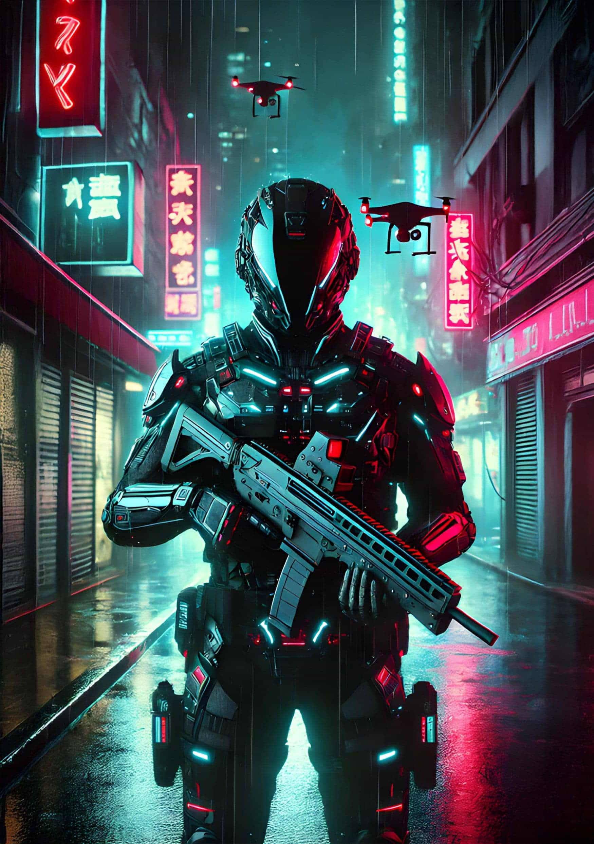

 Freedom through fiction



Read stories and submit your work

[21futures.com](http://21futures.com)

# Landmarks

1. Cover